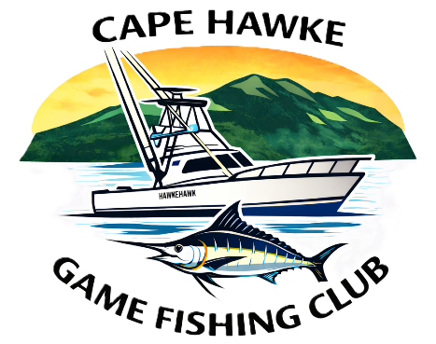

Cape Hawke Game Fishing Club Inc.
(Incorporated under the Associations Incorporation Act of 2009) ABN 80985447303

Membership Application Form
I, (full name)
Of, (address)
Suburb State Postcode
DOB
Phone Mobile
Email
Emergency Contact
Contact number
hereby apply for renewal/membership of Cape Hawke Game Fishing Club.
Membership fees for the year 1st July 2026 to 30th June 2027
Senior: $150 | $
Junior: $0 for 2026/27 (15 Years and under) | $
Small Fry: $0 for 2026/27 (10 Years and under) | $
Non fishing Member: $50 | $
Total: | $

I agree to be bound by the Rules and by Laws of the Association currently in force:

Signature:_______________________ Date:________________________

To be completed for New Member Application
Have you ever been suspended from another club? |  | Yes/No
If yes, please state reason:
Proposer and Seconder must be a member with at least 1 year standing
Proposed by: | Signed:
Seconded by: | Signed:

Please send the completed form to secretary@capehawkegfc.com.au along with confirmation of payment, or alternatively post post the form to:

Cape Hawke Game Fishing Club
PO Box 277
Tuncurry, NSW
2428
Once your membership application has been assessed by the Committee you will be notified by email and if accepted, payment details will be provided.

