1. System description

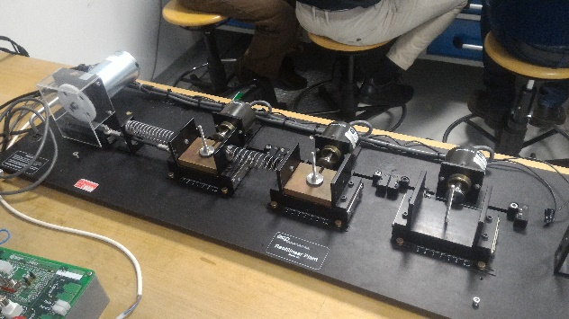

* A DC direct drive brushed motor
* Three carts with anti-friction ball bearing
* Three springs connecting the carts and the motor
* Several weights to put upon carts
* Three optical incremental digital encoders for the position
* An encoder for the motor
* A PoliArd board with an Arduino Due microcontroller

1. Preliminary issues
   * Motor current: Arduino saturation limits current limited to ±5A

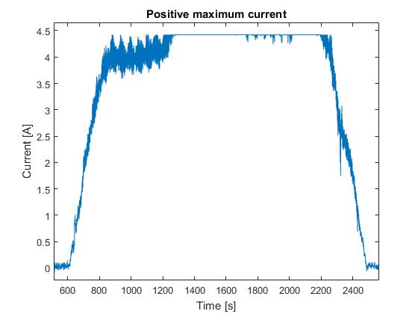

* + For negative current values the noise variance is not constant

Solved by simple linear interpolation? Chiarire meglio

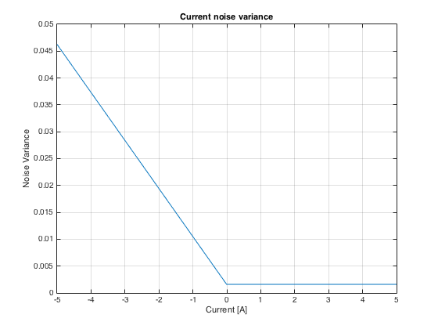

* + Conversion of encoder signal from Arduino output to cm

Measurement of the ratio between displacement and Arduino output

1. Protection

* Switch off alert based on current, voltage and displacement measurements
* Synchronization of Arduino e signal start time

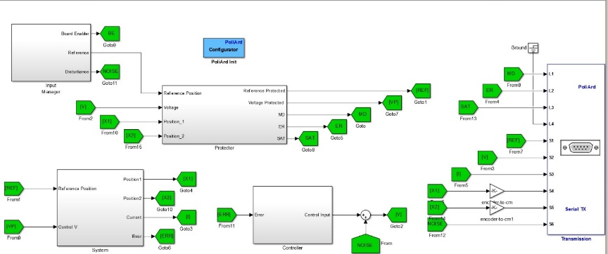

Four macroblocks:

* + Input Manager: decides input between potentiometer and signal
  + Protector: saturations on voltage, displacement and reference plus init and alert manager
  + System: motor and encoder feedback
  + Controller: pulls the control voltage to 0 Volt when the voltage is disabled

1. Motor (Pinion and Rack) modelling

Motor:  where

: input voltage

: motor current

: motor inductance

: motor resistance

: angular position of the disk

: back emf effect

: torque constant 

Pinion/rack:  where

load torque transmitted to the carts

inertia of motor, pinion and rack

 non linear motor friction

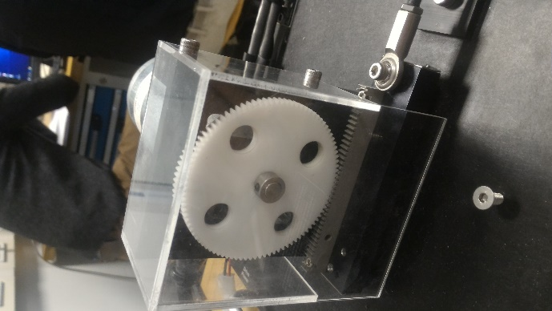

1. Carts springs and damping

Each cart  where

: total mass of the i-th cart

: total damping (viscous + spring) of the i-th cart

: stiffness of the i-th spring

Putting and neglecting non linear friction

 where



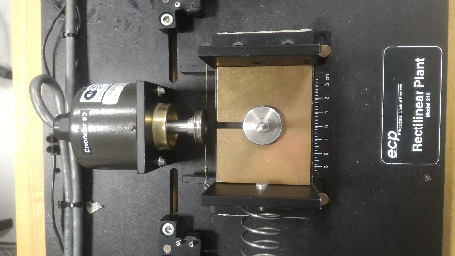

1. 1 dof

 state of the motor (current)

 position of the cart

 velocity of the cart



Put 

1 DOF: 

1. 2-3 dof

Lagrangian approach

1. Validation

Tempo 30 secondi a slide 7x3=21 -> 21x30=500= 10,5 minuti

Tempo 45 secondi a slide 7x3=21 -> 21x45=945= 15,75 minuti