AMAZON SALES INTELLIGENCE – DATA ARCHITECTURE & DAX STRATEGY DOCUMENT
E-Commerce Sales, Product, Customer & Regional Analytics | Power BI
Author: Sinegavalli.S
Purpose: provide a handover-ready architecture reference covering source, tables, facts/dimensions, columns, data types, relationships, schema, ER view, Power BI connectivity, references, and a DAX implementation strategy for the Amazon Sales Intelligence Dashboard.

1. Source & Evidence
Item | Observed / documented value | Status
Report | Amazon Sales Intelligence Dashboard (Amazon_dashboard.pbix) | Confirmed
PBIX model tables | FACT_TABLE, DIM_DATE, PRODUCT, CUSTOMER, REGION | Confirmed from report fields
Report pages | Amazon Front, Product Performance, Customer Analytics, Region-wise Performance, Sales Detail Explorer | Confirmed
Business scope | Sales, profit, quantity, orders, profit margin, products, customers, regions and payment methods | Confirmed
Headline values | Total Sales 428.58K; Total Profit 84.51K; Quantity 306; Orders 100; Profit Margin 0.20; Top region South (30.1%) | Confirmed from dashboard screenshot
Original physical source | Not exposed by the PBIX layout; the data source is held in the compressed data model | Needs validation
Storage mode | Not asserted from the evidence available | Needs validation
The report layout confirms the table and field names above; relationships, key columns and DAX text sit inside the compressed DataModel and are marked "validate" where used.

2. Data Model – Fact vs Dimension
Table | Role | Business purpose
FACT_TABLE | FACT | Sales transactions: sales amount, profit, quantity, payment method, order counts
DIM_DATE | DIMENSION | Calendar attributes: date, year, quarter, month, day (date hierarchy)
PRODUCT | DIMENSION | Product name and category
CUSTOMER | DIMENSION | Customer name, customer type and gender
REGION | DIMENSION | Region, state and city
The model follows a star schema: one central fact table filtered by four dimensions.

3. Column Inventory
Table | Columns / fields identified | Data type classification | Usage
FACT_TABLE | SALES_ID, SALES_AMOUNT, PROFIT, QUANTITY, PAYMENT_METHOD, TOTAL_ORDERS, dimension keys | Text/Integer, Decimal, Integer, Text (validate exact model types) | Measures and transaction analysis
DIM_DATE | DATE, MONTH, Year, Quarter, Day | Date / Text / Integer (validate) | Calendar filtering and trend axis
PRODUCT | PRODUCT_NAME, CATEGORY | Text | Product and category slicing
CUSTOMER | CUSTOMER_NAME, CUSTOMER_TYPE, GENDER | Text | Customer segmentation
REGION | Region, State, City | Text | Geographic slicing and drill-down
Fields used on the Sales Detail Explorer table: sales ID, customer, product, region, date (year, quarter, month, day), quantity, sales amount and profit.

4. Row-Level Design
Recommended grain documentation: FACT_TABLE should be documented as one row per sales transaction only after the physical key (SALES_ID) is confirmed unique. If several product lines share one order, state the true grain explicitly in the final technical specification.
Object | Required grain / key documentation | Current status
FACT_TABLE | Primary/business key (SALES_ID) and exact grain | Validate in Power BI Model/Data view
DIM_DATE | One row per calendar date | Conceptual expectation; mark as date table
PRODUCT | One row per product | Conceptual expectation; validate duplicates
CUSTOMER | One row per customer | Conceptual expectation; validate duplicates
REGION | One row per location (region / state / city) | Conceptual expectation; validate duplicates

5. Schema Strategy – Star Schema
The preferred semantic-model pattern is a star schema: dimensions filter facts, while measures are calculated from the fact table. Keep filter direction from dimension → fact. Avoid unnecessary many-to-many and bidirectional relationships.
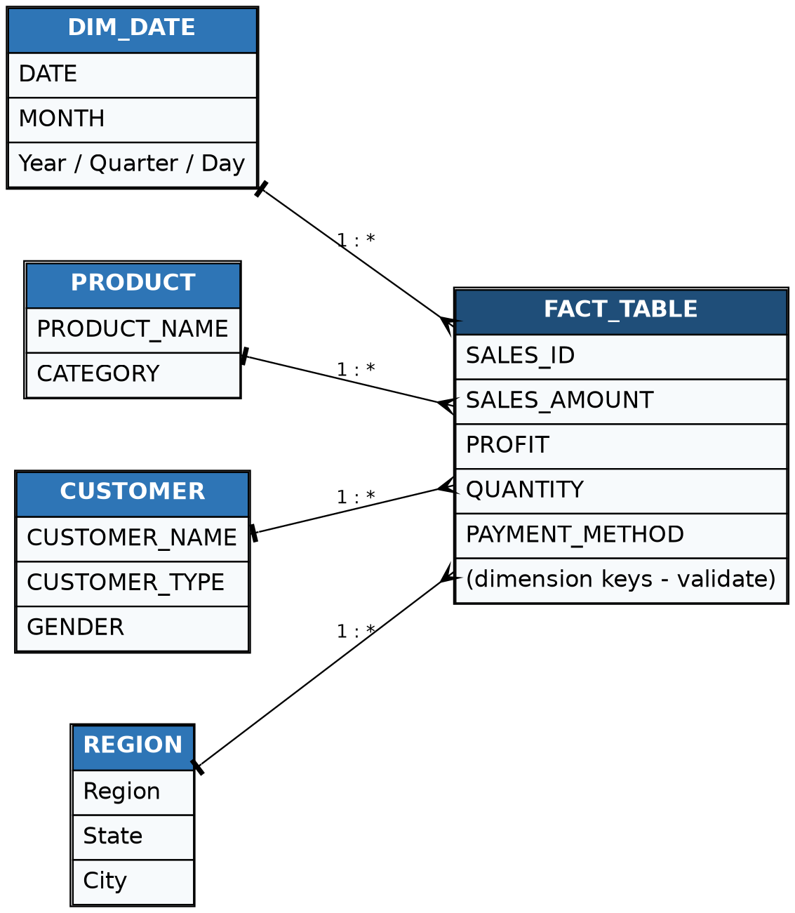
Figure 1. Conceptual star-schema view. Exact physical keys and cardinality must be validated in Power BI Model view.

6. Relationship / Connection Matrix
From | To | Conceptual relationship | Recommended direction | Validation
DIM_DATE | FACT_TABLE | Date key → transaction date | Single: DIM_DATE → FACT_TABLE | Confirm active date key
PRODUCT | FACT_TABLE | Product key → product key | Single: PRODUCT → FACT_TABLE | Confirm 1:*
CUSTOMER | FACT_TABLE | Customer key → customer key | Single: CUSTOMER → FACT_TABLE | Confirm 1:*
REGION | FACT_TABLE | Region key → region key | Single: REGION → FACT_TABLE | Confirm 1:*
Every report page uses FACT_TABLE measures sliced by one or more dimensions, for example sales by PRODUCT[CATEGORY], by REGION[Region] and by DIM_DATE[MONTH].

7. How to Connect the Model in Power BI
1. Power BI Desktop → Home → Get Data → select the real source (Excel, SQL Server, CSV, etc.).
2. Load or transform source data in Power Query. Standardize column names, nulls, dates, data types and keys.
3. Create dimension tables first: DIM_DATE, PRODUCT, CUSTOMER and REGION.
4. Load FACT_TABLE at its documented grain.
5. Open Model view and create key relationships. Prefer 1:* with the dimension on the 1-side and the fact on the *-side.
6. Set cross-filter direction to Single unless a documented business requirement needs otherwise.
7. Mark DIM_DATE as the date table and sort MONTH by a month-number column.
8. Hide technical key columns from report users after relationships are tested.
9. Create a dedicated Measures table and add DAX measures rather than calculated columns for aggregations.
10. Validate totals against source data before publishing.

8. KPI / DAX Reference
Measure | Business definition | DAX pattern
Total Sales | Sum of sales value | SUM(FACT_TABLE[SALES_AMOUNT])
Total Profit | Sum of profit | SUM(FACT_TABLE[PROFIT])
Total Quantity | Units sold | SUM(FACT_TABLE[QUANTITY])
Total Orders | Distinct count of orders | DISTINCTCOUNT(FACT_TABLE[SALES_ID])
Total Customer | Distinct customers | DISTINCTCOUNT(FACT_TABLE[CUSTOMER_ID]) (validate key)
Profit Margin % | Profit / Sales | DIVIDE([Total Profit],[Total Sales])
Average Order Value | Sales / orders | DIVIDE([Total Sales],[Total Orders])
Top Product | Product with highest sales | MAXX(TOPN(1,ALL(PRODUCT[PRODUCT_NAME]),[Total Sales],DESC),PRODUCT[PRODUCT_NAME])
Top Product Sales | Sales of the best product | MAXX(ALL(PRODUCT[PRODUCT_NAME]),[Total Sales])
Top Region | Region with highest sales | MAXX(TOPN(1,ALL(REGION[Region]),[Total Sales],DESC),REGION[Region])
Top Region Share % | Top region as share of all sales | DIVIDE([Top Region Sales],CALCULATE([Total Sales],ALL(REGION)))
Sales Last Month | Prior-month sales | CALCULATE([Total Sales],DATEADD(DIM_DATE[DATE],-1,MONTH))
Sales MoM Growth % | Current vs prior month | DIVIDE([Total Sales]-[Sales Last Month],[Sales Last Month])
Sales YTD | Year-to-date sales | TOTALYTD([Total Sales],DIM_DATE[DATE])
Important: the exact physical column names (for example CUSTOMER_ID) and the formulas already in the PBIX must be checked before these patterns are adopted. The formulas above are implementation patterns, not a claim that every physical column name is exactly this.

9. DAX Strategy Document
DAX layer | Strategy
Layer 1 – Base measures | Create reusable atomic measures first: Sales, Profit, Quantity, Orders, Customers.
Layer 2 – Profitability | Build Profit Margin % and Average Order Value from base measures instead of repeating SUM logic.
Layer 3 – Ranking | Use TOPN with MAXX (or RANKX) for Top Product, Top Customer and Top Region cards.
Layer 4 – Share of total | Use CALCULATE with ALL on one dimension to compute percentage of grand total, replacing typed-in text.
Layer 5 – Time intelligence | Use a dedicated marked Date table; build prior-month, MoM growth and YTD measures from it.
Layer 6 – Ratios | Use DIVIDE() for all percentage metrics to avoid divide-by-zero errors.
Layer 7 – Filter-aware metrics | Use CALCULATE() to modify filter context deliberately; avoid unnecessary ALL() because it removes slicer context.
Layer 8 – Presentation | Format currency, counts and percentages at the measure level; keep visuals thin and measure-driven.

10. Ranking / Share DAX Patterns
Top Product = MAXX(TOPN(1, ALL(PRODUCT[PRODUCT_NAME]), [Total Sales], DESC), PRODUCT[PRODUCT_NAME])
Top Region = MAXX(TOPN(1, ALL(REGION[Region]), [Total Sales], DESC), REGION[Region])
Top Region Sales = MAXX(ALL(REGION[Region]), [Total Sales])
Top Region Share % = DIVIDE([Top Region Sales], CALCULATE([Total Sales], ALL(REGION)))
Category Share % = DIVIDE([Total Sales], CALCULATE([Total Sales], ALL(PRODUCT[CATEGORY])))

11. Report / Visual Reference
Page | Purpose | Key content
Amazon Front | Management overview | KPI cards (sales, profit, quantity, orders, margin), monthly trend, sales by region, category and product, orders by payment method, Region/Category/Month slicers
Product Performance | Product analysis | Top product cards, sales/profit/quantity by product, product performance table
Customer Analytics | Customer analysis | Total customers, average order value, top customers, sales by customer type and gender, customer-by-category matrix
Region-wise Performance | Geographic analysis | Top region cards, sales by region, state and city, profit by region, Region slicer
Sales Detail Explorer | Row-level detail | Transaction table with date hierarchy, product and region slicers, drill-through

12. Power BI Service / Deployment Checklist
☐ Publish PBIX to the correct workspace.
☐ Confirm semantic model refresh succeeds.
☐ Configure gateway/credentials if the source requires an on-premises gateway.
☐ Set scheduled refresh only after manual refresh is successful.
☐ Validate RLS if security rules are implemented.
☐ Test report filters, totals and exports in the Service.
☐ Fix month sort order and replace hard-coded home-page text with measures before publishing.

13. References & Validation Notes
Primary reference: the supplied Amazon_dashboard.pbix and dashboard screenshot. The report layout confirms the table names, field names, measure names, page names and headline values.
PBIX validation note: the DataModel artifact is compressed and could not be read. Relationships, key columns, data types, the physical source and the existing DAX text are therefore marked "validate" rather than invented.

14. Final Architecture Summary
Recommended architecture: Source → Power Query → Star Schema → DAX Semantic Layer → Power BI Report → Power BI Service. Use FACT_TABLE for transactional facts, four reusable dimensions for filtering, and a layered measure strategy for maintainability and performance.

