PV Sysem Components:

A photovoltaic system typically includes an array of photovoltaic modules, an inverter, a battery pack for storage, interconnection wiring, and optionally a solar tracking mechanism.

Solar Array: Made of PV modules, Solar panels are typically measured under STC (standard test conditions) or PTC (PVUSA test conditions), in watts. Typical panel ratings range from less than 100 watts to over 400 watts. The array rating consists of a summation of the panel ratings, in watts, kilowatts, or megawatts.
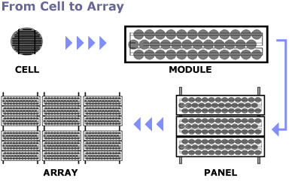

Battery: Common battery technologies used in today's PV systems include the valve regulated lead-acid battery– a modified version of the conventional lead–acid battery, nickel–cadmium and lithium-ion batteries.
PV systems with an integrated battery solution also need a charge controller, as the varying voltage and current from the solar array requires constant adjustment to prevent damage from overcharging. Basic charge controllers may simply turn the PV panels on and off, or may meter out pulses of energy as needed, a strategy called PWM or pulse-width modulation.

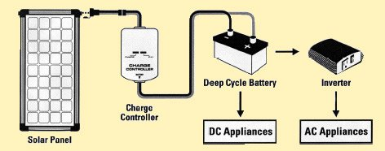

Inverter: Systems designed to deliver alternating current (AC), such as grid-connected applications need an inverter to convert the direct current (DC) from the solar modules to AC.

Utility Meter: utility power is automatically provided at night and during the day when the demand exceeds your solar electric power production.

The utility meter actually spins backwards when solar power production exceeds house demand, allowing you to credit any excess electricity against future utility bills.
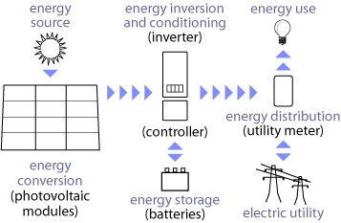

Terms:

Tilt Angle: PV Modules inclination, varies based on the lat.
Standard tAngle = lat – 15°

Isolation: Gathered energy in a day on an orizontally placed module. Measured in Kwh/sm

PV Panel: Made of PV modules. 8-10sm panel produces 1 Kwp D.C.

Solar K: 1.353 W/sm.

Irradiation: KW/sm. 1 KW/sm @ 12AM

PV Module Yield: Irradiation Energy/Obtained Energy. Typical yields: 15%-25%

Watt peak (Wp): Peak power while in standard conditions

Data Units:

Array voltage | VDC | V
Grid voltage | VAC | V
Array current | IDC | A
Grid current | IAC | A
Array power | PDC | W
Grid power | PAC | W

Module temperature | Tmod | °C
Ambient temperature | Tamb | °C
Global irradiance | G | W/m2
Global irradiation | H | J/m2
Wind speed | v | m/s
Inverter Efficiency:
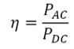

Annual solar energy output:

E = A * r * H * PR
E = Energy (kWh)
A = Total solar panel Area (m²)
r = solar panel yield or efficiency(%)
H = Annual average solar radiation on tilted panels (shadings not included)
PR = Performance ratio, coefficient for losses (range between 0.5 and 0.9, default value = 0.75)

r is the yield of the solar panel given by the ratio : electrical power (in kWp) of one solar panel divided by the area of one panel.
Example : the solar panel yield of a PV module of 250 Wp with an area of 1.6 m² is 15.6%.
Be aware that this nominal ratio is given for standard test conditions (STC) : radiation=1000 W/m², cell temperature=25 °C, Wind speed=1 m/s, AM=1.5.
The unit of the nominal power of the photovoltaic panel in these conditions is called "Watt-peak" (Wp or kWp=1000 Wp or MWp=1000000 Wp).

H is the annual average solar radiation on tilted panels. Between 200 kWh/m².y (Norway) and 2600 kWh/m².y (Saudi Arabia). You can find this global radiation value here : Solar radiation data
You have to find the global annual irradiation incident on your PV panels with your specific inclination (slope, tilt) and orientation (azimut).

PR : PR (Performance Ratio) is a very important value to evaluate the quality of a photovoltaic installation because it gives the performance of the installation independently of the orientation, inclination of the panel. It includes all losses.

Example of detailed losses that gives the PR value (depend on the site, the technology, and sizing of the system):
- Inverter losses (4% to 10 %)
- Temperature losses (5% to 20%)
- DC cables losses (1 to 3 %)
- AC cables losses (1 to 3 %)
- Shadings 0 % to 80% !!! (specific to each site)
- Losses at weak radiation 3% to 7%
- Losses due to dust, snow... (2%)
- Other Losses (?)

Useful links:

http://www.3e.eu/monitoring-of-photovoltaic-systems-good-practices-and-systematic-analysis/
http://www.pvresources.com/en/inverters/monitoring.php
http://photovoltaic-software.com/PV-solar-energy-calculation.php

