

*Interactive puzzle game for KS3 computing education in schools*

KS3 teachers are not equipped to teach the new curriculum that the government has introduced for Computing. Current tools are either ineffective at teaching the fundamentals of programming or don’t provide support tools to aid the teacher in their teaching, be that understanding the material themselves, or tracking the progress of their class.

EduBot aims to teach students the fundamentals of programming, through a series of puzzlelike levels each corresponding to the KS3 curriculum. A block-based programming language is used so that students can focus on their understanding instead of trying to remember complicated syntax.

* Gives teachers confidence when teaching unfamiliar topics, by providing concept explanations and example solutions
* Easy to use class management and progress tracking
* Fun and engaging for students

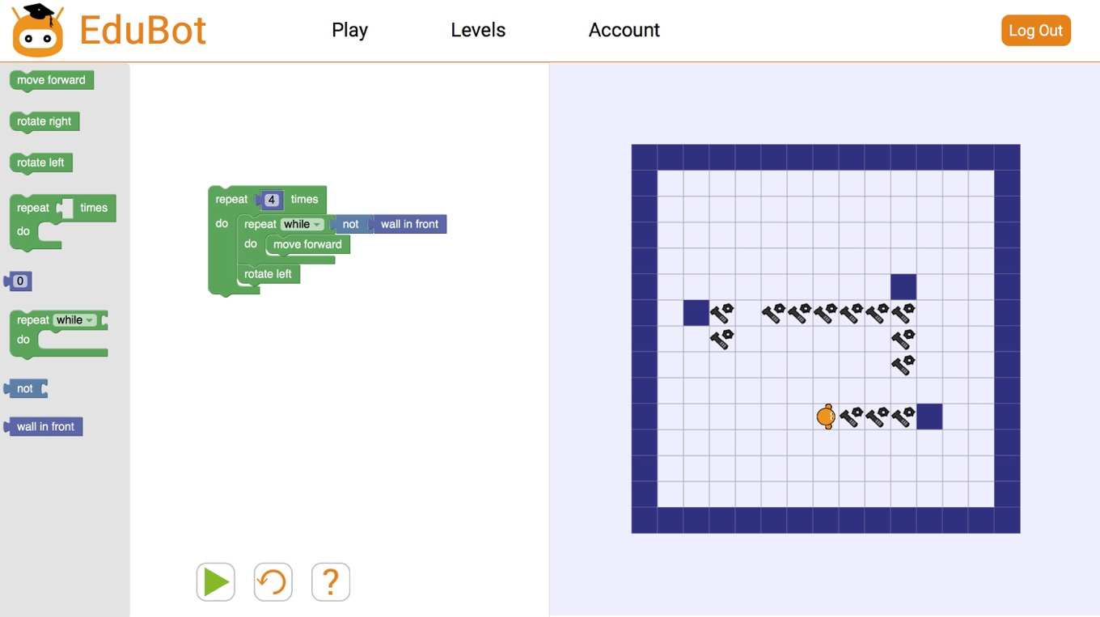

The play screen, where students drag blocks to create and run their programs. Each level has a goal, achieved by controlling EduBot through their code.