EXPT NO:8 | FORECASTING AND PREDICTIVE ANALYTICS USING TABLEAU  AND POWER BI
DATE: 14.08.2026

PRE-LAB QUESTIONS (PROVIDE BRIEF ANSWERS TO THE FOLLOWING QUESTIONS)
- What is forecasting in the context of Business Intelligence (BI)?

Forecasting in BI is the process of using historical data to predict future trends or values. It helps organizations estimate future sales, demand, revenue, and other business outcomes for better decision-making.
- Explain the difference between predictive analytics and descriptive analytics.
- Descriptive Analytics: Analyzes historical data to understand what happened in the past.
- Predictive Analytics: Uses historical data, statistical methods, and machine learning to predict what is likely to happen in the future.
Example:
Descriptive analytics shows last year's sales, while predictive analytics forecasts next month's sales.
- Name two common forecasting methods used in Tableau and Power BI.
Two common forecasting methods are:
- Exponential Smoothing
- Moving Average
These methods help identify trends and patterns in historical data and estimate future values.
- Why is data granularity important for accurate forecasting?
Data granularity refers to the level of detail in the data, such as daily, weekly, or monthly data. Choosing the appropriate granularity helps the forecasting model identify trends and seasonal patterns correctly.
For example, daily data can capture short-term fluctuations, while monthly data can provide a clearer view of long-term trends.
- Name two challenges in forecasting using multiple data sources.
Two common challenges are:
- Data inconsistency: Different sources may have different date formats, column names, units, or data types.
- Data integration issues: Combining datasets can cause problems such as duplicate records, missing values, or incorrect relationships between tables.

IN-LAB EXERCISE:
OBJECTIVE:
To perform time series forecasting and predictive analytics on historical sales data using Tableau and Power BI, and visualize future trends for informed decision-making. PROCEDURE:
- Data Collection:
  - Import historical sales data from multiple sources:
    - Dataset 1: Sales Data (CSV) → Order ID, Order Date, Region, Sales Amount
    - Dataset 2: Promotions Data (Excel) → Promotion ID, Region, Promotion Start Date, Promotion End Date, Discount
- Data Preparation and Transformation:
  - Clean data: standardize date formats, remove duplicates, handle missing values.
  - Aggregate sales data at the required granularity (daily, weekly, or monthly).
  - Ensure numeric fields (Sales, Discount) are correct.
- Data Integration and Modeling:
  - Tableau: Connect datasets and relate them using the Region field.
  - Power BI: Create relationships in the Model view; define cardinality where necessary.
- Forecasting and Predictive Analytics:
  - Tableau:
    - Use the Forecast feature on Sales over time. o Apply trend models like Exponential Smoothing and visualize prediction intervals.
  - Power BI:
    - Use built-in forecasting in line charts. o Optionally, create a DAX measure for predicted sales using moving averages or linear regression.
- Create Calculated Fields:
  - Forecasted Sales = Predicted value from the model
  - Sales Growth % = ((Forecasted Sales – Actual Sales) / Actual Sales) * 100
- Design a Comprehensive Dashboard:
  - Line chart showing actual vs. forecasted sales over time.
  - KPI cards: Total Forecasted Sales, Expected Growth %.
  - Use combo charts to show sales trends along with promotion periods.
  - Highlight regions with expected growth above or below target thresholds.
- Validate Forecast Accuracy:
  - Compare forecasts against actual historical sales (back-testing).
  - Adjust forecasting parameters if necessary (e.g., seasonality length, smoothing factor).
- Publishing and Sharing:
  - Tableau: Publish workbook to Tableau Public or Tableau Server.
  - Power BI: Publish report to Power BI Service and share with stakeholders.
Experiment Datasets:
  - Dataset 1: Historical Sales Data (CSV) → Order ID, Order Date, Region, Sales
  - Dataset 2: Promotions Data (Excel) → Promotion ID, Region, Promotion Start/End Date, Discount
POWER BI:
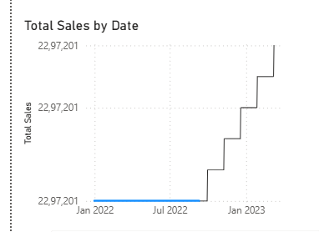
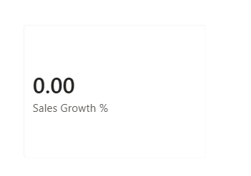
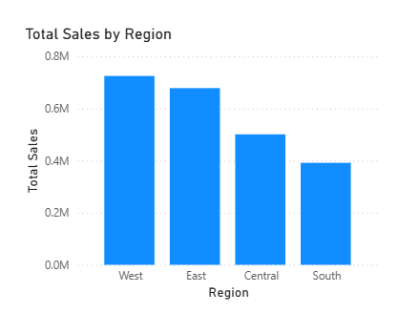
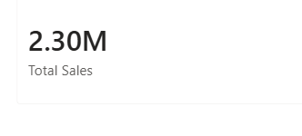
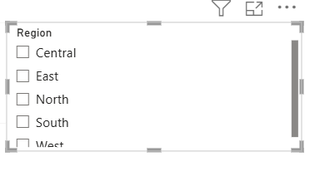
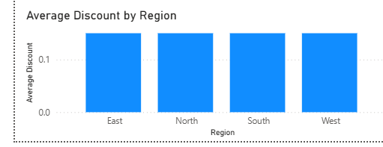
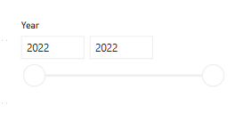
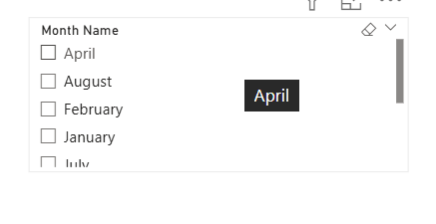
DASHBOARD:
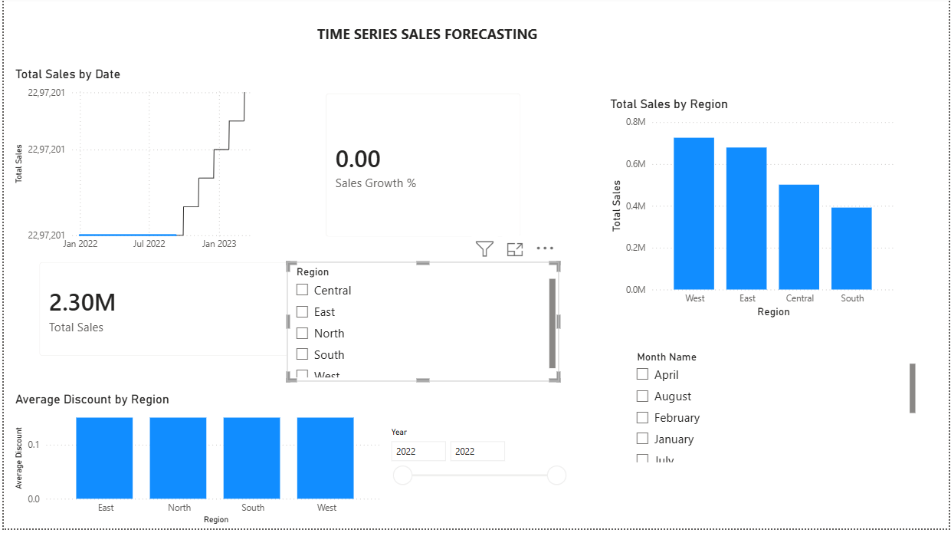

TABLEAU:
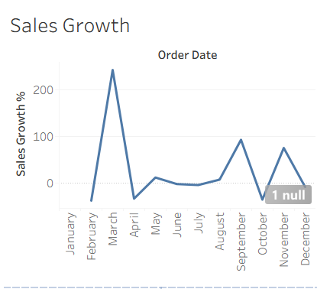
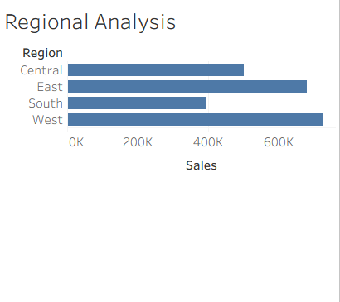
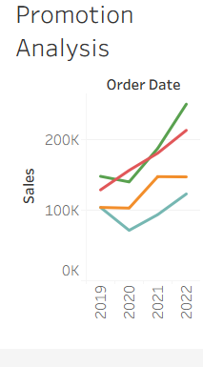
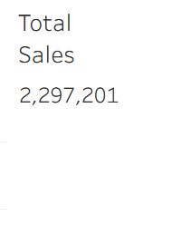
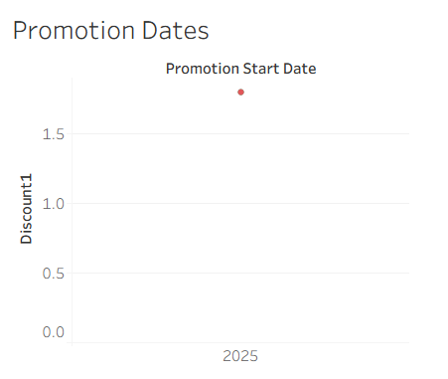

DASHBOARD:
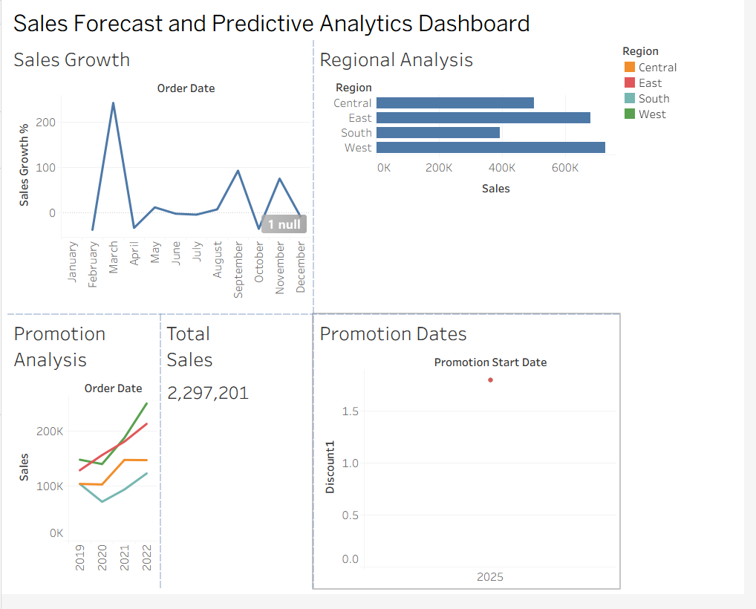

POST-LAB QUESTIONS (PROVIDE BRIEF ANSWERS TO THE FOLLOWING QUESTIONS)
- How did forecasting help in predicting future sales trends for business planning?

Forecasting helped predict future sales trends by analyzing historical sales data over time. In our Power BI dashboard, the forecast feature was used to estimate future sales and identify the expected trend. This can help businesses plan inventory, promotions, resources, and sales targets more effectively.
- What forecasting method did you use, and why was it suitable for the dataset?

We used the built-in Forecast feature in Power BI, which uses exponential smoothing for time series forecasting. It was suitable because our dataset contained historical sales values with dates, allowing Power BI to identify trends and patterns and estimate future sales.
- What challenges, if any, did you face regarding missing data or irregular time intervals?

The main challenges were ensuring that the date field was in the correct Date format and maintaining consistent time intervals. We created a separate DateTable and used the Date field for the time axis to provide a continuous timeline. This helped the forecasting model work correctly.
- How can predictive analytics influence decision-making in a retail environment?

Predictive analytics can help retailers predict future sales, identify high-performing regions, manage inventory, and plan promotional activities. For example, if the forecast shows increasing sales, the retailer can increase stock in advance and plan suitable promotions to meet expected demand.
- What additional data (e.g., competitor pricing, economic indicators) could be integrated to improve forecast accuracy?

Forecast accuracy could be improved by integrating additional factors such as:
- Competitor pricing
- Customer demand
- Discount and promotion details
- Seasonal trends
- Holiday and festival information
- Economic indicators
- Customer purchasing behavior
- Product availability and inventory levels
RESULT:
The historical sales and promotions datasets were successfully cleaned, integrated, and modelled in Tableau and Power BI. Forecasting techniques provided predicted sales trends, growth percentages, and region-wise performance expectations. The resulting dashboards allowed managers to visualize actual vs. forecasted sales, enabling better planning and data driven decision-making.

GITHUB LINK:

ASSESSMENT

Description |  | Max Marks | Marks Awarded
Pre Lab Exercise |  | 5
In Lab Exercise |  | 10
Post Lab Exercise |  | 5
Viva |  | 10
 | Total | 30
 | Faculty Signature

