EXPT NO: 8 | TRAIN A SIMPLE AUTOENCODER FOR DIMENSIONALITY REDUCTION AND FEATURE LEARNING
DATE: 02.11.2026

PRE-LAB QUESTIONS (PROVIDE BRIEF ANSWERS TO THE FOLLOWING QUESTIONS)

- What is an autoencoder?
An Autoencoder is a type of artificial neural network used to learn and compress data. It tries to recreate the original input data as accurately as possible.
Example: Compressing an image and then reconstructing it.
- What are the roles of the encoder and decoder in an autoencoder?
An autoencoder has two main parts:
- Encoder: Compresses the input data into a smaller representation.
- Decoder: Reconstructs the original data from the compressed representation.
Example: Encoder compresses an image, and the decoder recreates the image.

- What is dimensionality reduction?
Dimensionality reduction is the process of reducing the number of features or variables in a dataset while keeping important information.
Example: Reducing 100 features into 10 important features.
Use: It reduces data size and makes processing faster.

- What is meant by latent representation or latent space?
Latent representation is a compressed form of input data that contains the most important information.
It is created by the encoder and passed to the decoder.
Example: A 100 × 100 image is converted into a small set of important features.

- Why is reconstruction loss used when training an autoencoder?
Reconstruction loss measures the difference between the original input and the reconstructed output.
It helps the autoencoder learn to reproduce the input as accurately as possible.
Example: If the original image and reconstructed image are different, the reconstruction loss will be high.
Purpose: To minimize the difference between the original and reconstructed data.

AIM
To implement and train a simple autoencoder using a dataset such as MNIST, learn a lower-dimensional representation of the input data, and evaluate the model by reconstructing the input samples and visualizing their latent representations.

SOFTWARE REQUIREMENTS
- Python
- TensorFlow / Keras
- Google Colab or Jupyter Notebook
- GitHub
- NumPy
- Matplotlib
- Pandas (optional)

OBJECTIVES
Students will be able to:
- Understand the architecture and working of autoencoders.
- Differentiate between the encoder, latent representation, and decoder.
- Prepare and preprocess a dataset for autoencoder training.
- Build an autoencoder using appropriate neural network layers.
- Train the model using reconstruction loss.
- Perform dimensionality reduction and extract latent features.
- Visualize original and reconstructed samples.
- Evaluate reconstruction performance using loss values and visual inspection.

PROCEDURE
PART A: DATASET PREPARATION AND PREPROCESSING
Perform the following tasks:
- Load the MNIST handwritten digit dataset using TensorFlow/Keras.
- Explore the dataset and check the number of training and testing images and their dimensions.
- Display sample images from the dataset.
- Convert pixel values to floating-point values and normalize them to the range [0, 1].
- Flatten each 28 × 28 image into a 784-dimensional input vector for a basic dense autoencoder.
- Prepare training and testing data. Use the input images as both input and target output because the autoencoder learns to reconstruct its input.
(CODE: CONATAINS STUDENT ROLL NOS
SCREENSHOT OF CODE
SCREENSHOT OF OUTPUT)

PART B: IMPLEMENTING THE ENCODER AND DECODER
Perform the following tasks:
- Define the input layer with 784 features.
- Build the encoder using one or more Dense layers to map the input to a smaller latent dimension, such as 32 features.
- Build the decoder using Dense layers to map the latent representation back to 784 output values.
- Use suitable activation functions, such as ReLU for hidden layers and Sigmoid for the final layer.
- Combine the encoder and decoder into a single autoencoder model.
- Display the encoder, decoder, and autoencoder model summaries.
(CODE: CONATAINS STUDENT ROLL NOS
SCREENSHOT OF CODE
SCREENSHOT OF OUTPUT)

PART C: COMPILING AND TRAINING THE AUTOENCODER
Perform the following tasks:
- Compile the autoencoder using an optimizer such as Adam.
- Select an appropriate reconstruction loss, such as binary cross-entropy or mean squared error.
- Train the model by supplying the input images as both input data and target data.
- Use a suitable batch size and number of epochs. For example, use a batch size of 256 and 10 epochs.
- Validate the model using the test dataset or a validation split.
- Record training and validation loss for each epoch.
- Plot the training and validation loss curves to observe the reconstruction performance.
(CODE: CONATAINS STUDENT ROLL NOS
SCREENSHOT OF CODE
SCREENSHOT OF OUTPUT)

PART D: DIMENSIONALITY REDUCTION, FEATURE LEARNING AND RECONSTRUCTION
Perform the following tasks:
- Use the trained encoder to convert test images into lower-dimensional latent feature vectors.
- Display the original input dimension (784) and latent dimension (for example, 32).
- Pass the latent vectors through the decoder to reconstruct the images.
- Display original images and their corresponding reconstructed images side by side.
- Compare the original and reconstructed images and comment on the information retained or lost.
- Optionally, use PCA or t-SNE to visualize latent features in two dimensions, if covered in the course.
- Save the trained model or reconstructed images if required.
(CODE: CONATAINS STUDENT ROLL NOS
SCREENSHOT OF CODE
SCREENSHOT OF OUTPUT)
CODE:
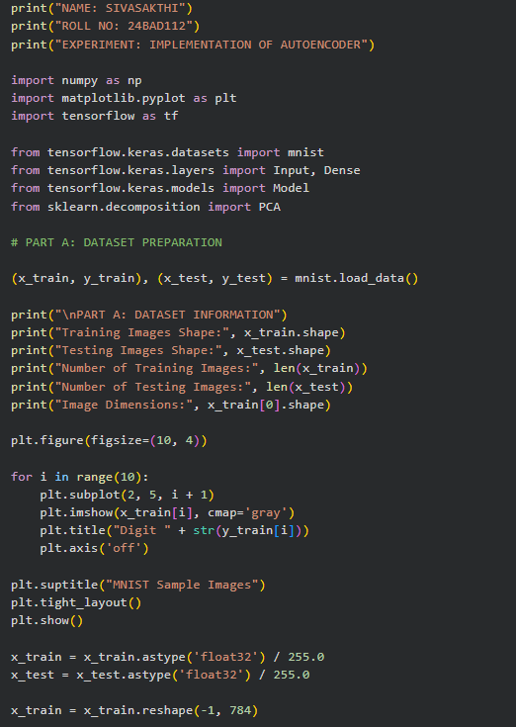
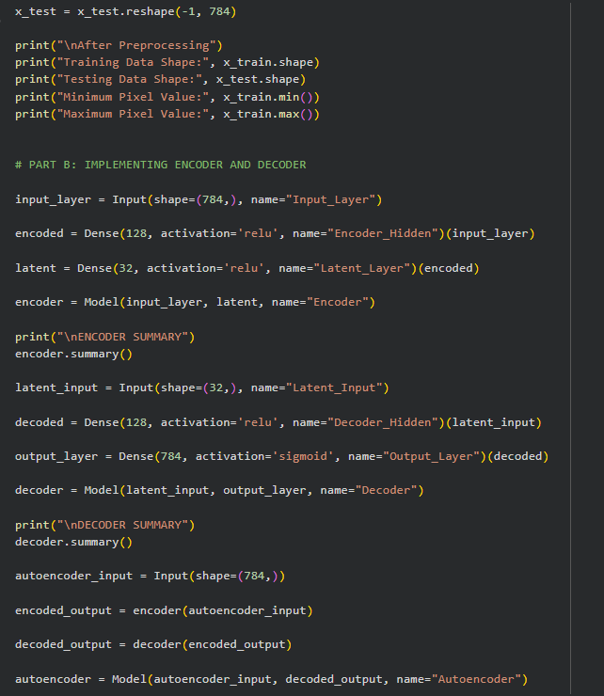

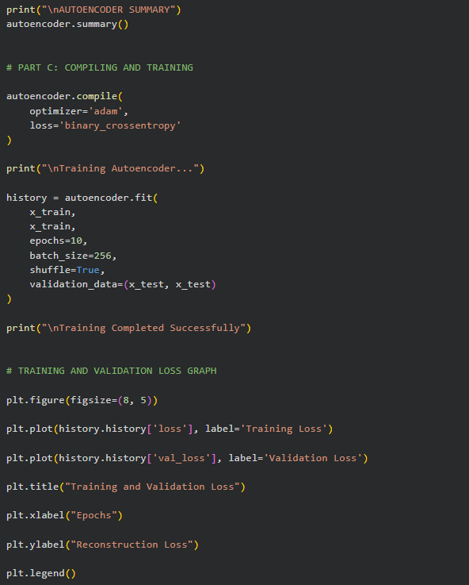
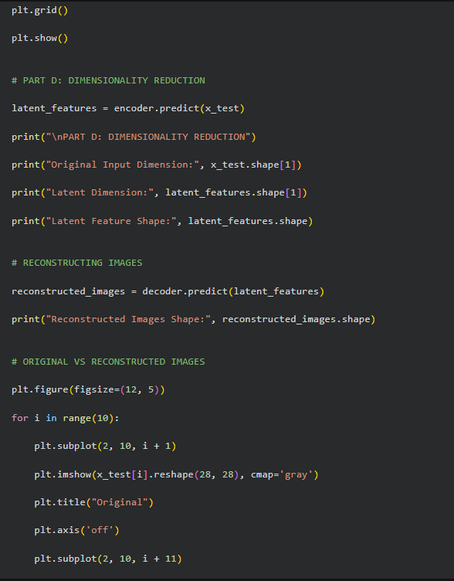
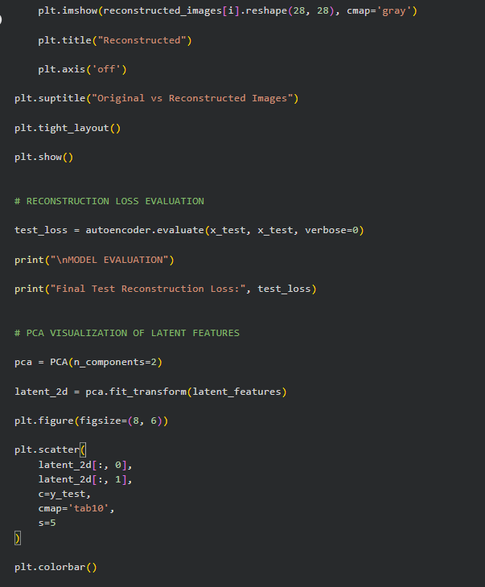
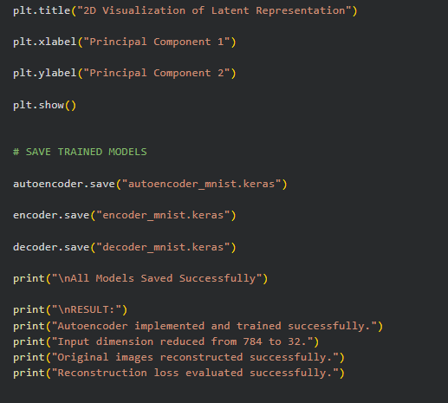

OUTPUT:
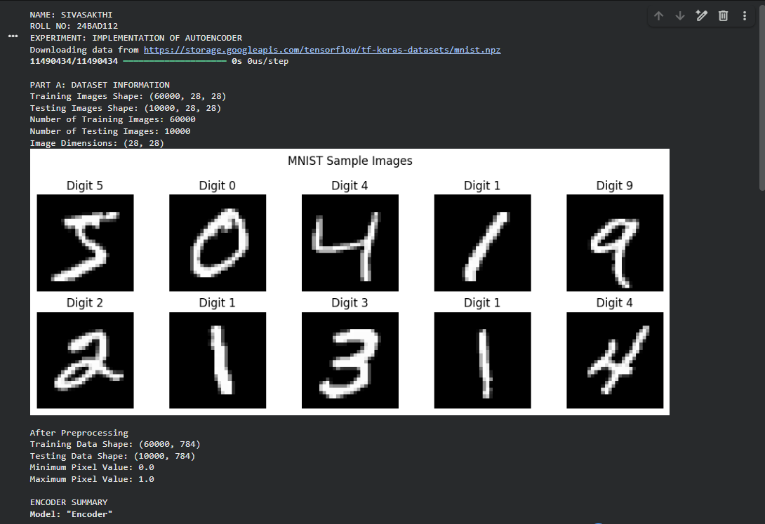
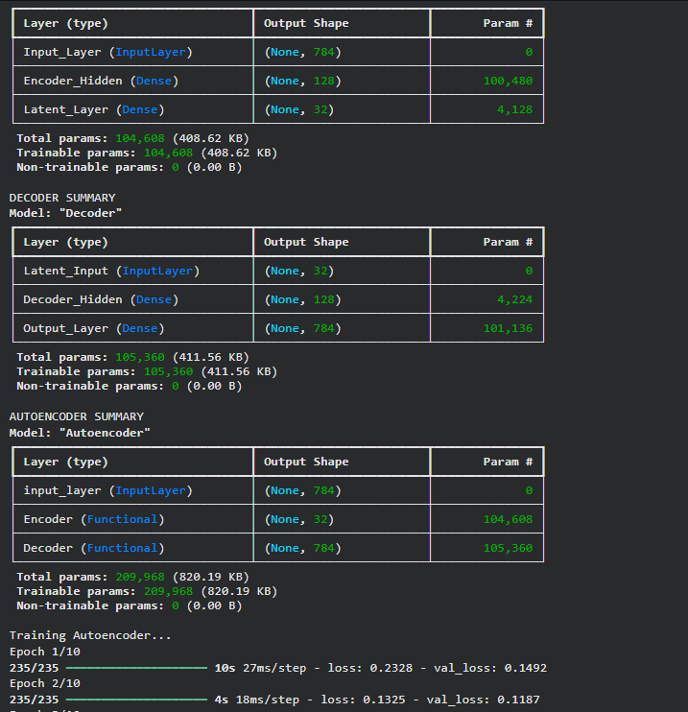
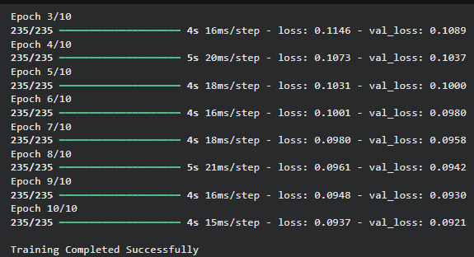

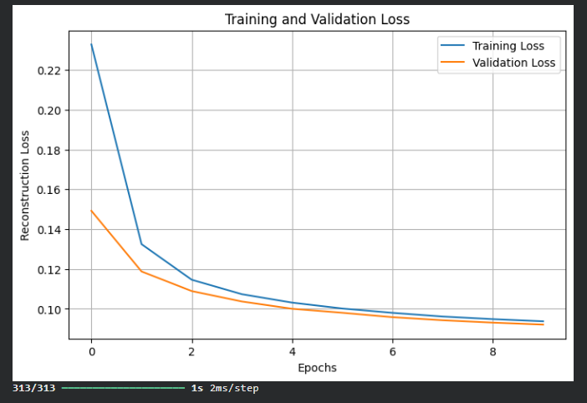
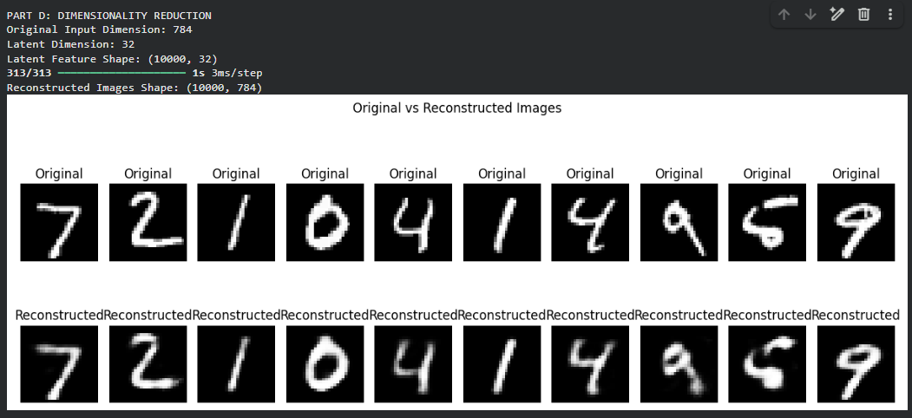
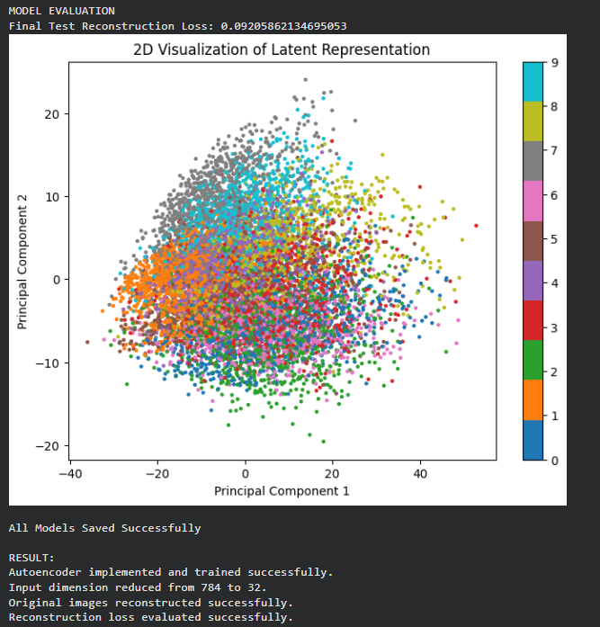
EXPECTED OUTCOME
Students will understand the architecture and working of a simple autoencoder and the roles of its encoder, latent representation, and decoder. They will learn to preprocess data, train the model using reconstruction loss, reduce input dimensionality, and extract compact latent features. They will evaluate the autoencoder by examining training and validation loss and comparing original images with reconstructed images.
POST-LAB QUESTIONS (PROVIDE BRIEF ANSWERS TO THE FOLLOWING QUESTIONS)

- What is the main purpose of an autoencoder?
The main purpose of an autoencoder is to compress data and reconstruct the original data with minimum information loss.
- How do the encoder and decoder differ?
• Encoder: Converts input data into a compressed representation.
• Decoder: Reconstructs the original data from the compressed representation.
- What is a latent representation?
Latent representation is the compressed form of input data that stores its most important features or information.
- How does an autoencoder perform dimensionality reduction?
An autoencoder reduces dimensionality by using the encoder to convert high-dimensional input data into a smaller number of features called latent representation.
Example: 100 features are reduced to 10 features.
- Why are the input images also used as target outputs during training?
Input images are used as target outputs because the autoencoder learns to reconstruct the same image.
It compares the original image with the reconstructed image and reduces the error using reconstruction loss.
- What does reconstruction loss measure?
Reconstruction loss measures the difference between the original input data and the reconstructed output data.
- What may happen if the latent dimension is too small?
If the latent dimension is too small, important information may be lost, resulting in poor reconstruction.
- Mention one real-world application of autoencoders.
Image denoising – Autoencoders are used to remove noise from images and produce clearer images.

SUGGESTIONS FOR DATASETS
- MNIST Handwritten Digits – https://www.tensorflow.org/datasets/catalog/mnist
- Fashion-MNIST – https://www.tensorflow.org/datasets/catalog/fashion_mnist
- CIFAR-10 – https://www.tensorflow.org/datasets/catalog/cifar10 (requires adapting the model for image inputs)

ASSESSMENT
Description | Max Marks | Marks Awarded
Pre Lab Exercise | 5
In Lab Exercise | 10
Post Lab Exercise | 5
Viva | 10
Total | 30
Faculty Signature

