KUMARAGURU COLLEGE OF TECHNOLOGY
Coimbatore, Tamil Nadu
Department of Artificial Intelligence and Data Science
A PROJECT REPORT ON
“Deep Learning-Based Real-Time Fire and Smoke Detection Using Surveillance Video”
Software-Based Deep Learning and Computer Vision Project
Submitted by
S.No | Name of the Student | Roll Number
1 | SIVASAKTHI S | 24BAD112
2 | INDHUMATHI V | 24BAD036
3 | SHALINI A | 24BAD409
Academic Year 2026 – 2027

Abstract
Fire is one of the most destructive hazards to life and property, and the damage it causes grows rapidly with every minute that passes before it is noticed. Conventional fire detection relies on dedicated smoke, heat or flame sensors, which respond only when smoke or heat physically reaches the device and are therefore poorly suited to large, open or high-ceilinged areas. This project presents a deep learning-based computer vision system that analyses images and surveillance video frames to detect fire and smoke automatically and to raise an early warning.
The system uses a YOLOv8n (You Only Look Once, version 8, nano) object detection model, implemented in Python with PyTorch-based Ultralytics, OpenCV for video handling, and a Gradio web interface, and executed on Google Colab. For every detected region the system reports the class (fire or smoke), a confidence score and the bounding-box location. Video files are processed by sampling frames at roughly two per second and writing an annotated output video together with a summary of the detected classes.
In a demonstration on a photograph of a burning wooden building, the system correctly detected fire with a confidence of 74.1% and smoke with a confidence of 70.0%, localising both with bounding boxes, and issued a detection alert. A control image containing neither fire nor smoke produced no detections. The work shows that a lightweight object detector can provide a practical, low-cost, software-only layer of fire monitoring on top of existing surveillance cameras.
Keywords: Fire detection, smoke detection, deep learning, YOLOv8, computer vision, OpenCV, surveillance video, object detection.
TABLE OF CONTENTS
Abstract 2
1. Introduction 4
2. Technology and Tools 4
3. System Architecture and Methodology 5
4. Implementation 6
5. Results and Discussion 8
6. Advantages, Limitations and Applications 9
7. Future Scope 10
8. Conclusion 10
References 11

1. INTRODUCTION

1.1 Background
Early detection is the single most important factor in limiting fire damage. Traditional fire alarm systems use point sensors that sense heat, smoke particles or radiation at the location of the device. They work well inside small rooms, but in warehouses, factories, forests, parking areas and other large spaces the smoke may take a long time to reach a sensor, or may never reach it. Many such places are already covered by CCTV or surveillance cameras, which presently serve only as a passive record that a human must watch.
Advances in deep learning and computer vision make it possible to turn these cameras into active fire monitors. Convolutional neural networks can learn the visual appearance of flames and smoke, such as colour, texture, flicker and the shape of a smoke plume, directly from labelled images, and object detection models can additionally state where in the frame the fire or smoke is located.

1.2 Problem Statement
Traditional fire detection systems may depend on dedicated sensors and may not effectively detect fire or smoke across large surveillance areas. This project aims to develop a deep learning-based computer vision system that analyses surveillance images or video frames to automatically detect fire and smoke and provide an early warning.

1.3 Objectives
- To detect fire and smoke automatically from images and surveillance video using a deep learning object detector.
- To localise each detection with a bounding box so that the exact region of the frame is known.
- To report a confidence score for every detection.
- To generate an automatic alert message when fire or smoke is found.
- To provide a simple web interface that supports both image and video input.
- To demonstrate the approach on Google Colab using freely available, open-source tools.

1.4 Scope
The project covers detection of two classes, fire and smoke, in still images and in uploaded video files. It is a software-based prototype intended to demonstrate the feasibility of vision-based fire detection. It is a research prototype and is not a certified fire alarm; it is not intended to replace approved fire safety systems.

2. TECHNOLOGY AND TOOLS
The project is built entirely from open-source components. Table 2.1 summarises the technologies used and the role of each in the system.
Table 2.1: Core technologies used in the project
Component | Technology | Purpose
Deep learning | YOLOv8n (CNN-based object detector) | Detects and localises fire and smoke
Computer vision | OpenCV | Reads video, extracts frames, writes annotated video
Programming language | Python 3 | Implementation of the full pipeline
Framework | PyTorch (through Ultralytics) | Model loading and inference
Model hosting | Hugging Face Hub | Source of the pretrained fire-smoke weights
User interface | Gradio | Web interface for image and video upload
Development platform | Google Colab | Cloud notebook environment for running the system
Input | Images or surveillance video | Data to be analysed
Output | Fire / Smoke / No detection + location | Class label, confidence and bounding box

2.1 Why YOLO instead of a simple CNN
A plain image-classification CNN can only state whether an image contains fire, smoke or neither. An object detector such as YOLO additionally tells us where the fire or smoke is in the frame. This is much more useful for surveillance, because the location can be shown to an operator, used to estimate the extent of the fire, and tracked from one frame to the next.
YOLO is a single-stage detector: it examines the whole image once and predicts bounding boxes and class probabilities together, which makes it fast enough for video processing. The nano variant (YOLOv8n) is the smallest in its family; the weight file used in this project is only about 6 MB, so it can run on modest hardware, which suits deployment near the camera.

2.2 Detection classes
The model detects two classes, indexed as 0 = smoke and 1 = fire. When neither class is found above the confidence threshold, the system reports that no fire or smoke was detected.

3. SYSTEM ARCHITECTURE AND METHODOLOGY

3.1 System architecture
The system follows the pipeline shown in Figure 3.1. A surveillance image or video is supplied by the user; video is broken into frames, each frame is preprocessed and passed to the YOLO model, and the resulting detections are drawn on the frame and summarised in an alert message.

3.2 Stage-wise description
- Input: The input is either a single image or a surveillance video file uploaded through the web interface.
- Frame extraction: For video, OpenCV reads the file frame by frame. To keep processing fast, one frame is analysed for roughly every half second of video, and the latest annotated frame is reused for the frames in between.
- Preprocessing: Frames are converted to the RGB colour order and resized by the model to 640 pixels, the input size used by the detector.
- Detection: The YOLOv8n network predicts candidate boxes with class probabilities; boxes below the confidence threshold of 0.25 are discarded.
- Localisation and scoring: Each remaining detection is drawn on the frame as a rectangle with its class name and confidence score, and its pixel coordinates are recorded.
- Alert: If any fire or smoke is found, a “DETECTION ALERT” message listing every detection is produced; otherwise a no-detection message is shown.
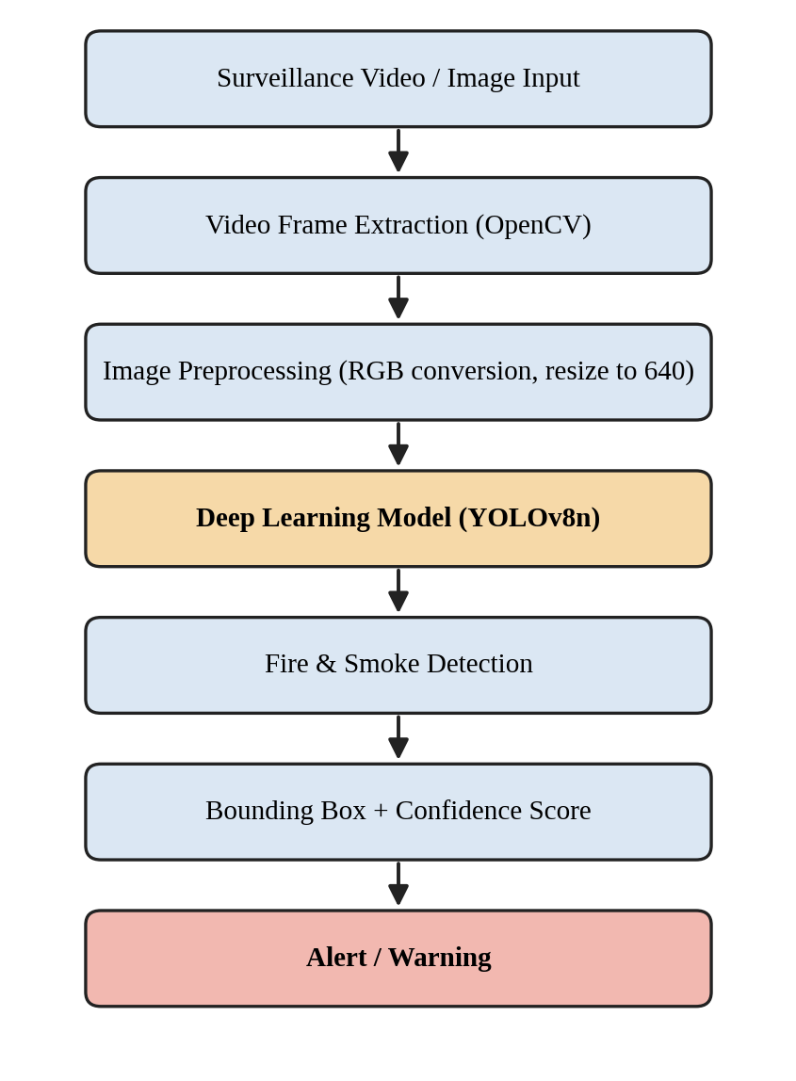
Figure 3.1: Architecture of the fire and smoke detection system

4. IMPLEMENTATION

4.1 Environment setup
The project was developed in a Google Colab notebook. The required Python libraries (Ultralytics, Hugging Face Hub, Gradio, OpenCV and Pillow) were installed with pip, so no local installation or dedicated hardware is required.

4.2 Model loading
A pretrained YOLOv8n fire-and-smoke detection model was obtained from the Hugging Face Hub (repository nobita111222/fire-smoke-yolov8n). The notebook lists the files in the repository, downloads the best-performing weights file (best.pt, about 6.2 MB) and loads it with Ultralytics. On loading, the model reports its two classes, smoke and fire, confirming that the correct weights were used. The training dataset and training details of these weights are those published by the model’s author.
Table 4.1: Detection settings used in the notebook
Parameter | Value
Model | YOLOv8n (best.pt)
Classes | 0: smoke, 1: fire
Confidence threshold | 0.25
Inference image size | 640 pixels
Video sampling rate | About 2 frames per second of video
Annotated video format | MP4 (mp4v codec)

4.3 Sanity check on a non-fire image
Before building the interface, the model was tested on a standard street photograph (the Ultralytics bus sample image) that contains neither fire nor smoke. The model returned zero detections, which shows that it does not raise false alarms on an ordinary scene.

4.4 Image detection
The image detection function accepts an uploaded picture, runs the model, draws the detections on the image and builds a text report. For each detection the report lists the class, the confidence as a percentage and the bounding box as pixel coordinates (x1, y1, x2, y2). If nothing is detected, the report says so and adds a reminder that the absence of a detection does not guarantee that the scene is free of fire.

4.5 Video detection
The video detection function opens the uploaded video with OpenCV, reads its frame rate and dimensions, and creates an output video of the same size. Every sampled frame is analysed by the model and annotated; the annotated frame is written to the output for that frame and the following unsampled frames. At the end, the report lists the distinct classes detected and the number of frames analysed.

4.6 User interface
The interface was built with Gradio and has two tabs, Image Detection and Video Detection. Each tab has an upload area, a detect button, an output display and a detection report box. A note at the bottom of the page states that the system is a research prototype and not a certified fire alarm. Figure 4.1 shows the image detection tab. When run in Colab, Gradio also provides a temporary public link so that the application can be opened from any browser.
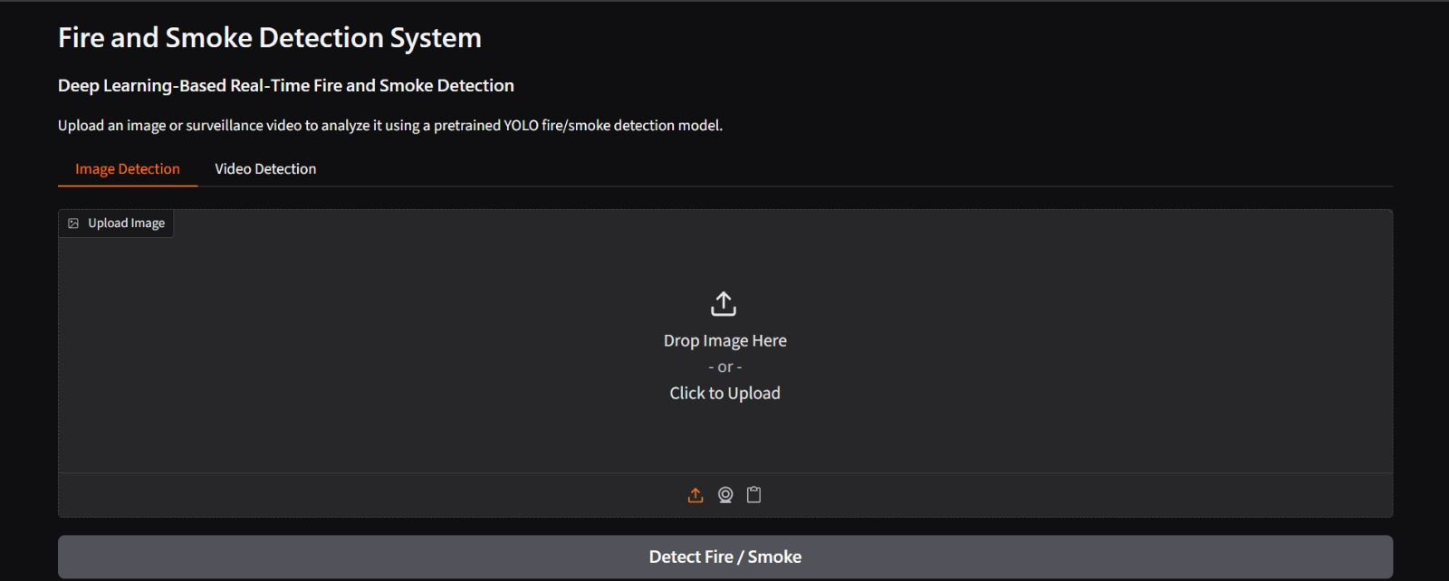
Figure 4.1: Image Detection tab of the Fire and Smoke Detection System

5. RESULTS AND DISCUSSION

5.1 Test on a fire image
The system was tested with a photograph of a wooden building on fire with dense smoke rising above it. The image was uploaded in the Image Detection tab and the Detect Fire / Smoke button was pressed. The annotated output and the detection report are shown in Figures 5.1 and 5.2.
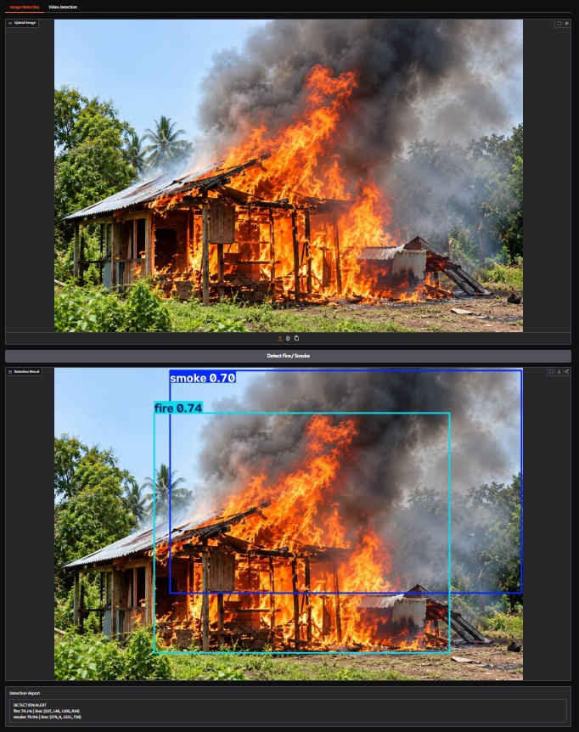
Figure 5.1: Uploaded image (top) and annotated detection result (bottom)
The model drew a bounding box around the burning structure labelled fire and a larger box around the rising plume labelled smoke. The smoke box extends upwards and to the right, following the direction of the plume, while the fire box is concentrated on the flames in the building.
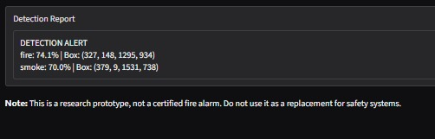
Figure 5.2: Detection report generated by the system
Table 5.1: Detection results for the test image
Class | Confidence (%) | Score | Bounding box (x1, y1, x2, y2)
Fire | 74.1% | 0.74 | (327, 148, 1295, 934)
Smoke | 70.0% | 0.70 | (379, 9, 1531, 738)

5.2 Discussion
Both classes were detected correctly in the same frame and the alert message was generated automatically. Confidence values of about 70–75% are well above the 0.25 threshold used, so the detections are retained comfortably, but they also show that the model is not absolutely certain; in practice a deployed system could require a higher confidence or detections that persist across several consecutive frames before raising a final alarm.
The negative test described in Section 4.3 showed no detections on a scene without fire or smoke. Together, these two tests demonstrate that the system behaves as expected on one positive and one negative example. They are demonstrations rather than a statistical evaluation: the project has not yet measured precision, recall or mean average precision on a labelled test set, which is listed as future work.

6. ADVANTAGES, LIMITATIONS AND APPLICATIONS

6.1 Advantages
- Uses existing surveillance cameras, so no new sensors are needed.
- Covers large and open areas where point sensors respond slowly or not at all.
- Shows where the fire or smoke is, not just that it exists.
- Provides a confidence score for every detection.
- Lightweight model (about 6 MB) that is fast and can run on modest hardware.
- Built wholly from free, open-source software.

6.2 Limitations
- The model is pretrained; it was not trained or fine-tuned on a dataset collected by the project team.
- Accuracy has been shown on sample images only and has not been measured with standard metrics.
- Video is processed from an uploaded file at about two frames per second; live camera streams are not yet connected.
- Visually similar objects such as fog, steam, dust, sunsets, orange lights or red objects may cause false alarms, and small, distant or thin smoke may be missed.
- Performance depends on image quality, lighting and camera angle, and a missed detection does not prove that a scene is safe.
- It is a research prototype and must not replace certified fire alarm and safety systems.

6.3 Applications
- Monitoring of factories, warehouses, godowns and industrial yards.
- Early warning in forests and in agricultural and plantation areas.
- Safety monitoring in malls, campuses, parking lots, railway stations and other public spaces.
- Smart-city and smart-building surveillance platforms.

7. FUTURE SCOPE
- Custom training and evaluation: Train or fine-tune the model on a larger, locally relevant dataset of fire, smoke and difficult negative images, and report precision, recall and mAP.
- Live-stream detection: Connect to live CCTV, IP camera (RTSP) or webcam streams for true real-time monitoring.
- Temporal confirmation: Require detections to persist over several frames, and track their growth, to reduce false alarms.
- Automatic alerting: Send SMS, e-mail or mobile notifications, sound a buzzer, or integrate with building alarm systems when fire is confirmed.
- Edge deployment: Run the model on edge devices such as a Raspberry Pi or Jetson Nano placed near the camera.
- Model comparison: Compare YOLOv8n with larger YOLO variants and other detectors to balance speed and accuracy.
- Severity estimation: Estimate the area and spread rate of the fire, and add detection of people in the danger zone.

8. CONCLUSION
This project developed a deep learning-based system that detects fire and smoke in images and surveillance video and presents the result as bounding boxes, confidence scores and an automatic alert. A YOLOv8n detector was loaded in Google Colab, combined with OpenCV for video handling, and wrapped in a Gradio interface with separate image and video tabs.
In the demonstration, the system detected both fire (74.1%) and smoke (70.0%) in a burning-building image and produced no detections on a normal scene. The results indicate that a small object detector can turn ordinary surveillance cameras into an additional early-warning layer for fire. With custom training, formal evaluation, live-stream support and alert integration, the prototype could be developed into a practical fire monitoring solution that complements, rather than replaces, conventional fire safety systems.

REFERENCES
- Redmon, J., Divvala, S., Girshick, R., and Farhadi, A. (2016). You Only Look Once: Unified, Real-Time Object Detection. Proceedings of the IEEE Conference on Computer Vision and Pattern Recognition (CVPR), pp. 779–788.
- Jocher, G., Chaurasia, A., and Qiu, J. (2023). Ultralytics YOLOv8. https://github.com/ultralytics/ultralytics
- Bradski, G. (2000). The OpenCV Library. Dr. Dobb’s Journal of Software Tools.
- Paszke, A., et al. (2019). PyTorch: An Imperative Style, High-Performance Deep Learning Library. Advances in Neural Information Processing Systems 32 (NeurIPS).
- Abid, A., et al. (2019). Gradio: Hassle-Free Sharing and Testing of ML Models in the Wild. arXiv:1906.02569.
- Pretrained model: nobita111222/fire-smoke-yolov8n, Hugging Face Hub. https://huggingface.co/nobita111222/fire-smoke-yolov8n
- Google Colaboratory. https://colab.research.google.com

