KUMARAGURU COLLEGE OF TECHNOLOGY
Department of Artificial Intelligence and Data Science
ACADEMIC PROJECT REPORT
on
Deep Learning-Based Real-Time Fire and Smoke Detection Using Surveillance Video
Submitted in partial fulfilment of the requirements of the subject
DEEP LEARNING (24ADI006)
Submitted by
SIVASAKTHI S – 24BAD112
INDHUMATHI V – 24BAD036
SHALINI A – 24NAD409
Subject Code: 24ADI006
Subject Name: Deep Learning
Faculty Names:
V Shriaarthy
Shalmiya P
Academic Year: 2026-2027

TABLE OF CONTENTS

Note: If the table above appears empty, right-click it in Microsoft Word and choose Update Field, then Update entire table.

1. Abstract
Fire is one of the most dangerous hazards in homes, industries and public places. When a fire or smoke is noticed late, the damage to life and property can increase quickly. This project presents a deep learning based application that detects fire and smoke in images and videos.
The system uses a pretrained YOLOv8 object detection model whose weights are downloaded from the Hugging Face Hub and loaded through the Ultralytics library. The user uploads an image or a video through a simple Streamlit web interface. The model analyses the uploaded media, identifies the classes “fire” and “smoke”, and marks each detection with a bounding box and a label. For videos, a processed output video is produced and shown in the browser, and the user can download it.
The application was developed in Python on Google Colab, and the Streamlit interface is made available in a web browser through an Ngrok public URL. The project demonstrates how an existing pretrained model can be reused to build a practical and easy-to-use fire and smoke detection tool without training a new network from scratch.

2. Introduction

2.1 Fire and Smoke Detection
Fire and smoke detection is the task of identifying the presence of flames or smoke in a scene. Smoke often appears before flames become large, so detecting it can give an early indication that a fire may be starting. In a vision-based approach, a camera captures images or video and a computer program examines them to find signs of fire or smoke.

2.2 Importance of Early Identification
A fire can spread very quickly. The earlier it is identified, the more time people have to respond, raise an alarm, evacuate and begin firefighting. Early identification therefore helps to reduce injuries, property loss and environmental damage.

2.3 Limitations of Manual Surveillance
Many buildings and public places already have surveillance cameras, but the footage is usually watched by people. Manual monitoring depends on the attention of the operator. One person may have to watch many camera feeds at the same time, and tiredness or distraction can cause a small fire or a thin layer of smoke to be missed. Reviewing recorded footage after an incident is also slow.

2.4 Role of Deep Learning Object Detection
Object detection is a deep learning task in which a model finds objects in an image, draws a bounding box around each one and assigns it a class label. YOLO (You Only Look Once) is a popular family of object detectors that predicts boxes and class labels in a single pass through the network, which makes it fast and suitable for video. By treating “fire” and “smoke” as object classes, a YOLO model can locate them in surveillance images and video frames and highlight them visually, supporting human operators in monitoring.

3. Problem Statement
Surveillance cameras produce a large amount of video, and it is difficult for people to examine all of it continuously for signs of fire. There is a need for an automated system that can analyse uploaded surveillance images and videos, identify fire and smoke in them, and present the results clearly so that a user can understand what was detected and where.
The system should also be simple to use. A user without programming knowledge should be able to open a web page, upload a file, start the detection, view the processed output and download the processed video.

4. Objectives
The main objectives of this project are:
- To detect fire and smoke in uploaded images and videos.
- To use a pretrained YOLO object detection model.
- To mark detected objects with bounding boxes.
- To display detection labels and results.
- To provide a simple browser-based interface.
- To allow users to download the processed video output.

5. Existing System

5.1 Manual Monitoring
In many places, fire safety relies on people watching CCTV screens or on staff noticing a fire directly. This approach needs constant attention and does not scale well when the number of cameras increases. The result depends on the alertness and experience of the person watching.

5.2 Traditional Fire Detection Approaches
Traditional systems commonly use dedicated sensors such as smoke detectors, heat detectors and flame detectors, together with alarms and sprinklers. These devices are widely used and are important parts of fire safety. However, they have some general limitations:
- Sensor-based detectors usually need smoke, heat or radiation to reach or be seen by the sensor, so their suitability can depend on the size and type of the area.
- They normally give an alarm only and do not show where in a camera view the fire or smoke is located.
- They do not make use of the video already being recorded by surveillance cameras.
- Installing and maintaining many physical sensors across a large area can be costly and time-consuming.
These limitations motivate the use of computer vision and deep learning to analyse camera images and videos directly.

6. Proposed System
The proposed system is a web application that uses a pretrained YOLOv8 model to detect fire and smoke in images and videos uploaded by the user. The model weights are obtained from the Hugging Face Hub and loaded with the Ultralytics library. The application is built with Streamlit and is run on Google Colab; Ngrok provides a public URL so that the interface can be opened in a browser.

6.1 Input
The user uploads an image (JPG or PNG) or a video (MP4, AVI or MOV) using the upload area of the web interface. The interface shows a limit of 200 MB per file.

6.2 Processing
After the user clicks the Start Detection button, the uploaded file is saved temporarily and passed to the pretrained YOLO model. The model predicts bounding boxes and class labels using a confidence threshold of 0.25. For videos, every frame is processed and the annotated frames are written to a new output video.

6.3 Output
The output shows the detected objects, labelled as “fire” or “smoke”, with bounding boxes drawn on the image or on the video frames. For videos, the processed video is displayed in the browser and can be downloaded.

6.4 User Interface
The interface is a single Streamlit page with a title, an upload area, a Start Detection button, a status message, a processed video player and a Download Processed Video button.

7. System Requirements
The project runs on Google Colab, so most of the computing is done on Google’s cloud runtime. The hardware values below are suggested for a smooth user experience. They are not measured values from tests.

7.1 Hardware Requirements (Suggested)
Component | Suggested Requirement
Computer | Any laptop or desktop capable of running a modern web browser
Processor | Dual-core or better CPU (suggested)
RAM | 4 GB or more (suggested)
Storage | Free space for uploaded and downloaded files (suggested)
Internet | Stable internet connection (required for Colab, Hugging Face Hub and Ngrok)
GPU (optional) | A Google Colab GPU runtime may speed up video processing (optional)

7.2 Software Requirements
Software / Tool | Purpose or Requirement
Operating System | Any operating system that supports a modern web browser
Web Browser | Google Chrome, Microsoft Edge, Mozilla Firefox or similar
Python | Programming language used for the complete implementation
Google Colab | Cloud notebook platform used to run the code
YOLOv8 | Pretrained object detection model
Ultralytics | Python library used to load and run the YOLO model
Hugging Face Hub | Source of the pretrained model weights (huggingface_hub library)
OpenCV | Library used to read and write images and video frames
Streamlit | Library used to build the browser interface
Ngrok | Service used to create a public URL for the Streamlit app

8. Technologies Used
The following table explains the role of each technology in this project.
Technology | Role in the Project
Python | Main programming language. It connects the model, the video processing code and the web interface.
YOLOv8 | A pretrained deep learning object detection model that finds objects in an image and predicts a bounding box and class label for each. Here it detects “fire” and “smoke”.
Ultralytics | Provides the YOLO class used to load the model weights and run predictions on images and video frames.
Hugging Face Hub | An online platform for sharing models. The pretrained weights file is downloaded from it using the huggingface_hub library.
OpenCV | Used to read video frames, draw or handle annotated frames, and write the processed output video.
Streamlit | A Python framework used to create the web page with the file upload area, buttons, status message, video player and download button.
Google Colab | A cloud-based notebook environment where the code is written and executed without installing software on the local computer.
Ngrok | Creates a secure public URL that forwards to the Streamlit server running inside Colab, so the app can be opened in any browser.

9. System Architecture
The workflow of the system is: User Upload → Image/Video Input → Pretrained YOLO Model → Fire/Smoke Detection → Bounding Boxes and Labels → Results Display → Processed Video Download. Figure 1 shows the architecture.
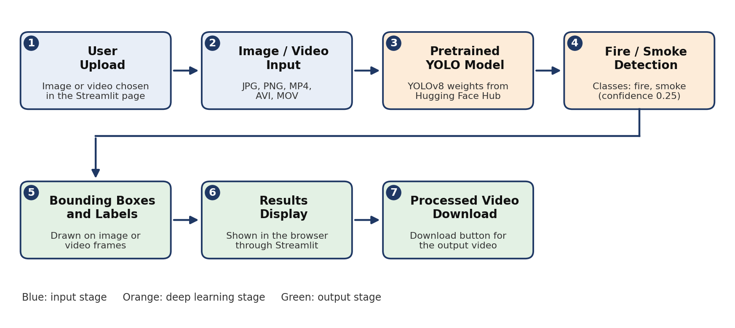
Figure 1: System Architecture of the Fire and Smoke Detection Application
The stages of the architecture are explained below.
- User Upload: The user selects an image or a video in the Streamlit page.
- Image/Video Input: The uploaded file is saved temporarily so that it can be read by the model and OpenCV.
- Pretrained YOLO Model: The YOLOv8 weights downloaded from Hugging Face Hub are loaded through Ultralytics.
- Fire/Smoke Detection: The model examines the image or each video frame and predicts the classes “fire” and “smoke” using a confidence threshold of 0.25.
- Bounding Boxes and Labels: Each detection is drawn as a box with its class label on the image or frame.
- Results Display: The result is shown in the browser through Streamlit.
- Processed Video Download: For videos, the annotated output video is available through the download button.

10. Methodology
The project was carried out in the steps below. Some steps are common to all inputs, while others apply only to image detection, video detection or the web application.

10.1 Step-by-Step Procedure
- Install and import required libraries. Ultralytics, Hugging Face Hub, OpenCV, Streamlit and the Ngrok client are installed in Google Colab and the required modules are imported.
- Download pretrained model weights. The YOLOv8 weights file is downloaded from the Hugging Face Hub.
- Load the model. The weights file is loaded with the Ultralytics YOLO class so it is ready for prediction.
- Upload an image or video. The user uploads a JPG, PNG, MP4, AVI or MOV file through the Streamlit upload area.
- Process the input. When Start Detection is clicked, the file is passed to the model for prediction.
- Apply the confidence threshold. A confidence threshold of 0.25 is used where configured, so only detections with confidence of at least 0.25 are kept.
- Identify classes and draw bounding boxes. The detected classes (“fire” and “smoke”) are read from the model output and bounding boxes with labels are drawn.
- Display results through Streamlit. The annotated image or processed video is shown on the web page along with a status message.
- Save and download processed video output. The annotated video is saved to a temporary file and offered through a download button.
- Access through a browser using Ngrok. The Streamlit server is started in Colab and Ngrok provides a public URL to open the app in a browser.

10.2 Image Detection
For an image, the uploaded file is read once and passed to the model. The model returns the detected boxes and classes, the boxes are drawn on a copy of the image, and the annotated image is displayed on the page. No video file is created for image input.

10.3 Video Detection
For a video, the file is opened with OpenCV and read frame by frame. Each frame is passed to the model, the detections are drawn on the frame, and the annotated frame is written to an output video file. After all frames are processed, the output video is displayed in the player and offered for download. Because every frame is processed, longer or higher-resolution videos take more time.

10.4 Web Application Execution
The detection code is placed in a Streamlit script. The script is run as a Streamlit server inside Google Colab, and Ngrok is used to create a public URL that points to this server. Opening the URL in a browser shows the application. The application keeps running only while the Colab session and the Streamlit server are active.

11. Code Description
This section explains the main parts of the code. The snippets are short and representative of the implementation. Items shown in angle brackets, such as the repository ID, weights file name and Ngrok token, are placeholders that must be replaced with the values used in the actual notebook.

11.1 Library Installation and Imports
The required libraries are installed in Colab using pip and then imported. Ultralytics provides the YOLO model, huggingface_hub downloads the weights, OpenCV handles video frames, and Streamlit builds the web page.
!pip install ultralytics huggingface_hub opencv-python-headless streamlit pyngrok

import os, tempfile
import cv2
import streamlit as st
from ultralytics import YOLO
from huggingface_hub import hf_hub_download

11.2 Pretrained Model Download
The weights file of the pretrained model is downloaded from the Hugging Face Hub. The function returns the local path of the downloaded file.
model_path = hf_hub_download(
repo_id="<HF_REPO_ID>",
filename="<WEIGHTS_FILE>.pt"
)

11.3 YOLO Model Loading
The downloaded weights are loaded with the Ultralytics YOLO class. In the Streamlit script, the model is loaded once and reused so that it is not reloaded for every interaction.
@st.cache_resource
def load_model():
return YOLO(model_path)

model = load_model()

11.4 Image Prediction
For an image, the model predicts on the uploaded file. The first element of the result list holds the detections for that image, and the plot() method returns the image with boxes and labels drawn.
results = model.predict(source=image_path, conf=0.25)
annotated = results[0].plot() # NumPy array in BGR order
st.image(annotated, channels="BGR")

11.5 Video Prediction
For a video, OpenCV reads the frames one by one. Each frame is passed to the model, the annotated frame is obtained, and it is written to the output video.
cap = cv2.VideoCapture(input_path)
fps = cap.get(cv2.CAP_PROP_FPS)
w = int(cap.get(cv2.CAP_PROP_FRAME_WIDTH))
h = int(cap.get(cv2.CAP_PROP_FRAME_HEIGHT))
fourcc = cv2.VideoWriter_fourcc(*"mp4v")
writer = cv2.VideoWriter(output_path, fourcc, fps, (w, h))

while True:
ok, frame = cap.read()
if not ok:
break
results = model.predict(source=frame, conf=0.25, verbose=False)
writer.write(results[0].plot())

cap.release()
writer.release()

11.6 Confidence Threshold
The confidence threshold decides how certain the model must be before a detection is kept. A value of 0.25 is used, so detections below 0.25 are ignored. A lower value shows more detections but may increase false alarms, while a higher value shows fewer detections but may miss some real ones.
CONF_THRESHOLD = 0.25

11.7 Bounding Box Visualization
Bounding boxes and labels are drawn by the plot() method of the Ultralytics result object. Each box surrounds a detected object and shows its class name. The same call is used for images and for each video frame.
annotated_frame = results[0].plot()

11.8 Fire and Smoke Class Extraction
The class index of each detected box is converted to a class name using the model’s names dictionary. The set of names found tells the application whether “fire”, “smoke” or both were detected.
detected = set()
for box in results[0].boxes:
class_id = int(box.cls[0])
detected.add(model.names[class_id]) # e.g. "fire", "smoke"

11.9 Streamlit File Upload
The page title, a short instruction and the file uploader are created with Streamlit. The uploader accepts JPG, PNG, MP4, AVI and MOV files, as shown in the interface.
st.title("🔥 Fire and Smoke Detection")
st.write("Upload an image or video to detect fire and smoke using YOLO.")

uploaded = st.file_uploader(
"Upload image or video",
type=["jpg", "png", "mp4", "avi", "mov"]
)

11.10 Start Detection Button
Detection starts only when the user clicks the Start Detection button after uploading a file. A spinner or status message tells the user that processing is in progress.
if uploaded is not None:
if st.button("Start Detection"):
with st.spinner("Processing..."):
... # run image or video detection

11.11 Processed Video Display and Download
When video processing is complete, the output video is displayed with the Streamlit video player and a download button is shown.
st.video(output_path)

with open(output_path, "rb") as f:
st.download_button(
"Download Processed Video",
data=f,
file_name="processed_video.mp4",
mime="video/mp4"
)

11.12 Error Handling and Temporary File Cleanup
Uploaded files are written to temporary files. A try–except–finally structure reports errors to the user without stopping the application, and the finally block removes the temporary files after processing.
tmp = tempfile.NamedTemporaryFile(delete=False, suffix=".mp4")
tmp.write(uploaded.read())
tmp.close()
try:
... # run detection
except Exception as e:
st.error(f"Detection failed: {e}")
finally:
if os.path.exists(tmp.name):
os.remove(tmp.name)

11.13 Streamlit Server and Ngrok Setup
The Streamlit script is saved to a file and started as a background server in Colab. Ngrok then creates a public URL for the server port (8501 by default), which is printed so that it can be opened in a browser.
!streamlit run app.py &>/content/streamlit_log.txt &

from pyngrok import ngrok
ngrok.set_auth_token("<YOUR_NGROK_AUTH_TOKEN>")
public_url = ngrok.connect(8501)
print(public_url)

12. User Interface Description
The application has a clean single-page interface in the browser. Figure 2 shows the front page of the application as it appears before a file is uploaded.
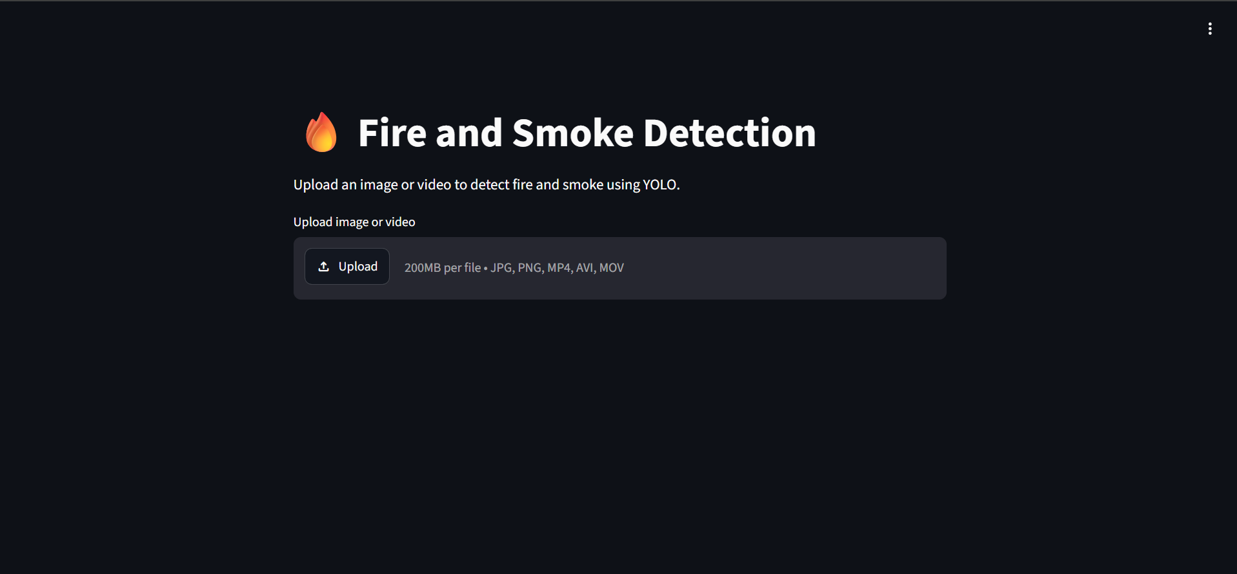
Figure 2: Fire and Smoke Detection Interface
The main elements of the interface are described in the table below.
Interface Element | Description
Project title | The heading “Fire and Smoke Detection” with a flame icon is shown at the top of the page, followed by a line telling the user to upload an image or video.
Image/video upload area | A file uploader labelled “Upload image or video”. It shows an Upload button and the allowed file types (JPG, PNG, MP4, AVI, MOV) with a limit of 200 MB per file.
Start Detection button | Appears after a file is uploaded. Clicking it starts the detection process.
Detection status message | A message that informs the user while the file is being processed and when detection has finished.
Processed video player | A video player that plays the processed video with bounding boxes and labels.
Download Processed Video button | Allows the user to download the processed video to the local computer.

[Insert screenshot of the interface after a video is uploaded, showing the Start Detection button]
Figure 3: Interface After File Upload with Start Detection Button

13. Results and Discussion
The application was tested with a demonstration video. In this demonstration, the application identified the classes “fire” and “smoke”, displayed bounding boxes around them in the processed video, and provided an option to download the processed video. These are observed demonstration results. They show that the pipeline works from upload to download, but they are not proof of the overall accuracy of the model.
Observation | Result in the Demonstration
Input type | Video uploaded through the Streamlit interface
Classes identified | “fire” and “smoke”
Visual output | Bounding boxes with labels shown in the processed video
Processed video | Displayed in the browser player
Download option | Available through the Download Processed Video button
Quantitative evaluation | Not performed in this project (no accuracy, precision, recall or speed figures are reported)

[Insert screenshot of the processed video showing fire and smoke bounding boxes]
Figure 4: Processed Video with Bounding Boxes for Fire and Smoke
The result shows that a pretrained YOLO model can be reused directly for fire and smoke detection and that bounding boxes make the detected regions easy to see. A proper evaluation on a labelled test set, using measures such as precision, recall and mean average precision, would be needed to judge how reliable the model is in different conditions.

14. Advantages
- Automated analysis: Images and videos are analysed by the model, which reduces the need to watch footage manually.
- Visual localization: Bounding boxes show where fire or smoke appears in the image or frame.
- Ease of use: The browser interface needs no programming knowledge. The user uploads a file and clicks a button.
- Pretrained model reuse: A ready-made YOLOv8 model is used, so no new training is needed, saving time and computing resources.
- Processed output download: The annotated video can be downloaded for review, sharing or record keeping.
- Cloud-based execution: The application runs on Google Colab, so no local installation of the deep learning libraries is required.

15. Limitations
- The current application processes uploaded media. It does not continuously monitor a live surveillance camera.
- Detection can be affected by image quality, lighting, the appearance of smoke and the training data of the model.
- False positives (detecting fire or smoke that is not present) and false negatives (missing real fire or smoke) are possible.
- Performance and accuracy have not been measured here and require further evaluation.
- The public Ngrok URL depends on the running Colab session. When the session stops, the URL no longer works.

16. Future Enhancement
The project can be improved in the following ways:
- Live camera integration: Connect to an IP camera or webcam stream for continuous monitoring.
- Real-time alerts: Send an alarm, email or message when fire or smoke is detected.
- Confidence score display: Show the confidence value of each detection in the interface.
- Detection history: Store past detections with time and file details for later review.
- Improved evaluation: Test the model on a labelled dataset and report precision, recall, mAP and processing speed.
- Deployment on a dedicated server: Host the application on a stable server so it does not depend on a Colab session.

17. Conclusion
This project implemented a fire and smoke detection application using a pretrained YOLOv8 model. The model weights were downloaded from the Hugging Face Hub and loaded with the Ultralytics library. A Streamlit interface lets the user upload an image or a video, start the detection, view the results and download the processed video. The application runs on Google Colab with Python and OpenCV, and Ngrok provides browser access.
In the demonstration, the application identified “fire” and “smoke” in a video and showed them with bounding boxes. The project shows how pretrained object detection can be reused to build a simple and practical tool for analysing surveillance media. Further work on live camera input, alerts and a proper accuracy evaluation would make the system more suitable for real-world use.

18. References
- Ultralytics. YOLO Documentation. https://docs.ultralytics.com/
- Ultralytics. YOLOv8 Model Documentation. https://docs.ultralytics.com/models/yolov8/
- Ultralytics. Predict Mode. https://docs.ultralytics.com/modes/predict/
- Hugging Face. Hugging Face Hub Python Library Documentation. https://huggingface.co/docs/huggingface_hub/index
- Hugging Face. Download Files from the Hub. https://huggingface.co/docs/huggingface_hub/guides/download
- Streamlit. Streamlit Documentation. https://docs.streamlit.io/
- Streamlit. st.file_uploader. https://docs.streamlit.io/develop/api-reference/widgets/st.file_uploader
- Streamlit. st.download_button. https://docs.streamlit.io/develop/api-reference/widgets/st.download_button
- OpenCV. OpenCV Documentation. https://docs.opencv.org/
- Google. Google Colaboratory. https://colab.research.google.com/
- Ngrok. Ngrok Documentation. https://ngrok.com/docs
- pyngrok. pyngrok Documentation. https://pyngrok.readthedocs.io/
All the web pages above are official documentation and were accessed in October 2026.

