Critical use case model

Parsing XML files

During the process of transcribing the old the transcribed version of the documents have been stored in XML format according to the TEI standard. The system have to parse the structure of these XML files and extract the text that should be provided to the search engine. Maintaining the data structure of the XML files is important. The XML-to-JSON module transforms the extracted text in JSON format that is suitable for the search engine but also contains the important information stored in the XML tags.

During the process of document parsing the system links each of the XML files with the record of extracted text that is imported into the search engine. This method allows the quick responsiveness of the search engine and direct link from element in the search result to the original XML files of the transcribed documents.

Searching

The search functionality of the system is based on the open-source project Elasticsearch. This core element of the system provides quick search response even with large amount of data. This open-source project have large pack of tools for language processing that “work out of the box”. Some of those features will be used to provide suggestions and misspelling correction for the search query.

The rich documentation and the large developer community of the Elasticsearch project allows quick development process and easy maintenance.

The storage layer module “Search Interface” generates specific JSON queries that are sent to the search engine. This module transforms the response of the search engine into a list of matched text results. This list is extended by the application layer module “Search Handler” which links each of the matched results to corresponding XML record.

The already extended list of search results along with search suggestions from the Elasticsearch are passed to the view layer module “Search Documents”. This module is responsible for generating the HTML page that contains the search results corresponding to the user input.

The searching functionality allows the use of filters such as:
- ID of document
- Annotations
- Proper names

Upload/Edit XML files

This functionality of the system allowed only for authentication users with administrative privileges. It provides simple way to import new documents. This process requires the user to submit scanned image of the original document together with XML file of the transcribed version.

The application layer module “Login handler” is responsible for the user authentication. It allows only authorised users to import and modify documents. The fundamental component of the system is based on the ruby-on-rails gem Devise which provides complete authentication system that “works out of the box”.

The application layer module “Read/Write/Delete documents” receives the image and XML files from the user and uploads them on the server and creates a corresponding record to the PostgreSQL database server. This method allows efficient access to all imported documents.

Candidate system architecture

The system provides three main functionalities:
- Display Documents.
- Searching through transcribed version of the documents.
- Control of the content.

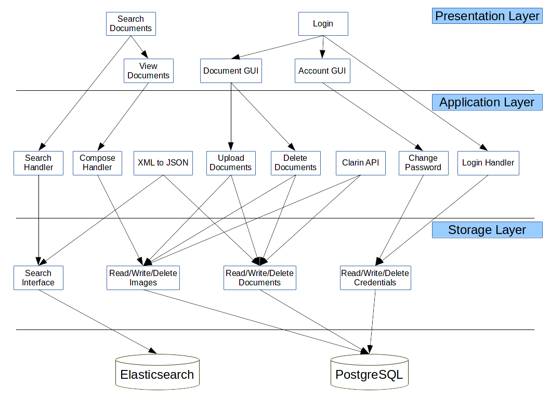
The system architecture is based on the three-tier architecture model. Each of these functionalities consist of modules in each of the three layers of the system.
The presentation layer of the system provides the graphical user interface. The application layer of the system provides the business logic for each of the functionalities where the storage layer consist of the modules that interact with the PostgreSQL database, Elasticsearch and apply read/write operations to the stored files.

The presentation layer have significant role in transforming the data gathered from the system into visual structure that is displayed to the user. Significant aspect of the modules in this layer is to provide smooth navigation between the different functionalities of the system. To achieve this intention the modules in the presentation layer take use of the CSS and JavaScript libraries provided by several open-source project such as BootStrap and Jquery.

The components in the application layer contain the business logic of the system. This layer contains the implementation for each of the functionalities of the system and transforms the data gathered from the storage layer into format that would be suitable for the presentation layer.

The modules in this part of the system analyse the user input and executes the corresponding functions. The application layer contains the methods that are responsible for the user authentication, uploading new documents and composing the search result into suitable format for the presentation layer. Minimising coupling requires each of these functionalities to be managed from small number of classes and methods at the same time to maximise cohesion of the system we require to split each of the functionality into at least several independent classes or methods. Achieving both minimum coupling and maximum cohesion in the application layer of the system requires each functionality to be composed into two independent parts.
The user authentication of the system is based on the ruby gem Devise which implements all necessarily modules to provide secure authentication. However, the module “Login handler” stores additional data and records the system requires for each user where the module “Change Password” provides the functionality for authenticated user with administrative privileges to set new password for the every user of the system.

The functionality of displaying stored documents is driven by the module “Compose handler” which is responsible for combining the transcription of a document with the corresponding scanned image of the document and the additional information such as: date, document ID.

The module “Search handler” is responsible for analysing the user input, executing the corresponding functionality of the storage layer module “Search interface” and provide the results in suitable format to the presentation layer module “Search Documents”

The users of the system are allowed to upload new documents and modify/remove existing ones. This functionality is composed of two modules “Upload document” and “Delete document”. The first module provides the upload/modify function and the second module is responsible for removing documents from the system. These are critical components of the system and they are available only for authenticated users with corresponding privileges.

The storage layer contains the modules that are responsible for the interaction of the system with the PostgreSQL database and the search engine. These modules are transforming the data from the user input to SQL queries and JSON requests. They are then sent to the corresponding external servers. The components in this layer also transform the response received from both the PostgreSQL database and Elasticsearch server into proper format that can be processed by the application layer.

