|  |
| --- |
| Nexus Access  User’s Guide |
| User’s Guide |
| A Guide to the NexusAccess_m.py python interface. Nexus Access Software is provides to illustrate some of the uses of the Python Library on the Nexus 3K platform. Software is provided “As Is” and there is no implied warrantee. |
|  |



Nexus Access - Users Guide

Contents

I. Overview 2

II. Socket Server 2

1. CLI Interface 2

2. Continuous Monitor 2

III. Socket Client 3

1. Menu Structure 3

II. CLI Interface 4

a. Script command (s) 4

b. Queue command (q) 4

c. Log file command (l) 5

d. Interface command (i) 5

e. Buffer (b) 6

f. Routing (r) 6

IV. Multi-Chassis Features 7

1. Menu 7

2. Script 7

3. 0, 1, 2 8

4. M 8

III. Include files 11

a. Nexus Object file: 11

IV. Script Files 13

a. script.txt 13

b. mscript.txt 13

c. mrun.txt 13

# Overview

The Nexus Access project goal is to provide a frame work to demonstrate the Nexus Python Interface with a Client🡪 Server connection.

* 1. The Client uses Python 2.7.3.
     1. The Linux version uses the curses module
     2. The PC version uses the Tkinter modules.
        1. The curses module is not available on the PC.
  2. The Server is on the Nexus 3K chassis.

Communication is over the myPort=50007 port and to the myHost = 172.25.187.155. Pending connects is set at 5 maximum.

N3K Host [0]

SocketServer_x.py

Client

NexusAccess_m.py

Nexus_Object.py

script.txt

mscript.txt

N3K Host [0]

SocketServer_x.py

N3K Host [0]

SocketServer_x.py

# Client Server Socket Connections

# Socket Server

## CLI Interface

* + 1. Uses the Nexus 3K Python library CLI Object in addition to the standard python libraries for date and time, socket.

## Continuous Monitor

* + 1. Runs in the background gathering data a 1 second intervals and sends out the last number of results from 1-20. The command is BMdata for buffer monitor data.

# Socket Client

## Menu Structure

* + 1. The menu and interface is based on the Curses library in the Python program.
    2. There are 7 options on the menu (shown below)
       1. Script - runs script.txt file
       2. Log file - reads local log file
       3. Interface - shows a summary of the N3K interfaces
       4. Buffer - reads and displays the buffer monitor data
       5. Routing - Show a summary of the current routing information
       6. Exit - Shuts down the socket interface and exits to the Linux prompt

#### Linux Version

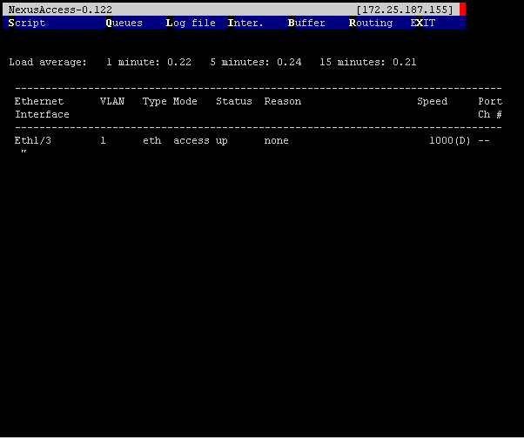

#### PC Version

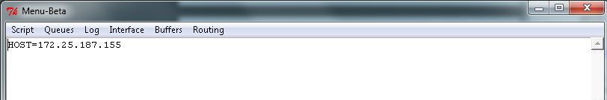

## CLI Interface

Consists of sending the commands as strings via the socket interface and receiving the output string and stores this in a buffer.

### Script command (s)

* 1. Loads the file script.txt in to a buffer
  2. Sends the buffer to the server
  3. Reads back the data and displays the result
  4. Sample Script file:

config t

int eth1/3

no shut

show int eth 1/3 brief

### Queue command (q)

* 1. Sends the show queue command to the N3K
  2. Formats the buffer and displays the result

System info:

cos2class-id[7-0 : 0 0 0 0 0 0 0 0

cls|flag|mtuS|cosM|grpM|wred|ecn

0|0x05|1500|0xff|0x01| 1| 1

1|0x00|1500|0x00|0x00| 0| 0

2|0x00|1500|0x00|0x00| 0| 0

3|0x00|1500|0x00|0x00| 0| 0

4|0x00|1500|0x00|0x00| 0| 0

5|0x00|1500|0x00|0x00| 0| 0

6|0x00|1500|0x00|0x00| 0| 0

7|0x00|1500|0x00|0x00| 0| 0

Scheduling info

actual configured

cls|priOut|bwOut qgrp|priOut|bwOut|WREDmin|WREDmax|DropProb|Gain|

0| 0 | 100 0 | 0 | 100 | 99 | 394 | 75 | 7 |

1| 0 | 0 1 | 0 | 0 | 0 | 0 | 0 | 0 |

2| 0 | 0 2 | 0 | 0 | 0 | 0 | 0 | 0 |

3| 0 | 0 3 | 0 | 0 | 0 | 0 | 0 | 0 |

4| 0 | 0 4 | 0 | 0 | 0 | 0 | 0 | 0 |

5| 0 | 0 5 | 0 | 0 | 0 | 0 | 0 | 0 |

6| 0 | 0 6 | 0 | 0 | 0 | 0 | 0 | 0 |

7| 0 | 0 7 | 0 | 0 | 0 | 0 | 0 | 0 |

### Log file command (l)

* 1. Reads the contents of the buffer logx file
  2. Formats and displays the results.

Load average: 1 minute: 0.26 5 minutes: 0.24 15 minutes: 0.19

Processes : 352 total, 2 running

CPU states : 9.9% user, 1.5% kernel, 88.6% idle

Memory usage: 4007288K total, 1466368K used, 2540920K free

Load average: 1 minute: 0.26 5 minutes: 0.24 15 minutes: 0.19

Processes : 352 total, 2 running

CPU states : 9.9% user, 1.5% kernel, 88.6% idle

Memory usage: 4007288K total, 1466368K used, 2540920K free

### Interface command (i)

* 1. Sends the show interface command to the N3K
  2. Formats the buffer and displays the result

--------------------------------------------------------------------------------

Ethernet VLAN Type Mode Status Reason Speed Port

Interface Ch #

--------------------------------------------------------------------------------

Eth1/1 -- eth routed down Link not connected auto(D) --

Eth1/2 1 eth access down Link not connected auto(D) --

Eth1/3 1 eth access up none 1000(D) --

Eth1/4 1 eth access down Link not connected auto(D) --

Eth1/5 1 eth access up none 1000(D) --

Eth1/6 1 eth access down Link not connected auto(D) --

Eth1/7 1 eth access up none 1000(D) --

Eth1/8 1 eth access down Link not connected auto(D) --

Eth1/9 1 eth access down Link not connected auto(D) --

Eth1/10 -- eth routed down Link not connected auto(D) --

Eth1/11 1 eth access down Link not connected auto(D) --

Eth1/12 1 eth access up none 1000(D) --

Eth1/13 1 eth access down Link not connected auto(D) --

Eth1/14 1 eth access up none 1000(D) --

Eth1/15 1 eth access down Link not connected auto(D) --

Eth1/16 1 eth access up none 1000(D) --

Eth1/17 1 eth access down Link not connected auto(D) --

Eth1/18 1 eth access down Link not connected auto(D) --

Eth1/19 1 eth access down Link not connected auto(D) --

### Buffer (b)

* 1. Sends the request for the N3K buffer monitor results
  2. Formats and displays the received the output

### Routing (r)

* 1. Sends the commands for a routing summary
  2. Formats and displays the result

[ IP Route Table for VRF "management"

" * denotes best ucast next-hop"

" ** denotes best mcast next-hop"

" [x/y denotes [preference/metric"

0.0.0.0/0, ubest/mbest: 1/0

*via 172.25.187.1, mgmt0, [1/0, 1w1d, static

172.25.187.0/24, ubest/mbest: 1/0, attached

*via 172.25.187.155, mgmt0, [0/0, 1w1d, direct

172.25.187.155/32, ubest/mbest: 1/0, attached

*via 172.25.187.155, mgmt0, [0/0, 1w1d, local

## Multi-Chassis Features

### Menu

Consists of the following Script, 0, 1, 2 and M.

### Script

Loads /root/scripts/script.txt and then runs the script on the current chassis. Results are displayed on the screen. For example:

echo " --> Running script.txt"

echo " ... show system resources ..."

echo " ... no shut on eth 1/3 "

echo " ... sho inf brief | grep up "

echo " "

show system resources | grep Load

show system resources | grep Load

show system resources | grep Load

show system resources | grep Load

config t

int eth1/3

no shut

echo ""

echo "--------------------------------------------------------------------------------"

echo "Interface VLAN Type Mode Status Reason Speed Port"

echo "--------------------------------------------------------------------------------"

echo ""

show int brief | grep up

#### Linux Screen:

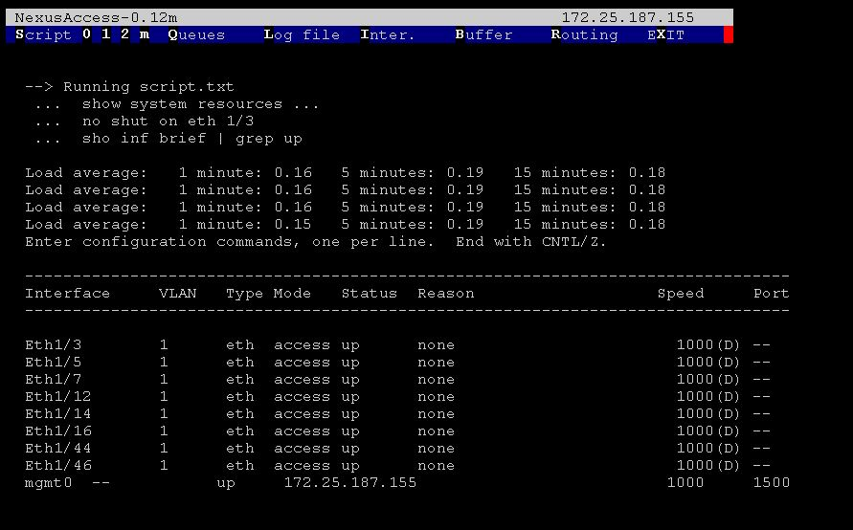

#### PC Screen:

### 

### 0, 1, 2

Changes the current default chassis to IP addresses 0, 1, or 2. The display line 1 is updated with the new chassis IP address.

### M

Loads /root/scripts/mscript.txt and then runs the script on the three chassis listed in the code from first to last. Results are displayed on screen. mscript.txt below.

Result:

show system resources | grep Load

show system resources | grep Load

#### Linux Version

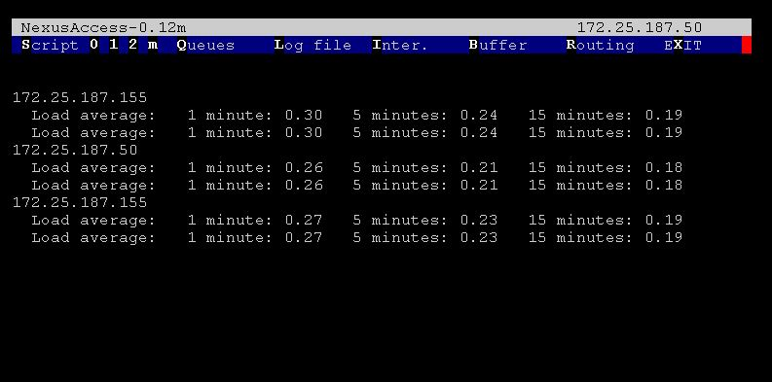

#### PC Version

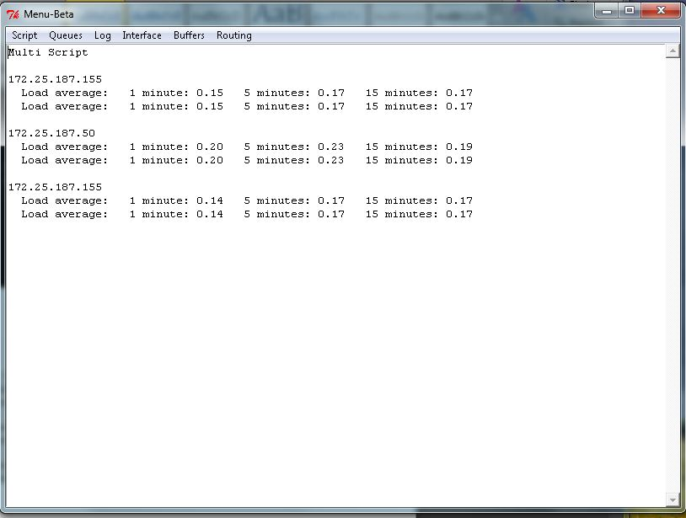

Output: mrun.txt

172.25.187.155

Load average: 1 minute: 0.50 5 minutes: 0.27 15 minutes: 0.20

Load average: 1 minute: 0.50 5 minutes: 0.27 15 minutes: 0.20

172.25.187.50

Load average: 1 minute: 0.16 5 minutes: 0.24 15 minutes: 0.16

Load average: 1 minute: 0.16 5 minutes: 0.24 15 minutes: 0.16

172.25.187.155

Load average: 1 minute: 0.50 5 minutes: 0.27 15 minutes: 0.20

Load average: 1 minute: 0.54 5 minutes: 0.28 15 minutes: 0.21

# Include files

### Nexus Object file:

# Nexus_Object.py program

# Modified 14 Nov 2012 - Robert J. Stellman

# Initial 01 Oct 2012

#

import socket

import os

from datetime import datetime

import time

import shutil

from shutil import *

class Nexus_switch:

def __init__(self, host, port):

HOST = host # The remote host

PORT = port # The same port as used by the server

def s_socket(self,sbuffer,HOST,PORT):

# Sends the buffer to the server

s = socket.socket(socket.AF_INET, socket.SOCK_STREAM)

s.connect((HOST, PORT))

s.sendall(sbuffer)

data = s.recv(6500)

s.close()

return(data)

def s_read (self,fname = "a.tmp"):

# Loads a file into the buffer string

#

nexusLogFile = fname

bufferText=" ... "

buffer1 = open(nexusLogFile,'r')

bufferText = buffer1.read()

buffer1.close()

return(bufferText)

def s_write (self,fname= "/bootflash/a.tmp", bufferText=""):

# ... Write to a file

#

bufferFile = open(fname, 'w')

bufferFile.write(bufferText)

bufferFile.close()

return()

def stringNexusFormat (self, bufferText, skip=0):

"""\n Format file data for Humans """

bufferText = bufferText.replace ('"[','')

bufferText = bufferText.replace (']','')

bufferText = bufferText.replace ("'"," ")

bufferText = bufferText.replace ('\\',' ')

bufferText = bufferText.replace ('",','"\n') # Needed for 'show routes'

bufferText = bufferText.replace (' ,','\n')

if (skip == 1): # Buffer Monitor; csv data

bufferText = bufferText.replace ('n','\n')

return (bufferText)

# Script Files

### script.txt

echo " --> Running script.txt"

echo " ... show system resources ..."

echo " ... no shut on eth 1/3 "

echo " ... sho inf brief | grep up "

echo " "

show system resources | grep Load

show system resources | grep Load

show system resources | grep Load

show system resources | grep Load

config t

int eth1/3

no shut

echo ""

echo "--------------------------------------------------------------------------------"

echo "Interface VLAN Type Mode Status Reason Speed Port"

echo "--------------------------------------------------------------------------------"

echo ""

show int brief | grep up

### mscript.txt

show system resources | grep Load

show system resources | grep Load

### mrun.txt (mscript.txt output)

172.25.187.155

Load average: 1 minute: 0.50 5 minutes: 0.27 15 minutes: 0.20

Load average: 1 minute: 0.50 5 minutes: 0.27 15 minutes: 0.20

172.25.187.50

Load average: 1 minute: 0.16 5 minutes: 0.24 15 minutes: 0.16

Load average: 1 minute: 0.16 5 minutes: 0.24 15 minutes: 0.16

172.25.187.155

Load average: 1 minute: 0.50 5 minutes: 0.27 15 minutes: 0.20

Load average: 1 minute: 0.54 5 minutes: 0.28 15 minutes: 0.21