|  |
| --- |
| Nexus Access (gui)  User’s Guide |
| User’s Guide |
| A Guide to the PC_Nexus_Access.py python interface. Nexus Access Software is provides to illustrate some of the uses of the Python Library on the Nexus 3K and 5K platform. Software is provided “As Is” and there is no implied warrantee. |
|  |



Nexus Access (gui) - Users Guide

Contents

I. Overview 2

II. Socket Server 2

1. CLI Interface 2

2. Continuous Monitor 2

III. Socket Client 3

1. Menu Structure 3

II. CLI Interface 4

a. Script command (s) 4

b. Queue command (q) 4

c. Log file command (l) 5

d. Interface command (i) 5

e. Buffer (b) 6

f. Routing (r) 6

IV. Multi-Chassis Features 7

1. Menu 7

2. Script 7

3. 0, 1, 2 8

4. M 8

III. Include files 11

a. Nexus Object file: 11

IV. Script Files 13

a. script.txt 13

b. mscript.txt 13

c. mrun.txt 13

# Overview

The Nexus Access project goal is to provide a frame work to demonstrate the Nexus Python Interface with a Client🡪 Server connection.

* 1. The Client uses Python 2.7.3.
     1. The Linux version uses the curses module
     2. The PC version uses the Tkinter modules.
        1. The curses module is not available on the PC.
  2. The Server is on the Nexus 3K chassis.

Communication is over the myPort=50007 port and to the myHost = 172.25.187.155. Pending connects is set at 5 maximum.

# 

N3K Host [0]

SocketServer_x.py

Client

NexusAccess_m.py

Nexus_Object.py

script.txt

mscript.txt

N3K Host [0]

SocketServer_x.py

N3K Host [0]

SocketServer_x.py

# Client Server Socket Connections

# Socket Server

## CLI Interface

* + 1. Uses the Nexus 3K Python library CLI Object in addition to the standard python libraries for date and time, socket.

## Continuous Monitor

* + 1. Runs in the background gathering data a 1 second intervals and sends out the last number of results from 1-20. The command is BMdata for buffer monitor data.

# 

# Socket Client

## Menu Structure

* + 1. The menu and interface is based on the Tkinter library in the Python program.
    2. There menu options are shown below:

|  |  |
| --- | --- |
| Menu | Actions |
| File | Displays the ‘script’, ‘mscript’ and results files  and closes the window. |
| Script | Runs multiscript on all hosts  or script.txt file on Hosts 0,1, and 2. |
| Queue | Shows queue status |
| Interface | Shows interface information on All, up, down and vlan |
| Buffer | reads and displays the buffer monitor data (N3K only) |
| Routing | Show a summary of the current routing information |
| TCP Sockets | Shows the current TCP sockets |
| About | License information |

#### PC Version/Linux Version

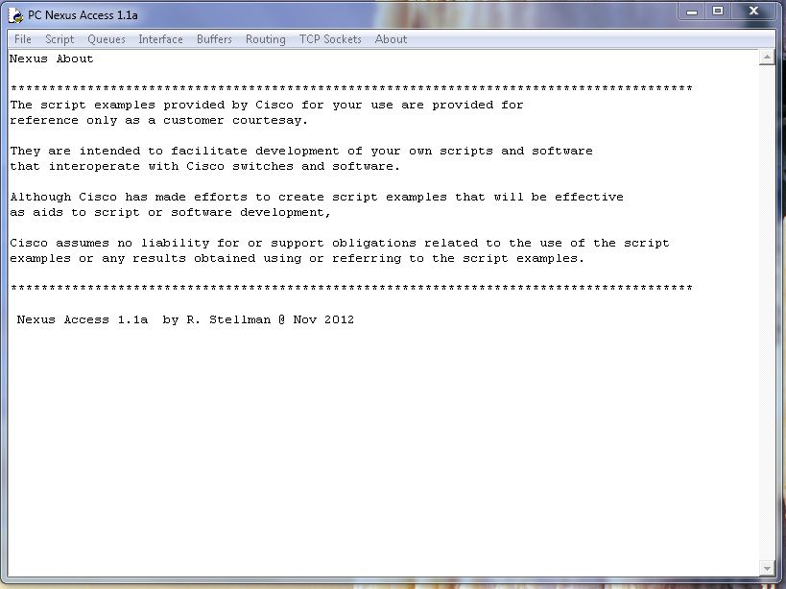

## CLI Interface

Consists of sending the commands as strings via the socket interface and receiving the output string and stores this in a buffer.

### File Commands

File Script Queues Interface Buffers Routing TCP Sockets About

|  |  |  |  |
| --- | --- | --- | --- |
| Script | Multi |  | All |
| Run | Host0 |  | Up |
| --------- | Host1 |  | Down |
| Mscript | Host2 |  | Vlan |
| Mrun |  |
| --------- |  |
| close |  |

### Script command (s)

* 1. Loads the file script.txt in to a buffer
  2. Sends the buffer to the server
  3. Reads back the data and displays the result
  4. Sample Script file:

config t

int eth1/3

no shut

show int eth 1/3 brief

### Queue command (q)

* 1. Sends the show queue command to the N3K
  2. Formats the buffer and displays the result

System info:

cos2class-id[7-0 : 0 0 0 0 0 0 0 0

cls|flag|mtuS|cosM|grpM|wred|ecn

0|0x05|1500|0xff|0x01| 1| 1

1|0x00|1500|0x00|0x00| 0| 0

2|0x00|1500|0x00|0x00| 0| 0

3|0x00|1500|0x00|0x00| 0| 0

4|0x00|1500|0x00|0x00| 0| 0

5|0x00|1500|0x00|0x00| 0| 0

6|0x00|1500|0x00|0x00| 0| 0

7|0x00|1500|0x00|0x00| 0| 0

Scheduling info

actual configured

cls|priOut|bwOut qgrp|priOut|bwOut|WREDmin|WREDmax|DropProb|Gain|

0| 0 | 100 0 | 0 | 100 | 99 | 394 | 75 | 7 |

1| 0 | 0 1 | 0 | 0 | 0 | 0 | 0 | 0 |

2| 0 | 0 2 | 0 | 0 | 0 | 0 | 0 | 0 |

3| 0 | 0 3 | 0 | 0 | 0 | 0 | 0 | 0 |

4| 0 | 0 4 | 0 | 0 | 0 | 0 | 0 | 0 |

5| 0 | 0 5 | 0 | 0 | 0 | 0 | 0 | 0 |

6| 0 | 0 6 | 0 | 0 | 0 | 0 | 0 | 0 |

7| 0 | 0 7 | 0 | 0 | 0 | 0 | 0 | 0 |

### Interface Menu Options

* 1. Show interface All
  2. Show interface up - All interfaces that are up
  3. Show interface down - All interfaces that are down
  4. Show vlan - Vlan status

--------------------------------------------------------------------------------

Ethernet VLAN Type Mode Status Reason Speed Port

Interface Ch #

--------------------------------------------------------------------------------

Eth1/1 -- eth routed down Link not connected auto(D) --

Eth1/2 1 eth access down Link not connected auto(D) --

Eth1/3 1 eth access up none 1000(D) --

Eth1/4 1 eth access down Link not connected auto(D) --

Eth1/5 1 eth access up none 1000(D) --

Eth1/6 1 eth access down Link not connected auto(D) --

Eth1/7 1 eth access up none 1000(D) --

Eth1/8 1 eth access down Link not connected auto(D) --

Eth1/9 1 eth access down Link not connected auto(D) --

Eth1/10 -- eth routed down Link not connected auto(D) --

Eth1/11 1 eth access down Link not connected auto(D) --

Eth1/12 1 eth access up none 1000(D) --

Eth1/13 1 eth access down Link not connected auto(D) --

Eth1/14 1 eth access up none 1000(D) --

Eth1/15 1 eth access down Link not connected auto(D) --

Eth1/16 1 eth access up none 1000(D) --

Eth1/17 1 eth access down Link not connected auto(D) --

Eth1/18 1 eth access down Link not connected auto(D) --

Eth1/19 1 eth access down Link not connected auto(D) --

### Buffer (N3K only)

* 1. Sends the request for the N3K buffer monitor results
  2. Formats and displays the received the output

### Routing

* 1. Sends the commands for a routing summary
  2. Formats and displays the result

[ IP Route Table for VRF "management"

" * denotes best ucast next-hop"

" ** denotes best mcast next-hop"

" [x/y denotes [preference/metric"

0.0.0.0/0, ubest/mbest: 1/0

*via 172.25.187.1, mgmt0, [1/0, 1w1d, static

172.25.187.0/24, ubest/mbest: 1/0, attached

*via 172.25.187.155, mgmt0, [0/0, 1w1d, direct

172.25.187.155/32, ubest/mbest: 1/0, attached

*via 172.25.187.155, mgmt0, [0/0, 1w1d, local

## Multi-Chassis Features

### Menu

Consists of the following Script, 0, 1, 2 and M.

### Script

Loads /root/scripts/script.txt and then runs the script on the current chassis. Results are displayed on the screen. For example:

echo " --> Running script.txt"

echo " ... show system resources ..."

echo " ... no shut on eth 1/3 "

echo " ... show interface status up "

echo " "

show system resources | grep Load

show system resources | grep Load

show system resources | grep Load

show system resources | grep Load

config t

int eth1/3

no shut

show interface status up

#### PC Screen:

### 

Output: mrun.txt

172.25.187.155

Load average: 1 minute: 0.50 5 minutes: 0.27 15 minutes: 0.20

Load average: 1 minute: 0.50 5 minutes: 0.27 15 minutes: 0.20

172.25.187.50

Load average: 1 minute: 0.16 5 minutes: 0.24 15 minutes: 0.16

Load average: 1 minute: 0.16 5 minutes: 0.24 15 minutes: 0.16

172.25.187.155

Load average: 1 minute: 0.50 5 minutes: 0.27 15 minutes: 0.20

Load average: 1 minute: 0.54 5 minutes: 0.28 15 minutes: 0.21

# Include files

### Nexus Object file:

# Nexus_Object.py program

# Modified 14 Nov 2012 - Robert J. Stellman

# Initial 01 Oct 2012

#

import socket

import os

from datetime import datetime

import time

import shutil

from shutil import *

class Nexus_switch:

def __init__(self, host, port):

HOST = host # The remote host

PORT = port # The same port as used by the server

def s_socket(self,sbuffer,HOST,PORT):

# Sends the buffer to the server

s = socket.socket(socket.AF_INET, socket.SOCK_STREAM)

s.connect((HOST, PORT))

s.sendall(sbuffer)

data = s.recv(6500)

s.close()

return(data)

def s_read (self,fname = "a.tmp"):

# Loads a file into the buffer string

#

nexusLogFile = fname

bufferText=" ... "

buffer1 = open(nexusLogFile,'r')

bufferText = buffer1.read()

buffer1.close()

return(bufferText)

def s_write (self,fname= "/bootflash/a.tmp", bufferText=""):

# ... Write to a file

#

bufferFile = open(fname, 'w')

bufferFile.write(bufferText)

bufferFile.close()

return()

def stringNexusFormat (self, bufferText, skip=0):

"""\n Format file data for Humans """

bufferText = bufferText.replace ('"[','')

bufferText = bufferText.replace (']','')

bufferText = bufferText.replace ("'"," ")

bufferText = bufferText.replace ('\\',' ')

bufferText = bufferText.replace ('",','"\n') # Needed for 'show routes'

bufferText = bufferText.replace (' ,','\n')

if (skip == 1): # Buffer Monitor; csv data

bufferText = bufferText.replace ('n','\n')

return (bufferText)

# Script Files

### script.txt

echo " --> Running script.txt"

echo " ... show system resources ..."

echo " ... no shut on eth 1/3 "

echo " ... sho inf brief | grep up "

echo " "

show system resources | grep Load

show system resources | grep Load

show system resources | grep Load

show system resources | grep Load

config t

int eth1/3

no shut

echo ""

echo "--------------------------------------------------------------------------------"

echo "Interface VLAN Type Mode Status Reason Speed Port"

echo "--------------------------------------------------------------------------------"

echo ""

show int brief | grep up

### mscript.txt

show system resources | grep Load

show system resources | grep Load

### mrun.txt (mscript.txt output)

172.25.187.155

Load average: 1 minute: 0.50 5 minutes: 0.27 15 minutes: 0.20

Load average: 1 minute: 0.50 5 minutes: 0.27 15 minutes: 0.20

172.25.187.50

Load average: 1 minute: 0.16 5 minutes: 0.24 15 minutes: 0.16

Load average: 1 minute: 0.16 5 minutes: 0.24 15 minutes: 0.16

172.25.187.155

Load average: 1 minute: 0.50 5 minutes: 0.27 15 minutes: 0.20

Load average: 1 minute: 0.54 5 minutes: 0.28 15 minutes: 0.21