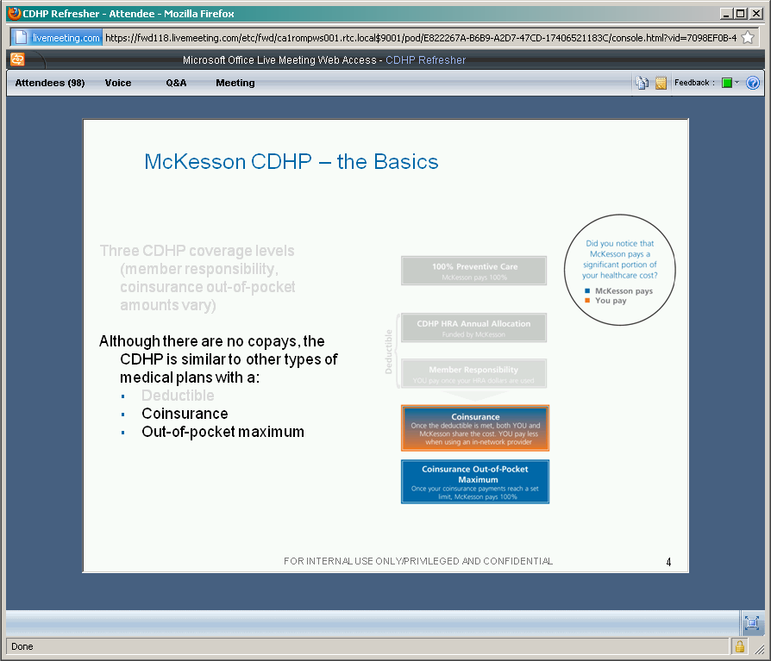

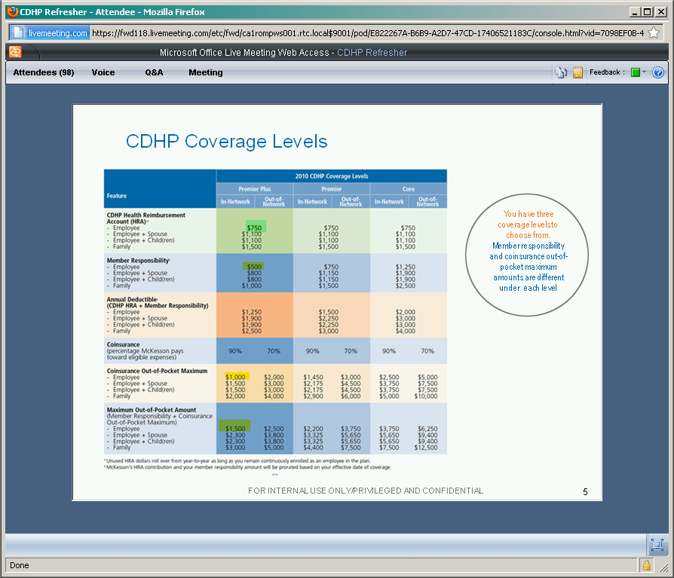

Three different levels shown above;  
e.g., employee-only, premier-plus:

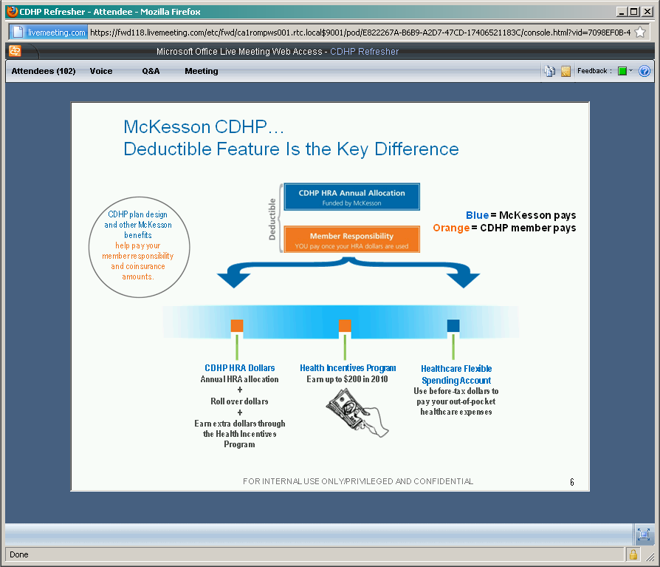

FSA money is funded by pulling stuff out of your paycheck; the full amt is available on day on of the new year, and you don’t have to wait for it to accrue before you can spend it; it’s filled in “in arrears,” sounds like.

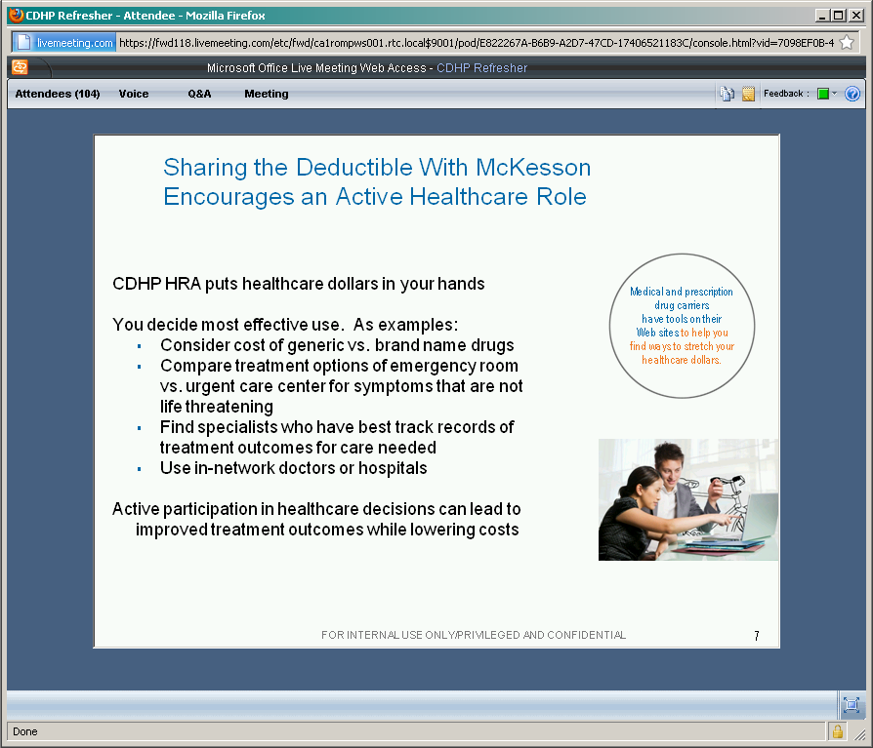

They want to encourage people to make efficient spending decisions.

They could’ve stuck with the build-your-own plan, and just hiked up the deductibles…

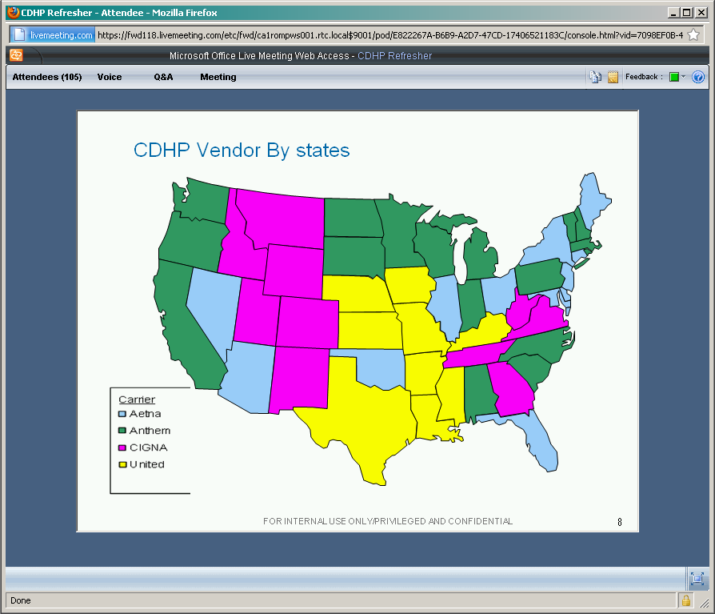

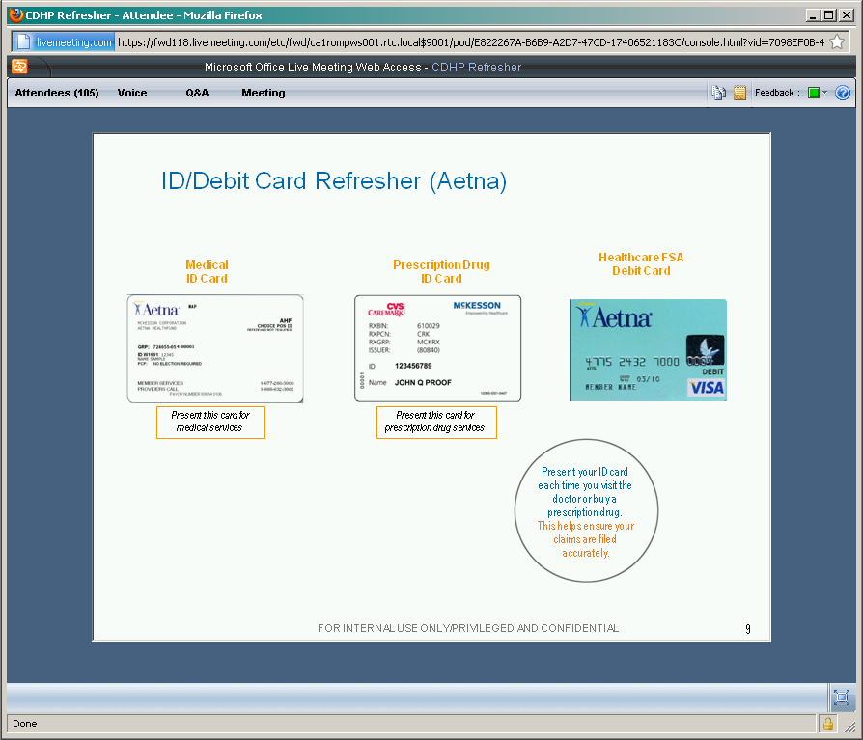

Anthem:

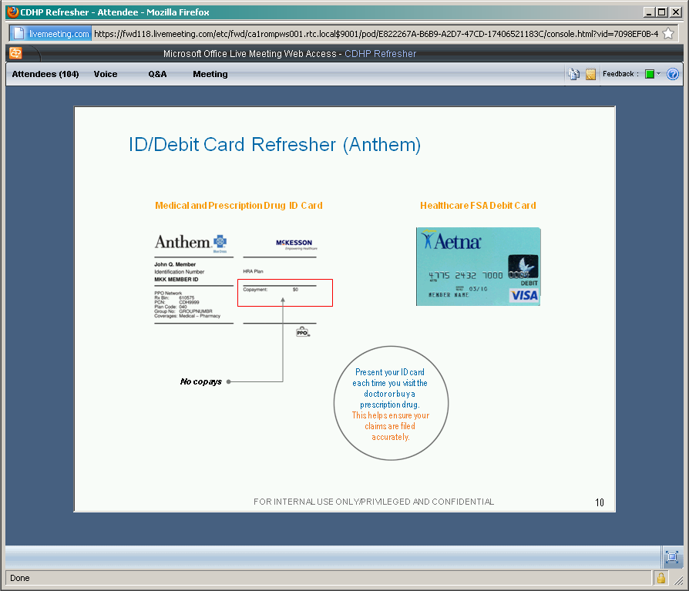

N.B. PRESCRIPTION DRUGS ARE HANDLED VIA THE SAME CARD.  
I think that this year, we didn’t do an FSA, I think…

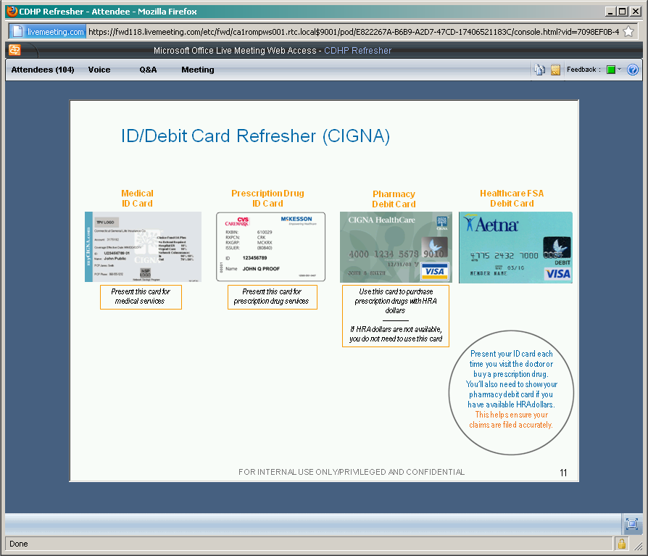

CIGNA is different, but doesn’t apply in AL, right?

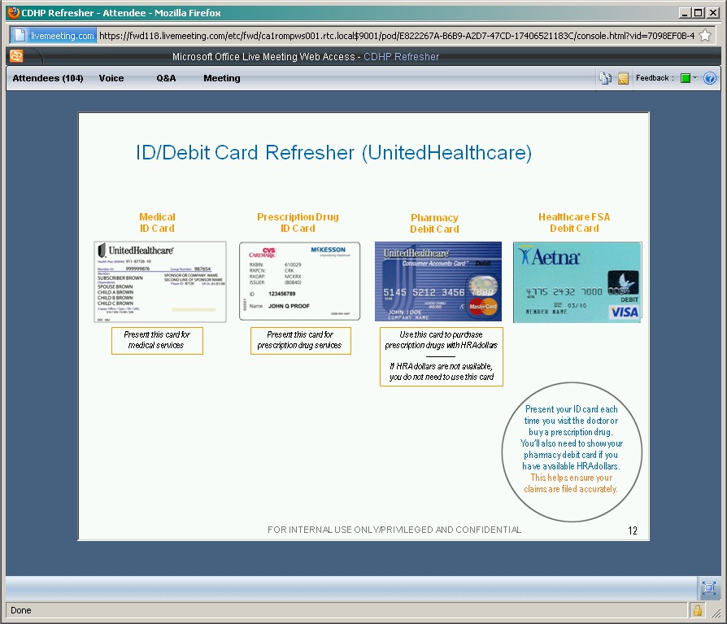

I’ll bet the above card, which I still have, was a left-over from the previous work year.  
But in this case, the UHC card above, is for pharmacy use only? The Aetna card was just to access HRA money?

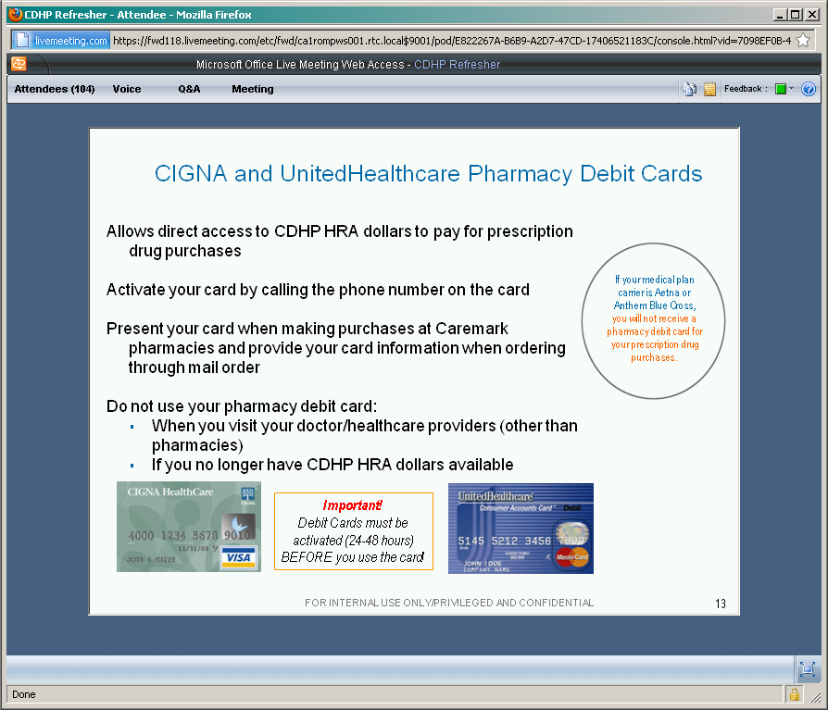

IMPORTANT TO ACTIVE YOUR CARDS, 1 TO 2 DAYS AHEAD OF USING IT?

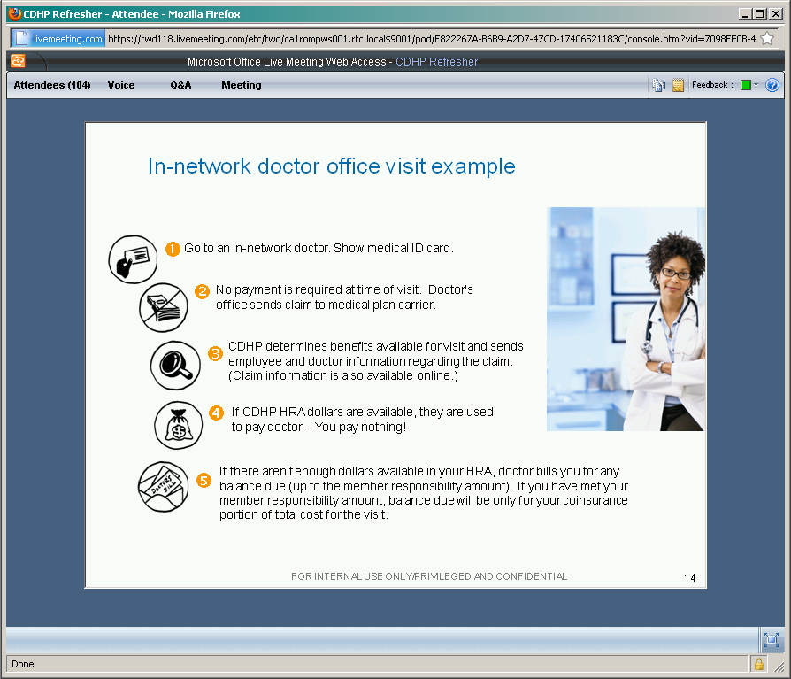

Be sure to show the id card…  
NO PAYMENT REQUIRED AT VISIT: it’s not a copay plan, and the Anthem card also says “$0 copay…”  
You start to get a bill when our HRA balance is exhausted, right?  
There’s an Explanation of Benefits statement sent to you…

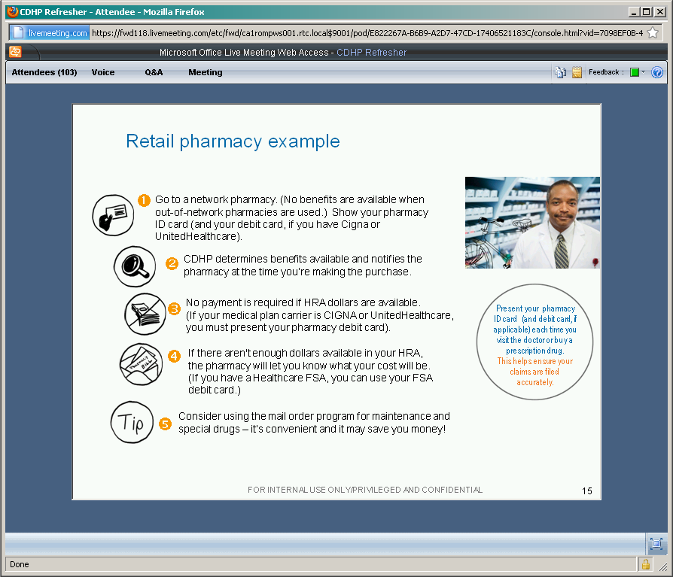

When you go to pharmacy, make sure it’s in-network! Else no benefit is paid.  
You just need to show the Anthem card, in your case.

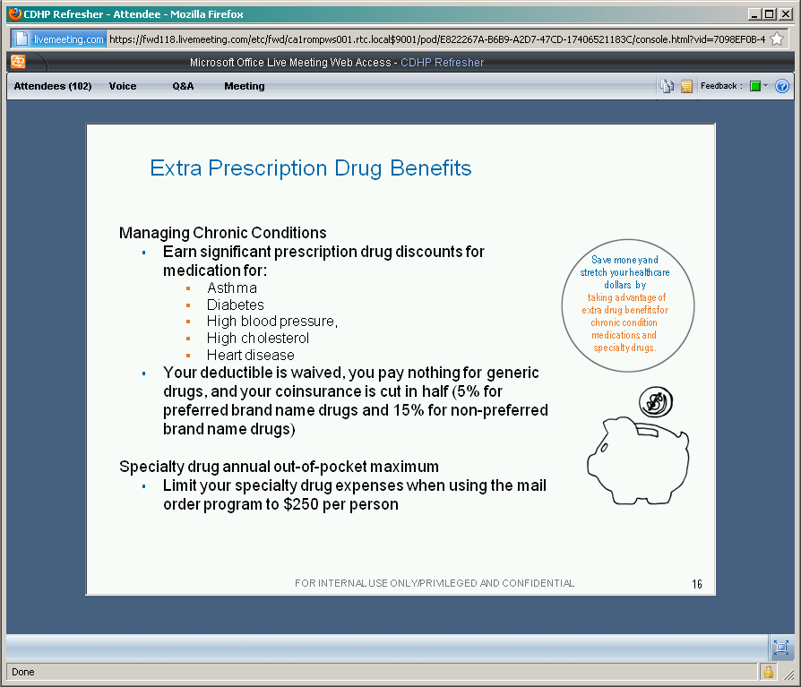

You can enroll in a chronic-conditions drugs program, to get discounts off your maintenance medications;  
You don’t have to meet a deductible, etc!  
There are spending limits placed on “specialty drugs,” like “injectables,” however…

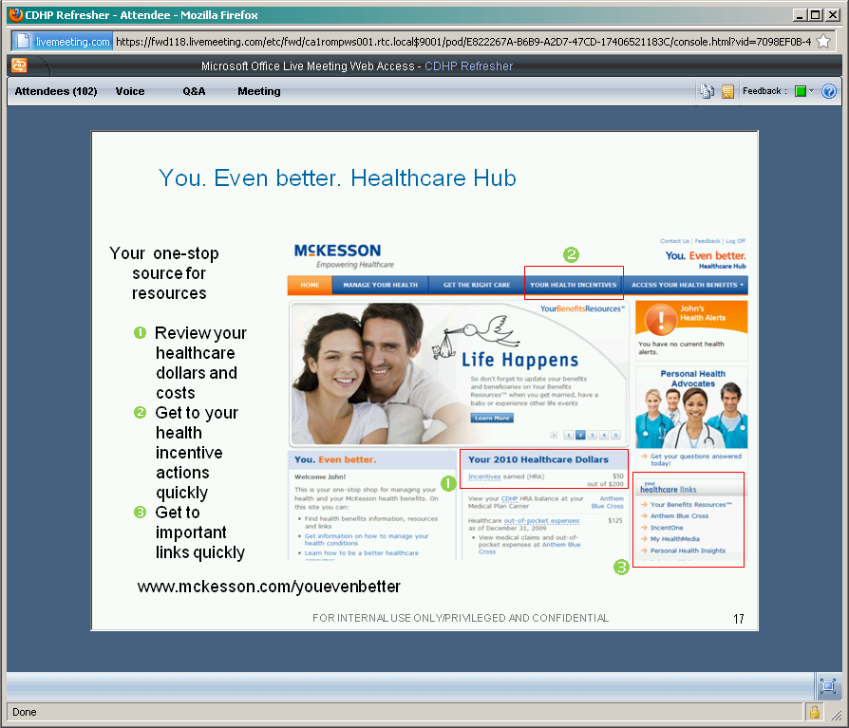

This is the “one stop shop” for medical information:  
Review everything here, balances, etc.  
Via McKNet, or the link at the bottom of the slide (where you use SSN to login, and use same password as used to access the Hewitt & Associates bene’s site…)  
THIS IS THE HIGHLY RECOMMENDED way to look at your “current status,” etc…  
You could earn $50 towards your HSA JUST BY LOGGING IN!

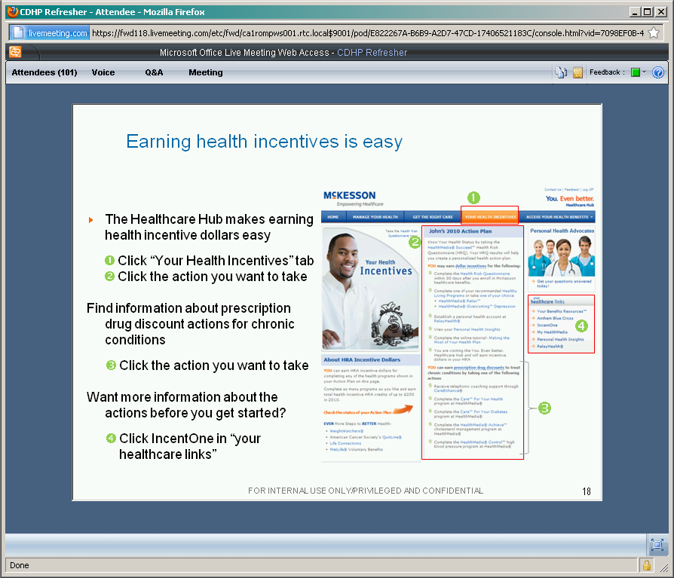

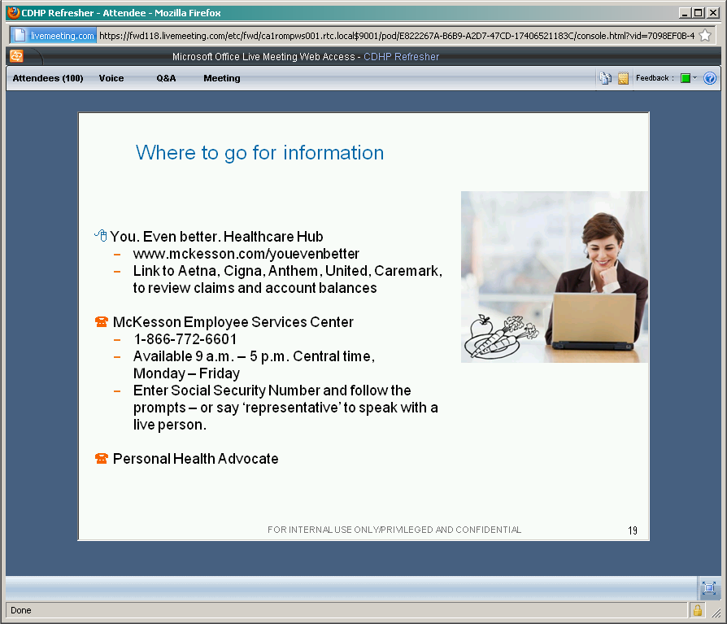

She made a special note of the Personal Health Advocate.

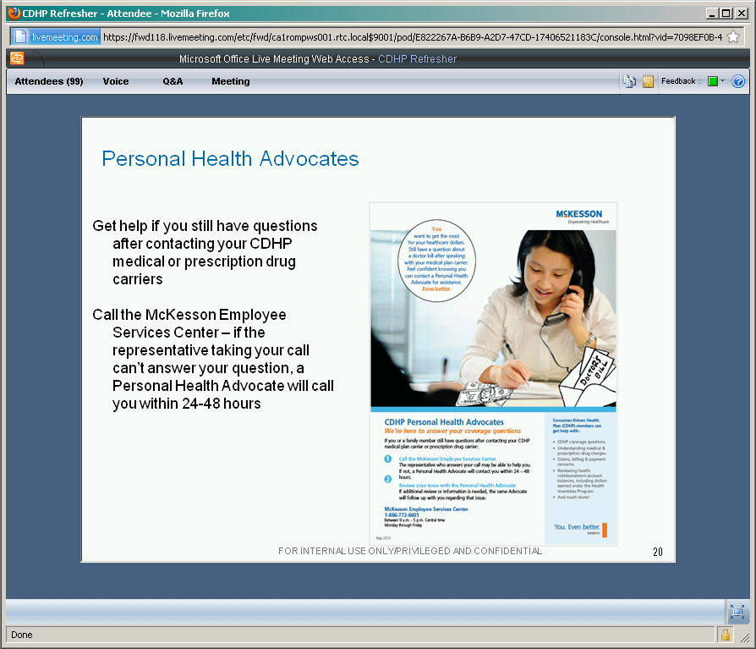

THIS IS THE PLACE TO GO FOR HELP WITH QUESTIONS THAT YOU HAVE ABOUT \*ANYTHING\*.  
PLEASE FEEL FREE TO CONTACT THE PERSONAL HEALTH ADVOCATE.  
The advocate will research into your situation, and call you back!  
These people have, on average, 10 years in claims-processing in the health insurance industry.  
Lynn recommended taking advantage of this feature!

Questions?

In FSA: you said that we could set aside, say $500, right? Do you forfeit the unused amount?  
You can use it for any healthcare related expenses, until the end of this year?  
But next year, because of “health care reform,” you have to get permission of your doctor to spend FSA dollars? Apparently…   
She elaborated: for 2011, they don’t allow FSA money to be used to buy otc med’s without a “prescription message slip” from a doctor.   
the amount will be changing to $2,600 also, but in 2011 or 2012 she couldn’t remember…

Personal health advocate question:  
somebody said their experience has been that a question is not handled by the same advocate all the way through; but Lynn said that this has been changed so that there is continuity with the same advocate person.

If, in cigna, we have been using the HRA for prescription drugs, instead of using that prescription drug debit card, then is there a way to “fix it back?” Lynn recommended that he get with an advocate, but it’s a paper-intensive process… The cigna debit card (for pharmacy) will be rolled into the next year? She said that next year, cigna’s plan will be simplified regarding the Rx debit card.

You do not have to use the FSA debit card; instead, you can submit paper claims, and then you can get reimbursed from the FSA account, apparently. (You can use the reimbursement to get money for Christmas spending?) Some pharmacies will only charge certain things via FSA? Using the card is painful at Dr. offices, dentists?

When using the HRA card, and go to provider asking for money, will they know right away that there’s HRA money there to pay for it? Confusing to me: she had to walk the questioner back through the process that the doc should bill cigna (in this case)…

Once you’ve used up the HRA money:  
If you’re “in network,” the doctor/hospital should bill you at the “contracted rate.”  
I guess the questioner is trying to find out what the contracted rates are.  
The Explanation of Benefits document/statement sent to you after you see the doctor should explain what the contracted rate was?

[CORP.BENEFITS@MCKESSON.COM](mailto:CORP.BENEFITS@MCKESSON.COM): good email address for further questions…