Marc Owen talking from Australia (where it’s current 1am?)

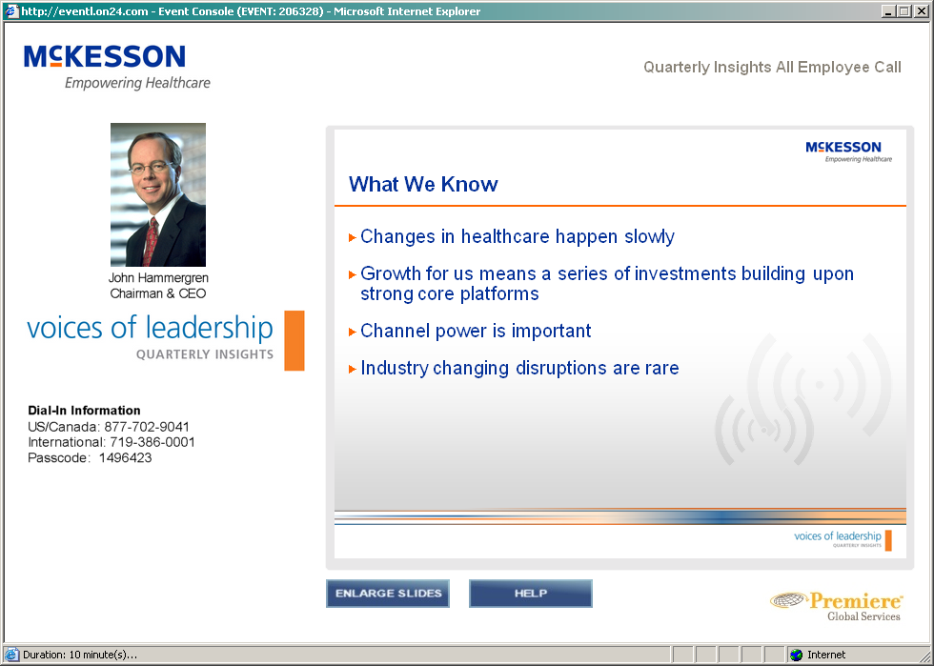

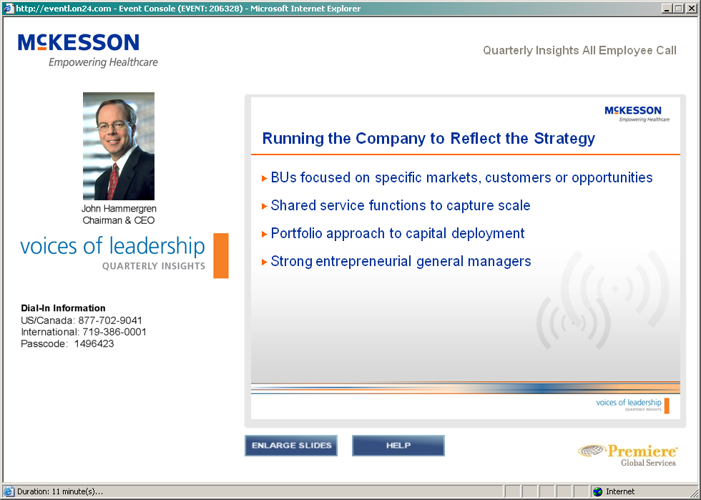

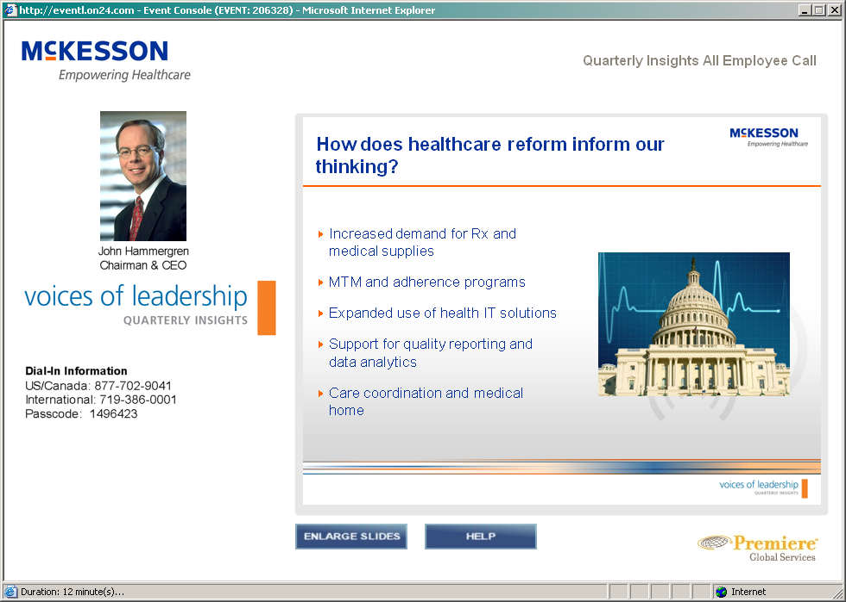

The “reforms” will be slightly positive for McKesson: we will benefit from it, like as not…  
“support for quality and data analytics”: hospitals will need to understand what is going on?  
“care coordination and medical…”: the “Henry Ford” work in Detroit is an example of this work(?)

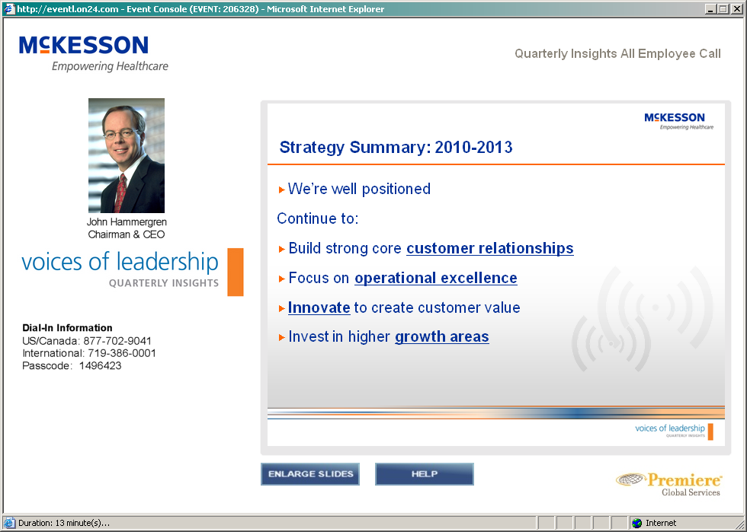

“Are we adding more value to the customer?”

“Are we investing in the right high-growth areas?”

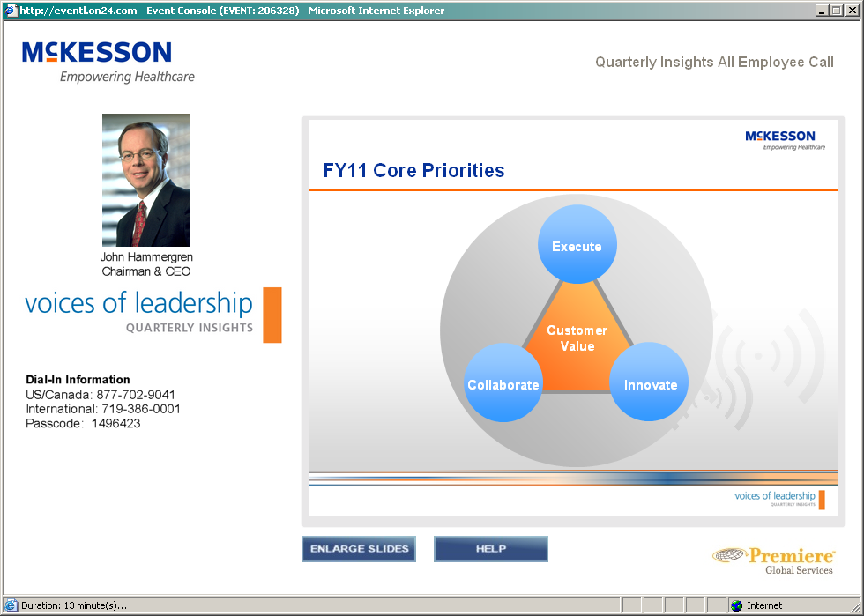

“We MUST deliver more customer value…” he kept pounding home…

Individual segment focus:

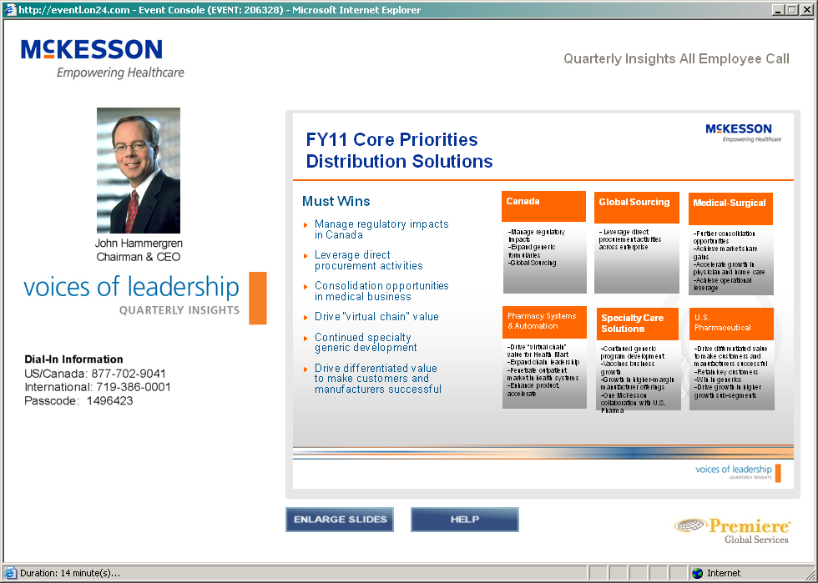

Talking switched to Paul Julian.

Day-to-day execution is important here: right product at right time for right price… this is what opens the door to continued sales of other stuff to a customer…

How can we help the small/independent pharmacies?

We make 10% more from “private brand” business than we do from the “regular?” {don’t totally understand this…}  
something about “generic’s vs others”  
our largest northstar customer is Wal-mart?

Pat blake and MCK-Technology Solutions:

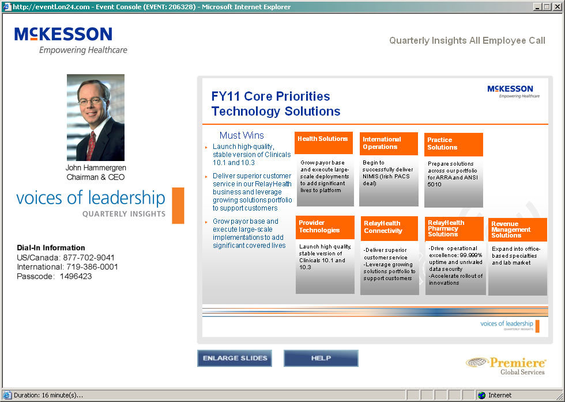

Mpt’s focus: high-quality version of rel 10.3 of our “clinical’s application” (horizon clinical) which is being submitted for “certification” (with a govt panel or something?)  
“meaningful use” has 22,23 requirements associated with it: maybe this is part of the certification; yes: it’s part of the stimulus stuff in USA.

RelayHealth: financial, clinical, etc solns for “health information exchange,” which is a huge part of the “meaningful use” bureaucratese… (sigh.)

Possible big implementations in next several months (after win with HCSC, Humana, Healthnet(?))  
there’s a group of helping customers… goal of “100e+06 lives?” into our systems?

Pharmaceuticals are a part of this conglomerate, somehow(?)  
Healthcare is going to continue to be delivered in non-acute settings: we’re well-positioned for this…  
Just because we sold the Australian business doesn’t mean that we’re shrinking from international business…

RelayHealth is a wholly-owned asset of McKesson, but it’s positioned to connect anybody’s software to anybody else’s(?) But Relay-connected-to-McKesson can be developed to be the better than non-Relay-connected-to-McKesson…