Multi-Modal Transformer Architecture for Integrative Cancer Genomics Analysis
Abstract
The complexity and heterogeneity of cancer genomic data demand ...
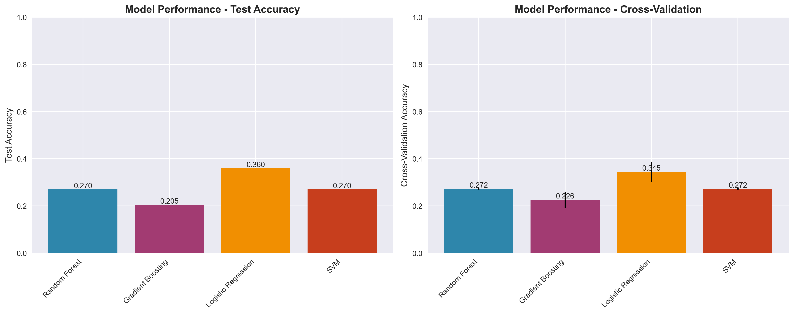
Figure 1: Model Performance Comparison
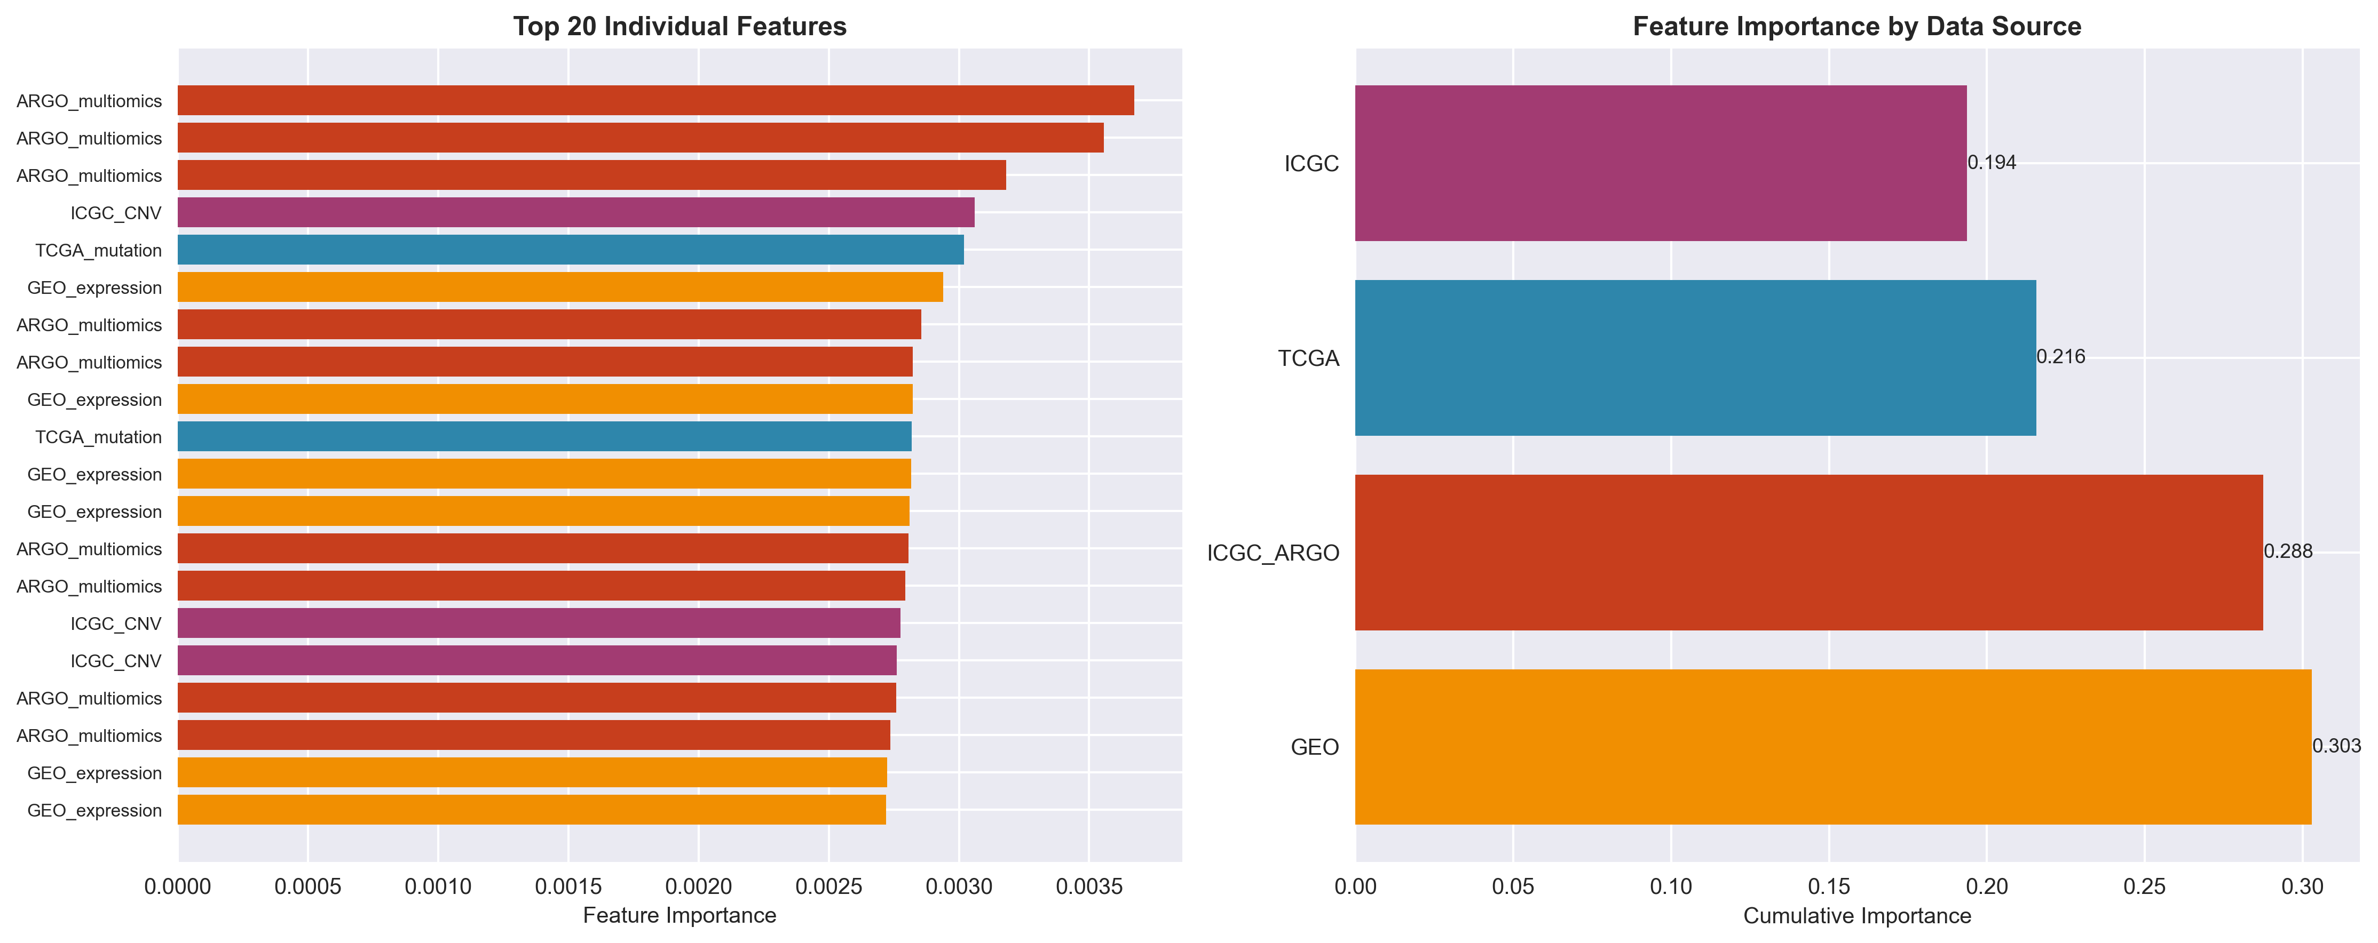
Figure 2: Feature Importance Analysis
Feature | Importance | Notes
Methylation | High | Key regulatory element
Fragmentomics | Medium | DNA integrity marker

References
[1] Author, Title, Journal, Year
[2] Author, Title, Journal, Year
[3] Author, Title, Journal, Year
[4] Author, Title, Journal, Year
[5] Author, Title, Journal, Year
[6] Author, Title, Journal, Year
[7] Author, Title, Journal, Year
[8] Author, Title, Journal, Year
[9] Author, Title, Journal, Year

