Multi-Modal Transformer Architecture for Integrative Cancer Genomics Analysis

**Abstract**The complexity and heterogeneity of cancer genomic data demand ...

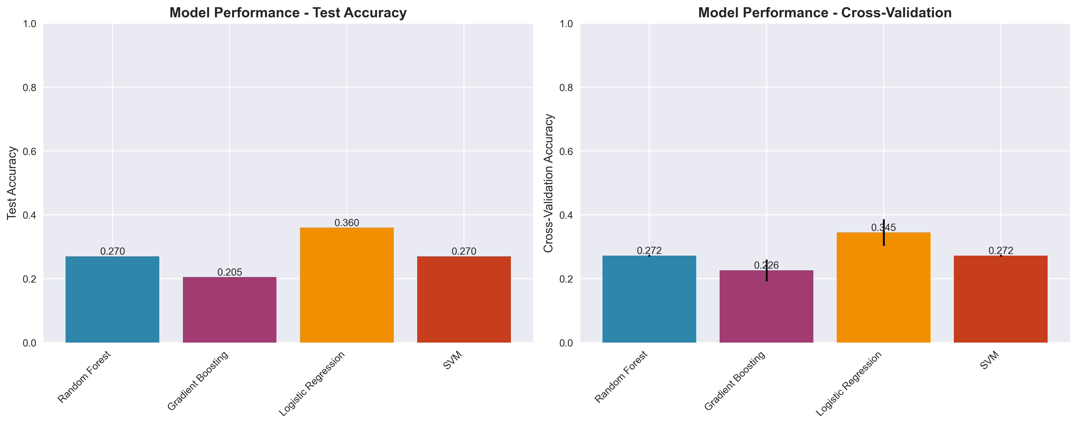

Figure 1: Model Performance Comparison

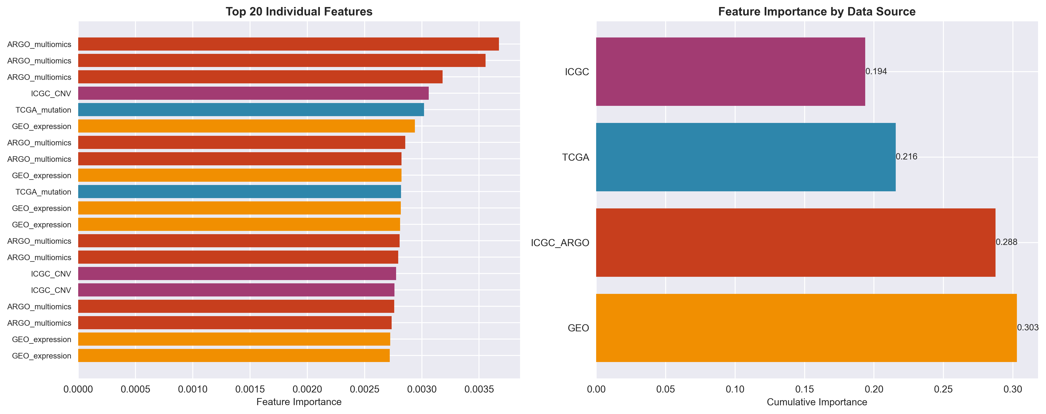

Figure 2: Feature Importance Analysis

|  |  |  |
| --- | --- | --- |
| Feature | Importance | Notes |
| Methylation | High | Key regulatory element |
| Fragmentomics | Medium | DNA integrity marker |

# References

[1] Author, Title, Journal, Year  
[2] Author, Title, Journal, Year  
[3] Author, Title, Journal, Year  
[4] Author, Title, Journal, Year  
[5] Author, Title, Journal, Year  
[6] Author, Title, Journal, Year  
[7] Author, Title, Journal, Year  
[8] Author, Title, Journal, Year  
[9] Author, Title, Journal, Year