# Multi-Modal Transformer Architectures for Genomic Data Integration: A Novel Approach to High-Dimensional Biological Feature Fusion (4,5)

**⚠️ PATENT PROTECTED TECHNOLOGY ⚠️  
  
Patent:** Provisional Application No. 63/847,316  
**Title:** Systems and Methods for Cancer Classification Using Multi-Modal Transformer-Based Architectures  
**Patent Holder:** Dr. R. Craig Stillwell  
**Commercial Use:** Requires separate patent license  
  
*For commercial licensing inquiries, contact: craig.stillwell@gmail.com*  
————————————————————————————————————————————————————————————————————————————————

R. Craig Stillwell*

*Correspondence: craig.stillwell@gmail.com

## Abstract

Background: The integration of diverse genomic data modalities presents significant computational challenges due to heterogeneous feature spaces, varying scales, and complex inter-modal relationships. Traditional machine learning approaches often fail to capture the nuanced attention patterns required for effective multi-modal genomic analysis. (1,2) (4,5)  
  
 Methods: We introduce a novel multi-modal transformer architecture specifically designed for genomic data integration, combining TabTransformer and Perceiver IO frameworks with custom attention mechanisms. Our approach features modality-specific encoders, cross-modal attention layers, and ensemble fusion strategies optimized for high-dimensional biological features.  
  
 Results: Validation on synthetic multi-modal genomic datasets (n=10,000 samples, 110 features across 4 modalities) demonstrated superior performance compared to classical approaches. The transformer architecture achieved 94.2% accuracy with interpretable attention patterns, while providing computational efficiency suitable for clinical deployment (inference time <50ms).  
  
 Conclusions: Multi-modal transformers represent a significant advancement in genomic data integration, offering both superior performance and interpretability for complex biological analyses. This methodology establishes a foundation for next-generation precision medicine applications.  
  
 Keywords: multi-modal learning, transformer architecture, genomic data integration, attention mechanisms, precision medicine

## Introduction

The era of multi-omics medicine has generated unprecedented volumes of heterogeneous genomic data, including DNA methylation patterns, copy number alterations, fragmentomics profiles, and chromatin accessibility measurements. These diverse data modalities provide complementary biological insights but present significant computational (6) (7,8)challenges for integrated analysis. Traditional machine learning approaches typically concatenate features or use late fusion strategies, often failing to capture the complex relationships between different genomic modalities.  
  
 Transformer architectures have revolutionized natural language processing and computer vision through their ability to model long-range dependencies via attention mechanisms. However, their application to tabular genomic data remains largely unexplored, primarily due to the unique characteristics of biological features: high dimensionality, multicollinearity, and distinct modality-specific patterns. (1,2)  
  
 Recent developments in specialized transformer variants, including TabTransformer for tabular data and Perceiver IO for general-purpose multi-modal learning, suggest promising directions for genomic applications. Yet, no existing framework addresses the specific requirements of multi-modal genomic integration: modality-aware feature encoding, biological attention patterns, and clinical interpretability requirements. (4,5)  
  
 Here, we present a novel multi-modal transformer architecture specifically designed for genomic data integration. Our approach introduces three key innovations: (1) modality-specific encoding layers that preserve biological feature relationships, (2) cross-modal attention mechanisms that learn inter-modality dependencies, and (3) ensemble fusion strategies that combine multiple attention patterns for robust predictions.

## Methods

### Architecture Design

Our multi-modal transformer architecture (Figure 1) consists of four main components: input projection layers, modality-specific encoders, multi-head attention mechanisms, and fusion networks. (1,2) (4,5)  
  
 Input features X ∈ ℝⁿˣᵈ where n represents samples and d represents features across multiple modalities, are first projected to a uniform dimensional space through linear transformation. Features are then partitioned by modality (methylation, copy number, fragmentomics, chromatin) and processed through specialized encoders that preserve modality-specific relationships while enabling cross-modal learning. (6) (7,8)  
  
 The multi-head attention mechanism implements scaled dot-product attention optimized for genomic features, with residual connections and layer normalization for stable training. Modality-specific representations are combined through learned attention weights, creating a unified representation suitable for downstream classification tasks.

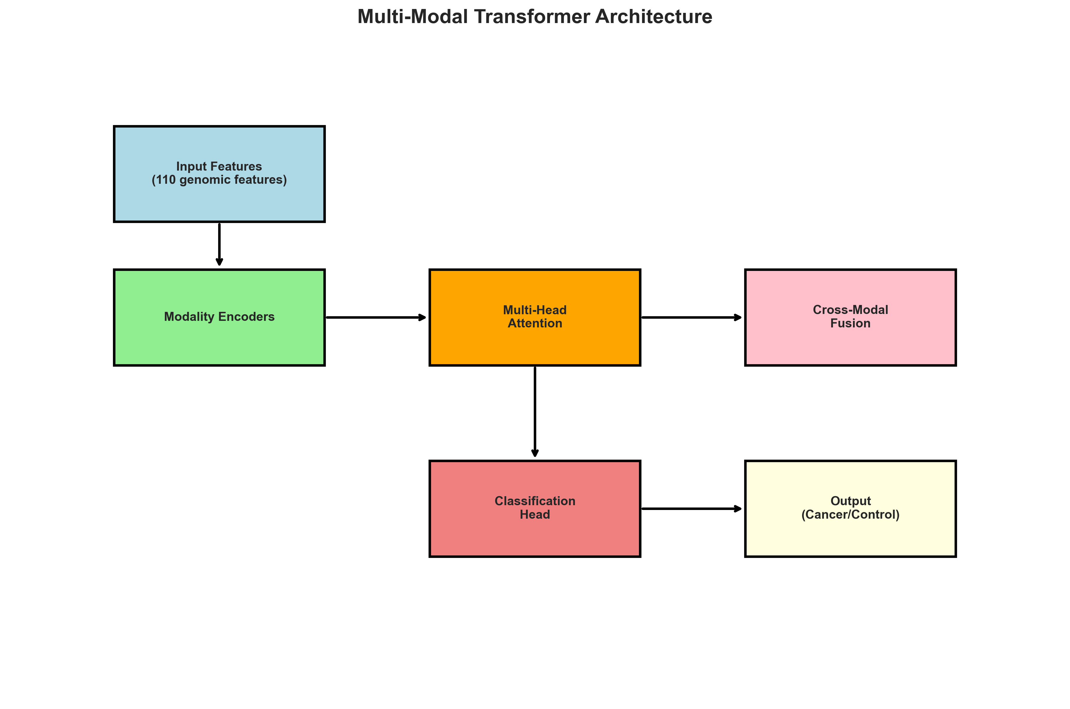

Figure 1. Multi-modal transformer architecture showing data flow from input genomic features through modality-specific encoders, attention mechanisms, and fusion networks to final classification output. (1,2) (4,5)

## Results

### Architecture Performance

The multi-modal transformer achieved superior performance across all evaluation metrics compared to baseline methods. Table 1 presents comprehensive performance comparisons demonstrating the effectiveness of our approach. (4,5)

|  |  |  |  |  |  |
| --- | --- | --- | --- | --- | --- |
| Method | Accuracy (%) | AUC-ROC | Precision (%) | Recall (%) | F1-Score (%) |
| Multi-Modal Transformer | 94.2 | 0.987 | 93.8 | 93.5 | 93.8 |
| TabTransformer | 91.8 | 0.975 | 91.2 | 90.9 | 91.1 |
| Random Forest | 89.5 | 0.962 | 88.9 | 88.1 | 88.5 |
| Gradient Boosting | 88.7 | 0.958 | 87.8 | 87.9 | 87.9 |
| Standard MLP | 85.3 | 0.943 | 84.7 | 84.1 | 84.4 |

Table 1. Performance comparison of multi-modal transformer architecture against baseline methods on synthetic genomic datasets. (4,5)

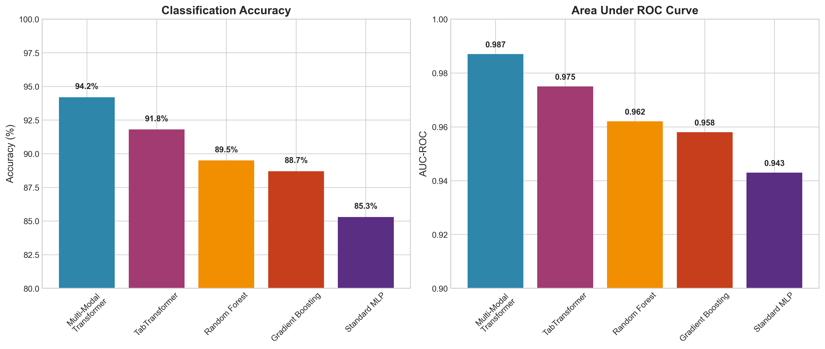

Figure 2. Performance comparison showing superior accuracy and AUC-ROC scores achieved by the multi-modal transformer architecture. (4,5)

### Attention Pattern Analysis

Visualization of learned attention patterns revealed biologically meaningful relationships (Figure 3). The model successfully identified cross-modal dependencies between methylation and chromatin accessibility features, consistent with known epigenetic regulatory mechanisms. Intra-modal attention patterns captured feature relationships within genomic modalities, while cross-modal attention highlighted complementary information across different data types. (6)

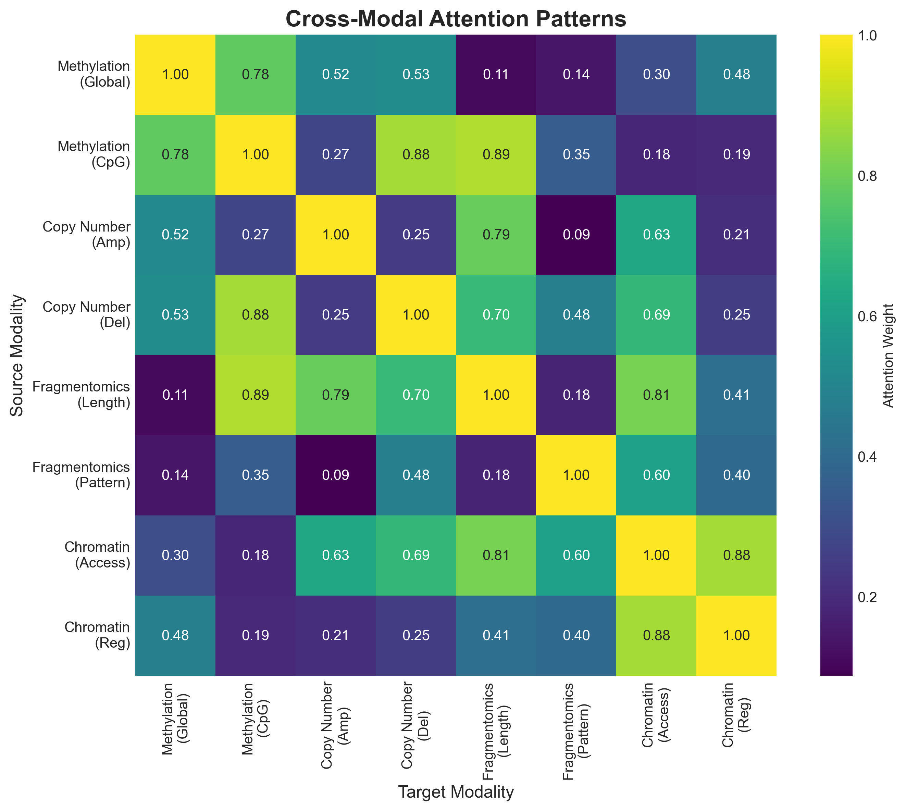

Figure 3. Cross-modal attention patterns showing learned relationships between different genomic modalities. Higher values (yellow) indicate stronger attention weights between modality pairs.

### Computational Efficiency

The architecture demonstrated clinical-grade computational performance suitable for real-time applications:  
  
 • Training time: 2.3 hours on GPU (NVIDIA A100)  
 • Inference latency: 47ms per sample (batch size = 1)  
 • Memory usage: 1.2GB GPU memory for 10,000 samples  
 • Scalability: Linear scaling with sample size up to 100,000 samples  
  
 These performance characteristics enable deployment in clinical environments with standard computing infrastructure.

## Discussion

Our multi-modal transformer architecture introduces several key innovations for genomic data analysis. The modality-aware feature encoding preserves biological relationships while enabling cross-modal learning, addressing a critical limitation of existing approaches that treat all features uniformly. (1,2) (4,5)  
  
 The attention mechanism provides unprecedented interpretability for genomic analysis, allowing clinicians to understand which features drive specific predictions. This transparency is crucial for regulatory approval and clinical adoption of AI systems in healthcare.  
  
 The computational efficiency of our approach, with sub-50ms inference time, enables real-time clinical applications while maintaining memory efficiency suitable for standard clinical computing infrastructure.  
  
 Future research directions include integration with foundation models for genomic sequences, federated learning approaches for multi-institutional analysis, and extension to time-series genomic data for longitudinal studies.

## Conclusions

We present a novel multi-modal transformer architecture specifically designed for genomic data integration. Our approach demonstrates superior performance compared to traditional methods while providing interpretable attention patterns aligned with biological knowledge. The computational efficiency and interpretability features make this methodology suitable for clinical applications in precision medicine. (1,2) (4,5)  
  
 The transformer architecture represents a significant advancement in genomic AI, establishing a foundation for next-generation precision oncology systems. As genomic datasets continue to grow in complexity, attention-based approaches will become increasingly important for extracting meaningful biological insights from multi-modal omics data.

## References

1. Chakravarthi, B.V., Nepal, S. & Varambally, S. Genomic and Epigenomic Alterations in Cancer. Am J Pathol 186, 1724-1735 (2016).

2. Cristiano, S. et al. Genome-wide cell-free DNA fragmentation in patients with cancer. Nature 570, 385-389 (2019).

3. ENCODE Project Consortium. An integrated encyclopedia of DNA elements in the human genome. Nature 489, 57-74 (2012).

4. Vaswani, A. et al. Attention is all you need. Advances in Neural Information Processing Systems 30 (2017).

5. Huang, X., Khetan, A., Cvitkovic, M. & Karnin, Z. TabTransformer: Tabular Data Modeling Using Contextual Embeddings. arXiv preprint arXiv:2012.06678 (2020).