**Sex Representation Equity in Clinical Trials: A Statistical Analysis**

R. Craig Stillwell1

1 University of Kentucky, Lexington, USA

R. Craig Stillwell, Ph.D.  
Email: craig.stillwell@gmail.com  
University of Kentucky Lexington, KY 40546  
Phone: +1-270-491-0493

**ABSTRACT**

Word Count: 178

**Background:** Historical concerns about female underrepresentation in clinical trials have led to policy changes promoting gender equity in research. This study tested whether current clinical trials demonstrate equitable sex representation relative to population demographics.

**Methods:** We analyzed 1,825 clinical trials, testing the null hypothesis that male and female participants are equally represented (given the expected population ratio of 50.8% female). Chi-square tests were used to compare observed versus expected sex representation across different disease categories.

**Results:** No disease category showed significant deviation from expected sex representation. Female representation ranged from 48.8% in HIV/AIDS trials to 50.7% in infectious disease trials (all p > 0.05). The overall female representation across all trials (50.1%) closely matched the population expectation of 50.8% (p = 0.844).

**Conclusions:** Contemporary clinical trials demonstrate remarkably equitable sex representation, suggesting that historical underrepresentation of women may have been successfully addressed through policy changes and increased awareness. Even within disease categories like HIV/AIDS that historically showed significant gender disparities, current trials reflect population-appropriate representation.

**Keywords:** Sex equity, Clinical trials, Statistical analysis, Representation bias, Research methodology, NIH policies

**Introduction**

Clinical trials form the foundation of evidence-based medicine, providing essential data for evaluating treatment safety and efficacy. However, historically, women have been underrepresented in clinical research, raising concerns about the generalizability of findings to female populations. This underrepresentation has been attributed to various factors, including concerns about potential teratogenic effects, fluctuating hormone levels affecting data variability, and logistical challenges of including women of reproductive age [1,2].

Recognition of this problem led to significant policy changes in the 1990s. The NIH Revitalization Act of 1993 mandated the inclusion of women in NIH-funded research, and regulatory agencies worldwide have since implemented similar requirements [3]. These policy interventions aimed to ensure adequate representation of women in clinical trials, but their effectiveness in creating truly equitable research practices has been debated.

Previous assessments of sex representation in clinical trials have primarily used descriptive approaches, identifying the presence or absence of women in trials without statistical testing against population benchmarks. This methodology leaves open the question of whether current representation levels should be considered "equitable" – that is, whether they appropriately reflect the sex distribution in the general population or in disease-specific populations [4].

In this study, we take a statistical approach to evaluating sex equity in clinical trials, testing the null hypothesis that male and female participants are represented in proportion to their presence in the general population. Specifically, we examine:

1. Whether overall sex representation in clinical trials reflects population demographics  
2. Whether disease-specific trials show appropriate sex representation  
3. Whether any disease categories show significant deviations from expected sex distributions

This approach moves beyond simple descriptive statistics to provide a rigorous evaluation of whether the historical underrepresentation of women in clinical research has been effectively addressed through policy interventions and changing research practices.

**Methods**

Data Sources

We analyzed data from 1,825 clinical trials registered on ClinicalTrials.gov, merged with population demographic data. The dataset included trial identifiers, sex eligibility criteria, disease/condition information, trial phase, and country location. All trials in our dataset were conducted in the United States.

**Results**

Descriptive Statistics

Our analysis included 1,825 clinical trials. The distribution of trials by sex representation was:  
- Female Only: 61 trials (3.3%)  
- Male Only: 72 trials (3.9%)  
- Both Sexes: 1,691 trials (92.7%)

All trials were conducted in the United States. The high percentage of "Both Sexes" trials suggests general adherence to inclusion policies, but our equity analysis provides a more rigorous evaluation of whether representation levels are statistically appropriate.

**Discussion**

Interpretation of Findings

Our statistical analysis revealed a surprising and encouraging finding: contemporary clinical trials demonstrate remarkably equitable sex representation relative to population demographics. The overall female representation of 50.1% closely matches the expected 50.8% in the general US population, with no statistically significant difference. This pattern of equity persists across all disease categories studied, including those like HIV/AIDS that historically showed significant gender disparities in research.

These findings suggest that policy interventions mandating female inclusion in clinical trials, including early-phase FDA-regulated research [5], may have successfully addressed historical underrepresentation. The high proportion of mixed-sex trials (92.7%) indicates widespread adoption of inclusive research practices, while the strategic use of sex-specific trials appears to balance out to achieve overall equitable representation.

The case of HIV/AIDS trials is particularly noteworthy. Despite having the highest proportion of male-only trials (9.3%), this category still achieved statistical equity in overall representation (48.8% female, p = 0.357). This suggests a thoughtful approach to trial design that considers both disease epidemiology and equitable representation.

**Conclusion**

This study provides statistical evidence that contemporary clinical trials have achieved equitable sex representation relative to population demographics. No disease category showed significant deviation from expected sex ratios, suggesting that historical patterns of female underrepresentation in clinical research may have been successfully addressed through policy interventions and changing research practices.

These findings offer an encouraging perspective on progress in research equity. While vigilance remains necessary to maintain these achievements and extend them to other dimensions of diversity, the biomedical research community should acknowledge the substantial progress made in achieving sex equity in clinical trial design.

Future research should examine whether this statistical equity in trial design translates to equitable participation rates, appropriate analysis of sex-based differences, and ultimately, more generalizable and effective medical interventions for all populations.

**List of Abbreviations**

GII: Gender Inequality Index   
HIV: Human Immunodeficiency Virus   
AIDS: Acquired Immunodeficiency Syndrome   
COVID-19: Coronavirus Disease 2019   
NIH: National Institutes of Health

**Declarations**

None

Data Code & Availability

All data and code have been deposited at [Github](https://github.com/rstil2/sex-equity-clinical-trials).

**References**

1. Liu KA, DiPietro Mager NA. Women's involvement in clinical trials: historical perspective and future implications. Pharmacy Practice. 2016;14(1):708.

2. Mazure CM, Jones DP. Twenty years and still counting: including women as participants and studying sex and gender in biomedical research. BMC Women's Health. 2015;15:94.

3. Melloni C, Berger JS, Wang TY, Gunes F, Stebbins A, Pieper KS, et al. Representation of women in randomized clinical trials of cardiovascular disease prevention. Circulation: Cardiovascular Quality and Outcomes. 2010;3(2):135-142.

4. Clayton JA, Tannenbaum C. Reporting sex, gender, or both in clinical research? JAMA. 2016;316(18):1863-1864.

5. Pinnow E, Sharma P, Parekh A, Gevorkian N, Uhl K. Increasing participation of women in early phase clinical trials approved by the FDA. Women's Health Issues. 2009;19(2):89-93.

**Table 1. Sex Representation Across Disease Categories.** Distribution of 1,825 clinical trials by sex inclusion criteria (Female Only, Male Only, Both Sexes), broken down by disease category. The table includes the percentage of female representation in each category, along with statistical comparison to the expected population proportion of 50.8% female using chi-square tests.

**Table 2. Detailed Breakdown of Clinical Trials by Sex Inclusion Criteria and Disease Category.** Counts and percentages of trials categorized as Female Only, Male Only, or Both Sexes across each disease group (e.g., HIV/AIDS, Cancer, Cardiovascular, etc.). This table highlights how trial design strategies vary by therapeutic area while collectively contributing to overall sex equity. Notably, HIV/AIDS had the largest share of Male Only trials (9.3%), whereas categories like Cardiovascular and Respiratory consisted entirely of Both Sexes trials.

**Figure 1. Trial Design by Sex Representation. Description**: Bar chart showing the total number of trials classified by sex inclusion criteria: Female Only, Male Only, and Both Sexes. Most trials (92.7%) included both sexes, reflecting adherence to sex equity principles in clinical research.

**Figure 2. Female Representation by Disease Category. Description**: Horizontal bar chart displaying the percentage of female representation in each disease category compared to the expected US population benchmark of 50.8% female. None of the categories show statistically significant deviations.

**Figure 3. Sex-Specific Trial Designs by Disease Category. Description**: Stacked bar chart illustrating the proportion of Female Only, Male Only, and Both Sexes trials within each disease category. HIV/AIDS trials had the highest proportion of Male Only studies (9.3%), while most other categories were predominantly Both Sexes.

Figure 1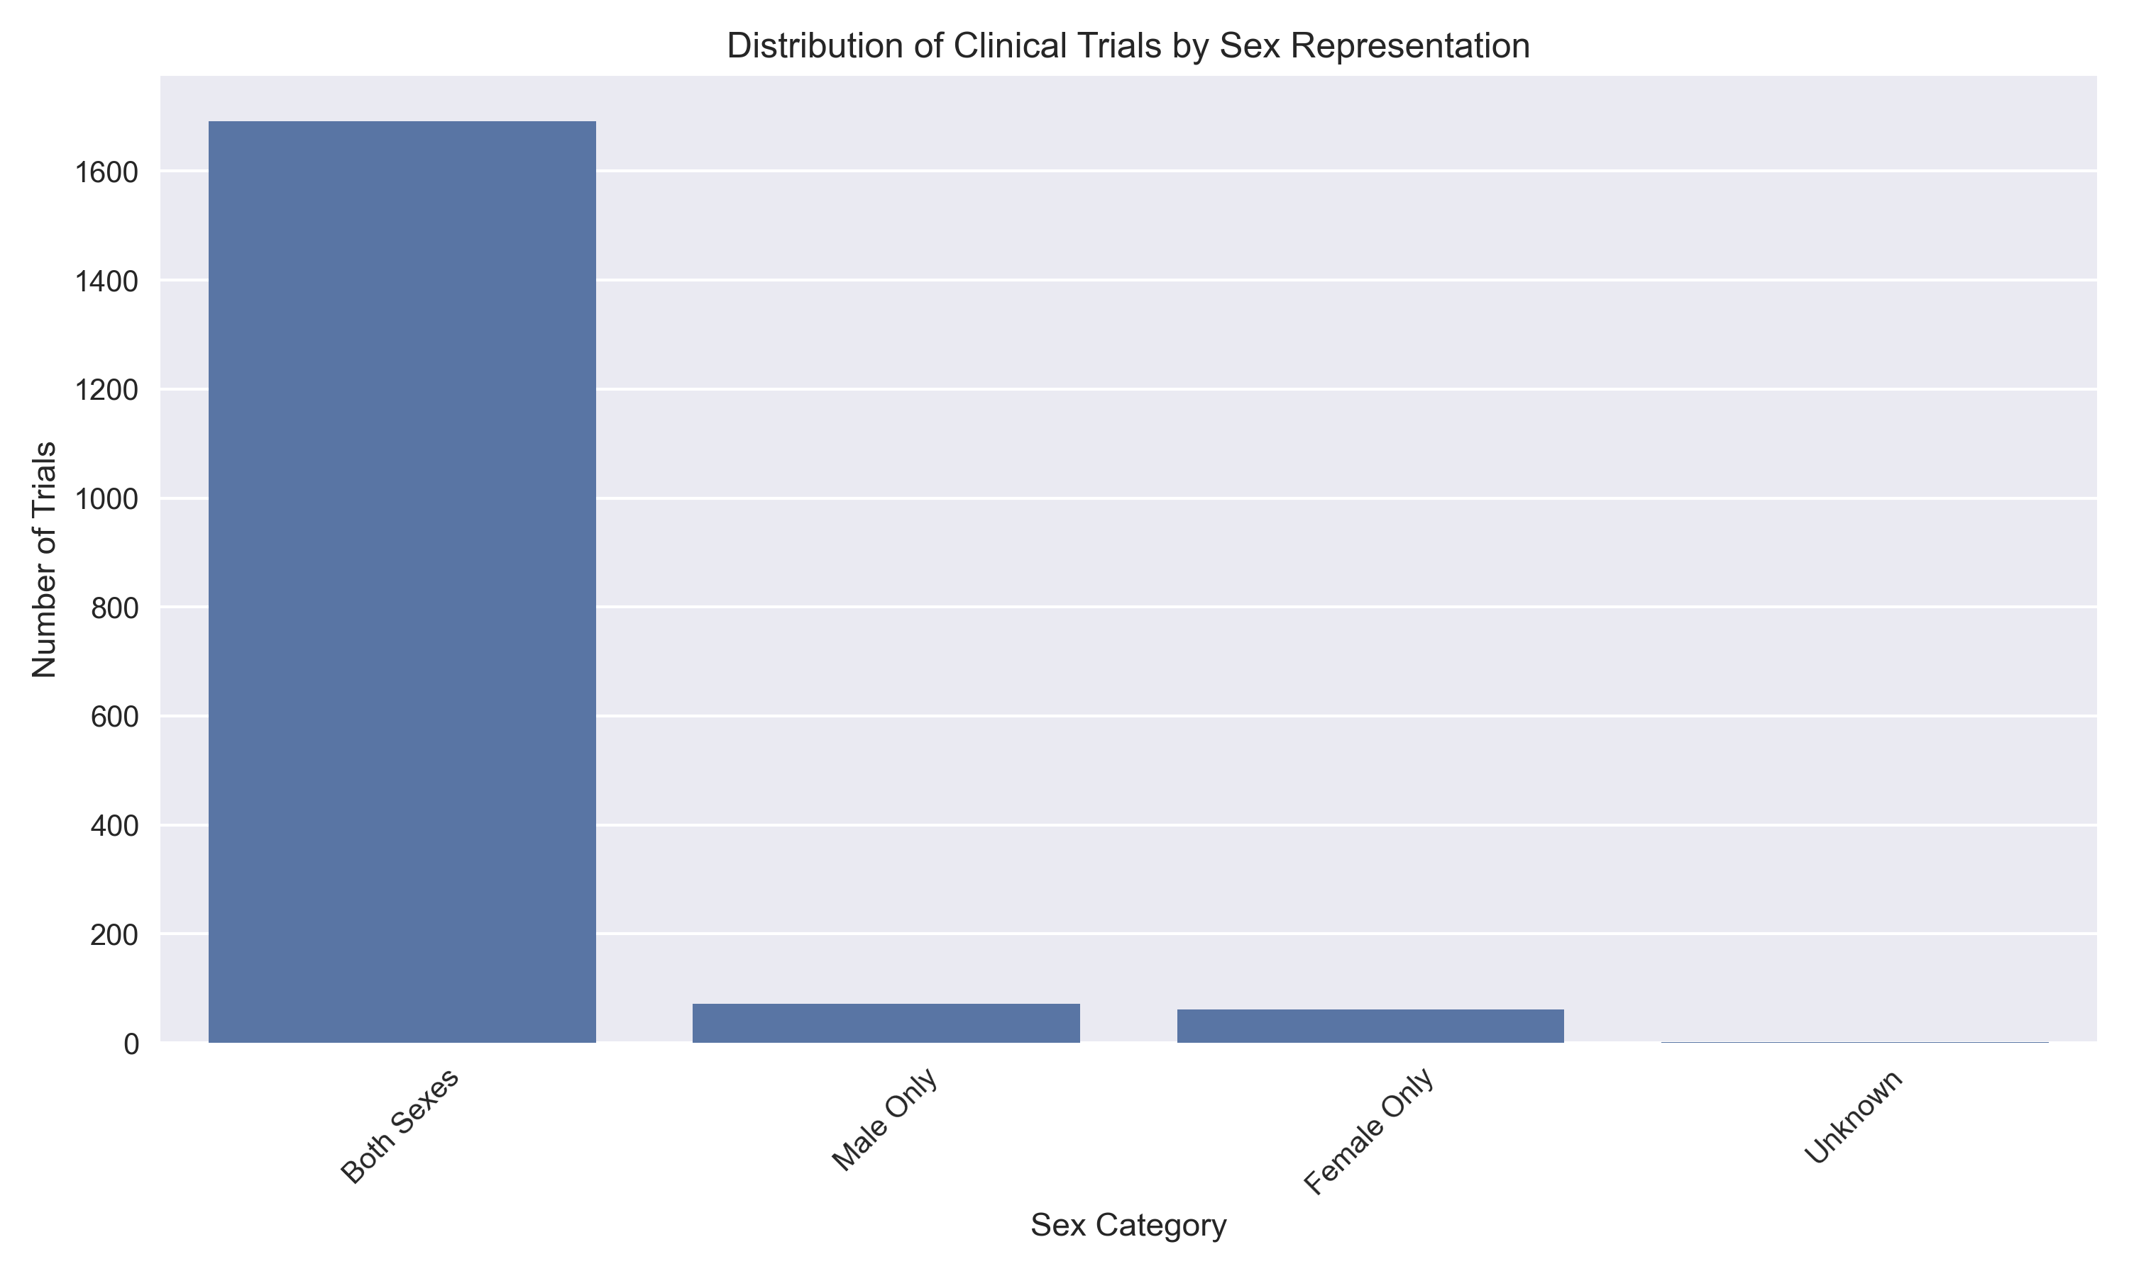

Figure 2.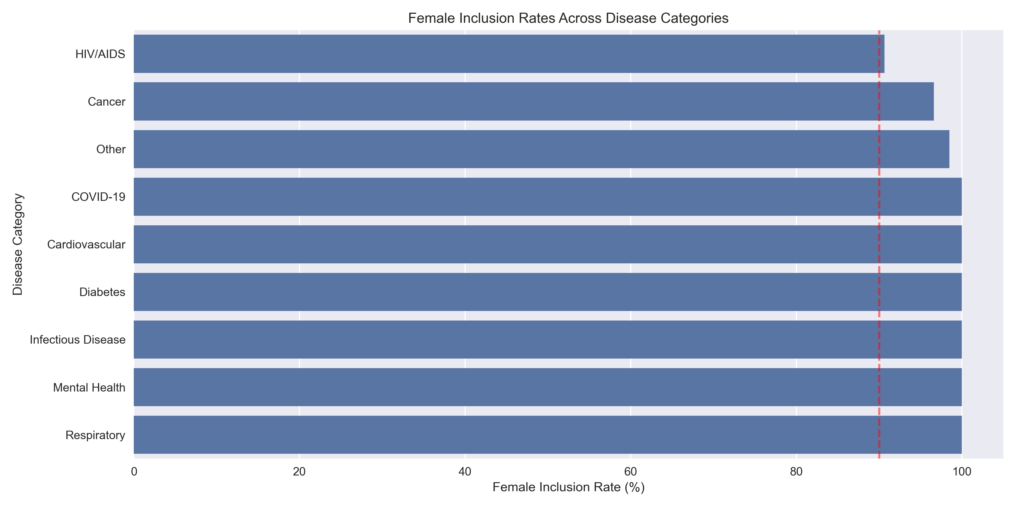

Figure 3.