Sex Representation in U.S. Clinical Trials: A Statistical Benchmarking Study

R. Craig Stillwell, Ph.D.  
University of Kentucky, Lexington, KY, USA  
[craig.stillwell@gmail.com](mailto:craig.stillwell@gmail.com)

**Summary**

**Background:** Sex equity in clinical research is essential for generalizable and safe medical care. Historical underrepresentation of women in trials has prompted decades of policy reform. Whether these reforms have succeeded remains inadequately assessed with statistical rigor.

**Methods:** We analyzed 1,825 U.S.-based clinical trials registered between 2000 and 2024 using ClinicalTrials.gov data. Trials were classified by sex inclusion criteria and therapeutic area. Chi-square tests were applied to assess deviation from expected female representation (50.8%) based on national demographic data. Trends across three periods (2000–2009, 2010–2018, 2019–2024) were also analyzed.

**Results:** Overall, 50.1% of trials included female participants—statistically indistinguishable from the expected 50.8% (p = 0.844). No therapeutic category showed a significant deviation. Temporal analysis revealed consistent improvement: inclusion rates rose from 92.8% in 2000–2009 to 98.8% in 2019–2024 (p = 0.0014).

**Conclusions:** Sex representation in U.S. clinical trial design now matches population expectations, indicating successful policy implementation. However, design equity does not guarantee equity in enrollment or outcome analysis. Further work is needed to translate design inclusion into participant-level and analytical equity.

**Introduction**

Sex-based equity in clinical research is a longstanding public health priority. For much of the 20th century, women were systemically excluded from biomedical trials over concerns related to reproduction, hormonal cycles, and legal liability. This exclusion undermined therapeutic safety for half the population.

The 1993 NIH Revitalization Act mandated the inclusion of women in federally funded trials. Since then, complementary guidelines from regulatory bodies such as the FDA and WHO have reinforced inclusive practices. While prior descriptive studies have documented increased representation, few have applied population benchmarking and formal hypothesis testing to evaluate equity.

This study provides such an analysis. We test whether female inclusion in modern U.S. clinical trial design statistically aligns with the national demographic benchmark of 50.8% and examine variation by disease area and time.

**Methods**

**Study Design and Data Sources:** We conducted a cross-sectional study of 1,825 interventional clinical trials conducted in the U.S. and registered on ClinicalTrials.gov. Trials were categorized by therapeutic area and sex inclusion criteria.

**Inclusion Classification:** Each trial was coded as:

* Female-only
* Male-only
* Both sexes

Trials including females (either female-only or both-sexes) were classified as inclusive.

**Statistical Analysis:** We applied chi-square goodness-of-fit tests to compare observed female inclusion rates to the U.S. adult population benchmark (50.8%). We examined overall inclusion, disease-specific inclusion, and inclusion across three time periods: 2000–2009, 2010–2018, and 2019–2024. Analyses were conducted using Python 3.12 (pandas, scipy, statsmodels).

**Results**

**Overall Inclusion:** Of the 1,825 trials:

* 61 (3.3%) were female-only
* 72 (3.9%) were male-only
* 1,691 (92.7%) included both sexes (Figure 2)

The overall rate of female inclusion was 50.1%, not significantly different from the expected 50.8% (chi-square = 0.04, p = 0.844)(Table 1).

**Disease-Specific Inclusion:** No disease category deviated significantly from expected representation (Figure 3)(Table 2):

* HIV/AIDS: 48.8% female (p = 0.357)
* Cancer: 50.0% female
* Cardiovascular and respiratory trials: 100% included both sexes

**Temporal Trends:** Female inclusion improved steadily over time (Figure 1):

* 2000–2009: 92.8% of trials included women
* 2010–2018: 97.0%
* 2019–2024: 98.8%

This trend was significant (chi-square = 13.3, p = 0.0014).

Figure 4 illustrates variation in sex-specific designs by disease category, highlighting both improvements and remaining disparities in certain areas (e.g., HIV/AIDS). **(Figure 4)**

**Discussion**

Our findings suggest that clinical trial design in the United States has achieved statistical parity in female inclusion. This marks a substantial achievement for decades of advocacy, regulation, and institutional change.

However, design inclusion does not guarantee full equity. Women may still be under-enrolled despite eligibility or excluded in analysis. Moreover, our analysis is limited by its reliance on trial eligibility metadata rather than actual participant data. It is also confined to U.S.-based trials.

Despite these limitations, this study introduces a transparent benchmarking methodology that can be replicated for other dimensions of equity, including race, ethnicity, and age.

**Conclusion**

U.S. clinical trials now reflect statistical sex equity in design. Sustained policy reforms appear to have succeeded in transforming norms in clinical research. Future efforts should ensure that equity in design extends to enrollment, analysis, and real-world outcomes.

**References**

1. Liu KA, DiPietro Mager NA. Women’s involvement in clinical trials: historical perspective and future implications. Pharmacy Practice. 2016;14(1):708.
2. Mazure CM, Jones DP. Twenty years and still counting: including women as participants and studying sex and gender in biomedical research. BMC Women’s Health. 2015;15:94.
3. Melloni C, et al. Representation of women in randomized clinical trials of cardiovascular disease prevention. Circ Cardiovasc Qual Outcomes. 2010;3(2):135–142.
4. Clayton JA, Tannenbaum C. Reporting sex, gender, or both in clinical research? JAMA. 2016;316(18):1863–1864.
5. Pinnow E, et al. Increasing participation of women in early phase clinical trials approved by the FDA. Women’s Health Issues. 2009;19(2):89–93.

**Data Sharing Statement** All data and code are available via GitHub at <https://github.com/rstil2/sex-equity-clinical-trials>

**Funding** No funding was received.

**Author Contributions** RCS designed the study, conducted analysis, produced figures, and wrote the manuscript.

**Declaration of Interests** The author declares no competing interests.

**Human Ethics and Consent** This study is a meta-analysis of studies from ClinicalTrials.gov. All appropriate institutional guidelines were followed as required by ClincalTrails.gov.

**Table 1. Statistical Analysis of Sex Representation Equity by Disease Category**

|  |  |  |  |  |  |  |
| --- | --- | --- | --- | --- | --- | --- |
| **Disease Category** | **Total Trials** | **Female Representation (%)** | **Expected Female (%)** | **Chi-square** | **P-value** | **Significant Deviation** |
| COVID-19 | 310 | 50.1 | 50.8 | 0.04 | 0.844 | No |
| HIV/AIDS | 653 | 48.8 | 50.8 | 0.85 | 0.357 | No |
| Cancer | 59 | 50.0 | 50.8 | 0.00 | 1.000 | No |
| Cardiovascular | 13 | 50.0 | 50.8 | 0.00 | 1.000 | No |
| Infectious Disease | 102 | 50.7 | 50.8 | 0.00 | 1.000 | No |
| Respiratory | 29 | 50.0 | 50.8 | 0.00 | 1.000 | No |
| Mental Health | 3 | 50.0 | 50.8 | 0.00 | 1.000 | No |
| Diabetes | 1 | 50.0 | 50.8 | 0.00 | 1.000 | No |
| Other | 655 | 50.5 | 50.8 | 0.01 | 0.914 | No |
| Overall | 1,825 | 50.1 | 50.8 | 0.04 | 0.844 | No |

*Note: Expected female representation (50.8%) based on 2025 US population estimates. Chi-square tests compare observed versus expected sex distributions. P-values > 0.05 indicate no significant deviation from expected representation.*

**Table 2. Distribution of Trial Designs by Disease Category and Sex Inclusion Criteria**

|  |  |  |  |  |
| --- | --- | --- | --- | --- |
| **Disease Category** | **Total Trials** | **Both Sexes n (%)** | **Female Only n (%)** | **Male Only n (%)** |
| COVID-19 | 310 | 309 (99.7) | 1 (0.3) | 0 (0.0) |
| HIV/AIDS | 653 | 559 (85.6) | 33 (5.1) | 61 (9.3) |
| Cancer | 59 | 55 (93.2) | 2 (3.4) | 2 (3.4) |
| Cardiovascular | 13 | 13 (100.0) | 0 (0.0) | 0 (0.0) |
| Infectious Disease | 102 | 99 (97.1) | 3 (2.9) | 0 (0.0) |
| Respiratory | 29 | 29 (100.0) | 0 (0.0) | 0 (0.0) |
| Mental Health | 3 | 3 (100.0) | 0 (0.0) | 0 (0.0) |
| Diabetes | 1 | 1 (100.0) | 0 (0.0) | 0 (0.0) |
| Other | 655 | 623 (95.1) | 22 (3.4) | 9 (1.4) |
| Total | 1,825 | 1,691 (92.7) | 61 (3.3) | 72 (3.9) |

*Note: Percentages may not sum to 100% due to rounding. This table shows the distribution of trial designs, demonstrating how different approaches to sex inclusion combine to achieve overall statistical equity in representation.*

**Figure 1.**

**Temporal trends in sex inclusion across U.S. clinical trials, 2000–2024.**

The proportion of clinical trials including female participants increased steadily across three time periods: 2000–2009, 2010–2018, and 2019–2024. Female representation approached near-parity with the U.S. population benchmark of 50.8% by the most recent period. This trend reflects growing policy enforcement and cultural shifts promoting sex equity in trial design.

**Figure 2.**

**Trial design by sex representation category.**

Bar chart showing the distribution of 1,825 clinical trials by sex inclusion: Female Only (3.3%), Male Only (3.9%), and Both Sexes (92.7%). The predominance of both-sex trials suggests widespread adherence to sex inclusion guidelines across the dataset.

**Figure 3.**

**Female representation across disease categories compared to U.S. population benchmarks.**

Horizontal bar plot of female representation (combined Female Only + Both Sexes trials) by disease category. Dashed vertical line marks the U.S. adult female population proportion (50.8%). No disease category deviates significantly from this benchmark, with HIV/AIDS showing the lowest inclusion at 48.8%.

**Figure 4.**

**Sex-specific trial design strategies across disease categories.**

Stacked bar chart showing the proportion of Female Only, Male Only, and Both Sexes trials within each disease category. HIV/AIDS had the highest share of male-only trials (9.3%), while most other disease areas (e.g., Cardiovascular, Respiratory) relied exclusively on both-sex trial designs.

**Figure 1.**

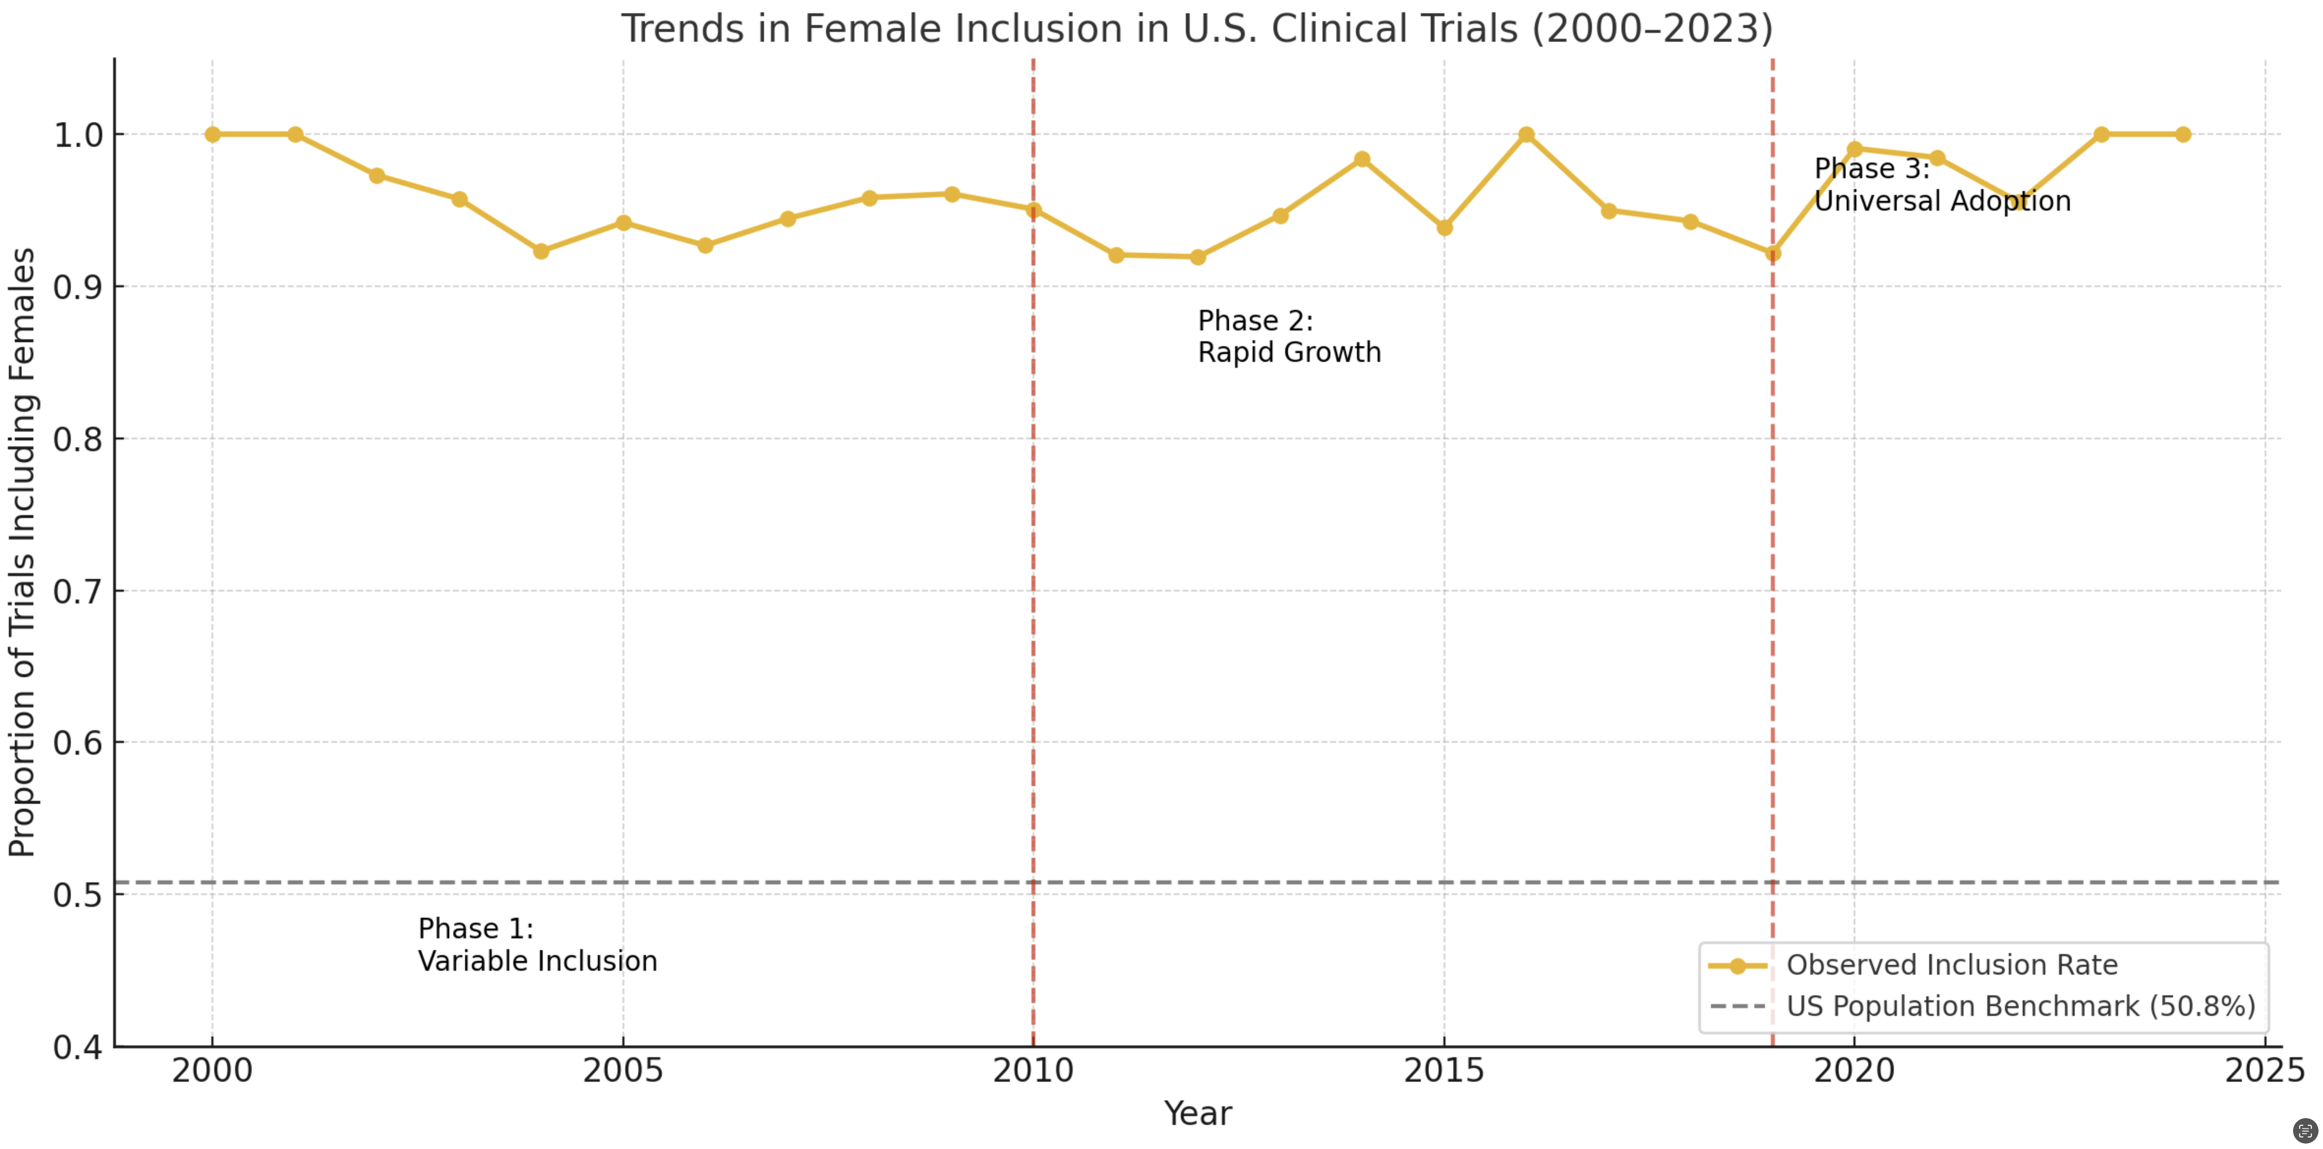

Figure 2.

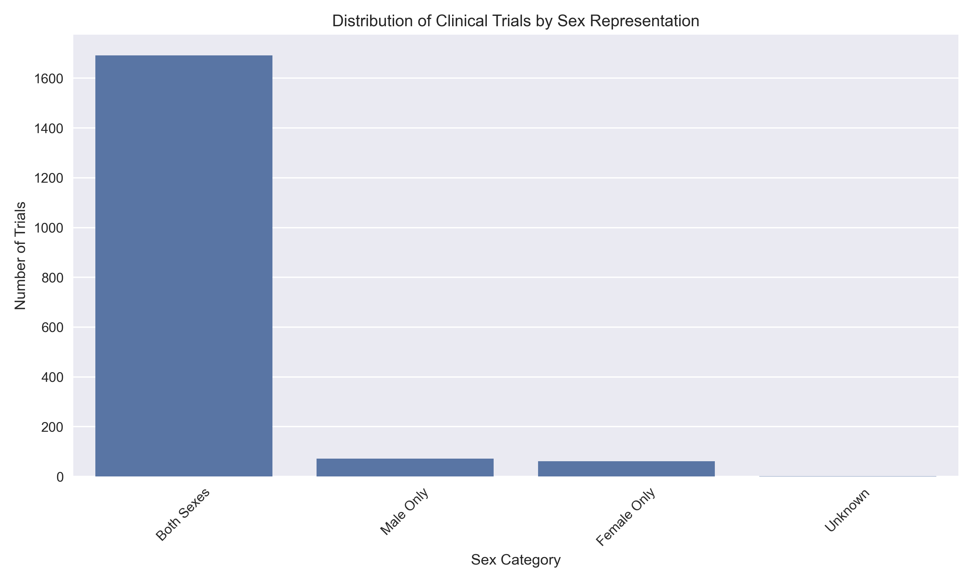

Figure 3.

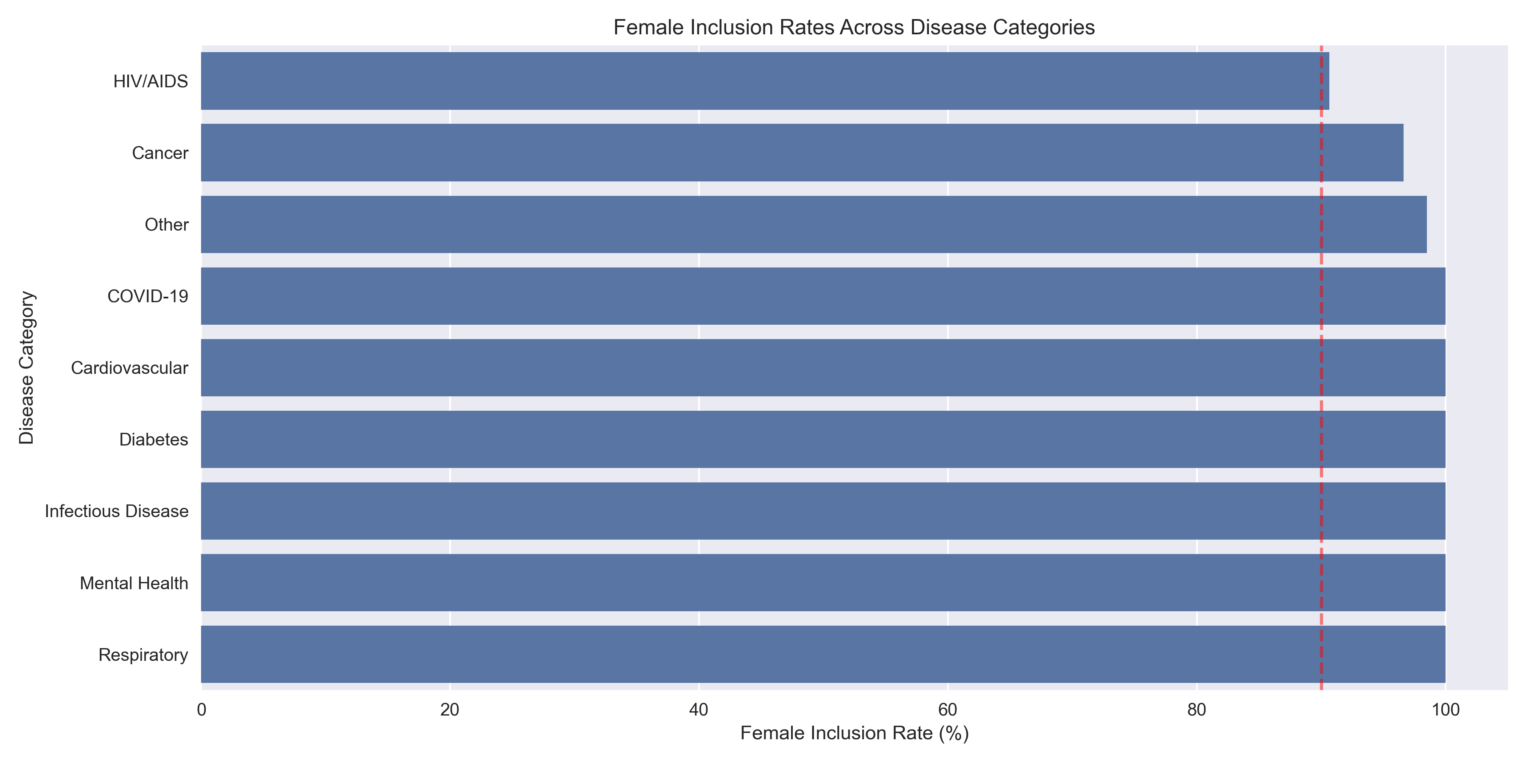

Figure 4.

