March Machine Learning Mania 2026
Training Data Plan — Feature Table Spec, Data Scope Options, and a Look at Top Solutions

1. How the Training File Gets Built
The model never trains on the 35 raw competition CSVs directly. One new table gets built from them — one row per matchup — and that table is the only thing the model ever sees. The raw files get combined in three stages:
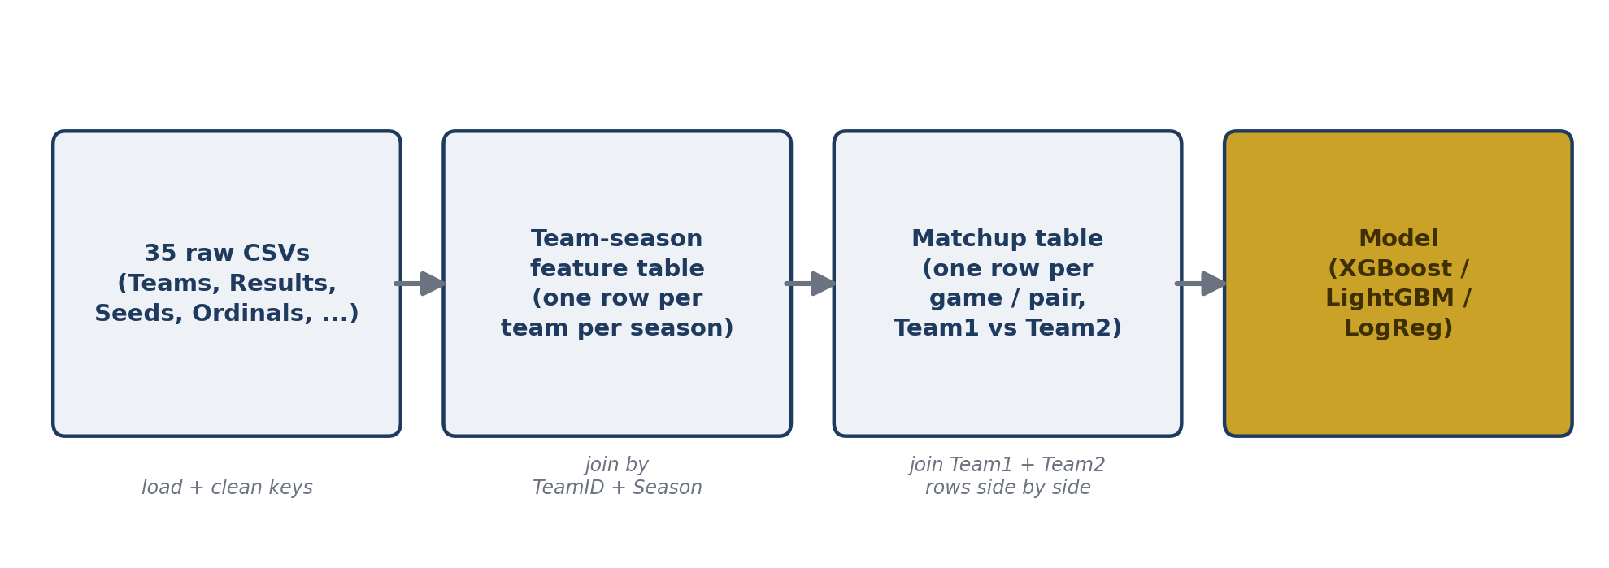
Figure 1 — Raw tables to trained model
Stage 1 — Team-season features: for every team, in every season, compute season-level stats (win rate, scoring margin, box-score efficiency, seed, power ranking) using only games/information available before that season's tournament started.
Stage 2 — Matchup join: for every game being trained on (or predicted), look up both teams' season-level stats and place them side by side in one row, oriented Team1 (lower TeamID) vs. Team2 (higher TeamID) to match the submission format.
Stage 3 — Model input: that matchup table — a few thousand to a few hundred thousand rows depending on scope (see Section 3) — is what XGBoost/LightGBM/Logistic Regression actually trains on.

2. The Training File — Column by Column
Every row = one matchup (Team1 = lower TeamID, Team2 = higher TeamID, matching the competition's own ID convention). Below is every proposed column, grouped by category, with the raw source table and how it's calculated. Most per-team stats appear three times in the actual file — Team1's value, Team2's value, and the difference — the table below describes the underlying stat once.
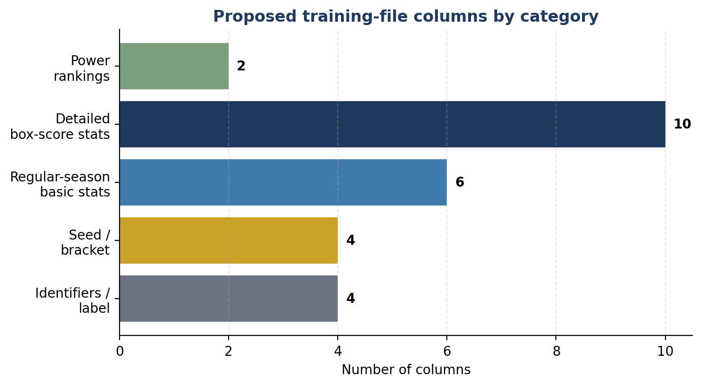
Figure 2 — Proposed column count by category (26 base columns, before Team1/Team2/Diff expansion)

2.1 Identifiers & label
Column | Description | Source table(s) | How it's computed
Season | Season year (e.g. 2026) | All tables | Direct copy
Team1_ID | Lower TeamID in the pair | {M,W}Teams | Matches submission ID convention
Team2_ID | Higher TeamID in the pair | {M,W}Teams | Matches submission ID convention
Label | 1 if Team1 won, 0 if Team2 won | {M,W}NCAATourneyCompactResults | Historical rows only — compare WTeamID/LTeamID to Team1/Team2. Not present for 2026 prediction rows (no 2026 results in the data — see EDA notes).

2.2 Seed & bracket
Column | Description | Source table(s) | How it's computed
SeedNum | Numeric seed, 1–16 | {M,W}NCAATourneySeeds | Parse the digits out of the seed string, e.g. “W01” → 1, “Z16a” → 16
SeedDiff | Team2 seed − Team1 seed | derived | Positive = Team1 is the better (lower) seed
Region | Bracket region letter (W/X/Y/Z) | {M,W}NCAATourneySeeds | First character of the seed string
IsPlayIn | Whether the team came from a First Four play-in game | {M,W}NCAATourneySeeds | Seed string ends in ‘a’ or ‘b’

2.3 Regular-season basic stats (per team, per season)
Column | Description | Source table(s) | How it's computed
WinPct | Wins ÷ games played | {M,W}RegularSeasonCompactResults | Count wins/losses per TeamID + Season
GamesPlayed | Total regular-season games | same | Row count per TeamID + Season
AvgPointsFor | Points scored per game | same | Mean of WScore/LScore depending on win/loss
AvgPointsAgainst | Points allowed per game | same | Mean of opponent's score
AvgScoreMargin | Points for − points against, per game | same | AvgPointsFor − AvgPointsAgainst
StrengthOfSchedule | Average win % of opponents faced | same, self-joined | Two-pass: compute each team's WinPct, then average it across everyone a given team played

2.4 Detailed box-score stats (men's from 2003, women's from 2010 only)
Column | Description | Source table(s) | How it's computed
FGPct | Field goal % | {M,W}RegularSeasonDetailedResults | sum(FGM)/sum(FGA) per team-season
FG3Pct | Three-point % | same | sum(FGM3)/sum(FGA3)
FTPct | Free-throw % | same | sum(FTM)/sum(FTA)
ReboundRate | Rebounds per game (off. + def.) | same | mean(OR + DR)
AssistRate | Assists per game | same | mean(Ast)
TurnoverRate | Turnovers per game | same | mean(TO)
StealRate | Steals per game | same | mean(Stl)
BlockRate | Blocks per game | same | mean(Blk)
OffEfficiency | Estimated points per 100 possessions (offense) | same | Points ÷ estimated possessions, scaled ×100 (possessions estimated from FGA/TO/FTA/OR)
DefEfficiency | Estimated points allowed per 100 possessions (defense) | same | Same formula, opponent side

Note: these columns are unavailable pre-2003 (men) / pre-2010 (women), per the EDA. Rows for earlier seasons either drop these columns or fall back to the basic stats above.

2.5 Power rankings (men's only — no women's equivalent file in this dataset)
Column | Description | Source table(s) | How it's computed
OrdinalRank | Team's power-ranking position as of right before Selection Sunday | MMasseyOrdinals | Filter to the latest RankingDayNum available each season (up to day 133), average across systems or use one consistent system (e.g. POM)
OrdinalRankDiff | Team2 rank − Team1 rank | derived | Positive = Team1 is ranked better (lower number = better)

2.6 Example row (illustrative, not real values)
Season | Team1_ID | Team2_ID | SeedDiff | WinPct (1 vs 2) | OrdinalRankDiff | Label
2024 | 1181 | 1120 | +8 | 0.82 vs 0.61 | +45 | 1

3. What Does the Model Train On?
Separate question from the columns above: which rows go in the file. The raw data provides two very different pools of labeled games to choose from.
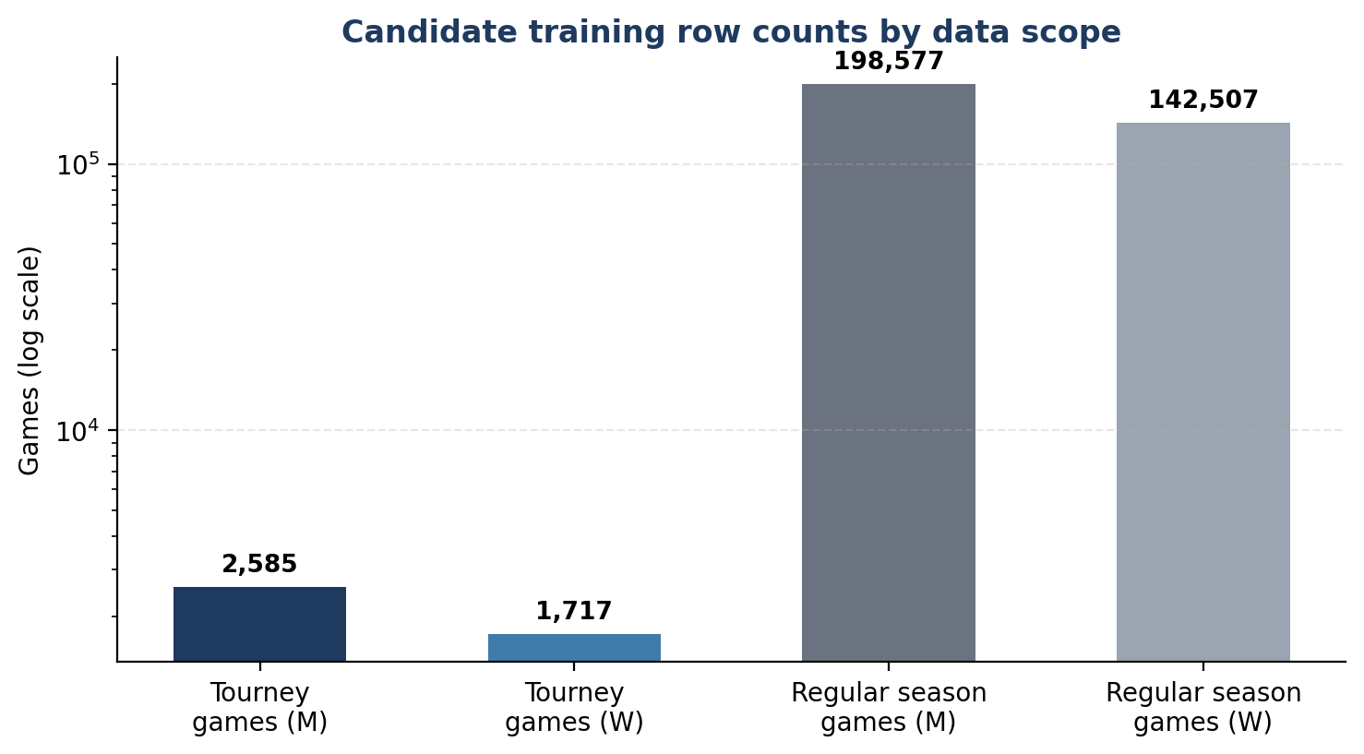
Figure 3 — Row counts per option, confirmed from the EDA (log scale)

Option A — Tournament games only
~4,302 rows (2,585 men's + 1,717 women's), spanning 1985–2025 (men) / 1998–2025 (women), excluding the cancelled 2020 tournament.
Pros: exact distributional match to the prediction target — single-elimination, neutral site, tournament-caliber teams only.
Cons: small sample; only 24 (men) / 17 (women) seasons have detailed box-score stats to draw features from.

Option B — Regular season games only
~341,000 rows (198,577 men's + 142,507 women's).
Pros: huge sample, statistically robust.
Cons: systematically different context — home-court advantage exists, mismatched/blowout games are common, non-tournament teams are included. No researched top-3 solution trained its classifier directly on this pool.

Option C — Hybrid: regular season builds the features, tournament games are the only labels (Recommended)
~4,302 labeled rows, but every row's features are computed from up to 341,000 regular-season games plus seeds and rankings.
Pros: matches what every researched top finisher actually did — regular season data is used to compute team-strength features, but the classifier is trained and validated only on tournament games, keeping the label distribution aligned with the real task.
Cons: still only ~4,302 labeled rows, so model complexity has to stay in check (regularization, simpler models, or many cross-validation folds rather than one split).

Option D — Two-stage pretrain/fine-tune (later-week stretch goal)
Pretrain a model on regular-season games, then fine-tune or blend with a tournament-only model. No researched top-3 solution did this explicitly, though the various “quality/rating” features several of them engineered are a lighter-weight version of the same idea. Worth trying in Phase 5 (iteration) once Option C is working.

Recommendation
Option C is the strongest starting point: train and validate only on historical tournament games, with features built from regular-season data. This part is well-supported — every researched top finisher trained its classifier on tournament-level matchups, not raw regular-season rows.

How much history to include — an open question, not a settled one
How many years of regular-season history should feed into that training set is a separate question, and the researched sources do not agree on it. The simple starter baseline used only the 3 most recent seasons to compute team strength. The most methodologically disciplined solution found (the 249th-place public repo) explicitly flagged “a lot of season-to-season drift” in college basketball — team quality, play style, and even which feature families are useful can shift meaningfully from one year to the next — which argues against assuming that more history is automatically better.
There is a real tension here: with only ~4,302 tournament games available as training rows, more seasons of history means more rows to train on, but older seasons may reflect a different game (rule changes, pace of play, the women's field expanding from 64 to 68 teams in 2022) that does not transfer cleanly to 2026. Rather than assume an answer either way, this is exactly what the walk-forward validation harness (Phase 2 of the project plan) is built to test directly: train the same model on a few different history windows — e.g. last 5 seasons, last 15 seasons, full history back to 2003 (when detailed stats start) — and check which one actually validates best on the most recent held-out seasons. Full history is the right default to start from, since it adds rows without baking in an assumption, but the final window length should be picked by what validates best, not by default.

4. What Did the Best Submissions Actually Do?
Kaggle writeup pages for this competition are JavaScript-rendered and weren't directly readable in this environment, so the 1st/2nd/3rd place details below come from a detailed public technical postmortem (a Kaggle Grandmaster's open-source repo that read and compared itself against the official 1st/2nd/3rd place writeups) plus one solution's own public summary. Treat the exact architecture claims for 1st place as secondhand until the source writeup is read directly — worth a follow-up for full confidence.
Result | Core model | Training data scope | Notable technique | Validation
1st place | Minimalist model, men/women modeled separately | Tournament-focused | Seed differential + custom rating differential + quality wins + one women's stat; manual injury deductions; hand-tuned reranking; aggressive global isotonic calibration | Not disclosed in sources found
2nd place | 60/40 blend: XGBoost + Logistic Regression | Pooled men+women tournament games | Compact seed/Elo/Massey/efficiency features; predictions clipped to [0.02, 0.98]; LogReg alone beat XGBoost alone | Random 10-fold CV
3rd place | Separate men's / women's Logistic Regression | Tournament-focused + heavy external data | BartTorvik, KenPom-style preseason, AP Poll, coach history, women's NET, ESPN BPI; final predictions blended with live market odds (men's Round 1 weighted 90% to market) | Leave-one-season-out CV (0.1235 Brier)
Silver medal | XGBoost on point differentials | Not specified | BartTorvik features; spline calibration | Not specified
Public repo, 249th (beat 92%) | Routed blend of LightGBM margin models | Tournament-focused, bracket-aware features | Box-score deltas, bracket geometry (round/region/Final Four side), multiple “quality” rating views, block-rate features, late prediction-market overlay | Strict walk-forward: train on prior seasons only, validate on last 5 seasons, required improving ≥4 of 5 folds
Simple starter baseline | Logistic regression on team-strength difference | 3 most recent seasons, regular season + tourney combined | Win % and point differential only | None (baseline)

Key takeaways
• Every researched solution trained its classifier on tournament-level matchups, not raw regular-season rows — directly supports Option C above.
• Seed and rating/ranking differentials are the strongest, most consistent signal across every solution, from 1st place down to the simple baseline — make sure these are rock-solid before adding anything fancier.
• Simplicity often won: 2nd place's plain Logistic Regression beat XGBoost standalone; 2026 was a “chalky” (favorite-heavy) year that rewarded conservative, well-calibrated probabilities over complex ensembles.
• External/market data (Vegas, Kalshi, BartTorvik, KenPom) gave real edges to 1st and 3rd place. Out of scope for this week's Kaggle-data-only pass, but a natural extension to consider later.
• Calibration — turning a raw model score into a well-behaved probability, via isotonic regression or splines — shows up repeatedly. Worth budgeting explicit time for in Phase 6 rather than treating it as an afterthought.
• The most methodologically rigorous public writeup found used exactly the walk-forward validation approach already in the plan — good confirmation of alignment with best practice, not just an assumption.

