PHASE 3
Project Design
AI WeatherWise API | AI-Augmented Backend Development
Project Name | AI WeatherWise API
Technology Track | AI-Augmented Backend Development
Team Members | Suji R; Sonika Sree A; Swapna M; Vidya N
Phase | 3
Maximum Marks | 10 Marks

1. Proposed Solution
AI WeatherWise API is designed as a headless REST backend. A client such as Postman sends HTTP requests to an Express.js server. Authentication requests are handled by authentication controllers and middleware. Weather requests are routed to the weather service. AI requests are handled by the AI service, with Google Gemini integration where configured and local/fallback logic available. MongoDB stores application data through Mongoose.

2. Architecture
Layer | Components | Responsibility
Client / Interface | Postman or any REST client | Sends HTTP requests and receives JSON responses.
API / Application | Node.js + Express.js | Routes requests, parses JSON, applies middleware and returns responses.
Authentication | JWT + bcryptjs | Authenticates users, hashes passwords and protects routes.
Controller Layer | Auth, Location, Weather, AI controllers | Coordinates request/response processing.
Service Layer | weatherService.js, aiService.js | Encapsulates external weather and AI logic.
Data Layer | Mongoose + MongoDB Atlas | Persists users and favorite locations.
External Services | OpenWeather; Google Gemini | Weather information and AI-generated insights.

3. Logical Data Model
Entity | Important Fields | Relationship
User | _id, name, email, password, role | One user can be associated with multiple saved locations.
Location | _id, user, city, country, createdAt | References the owning user.

4. API Design
Method | Endpoint | Purpose | Auth
POST | /api/auth/register | Create user account | Public
POST | /api/auth/login | Authenticate user | Public
GET | /api/auth/profile | Read authenticated profile | Bearer JWT
POST | /api/locations | Create saved location | Bearer JWT
GET | /api/locations | List saved locations | Bearer JWT
PUT | /api/locations/:id | Update saved location | Bearer JWT
DELETE | /api/locations/:id | Delete saved location | Bearer JWT
GET | /api/weather/:city | Get current weather | Project route
POST | /api/ai/weather-summary | Generate weather summary | Bearer JWT in supplied collection
POST | /api/ai/weather-recommendation | Generate recommendation | Bearer JWT in supplied collection

5. Security Design
- JWT-based authentication for protected endpoints.
- bcrypt/bcryptjs password hashing rather than storing plain passwords.
- Environment variables for database/API secrets.
- .gitignore used to keep local environment secrets out of version control.
- Bearer-token authorization for protected API operations.

6. Design Evidence
The supplied project structure contains config, models, middleware, routes, services, controllers, app.js and server.js. The supplied VS Code screenshot shows aiService.js and the running backend. The SmartBridge design templates call for a solution architecture, requirements, technology stack and external-interface/data-storage identification; this document consolidates those items for WeatherWise.

Actual Project Screenshot Evidence
The following screenshots were supplied from the actual AI WeatherWise API execution environment. They are included as evidence for this phase and are not mock/generated test results.

Evidence 1 — Backend Architecture / AI Service
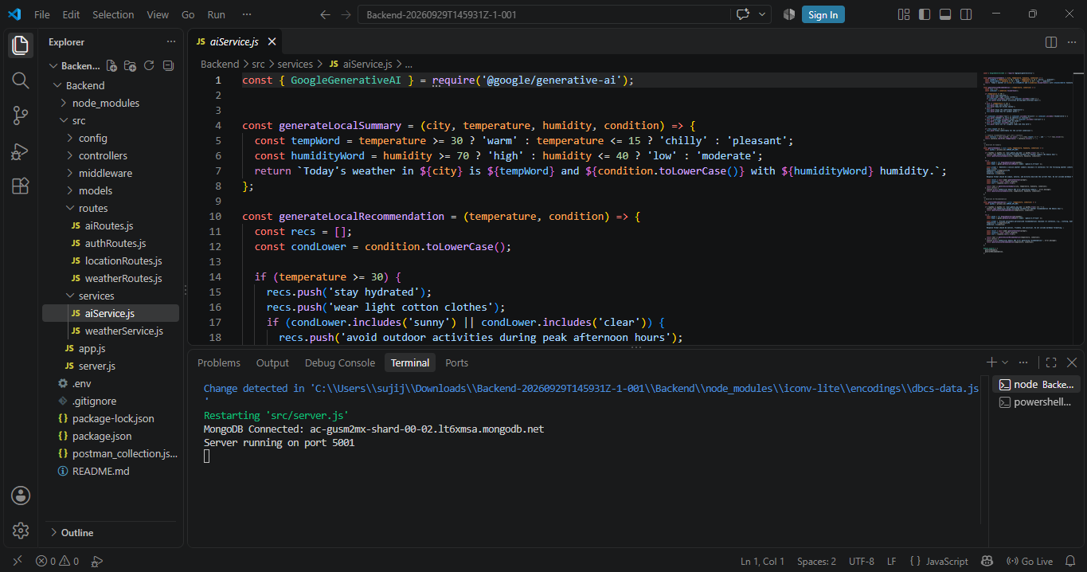
VS Code screenshot showing the WeatherWise source structure, aiService.js, routes/services and the running server with MongoDB connected on port 5001.

