PHASE 5
Project Development
AI WeatherWise API | AI-Augmented Backend Development
Project Name | AI WeatherWise API
Technology Track | AI-Augmented Backend Development
Team Members | Suji R; Sonika Sree A; Swapna M; Vidya N
Phase | 5
Maximum Marks | Implementation Evidence

1. Development Overview
AI WeatherWise API is implemented as a Node.js/Express backend with MongoDB/Mongoose persistence, JWT authentication, bcrypt password hashing, weather-service integration and AI-assisted weather insight generation.

2. Project Structure
Path / Component | Purpose
src/server.js | Starts the server and connects the application to the configured port/database flow.
src/app.js | Express application setup and route integration.
src/config/db.js | MongoDB connection configuration.
src/models/User.js | User data schema/model.
src/models/Location.js | Favorite location schema/model.
src/middleware/authMiddleware.js | JWT authentication middleware.
src/controllers/ | Request-handling logic for application features.
src/routes/authRoutes.js | Authentication endpoints.
src/routes/locationRoutes.js | Location CRUD endpoints.
src/routes/weatherRoutes.js | Weather endpoint.
src/routes/aiRoutes.js | AI summary/recommendation endpoints.
src/services/weatherService.js | Weather integration/fallback logic.
src/services/aiService.js | AI summary/recommendation logic.

3. Technology Stack
Technology | Use
Node.js | Backend runtime
Express.js | REST API framework
MongoDB Atlas | Cloud NoSQL database
Mongoose | MongoDB ODM
JWT / jsonwebtoken | Authentication tokens
bcryptjs | Password hashing
Google Gemini SDK | AI generation/integration
OpenWeather | Weather data service
Postman | API testing
Visual Studio Code | Development environment

4. Implemented API Flow
- User registers → account is stored in MongoDB → JWT token is returned.
- User logs in → credentials are checked → JWT is returned.
- Authenticated client sends weather request → backend returns weather JSON.
- Authenticated client sends AI summary request → AI/local service returns a readable summary.
- Authenticated client sends recommendation request → service returns practical weather guidance.
- User/location data is persisted in MongoDB through Mongoose.

5. Actual Execution Evidence Supplied
Evidence | Observed Result
VS Code terminal | MongoDB Connected; Server running on port 5001.
Postman — Register | HTTP 201 Created; success=true.
Postman — Login | HTTP 200 OK; success=true.
Postman — Weather Chennai | HTTP 200 OK; weather JSON returned; screenshot shows isMock=true.
Postman — AI Summary | HTTP 200 OK; summary returned.
Postman — AI Recommendation | HTTP 200 OK; recommendation returned.
MongoDB Atlas | WeatherAI users collection displays stored user documents.

6. Development Security Note
The local .env file contains sensitive credentials and should not be included in a public repository. Use .env.example for documentation and rotate exposed credentials if they have been shared outside the intended environment.

Actual Project Screenshot Evidence
The following screenshots were supplied from the actual AI WeatherWise API execution environment. They are included as evidence for this phase and are not mock/generated test results.

Evidence 1 — Running Backend and MongoDB Connection
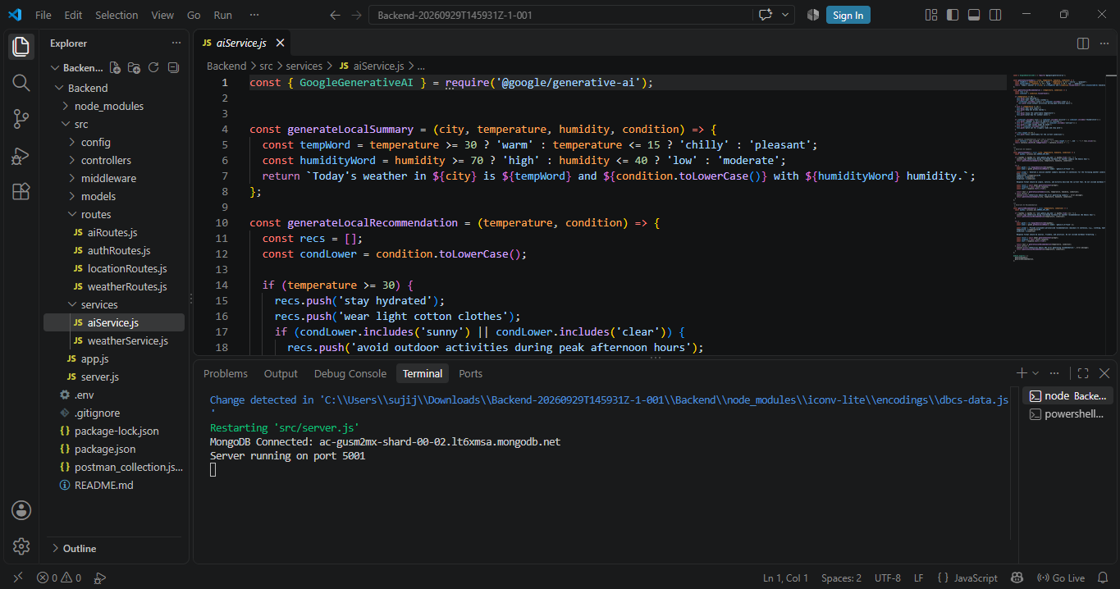
VS Code terminal shows MongoDB Connected and Server running on port 5001.

Evidence 2 — User Registration
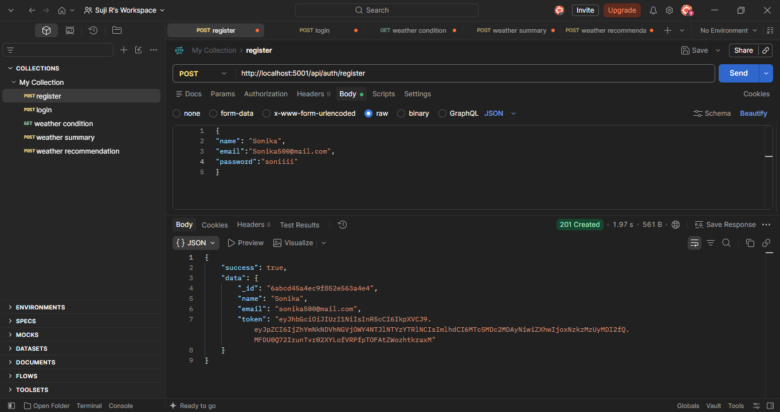
Postman registration request returns HTTP 201 Created with success=true.

Evidence 3 — User Login
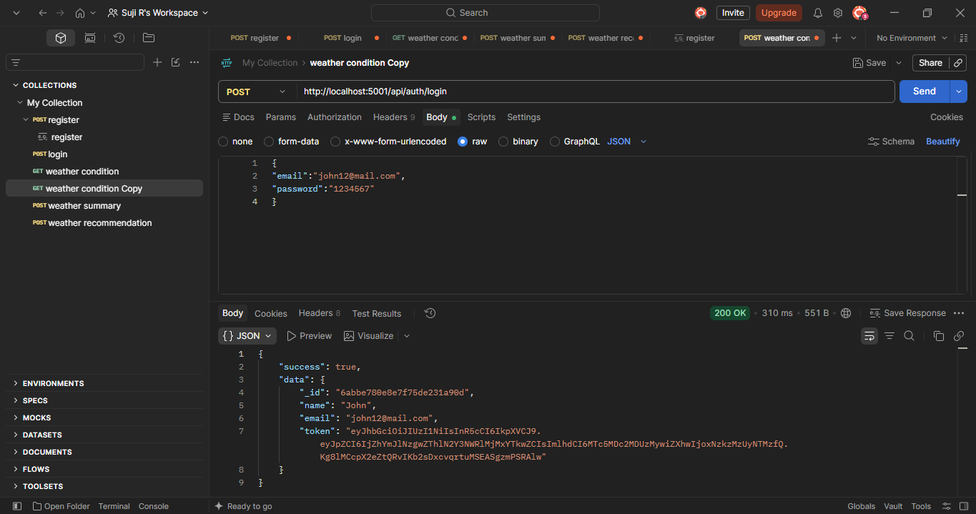
Postman login request returns HTTP 200 OK with success=true and authentication token.

Evidence 4 — Weather API
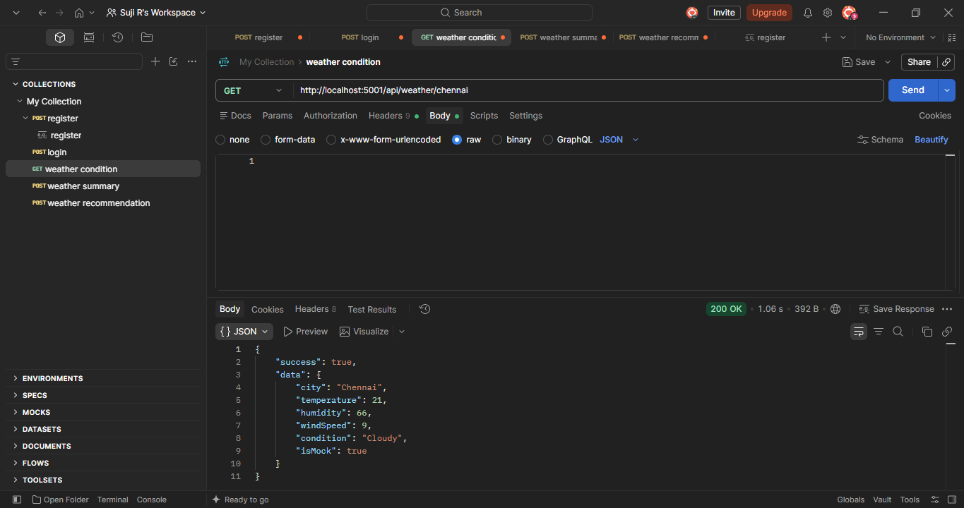
Postman weather request for Chennai returns HTTP 200 OK with temperature, humidity, wind speed and condition.

Evidence 5 — AI Weather Summary
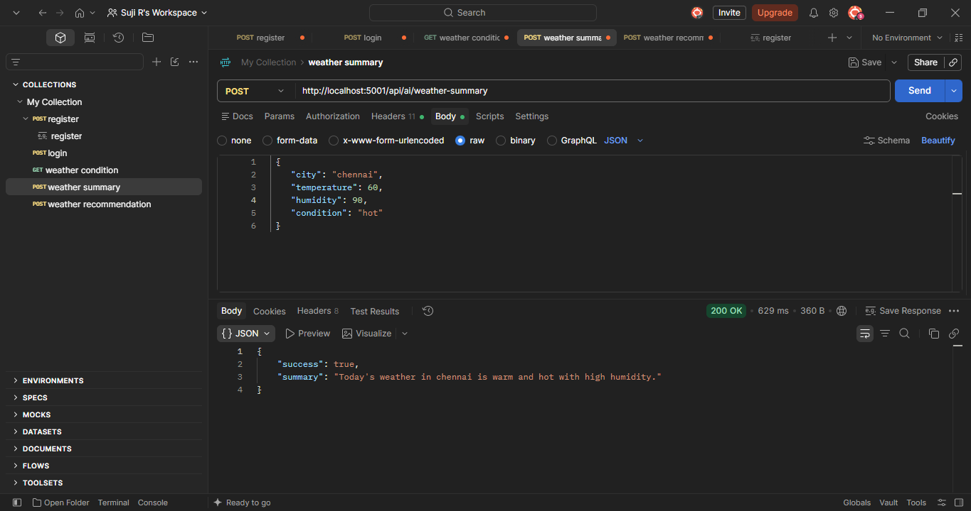
Postman weather-summary request returns HTTP 200 OK and a generated summary.

Evidence 6 — AI Weather Recommendation
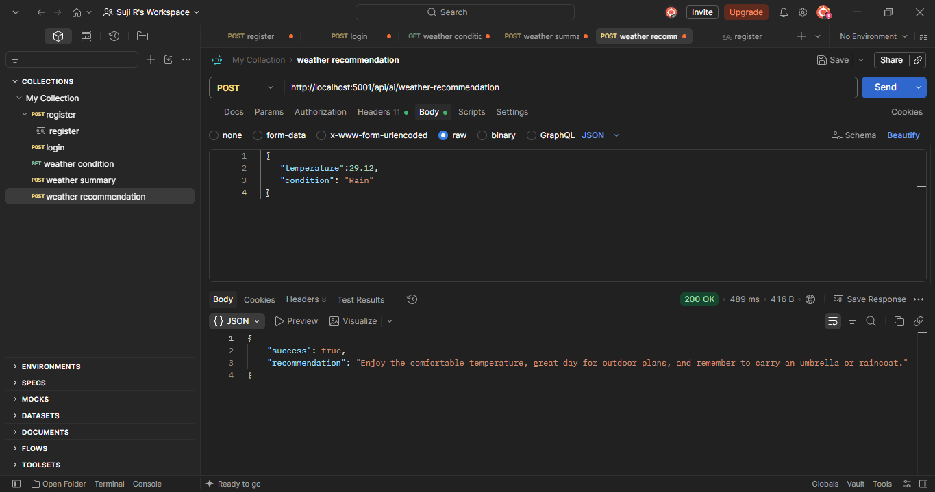
Postman weather-recommendation request returns HTTP 200 OK and a recommendation.

Evidence 7 — MongoDB Persistence
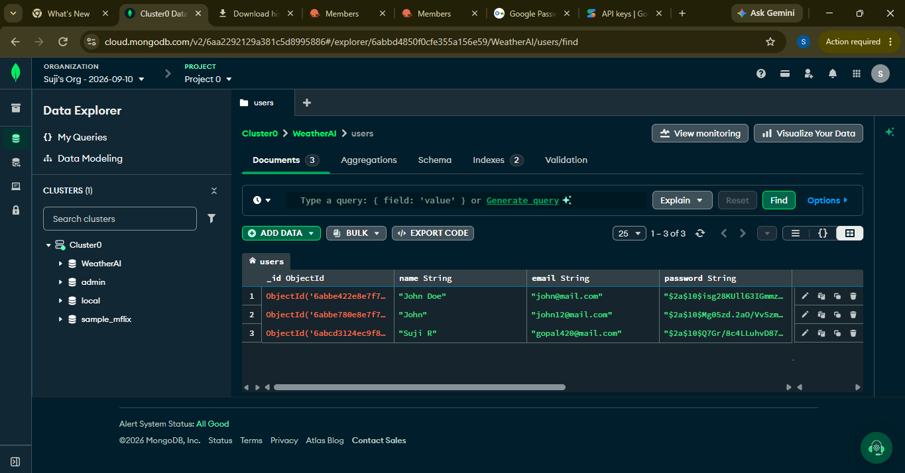
MongoDB Atlas Data Explorer shows stored user documents in the WeatherAI users collection.

