PHASE 6
Project Testing
AI WeatherWise API | AI-Augmented Backend Development
Project Name | AI WeatherWise API
Technology Track | AI-Augmented Backend Development
Team Members | Suji R; Sonika Sree A; Swapna M; Vidya N
Phase | 6
Maximum Marks | UAT + API Testing

1. Testing Strategy
Testing uses Postman for REST API execution, MongoDB Atlas Data Explorer for persistence verification, and VS Code terminal output for server/database connectivity. The supplied UAT template requires positive and negative scenarios, expected and actual results, bug tracking and sign-off.

2. Positive Test Results
TC ID | Scenario | Expected | Actual Evidence | Status
TC-001 | Registration | 201 + user created | Postman screenshot: 201 Created, success=true. | PASS
TC-002 | Login | 200 + JWT | Postman screenshot: 200 OK, success=true. | PASS
TC-003 | Weather | 200 + weather data | Chennai response includes temperature, humidity, wind speed, condition. | PASS
TC-004 | AI Summary | 200 + summary | Summary response returned successfully. | PASS
TC-005 | AI Recommendation | 200 + recommendation | Recommendation response returned successfully. | PASS
TC-006 | MongoDB Persistence | User stored | WeatherAI/users collection shows stored documents. | PASS
TC-007 | Server + DB connectivity | Server and DB connected | Terminal shows MongoDB Connected and port 5001. | PASS

3. Negative Test Plan
Test ID | Scenario | Expected Result | Evidence Status
NT-001 | Duplicate registration | Reject duplicate account appropriately. | Not evidenced
NT-002 | Wrong login password | Reject authentication and do not issue a valid JWT. | Not evidenced
NT-003 | Invalid city | Return controlled error/fallback response. | Not evidenced
NT-004 | Missing AI request field | Validate request and return controlled error. | Not evidenced
NT-005 | No/invalid JWT on protected route | Deny unauthorized request. | Not evidenced

4. Defect Tracking
No failed execution or reproducible defect was shown in the supplied screenshots. This is not a claim that the system has no defects; it records only the evidence supplied.

5. Test Environment
- Local API base URL: http://localhost:5001
- Postman for API calls
- MongoDB Atlas WeatherAI database
- Visual Studio Code terminal
- Do not place passwords, API keys or JWT tokens in submitted screenshots/documents.

6. Testing Conclusion
The supplied evidence demonstrates successful execution of the principal positive API flows and database connectivity. Final UAT should include the listed negative cases and completed sign-off before deployment/submission.

Actual Project Screenshot Evidence
The following screenshots were supplied from the actual AI WeatherWise API execution environment. They are included as evidence for this phase and are not mock/generated test results.

Test Evidence 1 — Registration
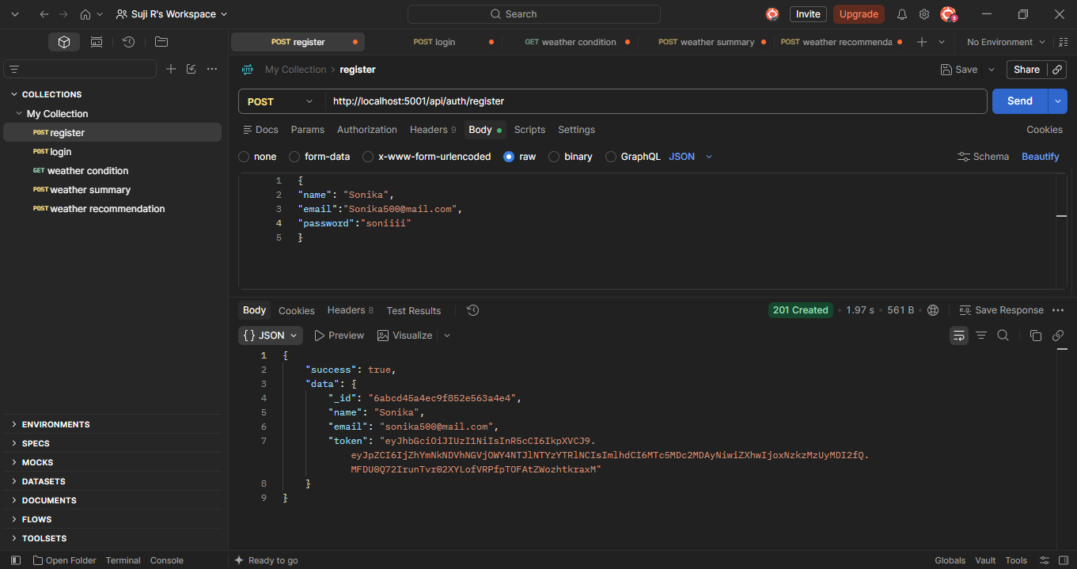
HTTP 201 Created; registration succeeded.

Test Evidence 2 — Login
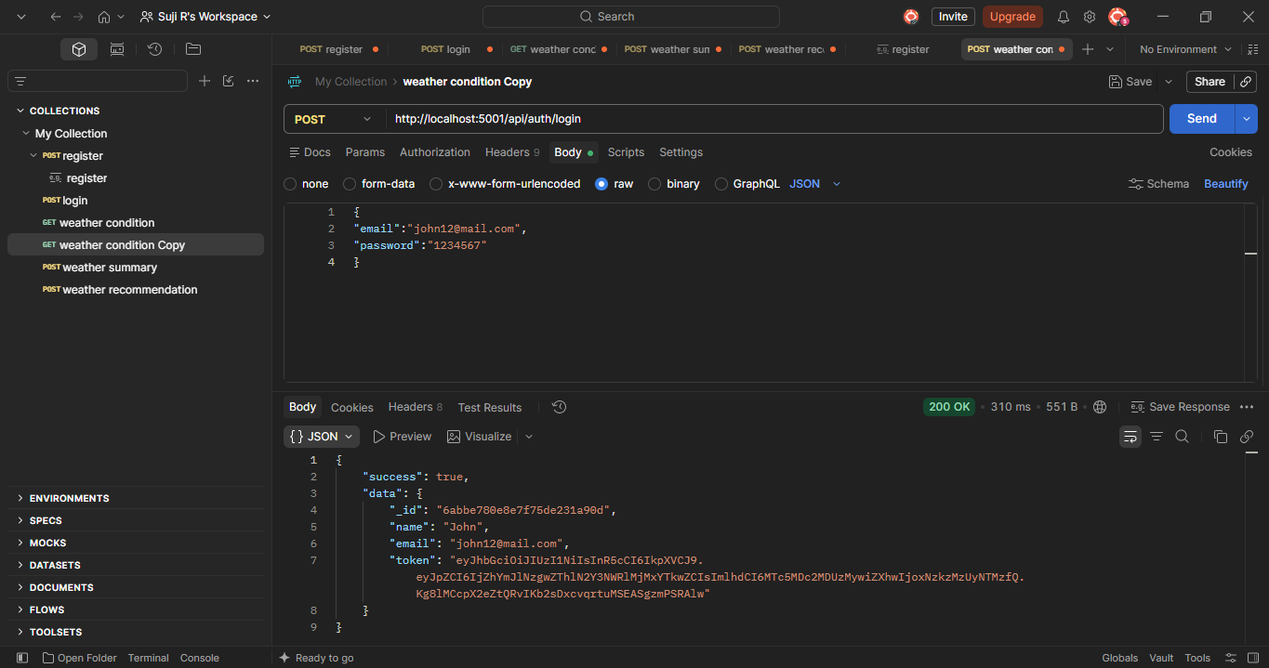
HTTP 200 OK; login succeeded.

Test Evidence 3 — Weather Condition
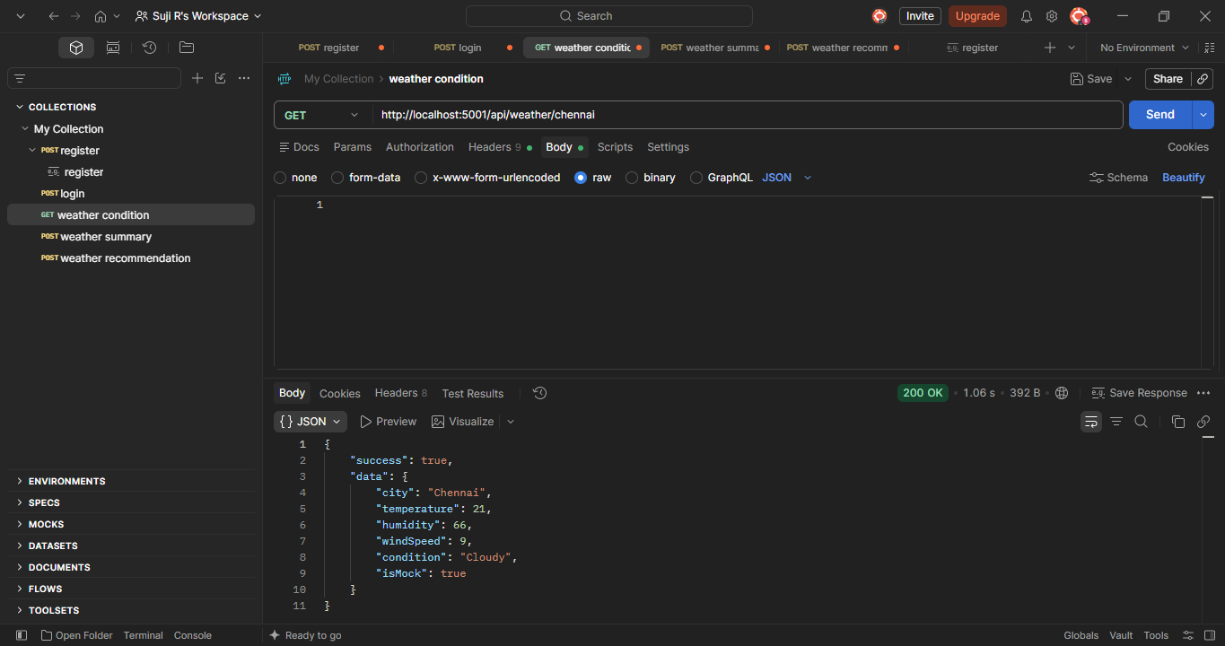
HTTP 200 OK; Chennai weather response returned.

Test Evidence 4 — AI Weather Summary
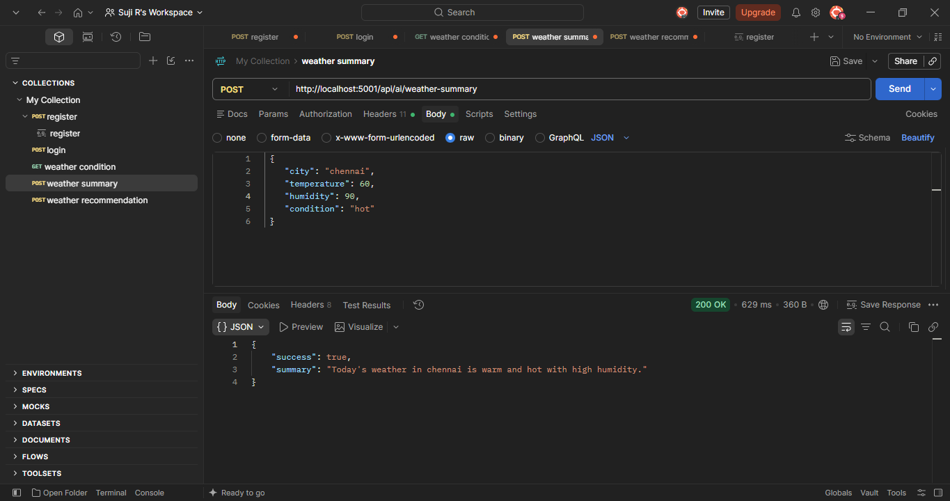
HTTP 200 OK; summary response returned.

Test Evidence 5 — AI Weather Recommendation
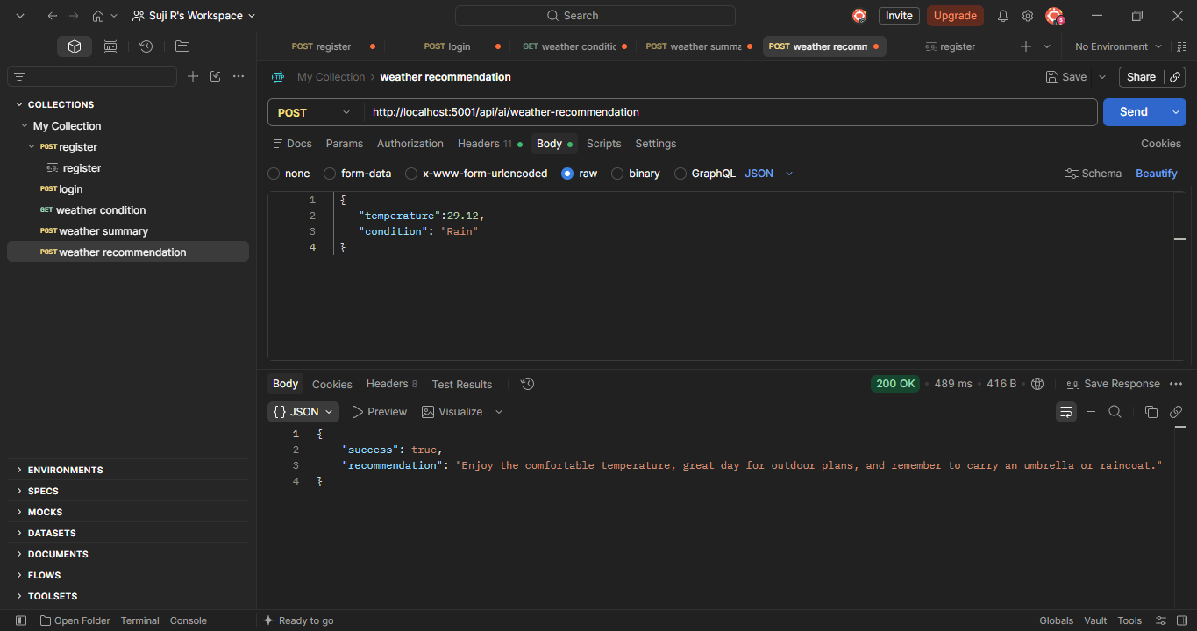
HTTP 200 OK; recommendation response returned.

Test Evidence 6 — Database Persistence
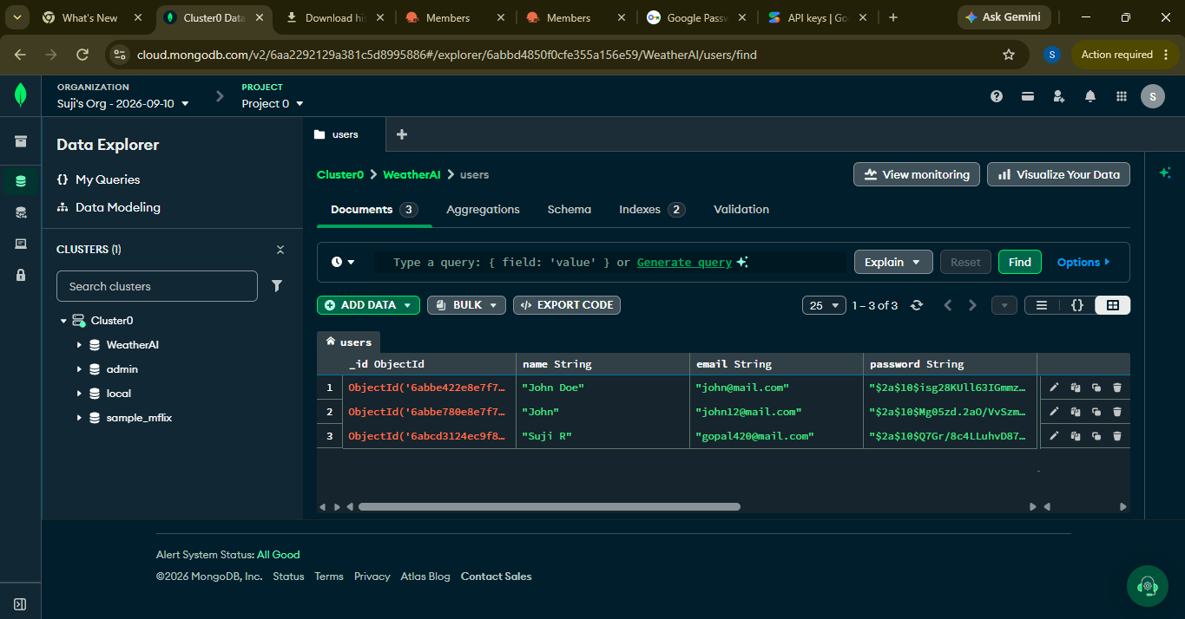
MongoDB Atlas shows stored user records in the WeatherAI users collection.

Test Evidence 7 — Server / Database Connectivity
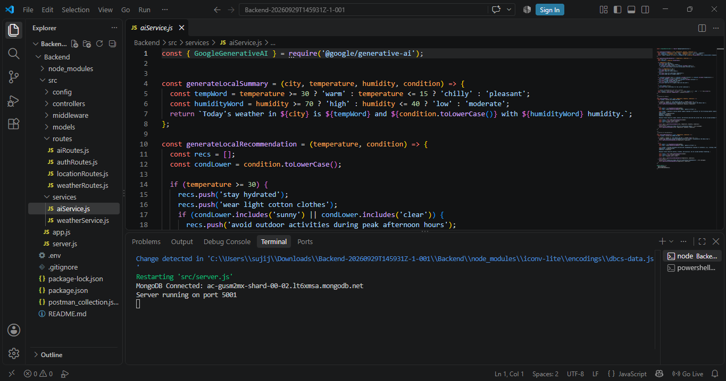
VS Code terminal shows MongoDB Connected and the server running on port 5001.

