PHASE 7
Project Documentation
AI WeatherWise API | AI-Augmented Backend Development
Project Name | AI WeatherWise API
Technology Track | AI-Augmented Backend Development
Team Members | Suji R; Sonika Sree A; Swapna M; Vidya N
Phase | 7
Maximum Marks | README + Submission Documentation

1. Documentation Objective
Provide a clear technical and user-facing record of AI WeatherWise API, including purpose, architecture, setup, dependencies, API endpoints, testing method and project evidence.

2. Project Description
AI WeatherWise API is a RESTful backend application that combines weather information with AI-assisted weather summaries and recommendations. It uses Node.js, Express.js, MongoDB/Mongoose, JWT authentication, bcryptjs, OpenWeather and Google Gemini.

3. Features
- User registration and login.
- JWT authentication and protected API operations.
- Favorite location CRUD.
- Current weather retrieval by city.
- AI weather summary.
- AI weather recommendation.
- MongoDB persistence.
- Fallback/local processing when configured external keys are unavailable, as documented in the project README.

4. API Documentation
Method | Endpoint | Description
POST | /api/auth/register | Register a new user.
POST | /api/auth/login | Authenticate and obtain JWT.
GET | /api/auth/profile | Retrieve authenticated profile.
POST | /api/locations | Save a location.
GET | /api/locations | List saved locations.
PUT | /api/locations/:id | Update a saved location.
DELETE | /api/locations/:id | Delete a saved location.
GET | /api/weather/:city | Retrieve weather for a city.
POST | /api/ai/weather-summary | Generate weather summary.
POST | /api/ai/weather-recommendation | Generate weather recommendation.

5. Setup Documentation
- Install Node.js and npm.
- Run npm install.
- Create a local .env file with PORT, MongoDB URI, JWT secret and required external API keys.
- Start development server using npm run dev or start using npm start.
- Use Postman to execute the documented endpoints.
- Verify stored users/locations in MongoDB Atlas when persistence is required.

6. Security and Repository Documentation
- Never publish .env or secret values.
- Use .env.example with placeholder values.
- Remove or rotate any secret that has been exposed.
- Do not include real passwords or JWT tokens in README/screenshots.
- Include package.json, README, Postman collection and source code in the GitHub repository.

7. Documentation Evidence
The supplied README describes the API, technology stack, project structure, setup and endpoint usage. The supplied package.json identifies the project as ai-weatherwise-api and defines start/dev scripts. The supplied Postman collection documents the API requests.

8. Submission Checklist
Item | Status / Action
README.md | Available in supplied project files
package.json / package-lock.json | Available
Postman collection | Available
Source code | Available in the supplied project workspace/screenshots; ensure all source files are included in final repository
.env.example | Create before public GitHub upload
GitHub repository | Add public repository link
Screenshots | Available from supplied execution evidence
UAT document | Prepared
Demo video | Record and add public Google Drive link

Actual Project Screenshot Evidence
The following screenshots were supplied from the actual AI WeatherWise API execution environment. They are included as evidence for this phase and are not mock/generated test results.

Implementation Evidence — Project Structure
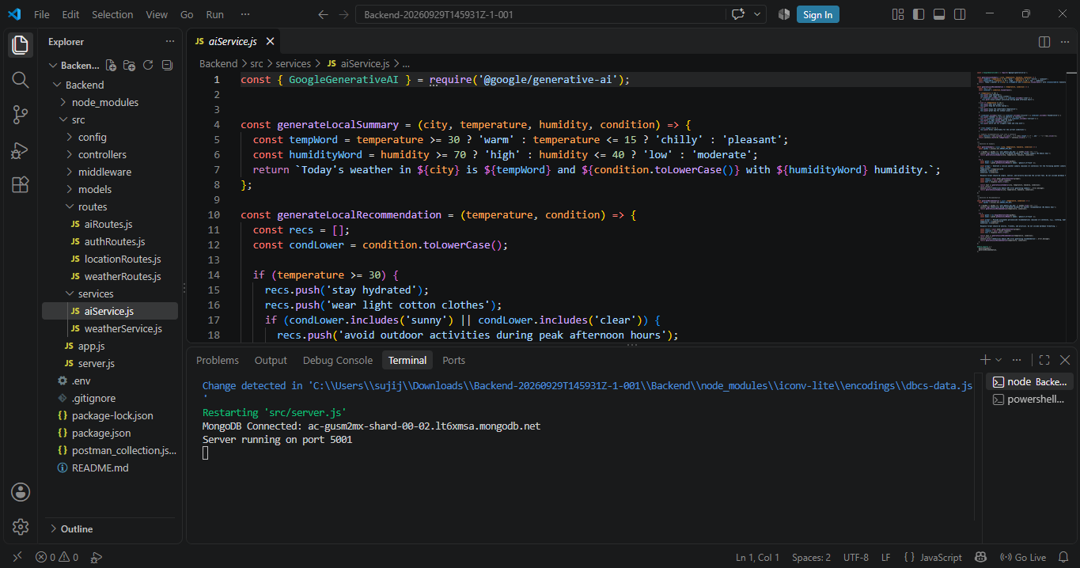
VS Code screenshot documents the source structure and active AI service implementation.

API Evidence — Registration
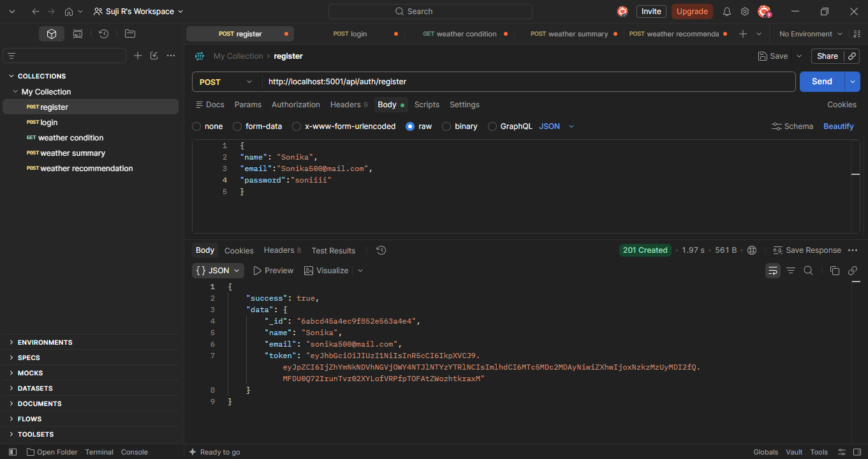
Postman screenshot demonstrates a successful registration API response.

Database Evidence
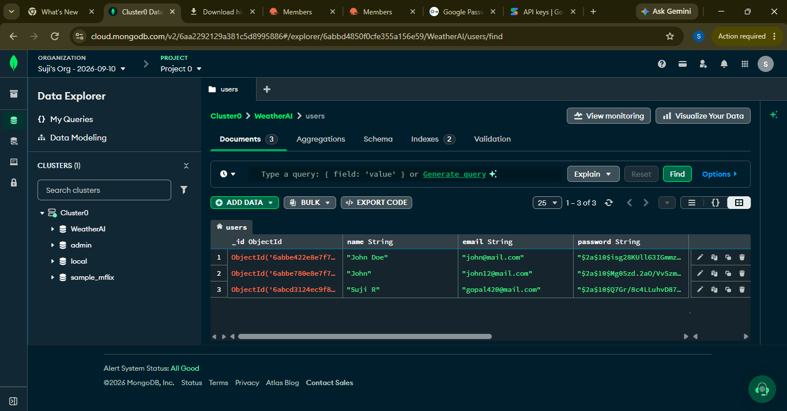
MongoDB Atlas screenshot demonstrates persisted user data.

