PHASE 8
Project Demonstration
AI WeatherWise API | AI-Augmented Backend Development
Project Name | AI WeatherWise API
Technology Track | AI-Augmented Backend Development
Team Members | Suji R; Sonika Sree A; Swapna M; Vidya N
Phase | 8
Maximum Marks | Demo Script & Evidence Plan

1. Demonstration Objective
Demonstrate the working AI WeatherWise API from startup through authentication, weather retrieval, AI insights and database persistence. The SmartBridge demonstration guidance calls for screen sharing, voice-over, project name, purpose, benefits, working process and final output.

2. Suggested Demo Sequence
Step | Screen / Action | What to Explain
1 | Title slide / project name | Introduce AI WeatherWise API and the four team members.
2 | VS Code project structure | Explain Node.js, Express, routes, controllers, services, models and middleware.
3 | VS Code terminal | Show MongoDB connection and server running on port 5001.
4 | Postman — Register | Send registration request and explain successful 201 response.
5 | Postman — Login | Send login request and explain JWT authentication.
6 | Postman — Weather | Call GET /api/weather/chennai and explain returned weather fields.
7 | Postman — AI Summary | Send weather inputs and show the generated summary.
8 | Postman — AI Recommendation | Send temperature/condition and show practical recommendation.
9 | MongoDB Atlas | Show WeatherAI/users collection and explain persistence.
10 | Architecture / code | Briefly explain how request → controller/service → external API/AI → response works.
11 | Conclusion | Summarize benefits and mention future enhancements.

3. Voice-over Script
“Our project is AI WeatherWise API, developed under the AI-Augmented Backend Development track. The goal is to provide weather information through REST APIs and add AI-assisted summaries and recommendations.”
“The backend uses Node.js and Express.js. MongoDB stores application data, while JWT and password hashing are used for authentication and security.”
“First, we register a user. The API returns a successful response and generates authentication information for subsequent protected requests.”
“Next, we log in with the registered credentials. The successful response demonstrates the JWT-based authentication flow.”
“We then request weather for Chennai. The API returns structured weather information such as temperature, humidity, wind speed and condition.”
“The AI summary endpoint converts weather inputs into a natural-language explanation, while the recommendation endpoint provides practical guidance based on the conditions.”
“Finally, MongoDB Atlas shows persisted user data, demonstrating that the backend is connected to the database.”
“The project can be extended with stronger live-weather verification, alerts, historical insights, deployment and additional user features.”

4. Benefits to Highlight
- Combines structured weather APIs with natural-language AI assistance.
- Provides reusable REST endpoints for other applications.
- Uses authentication and persistent storage.
- Separates routes, controllers, services, middleware and models for maintainability.
- Can be extended with alerts, historical analysis and additional recommendation features.

5. Demonstration Evidence
Evidence | Available
Running backend screenshot | Yes — VS Code terminal supplied
Registration response | Yes — Postman screenshot supplied
Login response | Yes — Postman screenshot supplied
Weather response | Yes — Postman screenshot supplied
AI summary response | Yes — Postman screenshot supplied
AI recommendation response | Yes — Postman screenshot supplied
MongoDB data | Yes — Atlas screenshot supplied
Architecture/code view | Yes — VS Code screenshot supplied
Demo video | To be recorded/uploaded by team
Public Google Drive link | To be added after upload

6. Demo Checklist
- Use screen sharing throughout the demonstration.
- Do not display API keys, MongoDB passwords, real user passwords or full JWT tokens.
- Keep Postman requests ready before recording.
- Show actual successful responses rather than fabricated outputs.
- Show MongoDB Data Explorer only after the API operation that created the record.
- Add the final Google Drive demo link to the submission document.

7. Final Status
The supplied screenshots provide substantial working-system evidence for the demonstration. The final demonstration requirement remains the recording and publication of the actual project demo video.

Actual Project Screenshot Evidence
The following screenshots were supplied from the actual AI WeatherWise API execution environment. They are included as evidence for this phase and are not mock/generated test results.

Demo Evidence 1 — Server Running
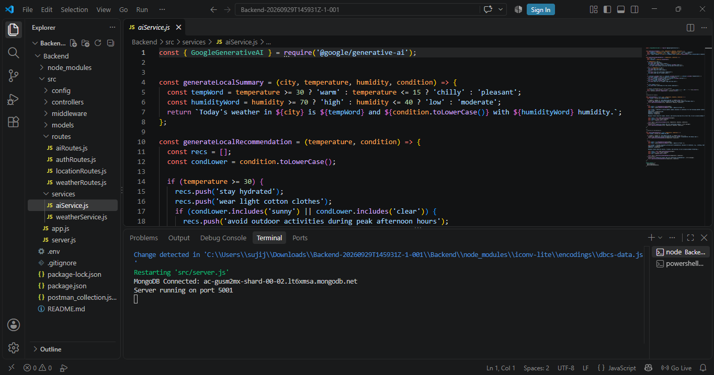
Show the running backend and MongoDB connection.

Demo Evidence 2 — Registration
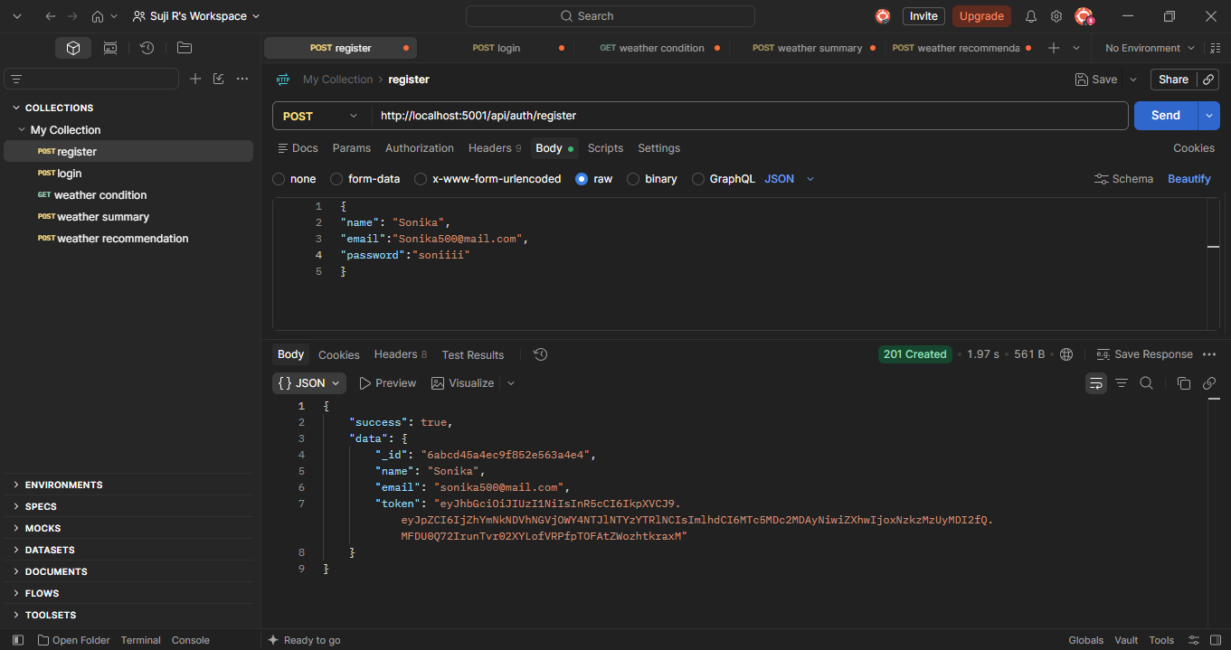
Demonstrate successful user registration.

Demo Evidence 3 — Login
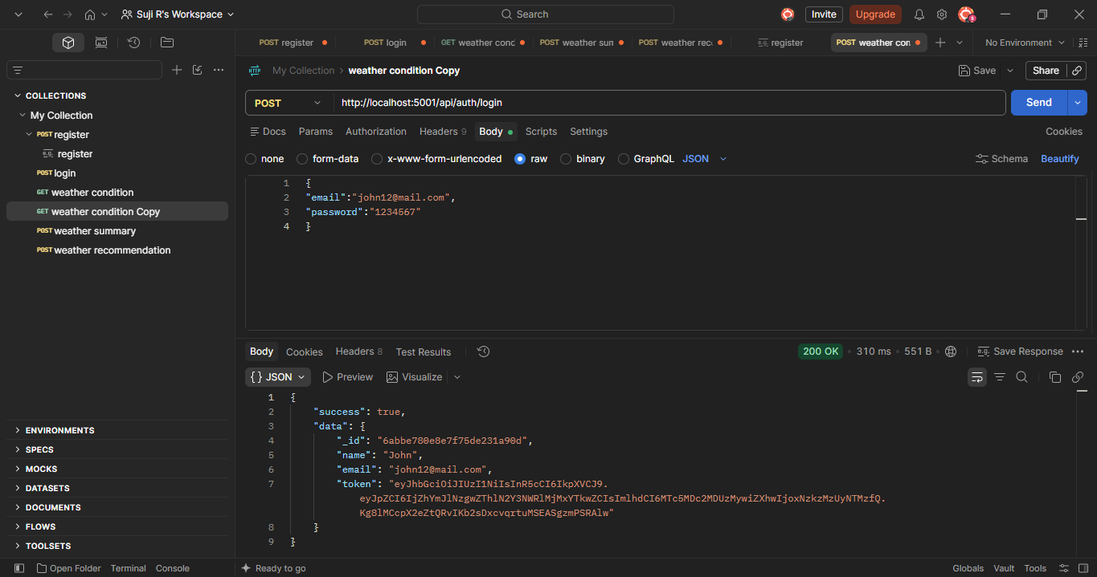
Demonstrate successful login/authentication.

Demo Evidence 4 — Weather API
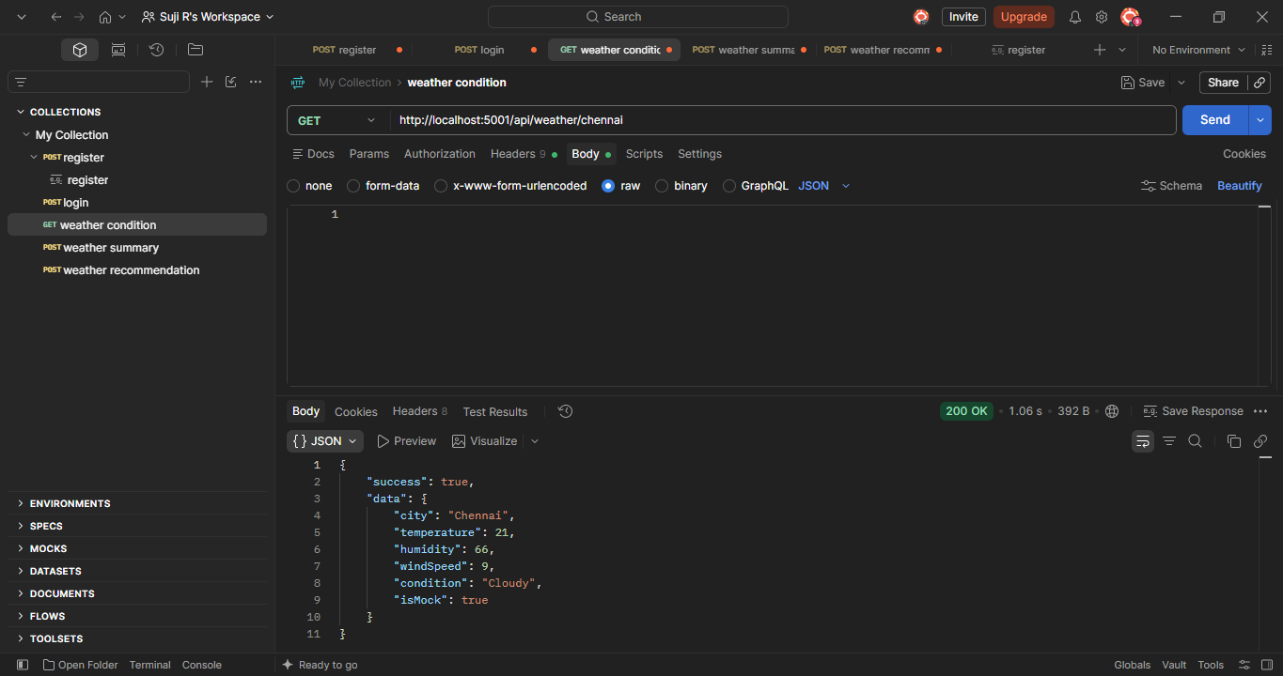
Demonstrate weather retrieval for Chennai.

Demo Evidence 5 — AI Summary
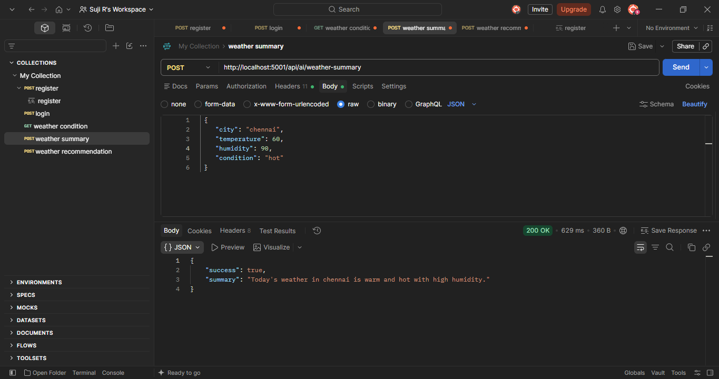
Demonstrate AI-generated weather summary.

Demo Evidence 6 — AI Recommendation
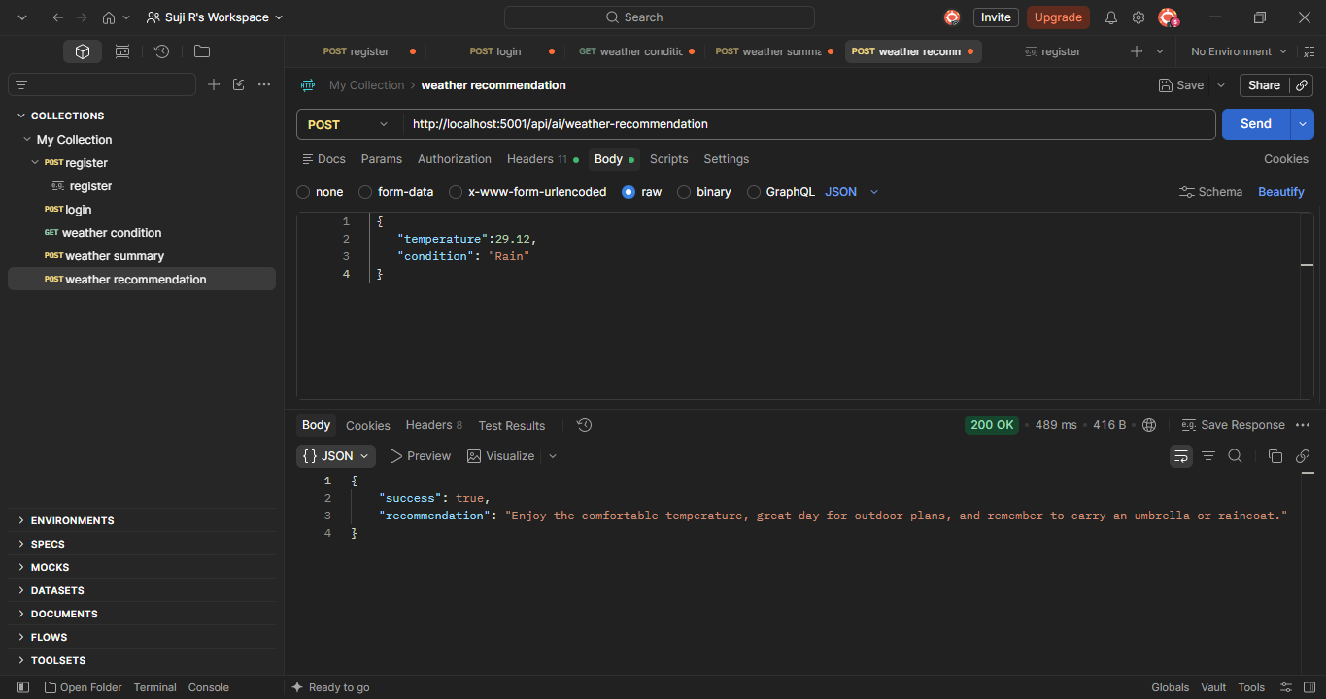
Demonstrate practical weather recommendation.

Demo Evidence 7 — MongoDB
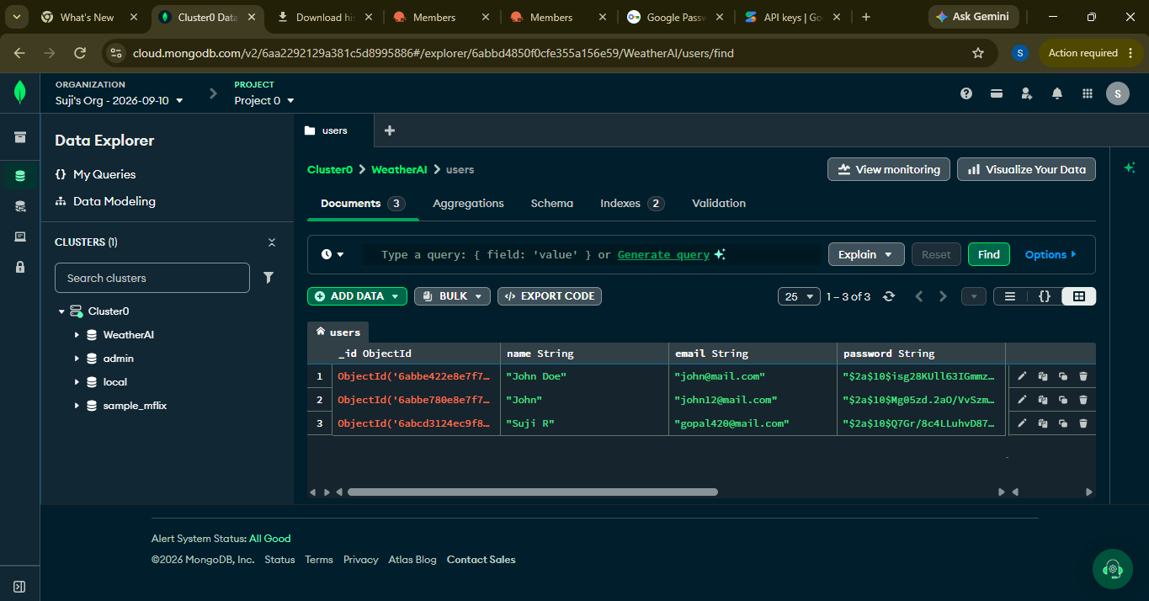
Demonstrate that application data is persisted in MongoDB Atlas.

