Outlier analysis (random forest model on the NIH cc 5 phase dataset with no patient overlap)

|  |  |  |
| --- | --- | --- |
| sample_id | prediction | label |
| Nephro/00055_5_Post_AP_2_Min_5__resized.nii.gz | 2 | 3 |

|  |  |  |
| --- | --- | --- |
| sample_id | prediction | label |
| NonContrast/00051_3_PRE_LIVER_PRE_LIVER_POST_NCAP_Neck__1__resized.nii.gz | 2 | 0 |

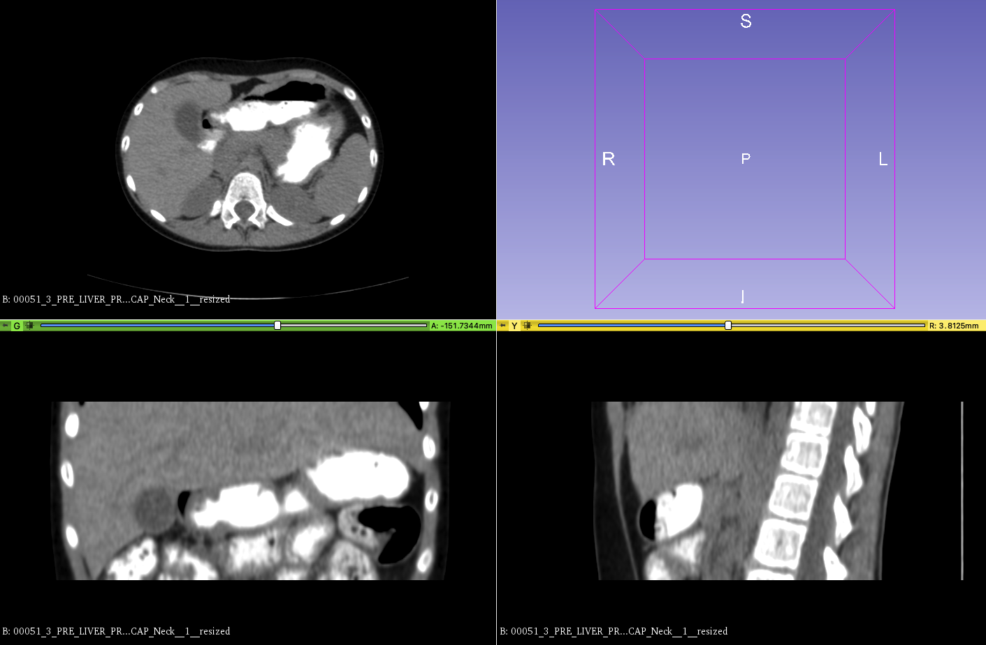

|  |  |  |
| --- | --- | --- |
| sample_id | prediction | label |
| NonContrast/00077_9_NON-CON_2X1_Body_2__resized.nii.gz | 4 | 0 |

