Build, Train, and Deploy Your First Neural Network with TensorFlow
by Jerry Kurata
In this course, you will learn the basic principles of machine learning and neural networks so you can quickly create, train, and deploy a neural network with TensorFlow.

Tensorflow pluralsight course notes
Tsfx = tensorflow extensions
tensorflow light – used for lightweight applications (integrated/phones/IoT/etc)
tensorflow alternate languages: Python, C++, Javascript, and Swift(new)
- C++ for embedding of speed
- swift is supposed to be faster but new and not fully supported?
Dense layer = every input connects to a layer output
google colaboratory: http://colab.research.google.com/ (requires google account)
- can use GPU/TPU
  - edit-> notebook setings-> change hardware accelerator to GPU (nvidia) or TPU (google)
  - no guarantee that a GPU/TPU will be available at runtime
- TPU = tensor processing unit (as designed by google)
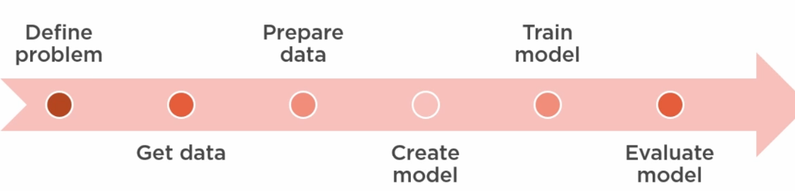
Weights – alternate name for coefficients
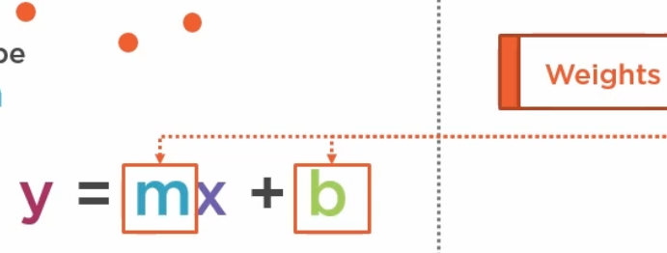
mimicking linear regression
- neuron weights are slope and intercept
- adjust the weights until prediciton matches training
- mini-batch gradient descent used to work to minimization of loss function
- Process
  - initialize weights
  - repeat until loss acceptable or max epochs reached
    - foreach mini-batch
      - make predictions
      - compute loss function
      - compute gradient to minimize loss
      - update m and b based on gradient (using learning rate)
    - next epoch
- intercept is referred to as 'bias' in certain cases
- only requires a single neuron
tensors are data flowing through the model – n dimensional structure used to represent data
- god for generalized mathematical operations
- properties
  - rank = # of dimensions (0: point; 1:vector; 2: matrix; 3: cube; 4+: n-tensor)
  - shape = # vectors and # values in each vector (0:[], 1:[5], 2:[5,7], 3:[5,7,13]) – directly related to rank
  - datatype: e.g. float32, float64, in8/16/32/64, uint8/16(unsigned int), string, bool, complex64/128, quant8/16 (quantized), quint8
    - quantized – scaled to reduce size for faster processing (75%) and possible reduced accuracy

keras is tensorflow's high-level API

tensorflow NN Steps
- preprocessing (e.g. scale data)
- create the model with activation function, data shape, weight/kernel initializer, and bias initializer
- compile the model with loss function and optimizer
  - can request a metric to use as well e.g. metrics = ['accuracy']
- train_test_split 80/20 or 70/30
  - give random_state seed if you want reproducability
- train: run model.fit(X, Y, epochs, batch_size, verbose)
  - loss should go down with subsequent epochs
  - test data can be passed to evaluate progress over time
  - callback to tensorboard if using it
- call model.predict on training data to get predicted values
  - check accuracy
    - visualize loss – check for convergence (loss levels out)
    - add more data or do more training?
  - may need to apply inverse transform to get data back to original scale
- evaluate model with test data
  - compare MSE from test vs train

Section 6
- Neuron inputs from sensors or other neurons
- Neuron
  - 1+ inputs – combined in neuron
    - trainable weights (for each input)
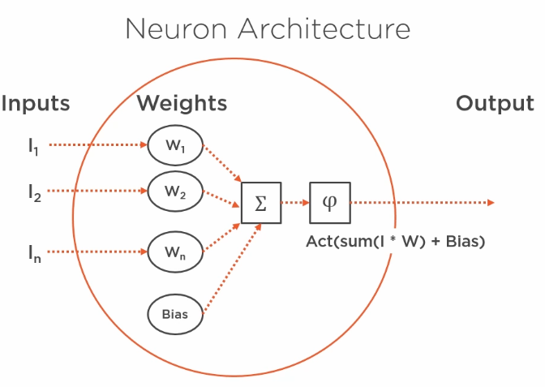
    - activation function applied to (sum of inputs times weights) plus bias
      - needed for non-linear modeling
      - prevents a single neuron from growing too large
      - vanishing gradient – small values fade to 0 – stops learning
      - Common ones
        - Sigmoid – output values 0 to 1 – flat tails limit impact of large values – vanishing gradient
        - Tanh (hyperbolic tangent) -1 to 1 – flatter tails – vanishing gradient
        - ReLU – rectified linear unit: 0 to x range; equation = max(0,x) – everything < 0 is zero, everything above is itself – con: lets through large values (possible blowing up) widely used
        - Leaky ReLU – lets through some negative but minimizes them
        - SoftMax – (classification last layer – computes probability that the input belongs to each of the classes) – probabilities must add to 100%
  - 1 output – might get passed as input for multiple downstream neurons
- hidden layers – catpure relationships between the data
- forward propagation – passing values forward through the NN
- Loss – measured across multiple samples and classes
  - categorical cross entropy (common) – calculates loss across multiople classes
  - hyperparameter that we need to specify
  - works with optimizer (commonly mini-batch SGD)
    - back propagation of error (backprop) – adjust weights and biases to reduce loss
    - must be compitible with loss function
    - GPU/TPU helps with these SGD calculations
- MNIST [hand drawn numbers] issues – (modified national institue for standards and technology)
  - too easy (>99% accuracy common)
  - overused
  - not repersentative of modern problems
  - fashion mnist – grayscale, 28x28, 70K rows
- sparse categorical cross-entropy – loss function for classification
- scaling data can prevent overflows when running the model
- Flatten layer – transformation layer that convers 28x28 array to 1x784
- input shape is only needed for first layer – keras implicitly handles shapes passed from prior layers
- how many neurons to use – keep it between the number of inputs and the number of outputs (e.g. 784 inputs >= 128 neurons >= 10 output classes)
- use model.summary to get a summary of NN layers
  - param # = inputs * weights * biases
- model.compile does not take long – model.fit (training) takes the longest time
  - put a %% time magic on these cells
- adam optimizer – variation fo mini-batch gradient descent
- large diff bewteen training score and testing score = model can be improved
  - model has overfit (memorized the training data)
- tensorboard – used to evaluate model performance
  - run from CLI and specify log directory where data from run was stored
  - starts a weeb server – default url: http://localhost:6006/
  - must be run after model fit?
  - Sections
    - scalars – data collected from our model
    - graphs – graphs for internal metrics from tensorflow
    - distributions – value dists
    - more
  - if graphs look funny tensorboard is probably reusing an old PID that needs to be killed
  - when run from CLI – old files seem to be used even when tensorboard is stopped and restarted
- overfitting solutions
  - reduce complexity – reduce neurons or layers
  - randomly drop neuron output (set to 0) – regularize
    - add a keras dropout layer
  - stop training early (when loss increases again, or accuracy decreases)

Deployment
- tensorflow serving (local, group, or global)
  - docker image
- steps (colab)
  - save model
  - install TF modelServer & launch
    - create APT key DB – Advanced package tool
    - use curl to get files
    - install with apt-get
  - call server and pass input
    - set up env variables: MODEL_DIR, REST_PORT , MODEL_NAME
    - run server in background (nohup)
      - tail server.log to verify running
      - use requests library to send data to the REST service for TF
        - need json to format the request – 3 key:value paris – 2 are empty
        - specify headers and content
        - construct url with port and /v1/models/model_name:predict
        - parse the json result and format for display
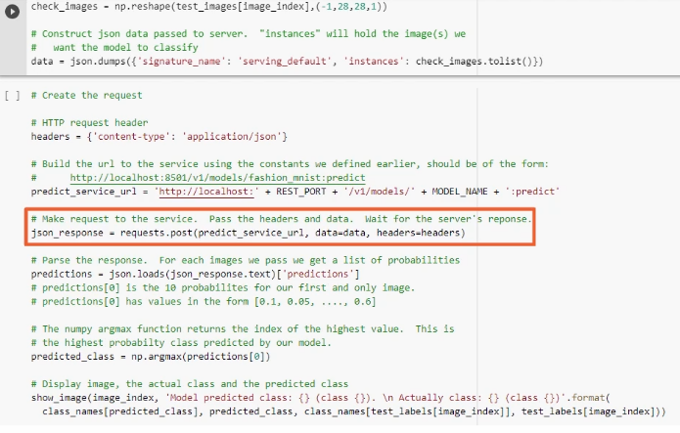
- call flow
  - client gets image ans ends to service interface of TF ModelServer – which are are then passed to the trained model
  - model runs on input and returns probabilities for class results to service interface, which is then sent to the client – client handles how the result is displayed

Strange file cleanup bug
  - can't clean up logs directory – no permission on certain files
  - error varies access denied or permission error
  - windows says that all users do not have read access (incl adminstrators)
    - TAKEOWN /f %DIRECTORY_NAME% /r /d y
      - fails
    - ICACLS %DIRECTORY_NAME% /grant administrators:F /t
      - fails
  - files can be deleted only after stopping the jupyter server – stopping/restarting the kernel for the notebook does not help

