

Politecnico di Milano

A.A. 2016-2017

Software Engineering 2: “PowerEnjoy”

Test Plan

Version 1.2

Prasanth Ravulapalli

Fathima B

Lipika L

January 15th 2017

Contents

Introduction 3

Purpose and Scope. 3

Scope 3

List of Definitions and Abbreviations 3

List of Reference Documents. 3

Integration Strategy 4

Entry Criteria 4

Elements to be integrated 4

Sequence of Component/Function Integration 5

Software Integration Sequence 5

Individual Steps and Test Description 7

Description of integration steps 7

Description of test procedures 18

Appendix 21

System integration sequence 21

Hours of Work 23

Change Log: 23

# Introduction

## Purpose and Scope.

This document is intended to present the Integration test plan for the PowerEnjoy application, in the context of the project of the course Software Engineering 2.

This document describes the plans for testing the integration of the created components. The purpose of this document is to test the interfaces between the components. For that reason, this document is strongly related to the high-level design presented in the Design Document, and thus does not provide specific details neither on the testing of the individual components nor on the whole system testing.

## Scope

The software implements a computational grid. This grid can execute jobs when it 20 receives an application accompanied by a set of data files. By hiding the complexity of grid technology, the system will be easy to use. Usability is also increases by offering a web-based front-end for users to access the system.

## List of Definitions and Abbreviations

The following are abbreviations are used in the present document (and have not already been presented in any of the reference documents):

* IP: Integration procedure
* IS: Integration step
* ITP: Integration test plan
* Top down integration testing: it is an integration testing strategy which consists on performing the integration of the components from the uppermost to the lowermost. At each step, it requires the use of stub components to emulate the lower level parts of the system, where the invocations will be sent to.

## List of Reference Documents.

The following is the list of documents that are related to this Test plan, and that totally define its context:

* RASD document for the same project
* Sample Test plan document.pdf

The Integration Test Plan Example was used as a guideline to develop the structure of this document though it is not relevant to understand the domain problem.

# Integration Strategy

In this section, we present the strategy that will be used to guide the test plan. This includes the preconditions to execute it, the specific components that will be tested, the description and justification of the strategy, and a list of the concrete steps to be followed.

## Entry Criteria

Within the context of the software development process, this test plan can only be executed when the following conditions hold:

* A requirements specification of the domain problem must have been done. In our case, this is presented in the RASD.
* A high-level design specification of the solution must have been performed. This is included in the DD.
* The source code of the implemented components that will be tested must be available.
* Code inspection activities are recommended to be executed on the source code of the components, even though it is not entirely mandatory.
* The components to be tested must have successfully passed the unit testing phase.

## Elements to be integrated

The following list of components to be tested is based on the components presented in the Component view section of the Design Document:

* UserWebView
* UserController
* UserMobileView
* UserNotification
* GuestMobileView
* GuestController
* GuestWebView
* GuestNotification
* SystemOperationManager
* ReservationManager
* RideManager
* Model
* DB

The components WebBrowser, Email and SMS are also included in this test plan even though they are external systems. This is because the integration testing is intended to validate the functionalities of the system when the different components are put together.

## Sequence of Component/Function Integration

Once that we have presented the strategy to guide the testing process and the specific parts of the system to be validated, we continue by listing the concrete steps that are to be followed to execute this test plan

### Software Integration Sequence

All the components presented in the Component view of the Design Document can be considered as subsystems of the PowerEnjoy application. Nevertheless, we only provided a deeper view only for Model, so we list integration steps only for its subcomponents.

For applying the top-down strategy we take the NotificationManager as critical component. We incrementally add the real components to the integration:

|  |  |  |
| --- | --- | --- |
| **Integration Test Step ID** | **Involved components** | |
| IS1-T1 | RequestManager, ReservationManager | |
| IS1-T2 | ReservationManager, RequestManager | |
| IS2-T1 | RequestManager, QueueManager | |
| IS2-T2 | UserManager, QueueManager | |
| IS3-T1 | RequestManager, UserManager | |
| IS4-T1 | RequestManager, GuestManager | |
| IS4-T2 | GuestManager, RequestManager | |
| IS5-T1 | ReservationManager, DataManager | |
| IS6-T1 | UserManager, DataManager | |
| IS6-T2 | GuestManager, DataManager | |
| IS7-T1 | | Model, NotificationManger |
| IS8-T1 | | NotificationManger, MessageManager |
| IS9-T1 | | Model, DB |
| IS10-T1 | | Model, SystemOperationManager |
| IS11-T1 | | NotificationManger, UserNotification |
| IS11-T2 | | NotificationManger, GuestNotification |
| IS12-T1 | | UserMobileView, UserController |
| IS12-T2 | | UserController, Model |
| IS13-T1 | | GuestMobileView, GuestController |
| IS13-T2 | | GuestController, Model |
| IS14-T1 | | WebBrowser, UserWebView |
| IS14-T2 | | UserWebView, UserController |
| IS14-T3 | | UserController, Model |

**Note**: You can find diagrams illustrating the integration sequence of the system and the subsystem in the appendix

# Individual Steps and Test Description

In this section, we provide the description of the integration steps. Since the purpose of this document is not to describe detailed testing but presenting the general guidelines for it.

## Description of integration steps

|  |  |
| --- | --- |
| **ID** | IS1-T1 |
| **Components involved** | RequestManager → ReservationManager |
| **Environmental conditions** | RequestManager, ReservationManager components  DataManager stub |
| **Input description** | Create a valid RequestManager inputs such as interactions between User and the application.  The inputs are of following:   * User request for a car * User request for end of the ride |
| **Output description** | We expect that the methods invoked during this series of calls generate the output and actions that correspond to the input provided. |
| **Observations** |  |

|  |  |
| --- | --- |
| **ID** | IS1-T2 |
| **Components involved** | ReservationManager → RequestManager |
| **Environmental conditions** | RequestManager, ReservationManager components  UserManager, GuestManager |
| **Input description** | Create a valid ReservationManager input such as results generated by application to the user:  The inputs are of following:   * Result for user’s request for a car * Result for user’s request for end of the ride |
| **Output description** | We expect that the methods invoked during the series of function calls generate the output and actions that correspond to the input provided. |
| **Observations** |  |

|  |  |
| --- | --- |
| **ID** | IS2 -T1 |
| **Components involved** | RequestManager → QueueManager |
| **Environmental conditions** | RequestManager, QueueManager components |
| **Input description** | Create a valid RequestManager input such as creating a user request and push them into the queue through QueueManager.  The inputs are of following:   * User request to provide a car * User request to reserve a car * User request to cancel a ride |
| **Output description** | We expect that the methods invoked during the series of function calls generate the output and actions that correspond to the input provided. |
| **Observations** |  |

|  |  |
| --- | --- |
| **ID** | IS2-T2 |
| **Components involved** | UserManager → QueueManager |
| **Environmental conditions** | RequestManager, UserManager component |
| **Input description** | Create a valid UserManager input to the QueueManager.  The inputs are of following:   * User reaching the reserved car * User update position * User unlocking/ locking the car |
| **Output description** | We expect that the methods invoked during the series of function calls generate the output and actions that correspond to the input provided. |
| **Observations** |  |

|  |  |
| --- | --- |
| **ID** | IS3-T1 |
| **Components involved** | RequestManager → UserManager |
| **Environmental conditions** | RequestManager , UserManager components  Model, Database |
| **Input description** | Create a valid RequestManager input such as result generated by application to the user’s request.  The inputs are of following:   * Result for user’s request for a car * Result for user’s request for end of the ride * Result for user’s request for show cars |
| **Output description** | We expect that the methods invoked during the series of function calls generate the output and actions that correspond to the input provided. |
| **Observations** |  |

|  |  |
| --- | --- |
| **ID** | IS3-T2 |
| **Components involved** | UserManager → RequestManager |
| **Environmental conditions** | RequestManager, UserManager components  Model, Database  The tests IS1 and IS2 must have succeeded. |
| **Input description** | Create a valid UserManager input such as request generated by user to the application through RequestManager.  The inputs are of following:   * User show cars * User request for car * User request for end of ride |
| **Output description** | We expect that the methods invoked during the series of function calls generate the output and actions that correspond to the input provided. |
| **Observations** |  |

|  |  |
| --- | --- |
| **ID** | IS4-T1 |
| **Components involved** | RequestManager → GuestManager |
| **Environmental conditions** | RequestManager , GuestManager components  Model, Database |
| **Input description** | Create a valid RequestManager input such as result generated by application to the guest’s request.  The inputs are of following:   * Result for guest’s request for show cars |
| **Output description** | We expect that the methods invoked during the series of function calls generate the output and actions that correspond to the input provided. |
| **Observations** |  |

|  |  |
| --- | --- |
| **ID** | IS4-T2 |
| **Components involved** | GuestManager → RequestManager |
| **Environmental conditions** | RequestManager, GuestManager components  Model, Database |
| **Input description** | Create a valid GuestManager input such as request generated by guest to the application through RequestManager.  The inputs are of following:   * Guest show cars |
| **Output description** | We expect that the methods invoked during the series of function calls generate the output and actions that correspond to the input provided. |
| **Observations** |  |

|  |  |
| --- | --- |
| **ID** | IS5-T1 |
| **Components involved** | ReservationManager -> DataManager |
| **Environmental conditions** | The tests IS1 to IS3 must have succeeded.  A stub for the DataBase component is used. |
| **Input description** | Create a valid ReservationManager input such as request generated by user to the application.  The inputs are of following:   * User cancel request * Process Request |
| **Output description** | We expect that the methods invoked during the series of function calls generate the output and actions that correspond to the input provided. |
| **Observations** | This test is supposed to validate the integration of ReservationManager with the DataManager and the already tested part of the system. |

|  |  |
| --- | --- |
| **ID** | IS6-T1 |
| **Components involved** | UserManager -> DataManager |
| **Environmental conditions** | The tests IS1, IS2, IS3, IS5 must have succeeded.  A stub for the DataBase component is used. |
| **Input description** | Create a valid UserManager input such as request generated by user to the application.  The inputs are of following:   * User email confirmation * User create account * User edit account * User log in |
| **Output description** | We expect that the methods invoked during the series of function calls generate the output and actions that correspond to the input provided. |
| **Observations** | This test is supposed to validate the integration of UserManager with the DataManager and the already tested part of the system. |

|  |  |
| --- | --- |
| **ID** | IS6-T2 |
| **Components involved** | GuestManager -> DataManager |
| **Environmental conditions** | The tests IS1, IS2, IS4 and IS5 must have succeeded.  A stub for the DataBase component is used. |
| **Input description** | Create a valid GuestManager input such as request generated by guest to the application.  The inputs are of following:   * Guest email confirmation |
| **Output description** | We expect that the methods invoked during the series of function calls generate the output and actions that correspond to the input provided. |
| **Observations** | This test is supposed to validate the integration of GuestManager with the DataManager and the already tested part of the system. |

|  |  |
| --- | --- |
| **ID** | IS7-T1 |
| **Components involved** | Model -> NotificationManger |
| **Environmental conditions** | The tests IS1 to IS6 must have succeeded.  Stubs of the MessageManager components are used.  Drivers of the OtherControllers components are used. |
| **Input description** | Create a valid Model input. The inputs are of following:   * Guest email confirmation * User account creation * User edit account * User email confirmation * User log in * Process request |
| **Output description** | We expect that the methods invoked during the series of function calls generate the output and actions that correspond to the input provided. |
| **Observations** | This test is supposed to validate the integration of Model with the NotificationManager only. |

|  |  |
| --- | --- |
| **ID** | IS8-T1 |
| **Components involved** | NotificationManger -> MessageManager |
| **Environmental conditions** | The tests IS1 to IS7 must have succeeded.  Stubs of the MessageManager components are used.  We have actual access to the Email servers and SMS protocols which belongs to external system. |
| **Input description** | Create a valid NotificationManger input which can be sent to the MessageManager. The inputs are of following:   * Send a mail body with the recipient added * Send a SMS to a mobile number |
| **Output description** | We expect that the methods invoked during the series of function calls generate the output and actions that correspond to the input provided. |
| **Observations** | This test is supposed to validate the integration of NotificationManger with the external system MessageManager’s Email/SMS system. |

|  |  |
| --- | --- |
| **ID** | IS9-T1 |
| **Components involved** | Model -> DB |
| **Environmental conditions** | DataBase should be accessible by the Model component. Tests from IS1 to IS8 are to be succeeded. |
| **Input description** | Create a valid input which can be sent to the Model which are required by the procedures. |
| **Output description** | We expect that the methods invoked during the series of function calls generate the output and actions that correspond to the input provided. |
| **Observations** | This test is supposed to validate the integration of Model with the DB and the already tested part of the system. |

|  |  |
| --- | --- |
| **ID** | IS10-T1 |
| **Components involved** | Model -> SystemOperationManager |
| **Environmental conditions** | The tests IS1 to IS9 must have succeeded.  Stubs from the SystemOperationManager and OtherControllers components are used. |
| **Input description** | Create a valid Model input which can be sent to the SystemOperationManager. The inputs are of following:   * Calculate the price * Add bank details * Make a transaction * Input validators |
| **Output description** | We expect that the methods invoked during the series of function calls generate the output and actions that correspond to the input provided. |
| **Observations** | This test is supposed to validate the integration of Model with the SystemOperationManager. |

|  |  |
| --- | --- |
| **ID** | IS11-T1 |
| **Components involved** | NotificationManger -> UserNotification |
| **Environmental conditions** |  |
| **Input description** | Create a valid NotificationManger input which can be sent to the UserNotification. The inputs are of following:   * Send Email * Send SMS |
| **Output description** | We expect that the methods invoked during the series of function calls generate the output and actions that correspond to the input provided. |
| **Observations** | This test is supposed to validate the integration of NotificationManger with the UserNotification. |

|  |  |
| --- | --- |
| **ID** | IS11-T2 |
| **Components involved** | NotificationManger -> GuestNotification |
| **Environmental conditions** |  |
| **Input description** | Create a valid NotificationManger input which can be sent to the GuestNotification. The inputs are of following:   * Send Email * Send SMS |
| **Output description** | We expect that the methods invoked during the series of function calls generate the output and actions that correspond to the input provided. |
| **Observations** | This test is supposed to validate the integration of NotificationManger with the GuestNotification. |

|  |  |
| --- | --- |
| **ID** | IS12-T1 |
| **Components involved** | UserMobileView -> UserController |
| **Environmental conditions** | IS11-T1 succeeded |
| **Input description** | Create a valid UserMobileView input which can be sent to the UserController. The inputs are of following:   * User create account * User edit account * User login * User accept request * User cancel request |
| **Output description** | We expect that the methods invoked during the series of function calls generate the output and actions that correspond to the input provided. |
| **Observations** |  |

|  |  |
| --- | --- |
| **ID** | IS12-T2 |
| **Components involved** | UserController -> Model |
| **Environmental conditions** | IS12-T1 succeeded |
| **Input description** | Create a valid input which can be sent to the UserController. |
| **Output description** | We expect that the methods invoked during the series of function calls generate the output and actions that correspond to the input provided. |
| **Observations** | This test is supposed to validate the integration of UserController with the Model and the already tested part of the system. |

|  |  |
| --- | --- |
| **ID** | IS13-T1 |
| **Components involved** | GuestMobileView -> GuestController |
| **Environmental conditions** |  |
| **Input description** | Create a valid GuestMobileView input which can be sent to the GuestController. The inputs are of following:   * Guest create request * Guest send details |
| **Output description** | We expect that the methods invoked during the series of function calls generate the output and actions that correspond to the input provided. |
| **Observations** |  |

|  |  |
| --- | --- |
| **ID** | IS13-T2 |
| **Components involved** | GuestController -> Model |
| **Environmental conditions** | IS13-T1 succeeded |
| **Input description** | Create a valid input which can be sent to the GuestController. |
| **Output description** | We expect that the methods invoked during the series of function calls generate the output and actions that correspond to the input provided. |
| **Observations** | This test is supposed to validate the integration of GuestController with the Model and the already tested part of the system. |

|  |  |
| --- | --- |
| **ID** | IS14-T1 |
| **Components involved** | WebBrowser -> UserWebView |
| **Environmental conditions** |  |
| **Input description** | The input will be the typical data for the procedure required by WebBrowser. |
| **Output description** | The output will be characterized by invoked methods and it match with the given input. |
| **Observations** | This test is supposed to validate the integration of WebBrowser with the MTSPassengerWebView. |

|  |  |
| --- | --- |
| **ID** | IS14-T2 |
| **Components involved** | UserWebView -> UserController |
| **Environmental conditions** | IS14-T1 succeeded |
| **Input description** | The input will be the typical data for the procedure required by UserController. |
| **Output description** | The output will be characterized by invoked methods and it match with the given input. |
| **Observations** | This test is supposed to validate the integration of UserWebView with the UserController. |

|  |  |
| --- | --- |
| **ID** | IS14-T3 |
| **Components involved** | UserController -> Model |
| **Environmental conditions** | IS14-T2 succeeded |
| **Input description** | The input will be the typical data for the procedure required by Model. |
| **Output description** | The output will be characterized by invoked methods and it match with the given input. |
| **Observations** | This test is supposed to validate the integration of UserController with the Model and the already tested part of the system. |

## Description of test procedures

Once we have described the test steps that make part of the integration plan, we now put them together into procedures accordingly to the functional role that each one of them has in the overall system.

We have defined 6 procedures:

Data management

|  |  |
| --- | --- |
| **Test Procedure ID** | TP1-1 |
| **Related functionalities** | This procedure is intended to verify the access to the database. |
| **Chain of steps** | Execute IS9, after having executed IS1 to IS7. |

External systems communication

|  |  |
| --- | --- |
| **Test Procedure ID** | TP2-1 |
| **Related functionalities** | This procedure is intended to verify the communication with external components through the NotificationManager component. |
| **Chain of steps** | Execute IS8-T1, after executing IS7. |

Notifications

|  |  |
| --- | --- |
| Test Procedure ID | TP3-1 |
| Related functionalities | This procedure is intended to verify the communication with UserNotification and GuestNotification through the NotifierManager component. |
| Chain of steps | Execute IS11-T1 and IS11-T2, after executing IS7 and IS8. |

User functionalities

|  |  |
| --- | --- |
| **Test Procedure ID** | TP4-1 |
| **Related functionalities** | This procedure is intended to verify the functionalities offered to the User through the web application. The steps will allow to verify the behavior of both graphical and logical components. |
| **Chain of steps** | Execute IS14-T1 to IS14-T3, after having executed IS1 to IS11. |

|  |  |
| --- | --- |
| **Test Procedure ID** | TP4-2 |
| **Related functionalities** | This procedure is intended to verify the functionalities offered to the User through the mobile application. The steps will allow to verify the behavior of both graphical and logical components. |
| **Chain of steps** | Execute IS12-T1 to IS12-T2, after having executed IS1 to IS11. |

Guest functionalities

|  |  |
| --- | --- |
| Test Procedure ID | TP5-1 |
| Related functionalities | This procedure is intended to verify the functionalities offered to the Guest through the mobile application. The steps will allow to verify the behavior of both graphical and logical component. |
| Chain of steps | Execute IS13-T1 and IS13-T2, after having executed from IS1 to IS11. |

Business logic

|  |  |
| --- | --- |
| **Test Procedure ID** | TP1-1 |
| **Related functionalities** | This test procedure verifies whether the Model:  - handle Guest input  - handle User input |
| **Chain of steps** | Execute IS10-T1, after executing IS1 to IS9. |

# 

# Appendix

## System integration sequence

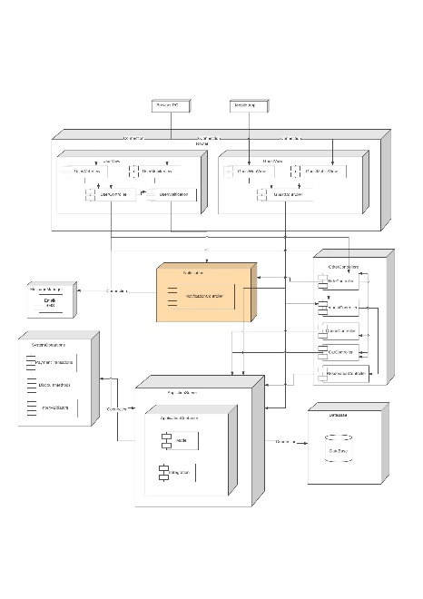 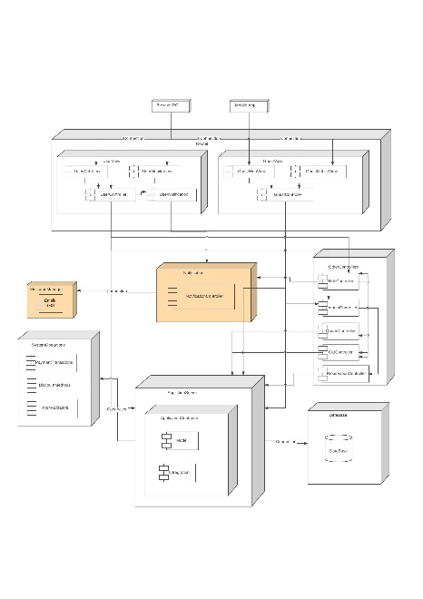 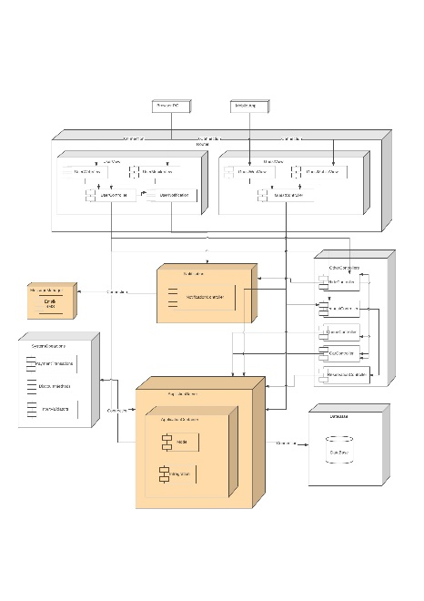

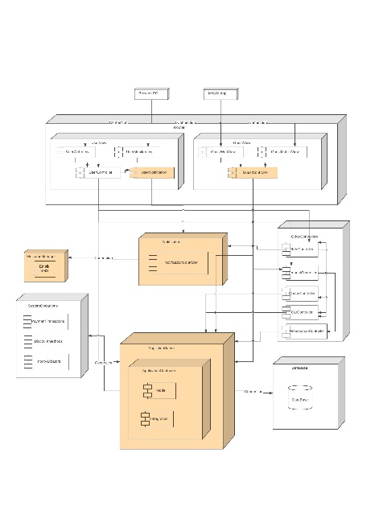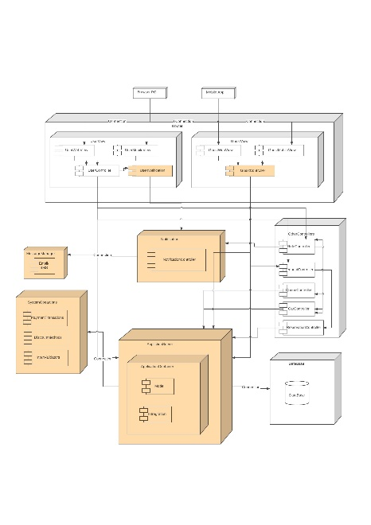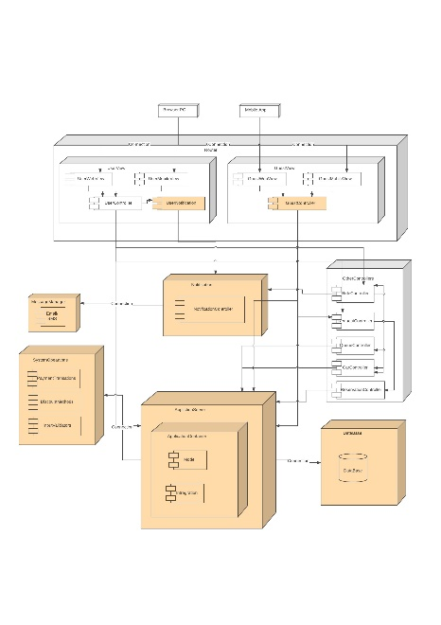

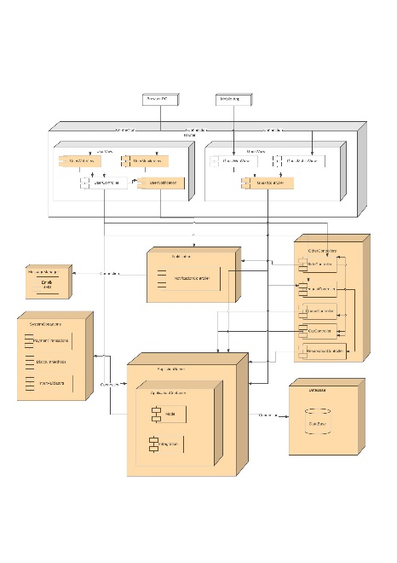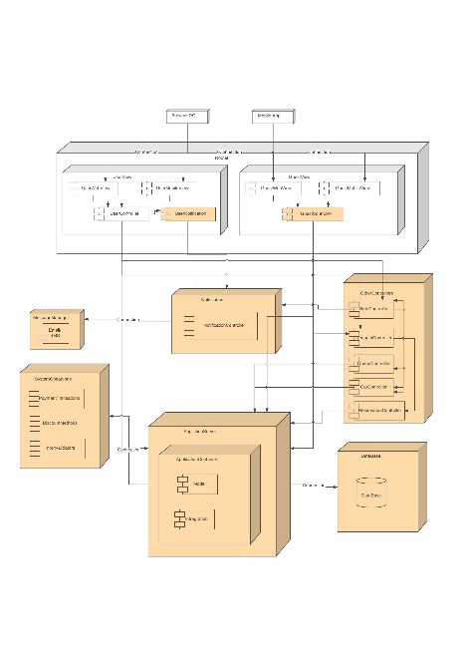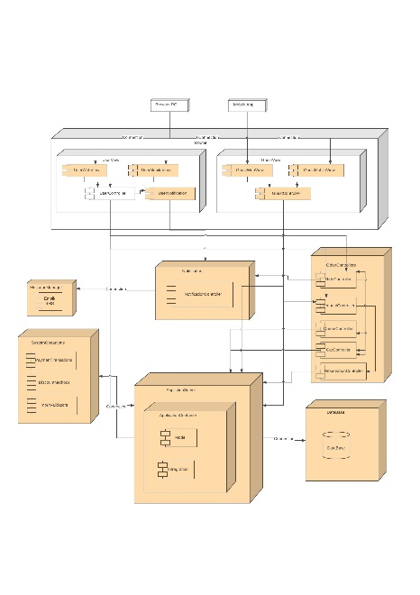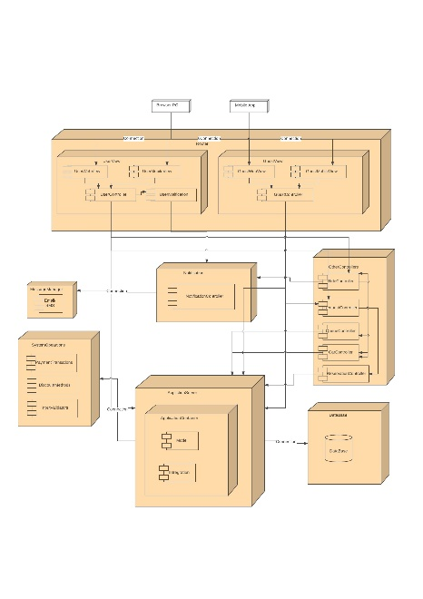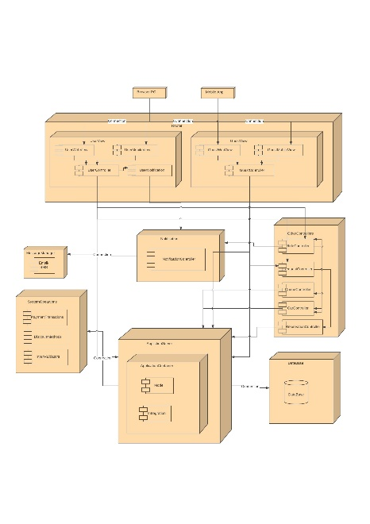

# Hours of Work

Prasanth R: 18 hrs

Fathima B:

Lipika L:

# Change Log:

* V 1.1
  + Created basic structure of the document.
  + Added all initial basic things to the document.
* V 1.2
  + Added all tests needed to performed.
  + Added all diagrams which represents the integration sequence.