Amazon Bedrock AgentCore Identity – Detailed Notes
1. What is AgentCore Identity?
Amazon Bedrock AgentCore Identity is a security service designed specifically for AI agents. It manages identity, authentication, authorization, and credentials in one place. Instead of developers manually handling login, tokens, API keys, and secrets, AgentCore Identity securely manages them. This allows AI agents to safely access AWS services and third-party applications while following enterprise security standards and reducing the risk of credential exposure.

2. Why do we need AgentCore Identity?
AI agents often perform actions on behalf of users, such as reading emails, accessing databases, or creating GitHub issues. These actions require secure authentication and proper permissions. AgentCore Identity ensures the agent proves its identity, receives the correct credentials, and accesses only authorized resources. This eliminates the need to hardcode secrets and simplifies secure integrations with multiple external services.

3. Identity vs Authentication vs Authorization vs Credential Management
Although these terms are related, they have different purposes:
- Identity – Identifies who the user or agent is.
- Authentication – Verifies that the identity is genuine (login process).
- Authorization – Determines what actions the authenticated user or agent is allowed to perform.
- Credential Management – Securely stores and manages passwords, tokens, API keys, client secrets, and certificates.
AgentCore Identity combines all these capabilities into a single managed service for AI agents.

4. Access AWS Resources and Third-Party Services
AgentCore Identity allows AI agents to access AWS resources (such as Lambda, S3, DynamoDB) and third-party services (such as Google, GitHub, Slack, and Salesforce). The important point is that the agent performs these actions on behalf of the user. Instead of using the agent's own identity, it uses securely managed credentials that represent the user's permissions while maintaining complete security and access control.

5. "On Behalf of the User" Explained
Suppose a user asks:
"Create a GitHub issue for my project."
The agent does not own the GitHub account. Instead, the user first authorizes the application through OAuth. AgentCore Identity securely stores the user's access token. Later, whenever the agent needs to call GitHub, it uses that stored token. The action is performed using the user's permissions, not the agent's own identity.

6. Strict Security Controls
Every request made by an AI agent is protected using security controls. AgentCore Identity ensures only authenticated users and authorized agents can access sensitive resources. It prevents unauthorized API calls, protects stored credentials, and enforces enterprise security policies. This helps organizations safely deploy AI agents without exposing confidential information or allowing unauthorized access to business systems.

7. Audit Trails
AgentCore Identity maintains audit logs for security and compliance purposes. Every important action, such as authentication, token usage, API access, or credential operations, can be recorded. These logs help administrators understand who performed an action, when it happened, and which resource was accessed. Audit trails are essential for debugging, compliance, security investigations, and enterprise governance.

Authentication Methods Supported
8. AWS Signature Version 4 (SigV4)
SigV4 is AWS's standard authentication mechanism for AWS services. Whenever an AI agent accesses services like Amazon S3, Lambda, DynamoDB, or Bedrock, the request is digitally signed using AWS credentials. AWS verifies the signature before accepting the request. This ensures the request has not been modified and is coming from an authenticated AWS identity.

9. OAuth 2.0
OAuth 2.0 is the industry-standard authorization framework used by services such as Google, GitHub, Slack, Microsoft, and Salesforce. Instead of sharing usernames and passwords, users grant permission to the application. The application receives an access token that allows the AI agent to perform approved actions. AgentCore Identity securely stores, refreshes, and manages these OAuth tokens automatically.

10. API Keys
Some APIs use API keys instead of OAuth authentication. Examples include weather APIs, translation APIs, and many SaaS services. AgentCore Identity securely stores these API keys instead of hardcoding them into the application. When the AI agent needs to call the API, the correct key is automatically supplied, reducing security risks and simplifying credential management.

Encryption
11. AWS Owned Keys
By default, AgentCore Identity encrypts stored credentials using AWS-owned encryption keys. AWS manages the complete lifecycle of these keys, including generation, storage, rotation, and security. Developers do not need to configure anything. This option is suitable for most applications that do not require direct control over encryption key management.

12. Customer Managed Keys (AWS KMS)
Organizations with strict compliance or security requirements can choose Customer Managed Keys (CMKs) from AWS Key Management Service (KMS). The organization owns and controls the encryption key. Administrators can rotate keys, disable them, restrict access, and monitor every usage through CloudTrail. This provides greater security, compliance, and operational control over sensitive credentials.

OAuth Providers
13. Managed OAuth Providers
AgentCore Identity supports popular OAuth providers such as Google, GitHub, Slack, Salesforce, and other OAuth 2.0 compatible identity providers. Instead of implementing OAuth separately for every provider, developers can configure these providers once in AgentCore Identity. This simplifies authentication and provides a consistent way to securely integrate external services.

Inbound and Outbound Authentication
14. Inbound Authentication
Inbound authentication happens when a user logs into your AI application. The authentication request comes into your application from an external identity provider like Google or Microsoft. After successful login, AgentCore Identity verifies the user and establishes a trusted identity that the AI agent can use during future interactions.
Example:
User → Google Login → AgentCore Identity → AI Application

15. Outbound Authentication
Outbound authentication happens when the AI agent calls another service after receiving a user request. Instead of asking the user to log in every time, AgentCore Identity uses securely stored credentials or OAuth tokens to authenticate with external systems such as GitHub, Slack, Salesforce, or AWS services. This allows the agent to perform actions safely on behalf of the authenticated user.
Example:
AI Agent → AgentCore Identity → GitHub API

Real-World Example
A user signs into an AI assistant using Google. AgentCore Identity authenticates the user and securely stores the OAuth token. Later, the user asks:
"Create a GitHub issue and send a Slack notification."
The AI agent requests credentials from AgentCore Identity. The stored GitHub and Slack OAuth tokens are used to authenticate with both services. The actions are performed on behalf of the user, while all credentials remain encrypted and every request is recorded in audit logs.

Quick Revision
Concept | Meaning
Identity | Identifies the user or AI agent.
Authentication | Verifies identity through login.
Authorization | Determines allowed actions after authentication.
Credential Management | Securely stores tokens, API keys, and secrets.
SigV4 | AWS authentication method for AWS services.
OAuth 2.0 | Authorization method for third-party services like Google and GitHub.
API Keys | Authentication using a unique API key.
AWS Owned Keys | AWS manages encryption keys automatically.
Customer Managed Keys | Customer controls encryption keys using AWS KMS.
Inbound Authentication | User logs into the AI application.
Outbound Authentication | AI agent securely calls external services on behalf of the user.
Audit Trail | Records every authentication and access event for security and compliance.
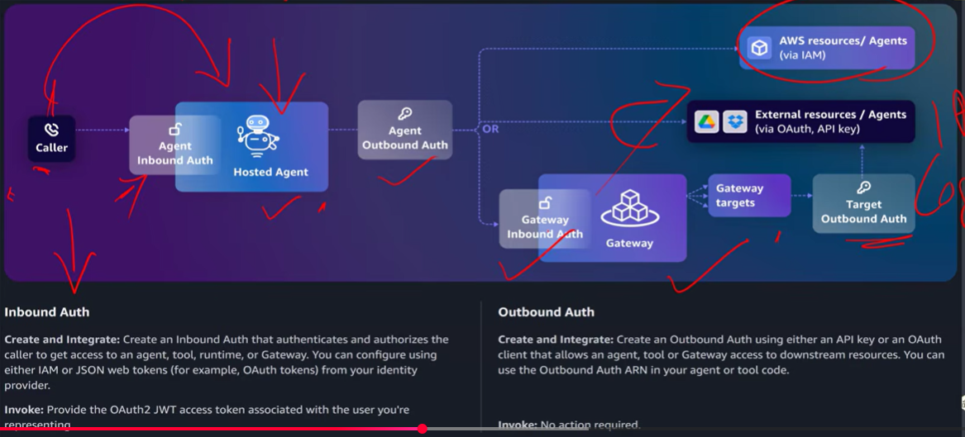

1. What is Authentication?
Authentication is the process of verifying the identity of a user, application, or AI agent before granting access to any resource or service. It answers the question "Who are you?". Authentication ensures that only legitimate users or systems can access protected resources. In Amazon Bedrock AgentCore Identity, authentication is managed securely using mechanisms such as OAuth 2.0, AWS Signature Version 4 (SigV4), API Keys, or enterprise identity providers. Authentication always happens before authorization because the system must first know who is making the request.

2. What is Inbound Authentication?
Inbound Authentication occurs when a user or an external application logs into your AI application. The authentication request comes from outside into your application. During this process, the user's identity is verified using an Identity Provider such as Google, Microsoft, Amazon Cognito, Okta, or a corporate Single Sign-On (SSO) system. After successful authentication, AgentCore Identity creates a trusted identity for the user, allowing the AI agent to perform actions on behalf of that authenticated user throughout the session.
Example:
User → Google Login → AgentCore Identity → AI Application

3. Why is Inbound Authentication Important?
Inbound Authentication protects your AI application from unauthorized access by ensuring that only verified users can use the system. It also allows the application to identify who is interacting with the AI agent and what permissions that user should have. Once the user is authenticated, the application can maintain a secure session and use the user's identity for future authorization decisions. This process is essential for enterprise applications where user identity, security, and compliance are critical requirements.

4. What is Outbound Authentication?
Outbound Authentication occurs when the AI agent accesses another service after receiving a user's request. In this case, the authentication request goes from your application to an external system. The AI agent uses securely stored credentials such as OAuth access tokens, API keys, IAM roles, or SigV4-signed requests to prove its identity to the external service. This allows the agent to perform actions on behalf of the authenticated user without asking the user to log in repeatedly.
Example:
AI Agent → OAuth Token → GitHub API

5. Why is Outbound Authentication Important?
AI agents frequently communicate with external services such as GitHub, Slack, Salesforce, Google Calendar, Amazon S3, or DynamoDB. Every external service must verify that the request is coming from a trusted source before allowing access. Outbound Authentication provides this verification by securely using stored credentials instead of hardcoding usernames, passwords, or API keys inside the application. It also supports automatic token refresh, improves security, simplifies integration, and helps maintain compliance with enterprise security standards.

6. Difference Between Inbound and Outbound Authentication
Although both processes involve authentication, they happen in opposite directions. Inbound Authentication verifies users entering your application, while Outbound Authentication verifies your AI agent when it accesses external systems. Inbound Authentication establishes the user's identity, whereas Outbound Authentication allows the agent to securely communicate with third-party services using the user's approved credentials. Both processes work together to create a secure end-to-end authentication flow in enterprise AI applications.

7. Real-World Example
Suppose a user signs into an AI Assistant using Google. This is Inbound Authentication because the user is proving their identity before accessing the application. Later, the user asks the AI assistant to create a GitHub issue and send a Slack notification. The AI agent uses the user's previously stored OAuth tokens to authenticate with GitHub and Slack APIs. This is Outbound Authentication because the agent is securely accessing external services on behalf of the authenticated user.

8. Complete Authentication Flow
The complete authentication process begins when a user logs into the AI application using an identity provider such as Google or Amazon Cognito. AgentCore Identity verifies the user's identity and establishes a secure session. Later, when the user requests an action that requires an external service, the AI agent retrieves the required credentials from AgentCore Identity and authenticates with that service. This ensures secure communication, protects sensitive credentials, and enables the agent to safely perform actions on behalf of the authenticated user.

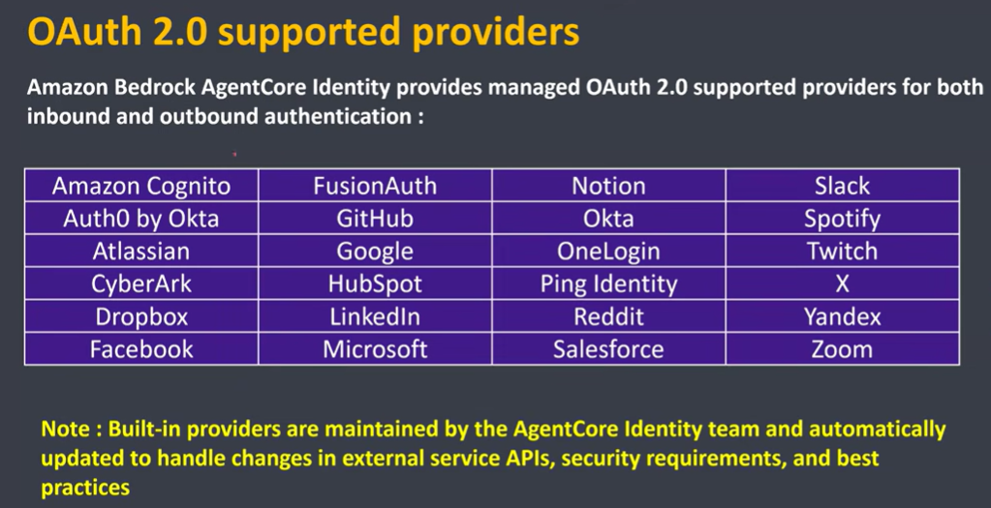

Although they are all called Client IDs, they belong to different systems and serve different purposes.
1. Google Client ID
- Issued by Google OAuth.
- Used when users sign in with Google Login.
- Identifies your application to Google's authentication server.
- Google uses this Client ID to verify that the login request is coming from a registered application.
Flow:
User → Google Login → Google (checks Client ID) → Access Token

2. Amazon Cognito Client ID
- Issued by an Amazon Cognito User Pool.
- Represents an App Client in Cognito.
- Used during authentication with Cognito.
- Tells Cognito which application is requesting authentication.
- After successful authentication, Cognito issues JWT tokens (ID Token, Access Token, Refresh Token).
Flow:
User → Amazon Cognito (checks App Client ID) → JWT Tokens

3. AgentCore Gateway Client ID
- Used by the AgentCore Gateway.
- Identifies the AI Agent or application accessing the Gateway.
- Helps the Gateway determine:
  - Which agent is making the request.
  - What tools the agent is allowed to access.
  - Which security policies and permissions should be applied.
- This Client ID is for Gateway authorization and agent identification, not for user login.
Flow:
Agent → AgentCore Gateway (checks Client ID) → Allowed Tools

