Modeling Black Panther Suit Response to Force and Temperature Inputs

Signals and Systems Course Project

Department of Biomedical Engineering

September 2018

Rachel K. Surridge



# Introduction

The purpose of this project is to develop mathematical models for the force and temperature-dissipation capabilities of vibranium-based suit material. The suit has demonstrated promising heat-dissipation qualities, and mathematical modeling is needed to further characterize this behavior. Of particular interest is the material’s ability to prevent or delay thermal burns. Data indicates that contact exposure to temperatures above 68-70°C will cause thermal burns in less than 1 second, and prolonged exposure to temperatures above 50°C are also capable of causing injury [1] (see Figure 1). A model developed from initial experimental data will allow us to model the suit’s response to brief and prolonged heat exposure and characterize risk to the wearer.

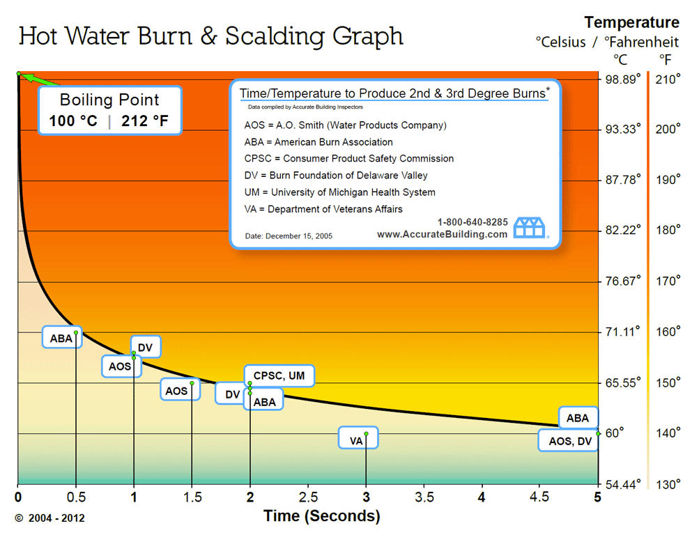

Figure : Aggregated data defining the relationship between second and third degree burn injury vs contact time at various temperatures, courtesy of Accurate Building Inspectors [1].

The potential of vibranium to confer force-dissipation and energy-redistribution qualities is still being explored, but initial tests suggest that the force filtering can be modeled using a linear, time-invariant, causal system. Initial prototypes aim to significantly attenuate forces with frequencies greater than 4 Hz, to protect the wearer from sudden impact. A model will be developed and used to characterize force attenuation for sinusoidal inputs of various frequencies.

# Methods

In order to determine the system that governed the temperature response of the material, the given dataset was interpreted as a total response – a sum of both a forced and a natural response.

First the exponential curve in the data was considered. The positive shift of 25°C was removed and the data was fit using a single term exponential curve and a sum of two exponential terms. The latter was performed under the assumption that the first five data points (0-0.5 seconds) would be primarily governed by the exponential term with the smaller time constant (Τ1). The next exponential term was fit to data points collected at time greater than 5Τ1 to minimize the impact of the behavior of the first exponential term on the second (3-3.5 seconds).

The positive shift of 25°C was assumed to represent the system response to the external energy input from the room where the material was being tested.

The total response curve was modeled generally as

$y\left(t\right)=C1e^{{-t}/{Τ1}}+ C2e^{{-t}/{Τ2}}+T$ [1]

The first two terms in the equation, the exponentials, were assumed to represent the natural modes of the system and therefore the natural response.

$y_{n}\left(t\right)=C1e^{-At}+ C2e^{-Bt}$ [2]

A natural response of two modes indicates a second-order system. Since $y_{n}$ is derived from Q(D), the system can be represented as

${(D}^{2}+\left(A+B\right)D+AB)y\left(t\right)= P\left(D\right)x(t)$ [3]

$T$ was assumed to represent the forced response. By the method of undetermined coefficients, the forced response to a constant input is a constant. Since the given dataset was collected in a temperature-controlled room, it can be assumed that the input was a constant and was assumed to be 25°C.

$y_{∅}\left(t\right)=25$ [4]

Substituting Eq. 4 into Eq. 3 and setting x(t) = 25 yields

$25AB=25P(D)$ [5]

Therefore, P(D) = AB and the system equation can be written as

${(D}^{2}+\left(A+B\right)D+AB)y\left(t\right)= ABx(t)$ [6]

For all simulated testing conditions, it was assumed that starting conditions were consistent with the material being fully acclimated at room temp (y(0) = 25). Based on the idea that a material cannot respond instantaneously to temperature, y’(0) was assumed to be 0. For piecewise inputs, the initial conditions were assumed to be the final conditions of the previous function.

In order to characterize the force response of the suit, a second-order low pass filter was designed in accordance with the second-order low-pass unity gain transfer function typically modeled by an RLC circuit [2].

$H\left(s\right)= \frac{{ω_{n}}^{2}}{s^{2}+2ζω_{n}s+{ω_{n}}^{2}}$ [7]

The transfer function represents the frequency response of the system to inputs of the form $x\left(t\right)= e^{st }$ via the relationship

$H\left(s\right)=\frac{P(s)}{Q(s)}$ [8]

as demonstrated by Lathi [3]. Via this relationship, the system equation can be written as

${(D}^{2}+2ζω_{n}D+{ω_{n}}^{2})y\left(t\right)= {ω_{n}}^{2}x(t)$ [9]

Values of $ω_{n}$ and $ζ$ were determined from the design criteria in the problem statement. The system behavior in response to sinusoidal inputs was demonstrated with a bode plot and an amplitude vs frequency curve.

# Results

From the curve fit on the temperature data, the coefficients A and B for Eq. 2 were found to be 1.678 and 0.1624, making the overall system equation

$y^{''}+1.8404y'+0.2725y=0.2725x$ [10]

The response to the piecewise input

$x\left(t\right)=300 (u\left(t\right)-u\left(t-1\right))$ [11]

is shown below.

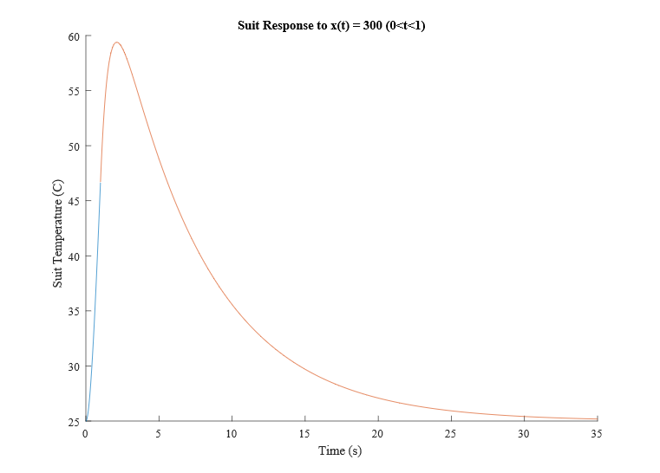

Figure : Temperature of suit in response to x(t) = 300(u(t) - u(t-1)). Blue portion represents response from 0 to 1 second, red portion represents response from 1 to 35 seconds.

The maximum temperature in this response occurs at t = 2.13 s and has a value of 59.4°C. The response does not exceed 70°C, the temperature at which thermal burns can occur.

The response exceeds of 50°C for 3.57 seconds, which is less than the 20 seconds necessary to cause thermal burns.

The response to the input

$x\left(t\right)=150 u(t)$ [12]

is shown below.

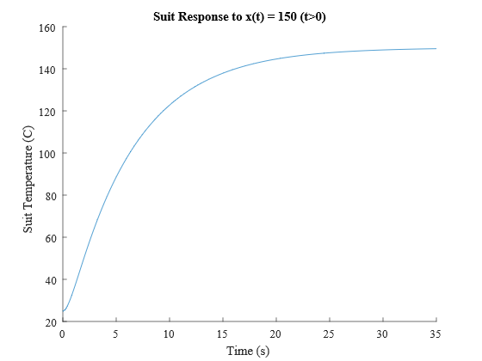

Figure : Temperature of suit in response to x(t) = 150 u(t).

The limit of this response as time approaches infinity is 150°C, so for all intents and purposes, the maximum temperature of the material under these conditions is 150°C.

The temperature exceeds 50°C at 1.98 seconds and 70°C at 3.38 seconds and continues to increase towards the limit as time increases.

From the design criteria for the force filter system, $ω_{n}$ was set equal to 25.13 rad/sec (4 Hz), and $ζ$ was set equal to 0.7071, defining a critically damped system. This degree of damping was chosen because an underdamped system would result in resonance, posing a risk to the wearer. An overdamped system will recover slowly, and will attenuate inputs at the resonant frequency to a greater extent, decreasing the wearer’s tactile sensitivity.

According to Eq. x, the system can be characterized with the following equation:

$y^{''}+35.5y'+631.5y=631.5x$ [13]

The bode plot demonstrates the extent to which the input signal $e^{st}$ is attenuated depending on its’ frequency. Since sinusoidal inputs can be represented in the form $e^{st}$ according to Euler’s formula, this plot is representative of the system response to sinusoidal inputs of varying frequencies.

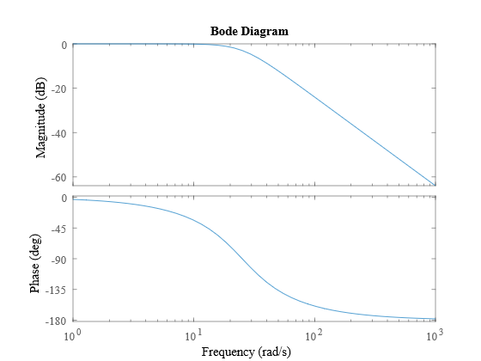

Figure : Bode plot of second-order low-pass filter described in Eq. x

Another (slightly more inituitive) way to visualize this response is by defining a sinusoidal input with a known amplitude and varying frequencies, and plotting the amplitude of the ouput vs input frequency.

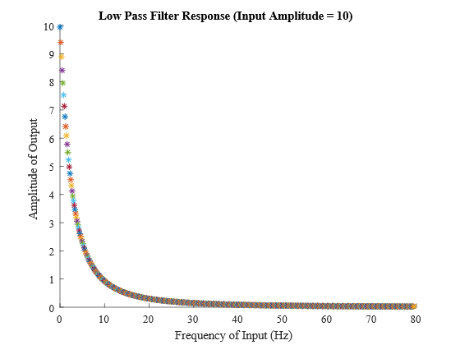

Figure : Amplitude of output in response to input with amplitude of 10 and variable frequency.

This plot demonstrates that unhindered tactile sensitivity is maintained only for input frequencies very close to zero. As the input frequency approaches the cut-off of 4Hz, the output is attenuated by approximately 70%. High frequency inputs are greatly attenuated, and the output amplitude is approximately 0.2% of the input by the time frequency reaches 80 Hz.

# Discussion & Conclusion

The second-order system derived from the provided temperature data indicates that the suit material confers protection against brief exposures to high temperatures. The data provided and the model developed suggests that the suit is incapable of self-cooling to maintain a temperature offset in the presence of a constant, long-lasting input, meaning that any sustained exposure to unsafe temperatures will eventually result in thermal burns to the wearer. However, the material properties allow the wearer to tolerate brief exposure to temperatures that would without doubt cause third degree burns to exposed skin, as demonstrated in Figure 2.

Some assumptions were made about the initial conditions of the system in the modeled responses that may or not be accurate, which becomes especially relevant in the modeled response in Figure 2. Depending on how fast the system conditions can change in response to suddenly changing inputs, the estimated y’(0) and y’(1) values may vary from initial estimates, and the temperature of the material may not overshoot the temperature reached at t=1 in response to x(t) = 300(u(t)-u(t-1)).

By modeling the system equation (Eq. 10) as a second order low-pass filter via Eq. 9, the damping coefficient can be calculated as 1.76, indicating an over-damped system. This value suggests that the response will not oscillate in response to a sudden input, which calls into question the accuracy of the modeled response in Figure 2. If the system does not overshoot, then the extent to which the material confers protection will increase (since temperature will not continue to increase post-exposure), and the wearer will be able to tolerate higher temperature exposures for longer.

The proposed system equation for force dissipation demonstrates significant attenuation of high-frequency forces. However, the system does attenuate forces below the cut-off frequency to some extent. Depending on how desirable tactile sensitivity is at these lower frequencies, the cut-off frequency can be increased to minimize the impact of attenuation at 4 Hz. Reducing the damping coefficient would also confer greater sensitivity at the cutoff frequency but is not recommended due to the resulting amplification of forces at the resonant frequency, endangering the wearer.

It is worth noting that while sudden-impact forces are high-frequency, sonic weapons often generate infrasonic waveforms (<20 Hz) [4]. Infrasonic waveforms are inaudible but can cause significant harm at high enough amplitudes. Waveforms at 19 Hz have been demonstrated to induce visual disturbances, and very low frequency waveforms of 0.5-8Hz at 177 dB have interfered with respiration. Infrasonic exposure to lower amplitude waveforms induce nausea and interfere with hearing [5].

Intelligence from Stark Industries confirms that the Mark II War Machine Armor features an on-board long-range acoustic device capable of generating infrasonic waveforms [6]. In order to minimize unintended collateral harm to the wearer during allied combat, it is highly suggested that the force response of the suit be modified to confer protection against sonic waveforms greater than 0.5 Hz.

This data demonstrates promising temperature and force dissipation behavior of prototype vibranium-based textiles. Development of linear, time-invariant, causal mathematical models of material behavior have allowed the prediction of suit response to various thermal and force inputs. Further testing should be conducted to thoroughly characterize material behavior and refine the resulting mathematical models.



# References

[1] “Hot Water Burn Prevention & Consumer Safety,” Accurate Building Inspectors. [Online]. Available: http://www.accuratebuilding.com/services/legal/charts/hot_water_burn_scalding_graph.html. [Accessed: 15-Sep-2018].

[2] “RLC circuit,” Wikipedia. [Online]. Available at: https://en.wikipedia.org/wiki/RLC_circuit [Accessed 15-Sep-2018].

[3] B.P. Lathi, *Linear Systems and Signals,* 2nd ed. New York: Oxford University, 2018.

[4] “Infrasound,” Wikipedia. [Online]. Available at: <https://en.wikipedia.org/wiki/Infrasound>. [Accessed: 15-Sept-2018].

[5] S. S. Horowitz, “Could A Sonic Weapon Make Your Head Explode?” *Popular Science,* 20-Nov-2012. [Online]. Available: <https://www.popsci.com/technology/article/2012-11/acoustic-weapons-book-excerpt>. [Accessed: 15-Sept-2018].

[6] “Stark Sonic Canon,” Marvel Cinematic Universe Wiki. [Online]. Available at: <http://marvelcinematicuniverse.wikia.com/wiki/Stark_Sonic_Cannon>. [Accessed: 15-Sept-2018].

# Appendix

### MATLAB CODE (PART 1)

time = tempdata(:,1);

temp = tempdata(:,2);

%This curve has poor fit with a single exponential term and does not decay

%to 0

%ASSUMPTION 1:

%This response can be approximated as the sum of two natural modes.

%ASSUMPTION 2:

%The response decays towards a constant ambient temperature of 25*C

%If the time constant on the natural modes is sufficiently different, the

%initial decay will be primarily governed by the mode with the smaller

%time constant, while the later decay will be primarily governed by the

%mode with the larger time constant.

%Therefore, time[0:0.5] will be used to estimate the smaller time constant.

region1_time = time(1:6);

region1_temp = temp(1:6);

% y = a*exp(b*x)

% ln y = ln a + b*x

% a0 = intercept = ln a

% a1 = slope = b

y_lin = log(region1_temp);

x_lin = region1_time;

n = length(x_lin);

sum_xy = sum(y_lin.*x_lin);

sum_x = sum(x_lin);

sum_y = sum(y_lin);

sum_x2 = sum(x_lin.^2);

sum_x_2 = sum_x^2;

a1 = (n*sum_xy - sum_x*sum_y)/(n*sum_x2 - sum_x_2);

%From curve fit, a*exp(b*x), b = -1.678

%A b value of -1.678 translates to a time constant (T1) of approximately

%0.60 seconds. By t = 5*T1, the influence of this mode will be orders of

%magnitude less than the mode with the larger time constant.

%Therefore, we will calculate the next mode for time[3:3.5].

region2_time = time(31:36);

region2_temp = temp(31:36);

y_lin = log(region2_temp);

x_lin = region2_time;

n = length(x_lin);

sum_xy = sum(y_lin.*x_lin);

sum_x = sum(x_lin);

sum_y = sum(y_lin);

sum_x2 = sum(x_lin.^2);

sum_x_2 = sum_x^2;

a1 = (n*sum_xy - sum_x*sum_y)/(n*sum_x2 - sum_x_2);

%From curve fit, a*exp(b*x), b = -0.1624

%Natural response, yn(t) = C1*exp(-1.678*t) + C2*exp(-0.1624*t)

%roots = (x+1.678)(x+0.1624)

%characteristic polynomial = x^2 + 1.8404x + 0.2725

%system equation: (D^2 + 1.8404D + 0.2725)y(t) = P(D)x(t)

%Assuming that the forced response of the system is 25 in the original

%data, and the input that caused that response was x(t) = 25, then P(D)

%must equal AB because both the first and second derivative of a constant

%y(t) are zero.

%% INPUT 1

%x(t) = 300u(t) - 300(u(t-1))

%This can be done by convolution since h(t) can be found via the simplified

%impulse matching method, but it's faster and more straight-forward to break the input into two

%pieces and use the final conditions from the first block as the initial

%conditions for the second.

%FOR 0<t<1

%yn = K1*exp(-1.678*t) + K2*exp(-0.1624*t); %natural response

%yp = B; %forced response

%yp' = 0;

%yp'' = 0

%0.2725B = 0.2725*300;

%B = 300;

yp = 300;

%assuming initial conditions y(t) = 25 and y'(t) = 0

%25 = K1 + K2 + 300;

%K1 = -275 - K2

%0 = -1.678K1 - 0.1624K2

%K1 = -0.0968K2

%-0.0968K2 = -275 - K2

K2 = -275/(-0.0968+1);

K1 = -275 - K2;

t = 0:0.01:1;

ya = K1*exp(-1.678*t) + K2*exp(-0.1624*t) + yp;

figure(1)

hold on

plot(t,ya)

t = 1;

dy1 = -1.678*K1*exp(-1.678*t) - 0.1624*K2*exp(-0.1624*t);

y1 = K1*exp(-1.678*t) + K2*exp(-0.1624*t) + yp;

%FOR t>1

yp = 25;

%y1-25 = K1 + K2;

%dy1 = -1.678K1 - 0.1624K2

%K1 = y1 - 25 - K2;

%K1 = (dy1 + 0.1624K2)/(-1.678)

%y1 - 25 - K2 = (dy1 + 0.1624K2)/(-1.678)

K2 = (-1.678*(y1-25) - dy1)/(0.1624-1.678);

K1 = y1-25-K2;

t = 0:0.01:34;

yb = K1*exp(-1.678*t) + K2*exp(-0.1624*t) + yp;

x = t+1;

plot(x,yb)

title('Suit Response to x(t) = 300 (0<t<1)')

ylabel('Suit Temperature (C)')

xlabel('Time (s)')

knit_y = [ya yb];

knit_x = 0:0.01:35;

max_temp = max(knit_y);

max_temp_time = knit_x(find(knit_y==max(knit_y)));

range50 = find(knit_y>=50);

length50 = knit_x(range50(end)) - knit_x(range50(1));

%% INPUT 2

yp = 150;

%assuming initial conditions y(t) = 25 and y'(t) = 0

%25 = K1 + K2 + 150;

%K1 = -125 - K2

%0 = -1.678K1 - 0.1624K2

%K1 = -0.0968K2

%-0.0968K2 = -125 - K2

K2 = -125/(-0.0968+1);

K1 = -125 - K2;

t = 0:0.01:35;

y = K1*exp(-1.678*t) + K2*exp(-0.1624*t) + yp;

figure(2)

hold on

plot(t,y)

title('Suit Response to x(t) = 150 (t>0)')

ylabel('Suit Temperature (C)')

xlabel('Time (s)')

temp70_time = t(find(y>=70,1));

temp50_time = t(find(y>=50,1));

## MATLAB CODE (PART 2)

%%PART 2

%We are designing a low pass filter. Considering this filter is probably designed to

%stop bullets, significant attenuation at higher frequencies is desired.

%A second order filter with a cutoff frequency of 4 Hz is a good initial

%approach.

%Borrowing from 222, we can derive the transfer function H(s) for a

%second-order low pass circuit as Wo^2/(s^2 + 2*d*Wo*s + Wo^2).

%For our system, we want an Wo value of 4 Hz and a damping coefficient of

%0.7071 for a critically damped system.

%From our textbook, we know that the transfer funtion H(s) = P(s)/Q(s).

%Thus, our second order differential equation is defined.

%(D^2 + 35.5D + 631.5)*y(t) = 631.5*x(t)

%We can demonstrate the response of this system with a bode plot, but we

%will also do it by plugging in sin functions for x(t).

s = sym('s');

sys = tf([631.5],[1 35.5 631.5]);

figure(1)

bode(sys)

w = [0.1:1:500];

amp_in = 10; %amplitude of x(t)

figure(2)

hold on

for i = 1:1:length(w)

%H(w) = Vo/Vin;

%Vo = H(w)*Vin;

Vo = 631.5/(w(i)^2 + 35.5*w(i) + 631.5)*amp_in;

plot(w(i)/(2*pi),Vo,'*')

end

xlabel('Frequency of Input (Hz)')

ylabel('Amplitude of Output')

title('Low Pass Filter Response (Input Amplitude = 10)')