TANBIR HUSSAIN
PACKET TRACER

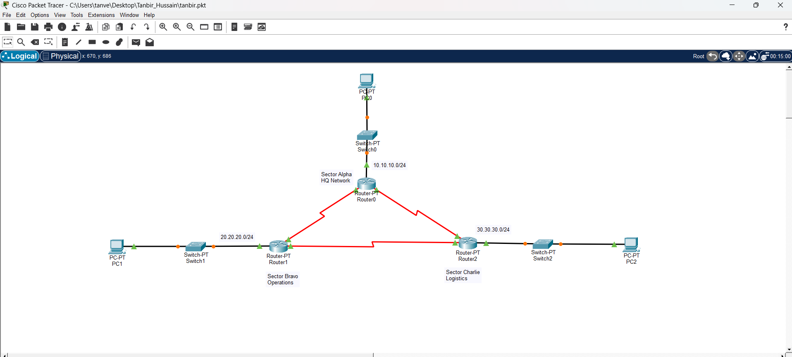

ROUTER A
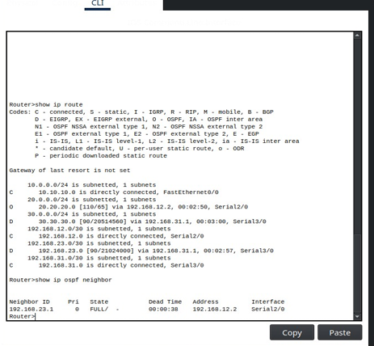

ROUTER B
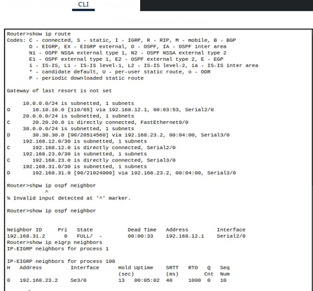

ROUTER C
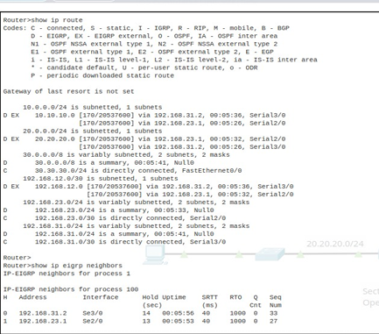

INTRODUCING ERROR
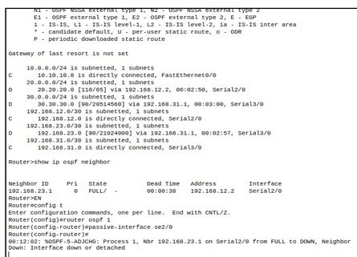

CORRECTING ERROR:-

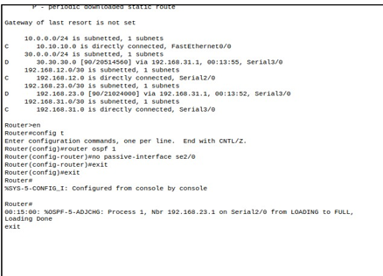

PING FROM HQ TO CHARLIE PC:-
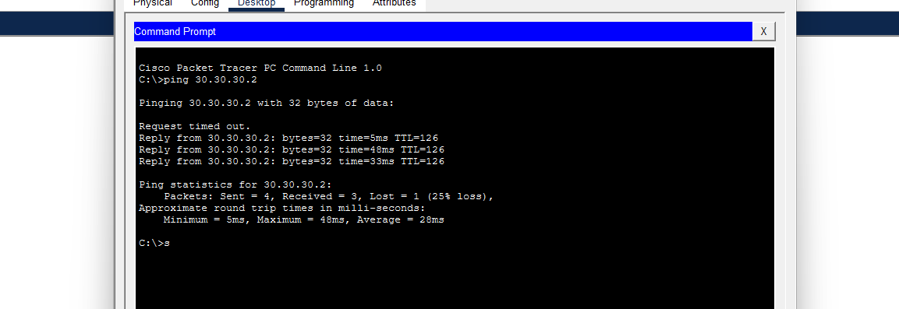

COMMANDS USED TO IDENTIFY ISSUE
- show ip route
- show ip protocols
- show ip eigrp neighbors
- show running-config

EXPLANATION OF FAILURE
- Root Cause
1.1. Missing network statement in EIGRP prevented advertisement of Charlie LAN
- Impact
2.1. OSPF routers (R1, R2) had no route to 30.30.30.0
2.2. Resulted in connectivity failure from HQ
- Resolution
3.1. Adding correct network statement restored route propagation

