TANBIR HUSSAIN
SURICATA

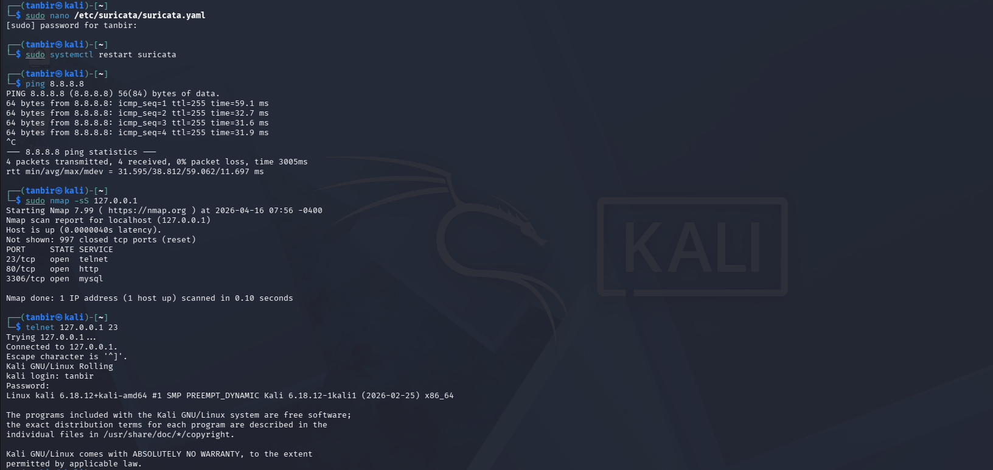

RULES ADDED:-
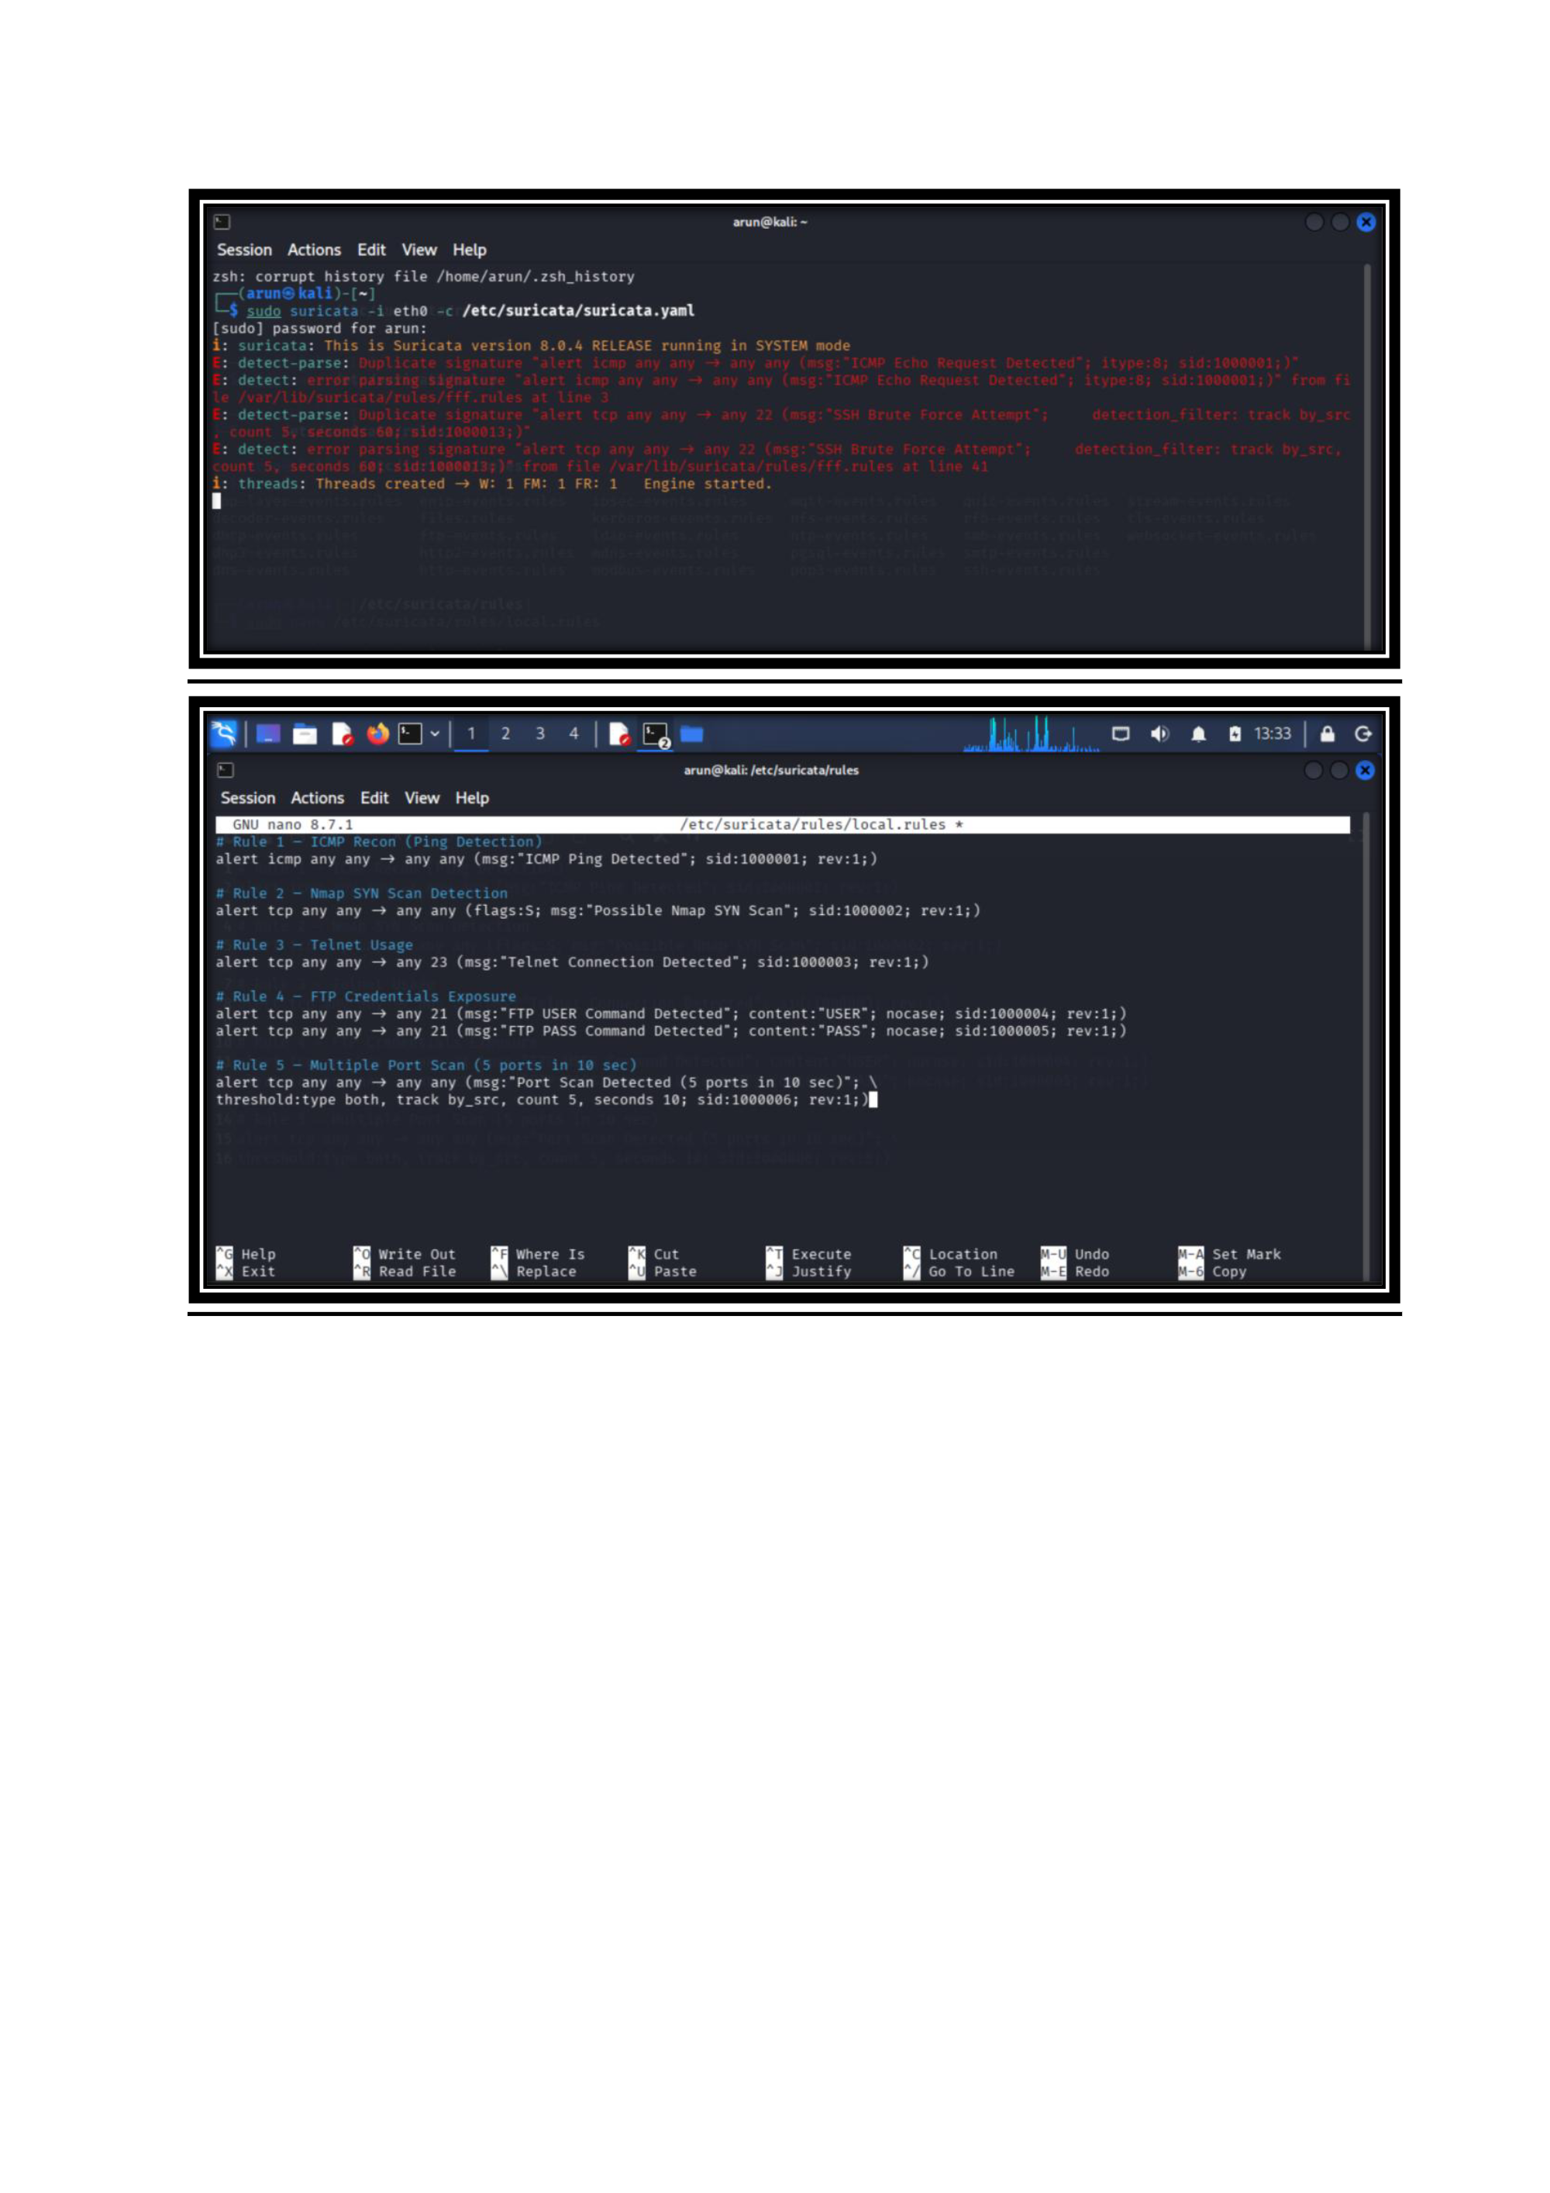

HIGHEST PRIORITY ALERT
Port Scan Detection (Rule 5)

Reason :-
- Indicates Active Reconnaissance
1.1. Port scanning is used by attackers to identify open ports and services.
1.2. It is usually the first step before launching an attack.
- Shows Malicious Intent
2.1. Unlike simple ping or normal traffic, scanning multiple ports in a short time is suspicious.
2.2. It indicates the attacker is actively probing the system.
- Precedes Exploitation
3.1. After finding open ports, attackers may exploit vulnerabilities.
3.2. Early detection helps prevent further compromise.
- Higher Risk than Other Alerts
4.1. ICMP → low risk (basic connectivity check)
4.2. Telnet/FTP → risky but depends on usage
4.3. SYN scan → important but single attempt less critical
4.4. Port scan → coordinated behavior → highest threat

