NETSTAT

Answer

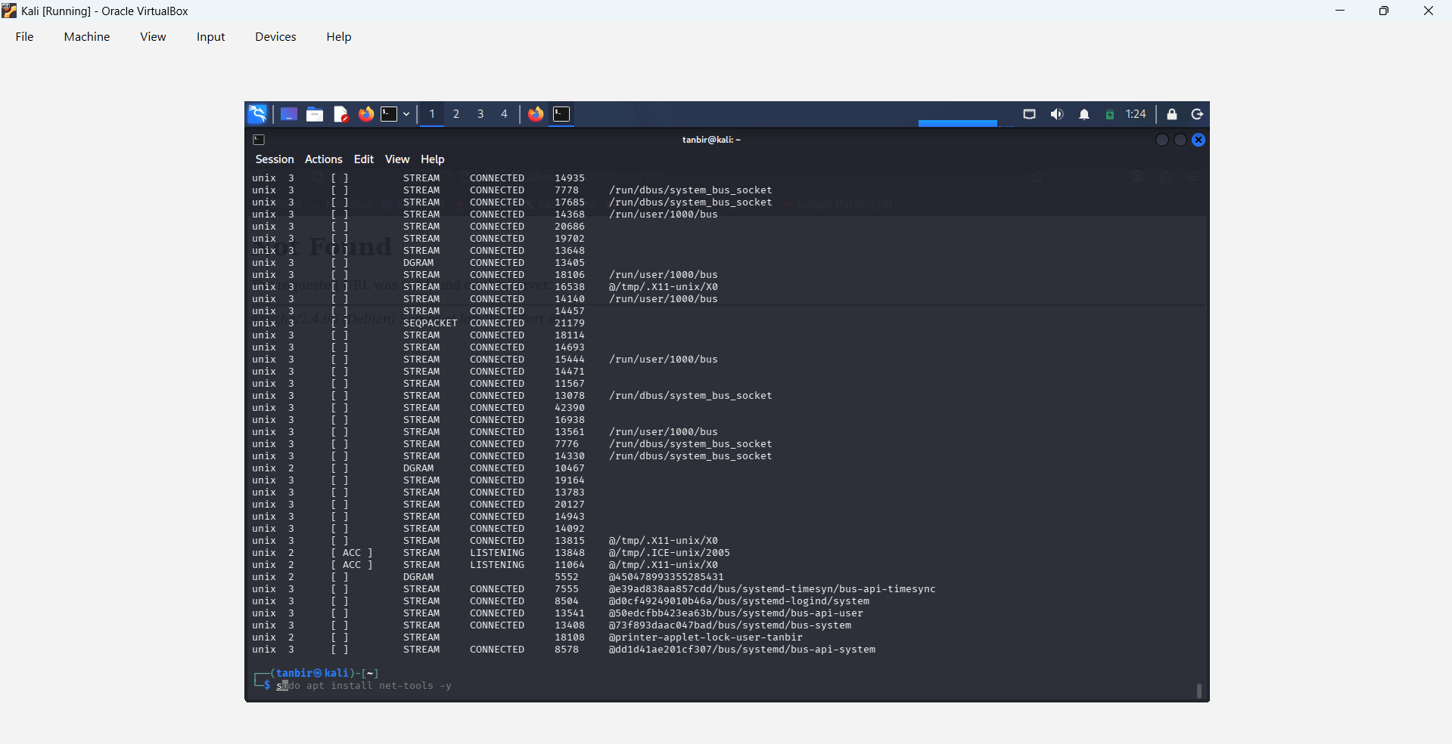

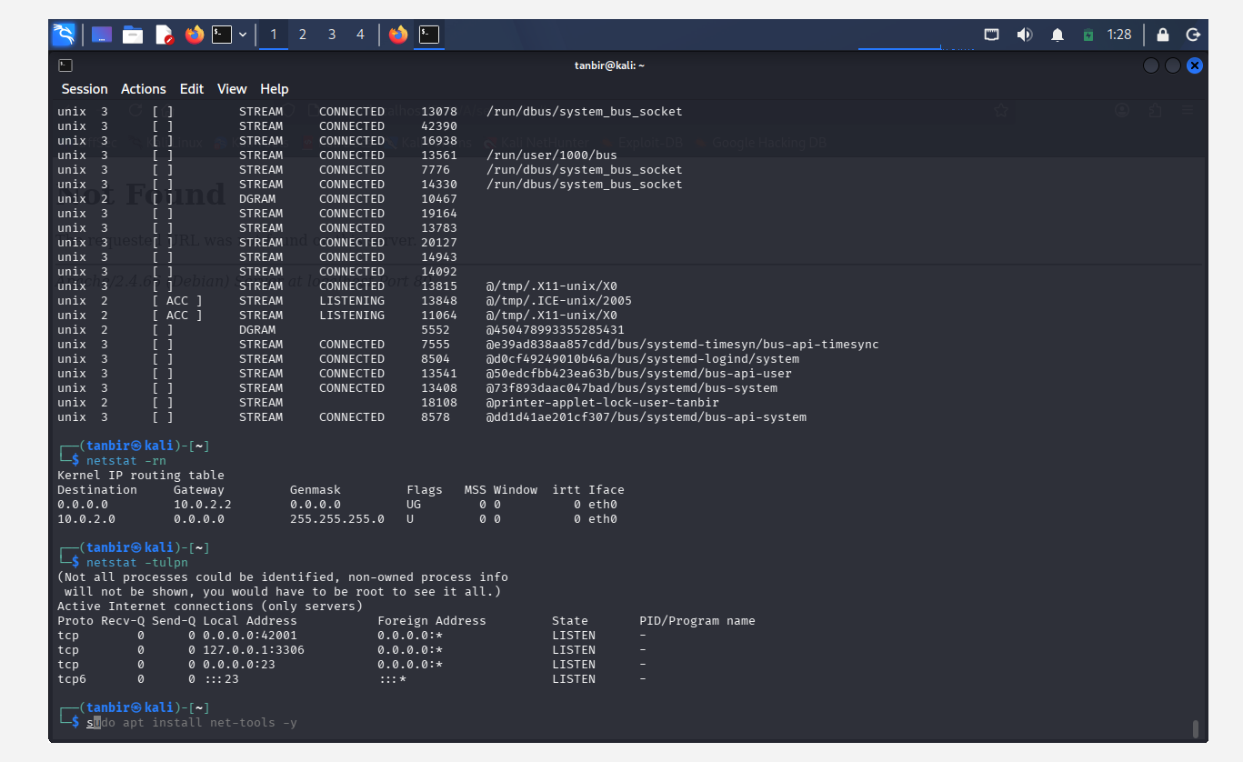

Details of suspicious IP:-

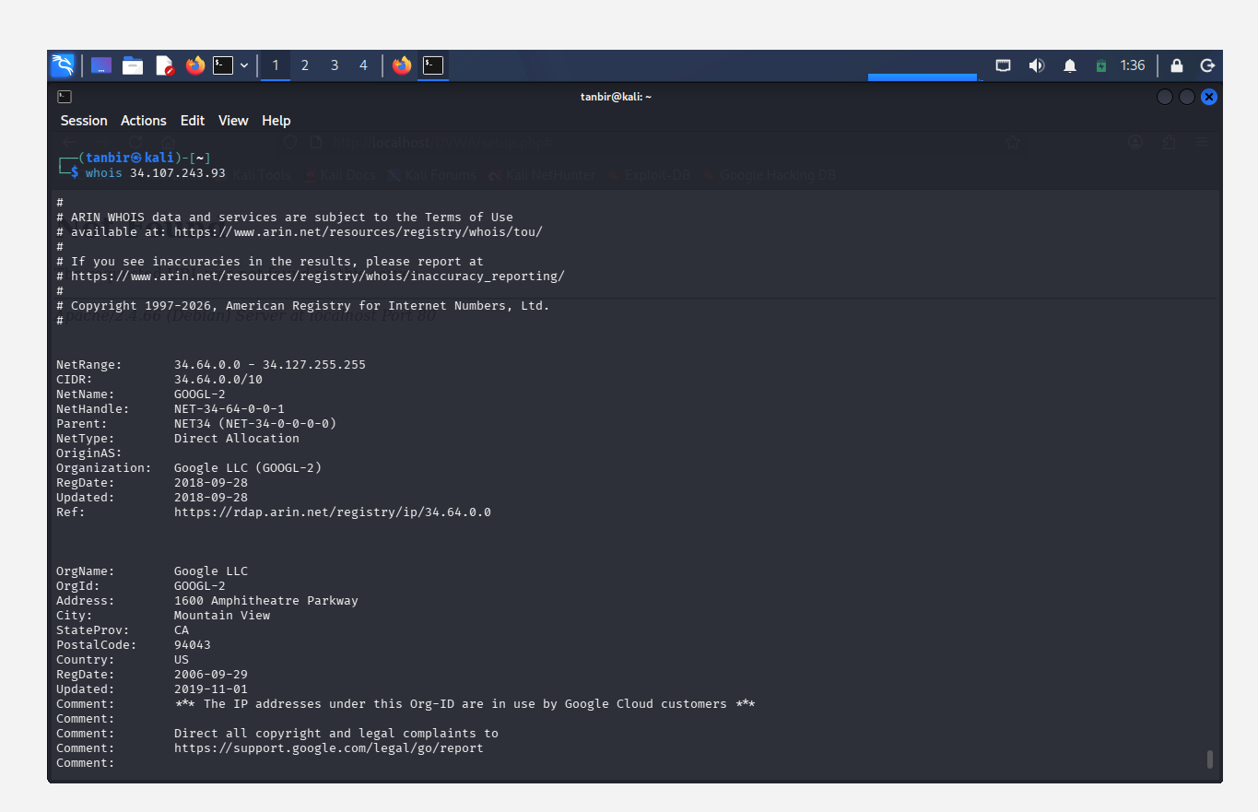

Recommended Containment steps:-

1. Terminate Suspicious Process
1.1. Identify the malicious process using PID and stop it immediately:
sudo kill -9 <PID>
1.2. This prevents further communication with unauthorized hosts.

2. Block Malicious IP Address
2.1. Block the suspicious external IP using firewall rules:
sudo iptables -A OUTPUT -d <Suspicious_IP> -j DROP
2.2. Stops all outgoing traffic to that IP.

3. Disable Suspicious Service
3.1. If the connection is from a service, stop and disable it:
sudo systemctl stop <service_name>
sudo systemctl disable <service_name>
3.2. Prevents it from restarting.

4. Scan System for Malware
4.1. Run security tools to detect hidden threats:
sudo apt update
sudo apt install rkhunter -y
sudo rkhunter --check
4.2. Helps identify rootkits or malware.

5. Check Startup Programs (Persistence)
5.1. Verify if malware is set to run at startup:
crontab -l
ls /etc/cron*
5.2. Remove any unknown scheduled tasks.

6. Check Open Ports Again
6.1. Re-run netstat to confirm system is clean:
netstat -tulpn

7. Update System & Patch Vulnerabilities
7.1. sudo apt update && sudo apt upgrade -y
7.2. Ensures system is protected from known exploits.

8. Network Isolation (If Severe)
8.1. Disconnect the system from the network:
nmcli networking off
8.2. Prevents spread of attack.

9. Change Credentials
9.1. Change system passwords
9.2. Reset SSH keys (if applicable)
9.3. Prevents unauthorized re-access.

10. Enable Firewall Protection
sudo ufw enable
sudo ufw deny from <Suspicious_IP>

