Phase 1 – Routing Crisis (Cisco Packet Tracer)

TOPOLOGY
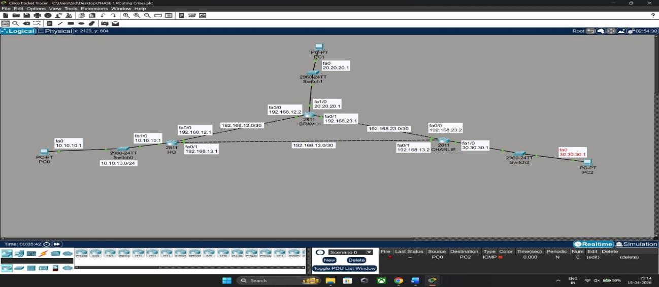

CONFIG ROUTERS

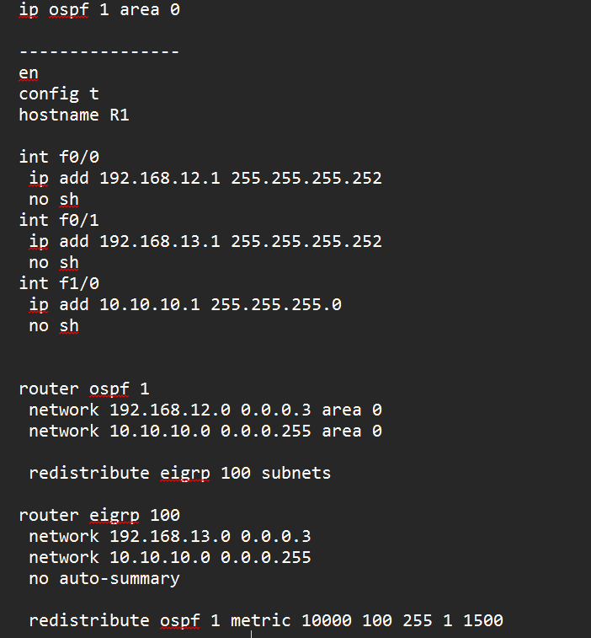
Router 1(HQ)

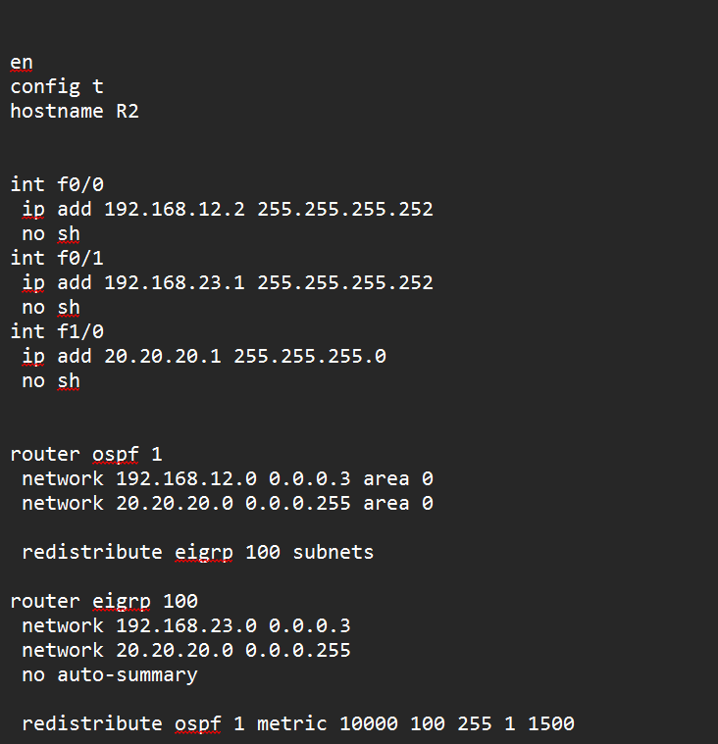
Router 2(BRAVO)

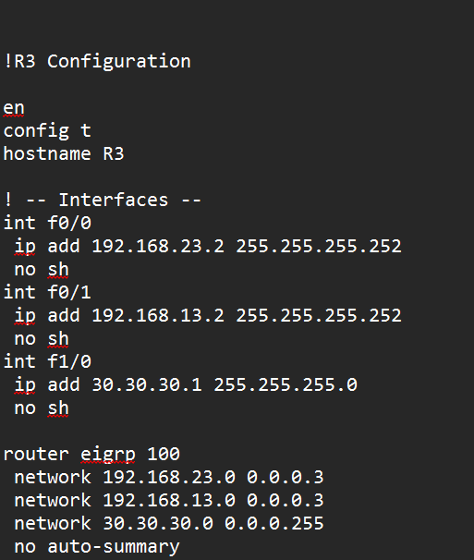
  - Router 3 (CHARLIE)

REDISTRBUTE –

  - The redistribute command is used to share routing information between different routing protocols (e.g., OSPF to EIGRP), allowing routers to learn paths across diverse network domains. Without it, a router running one protocol remains "blind" to the networks managed by another, causing communication gaps between different parts of the organization. It acts as a protocol translator, converting the unique metrics (like hop count or bandwidth) of one protocol into a format the other can understand and
process. This is essential for network integration during mergers, migrations, or when connecting specialized tactical equipment to a broader strategic
backbone.

DELIBERATE FAULT- PASSIVE INTERFACE
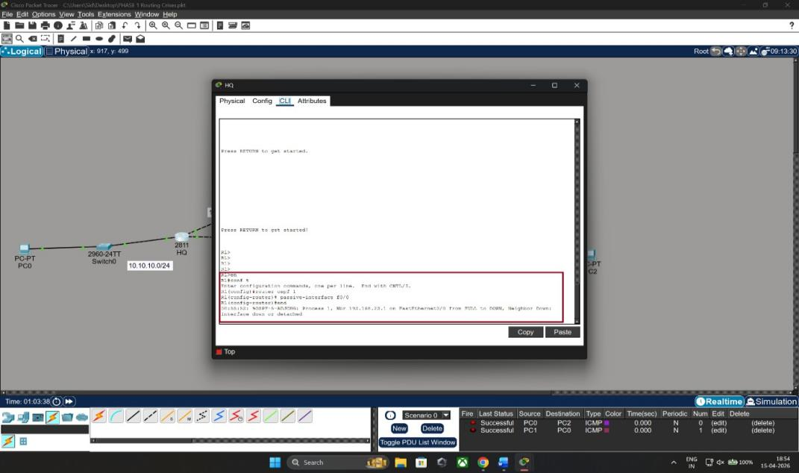

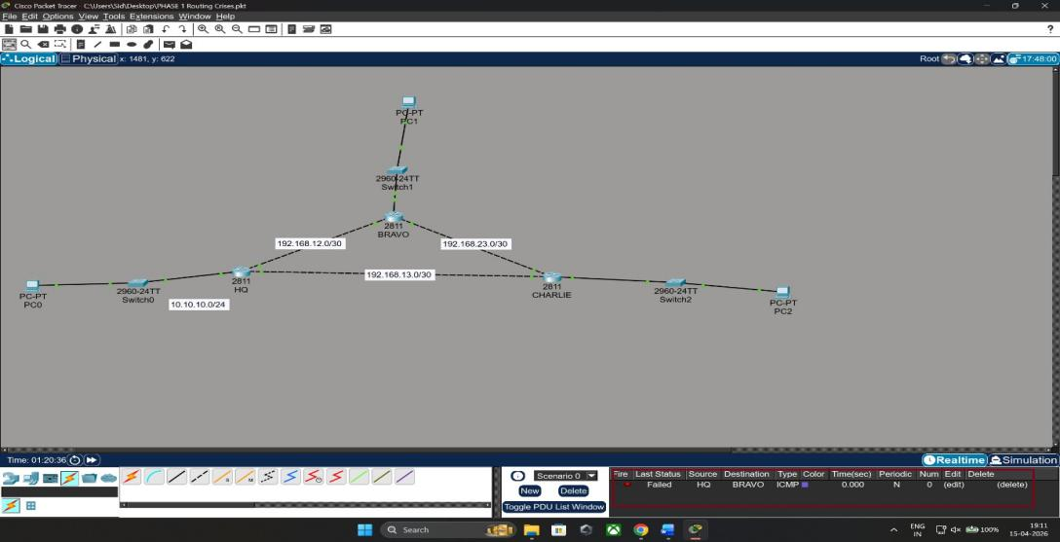

Troubleshoot and restore connectivity

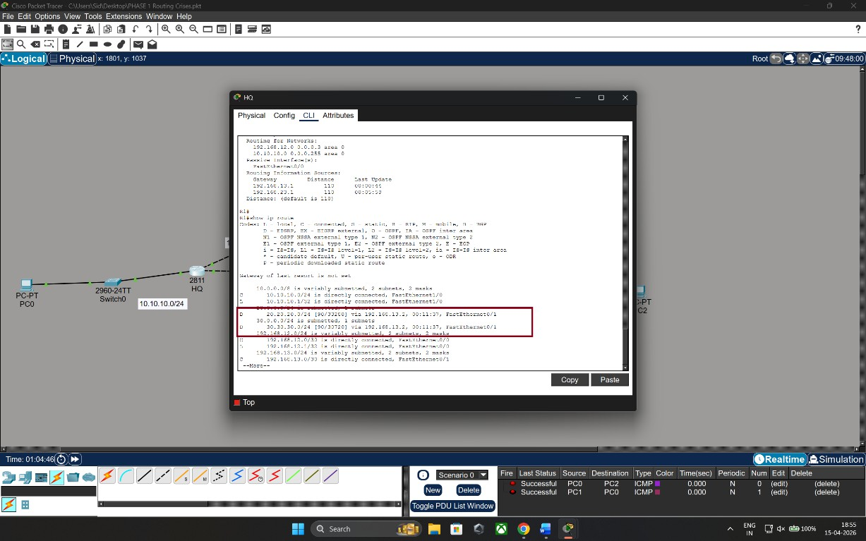

To Restore Connectivity
    - To restore the signal and re-establish the OSPF relationship, I removed the passive-interface suppression with the following commands:
      - router ospf 1
      - no passive-interface f0/0
      - end
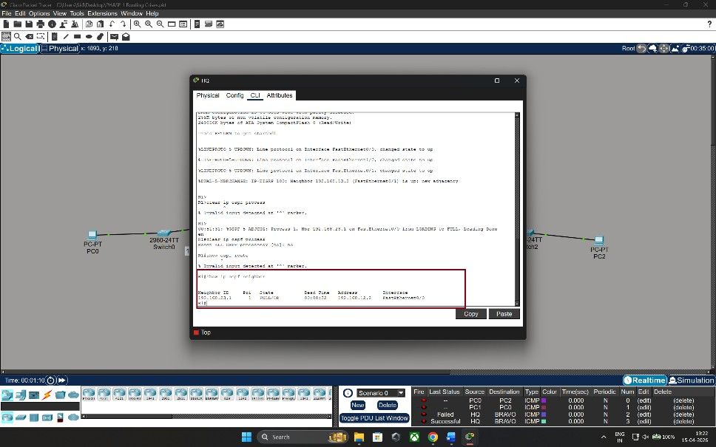

To verify

    - show ip route and confirmed that the "O" routes for the Bravo sector reappeared in the table.End-to-End Connectivity
    - I performed a successful ping from PC Alpha (10.10.10.2) to PC Bravo (20.20.20.2).

