DETECT :1

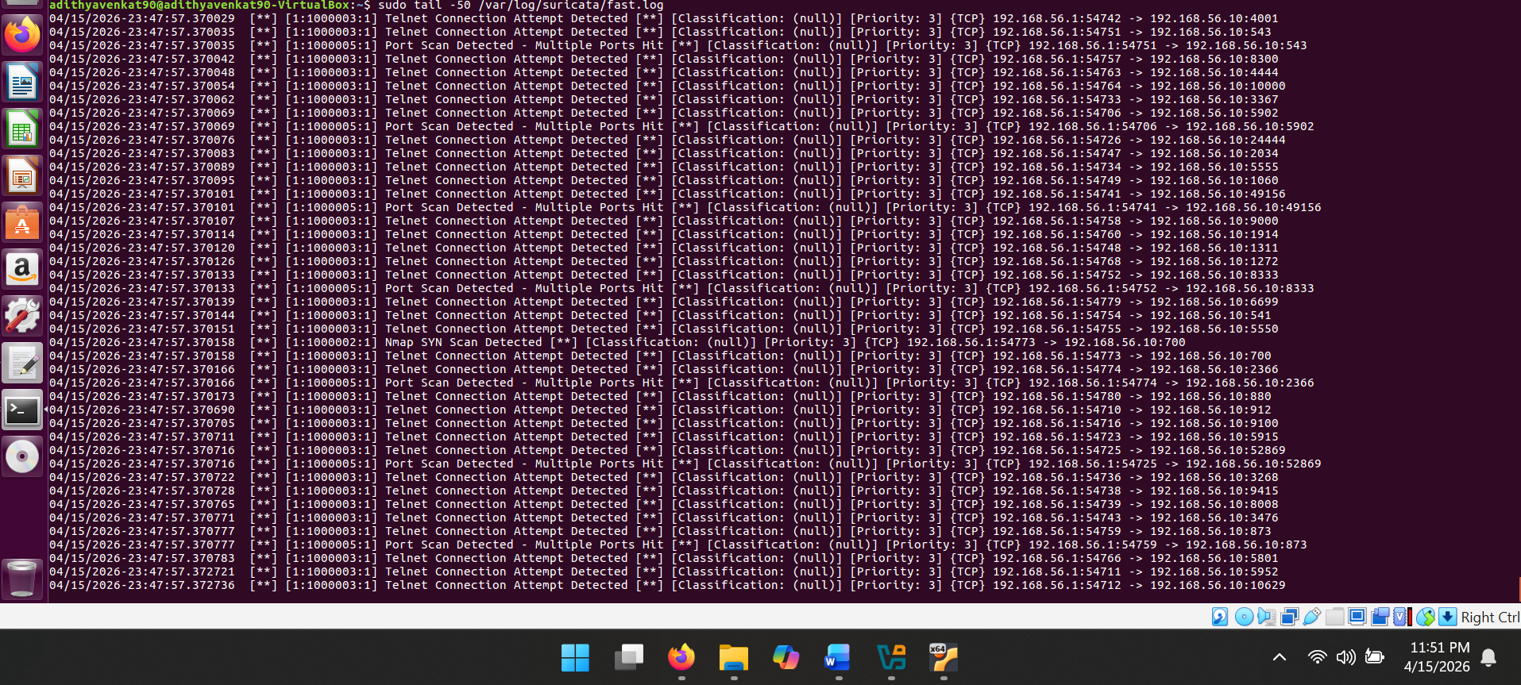

DETECT :2

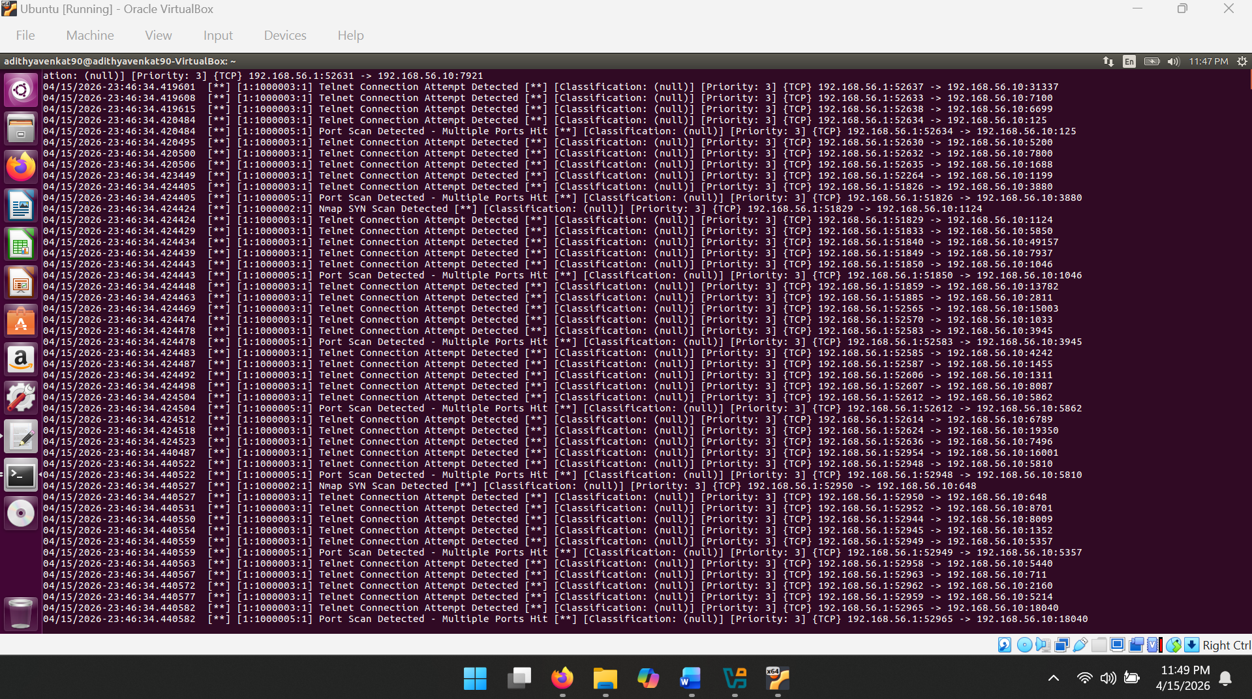

ENGINE STARTED

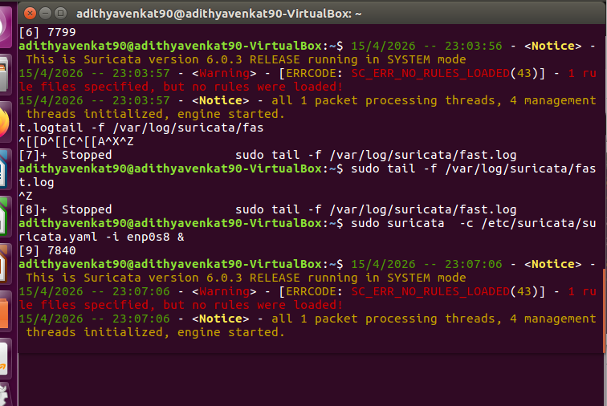

ICMP PING DETECT:

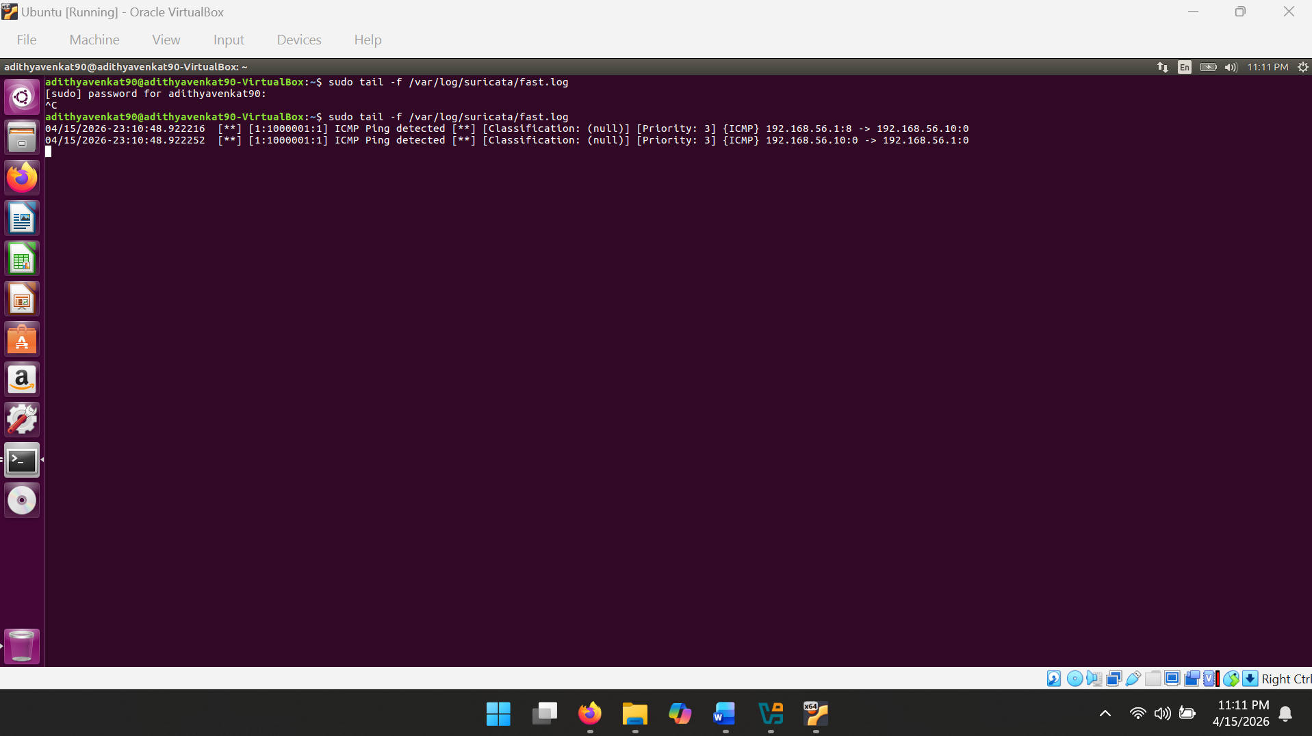

LOCAL RULES:

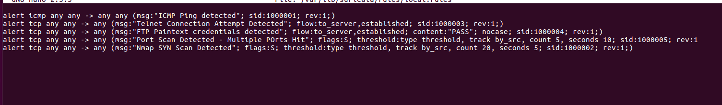

Which Alert Is Highest Priority and Why

The highest priority alert is Rule 1000004 – FTP Plaintext Credentials Detected.

Reason: This rule detects active credential theft in progress. When the PASS keyword appears on port 21, a real password is being transmitted in clear text over the network. An attacker capturing this traffic has everything they need to log in as that user. The other alerts are also important, but:
- ICMP pings (1000001) are low risk by themselves – they indicate reconnaissance but not a direct attack.
- Nmap scans (1000002, 1000005) show the attacker is mapping the network but no data has been stolen yet.
- Telnet detection (1000003) is serious but the attacker still needs the credentials, which FTP directly reveals.

In a real-world priority model (like CVSS), credential exposure scores higher than reconnaissance because it enables further compromise of systems.

