WIRESHARK

FTP:

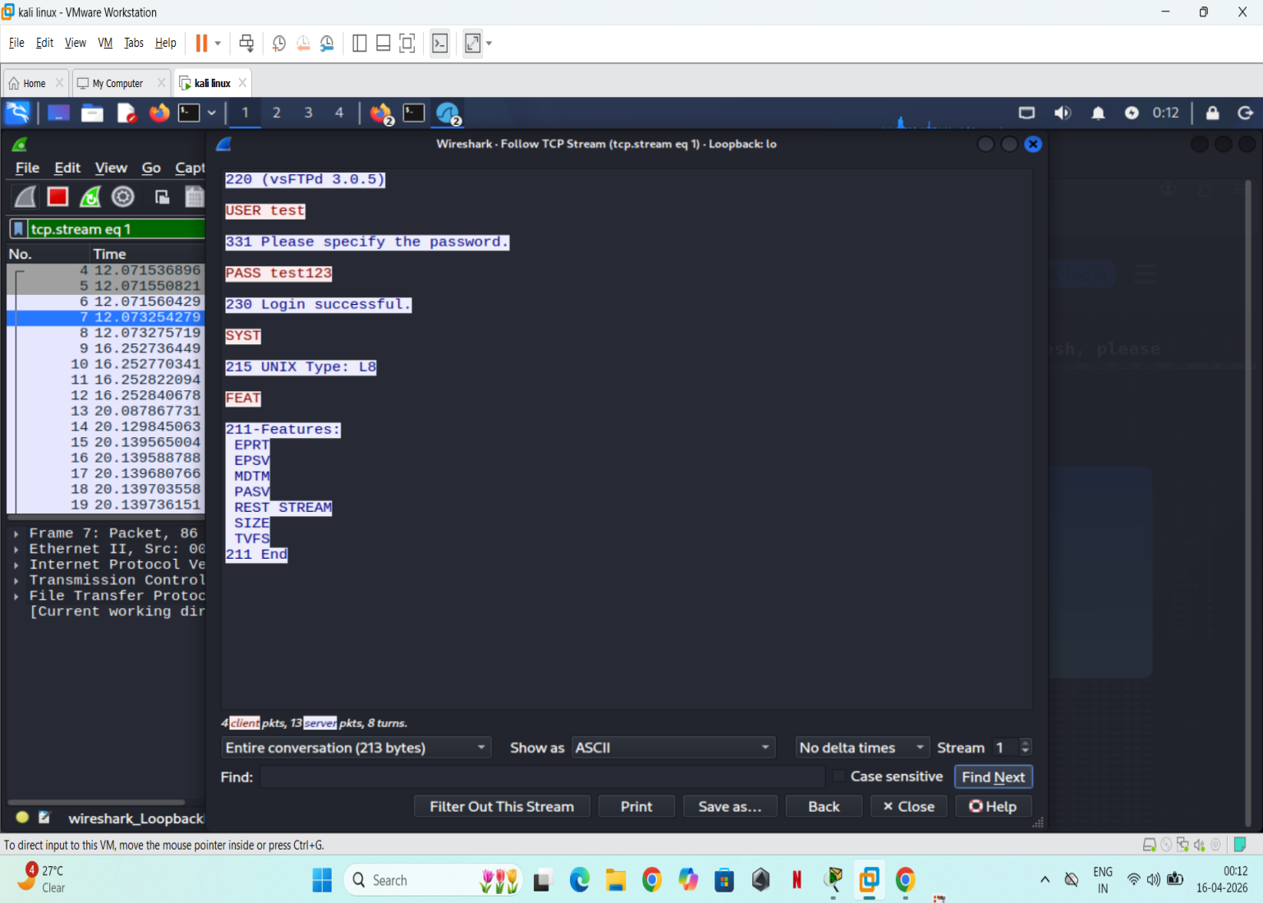

TELNET:
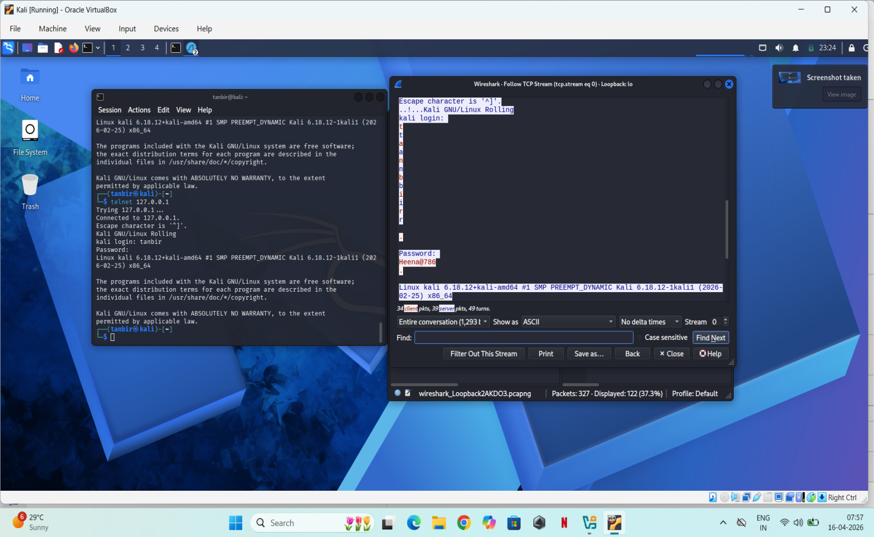

DVWA:
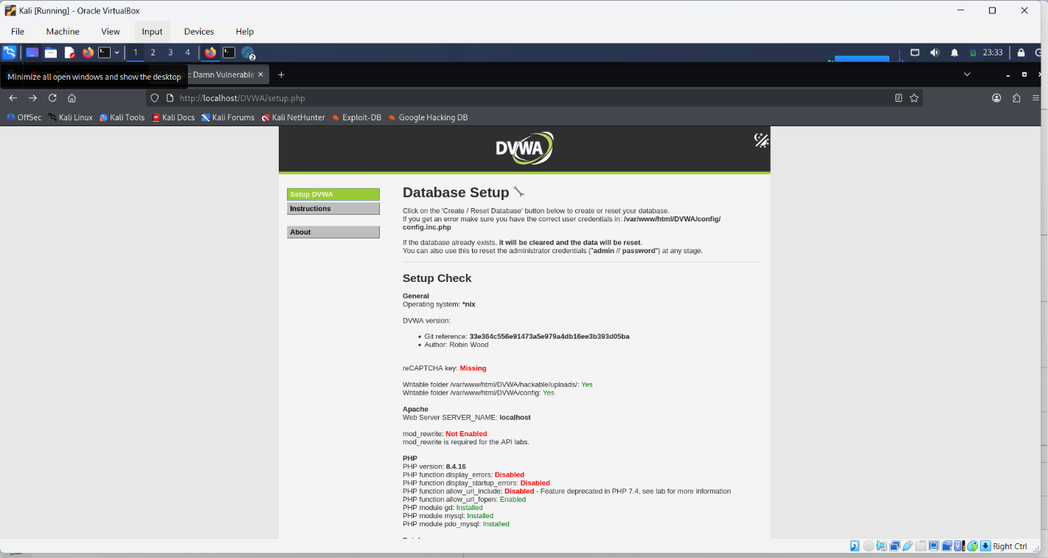

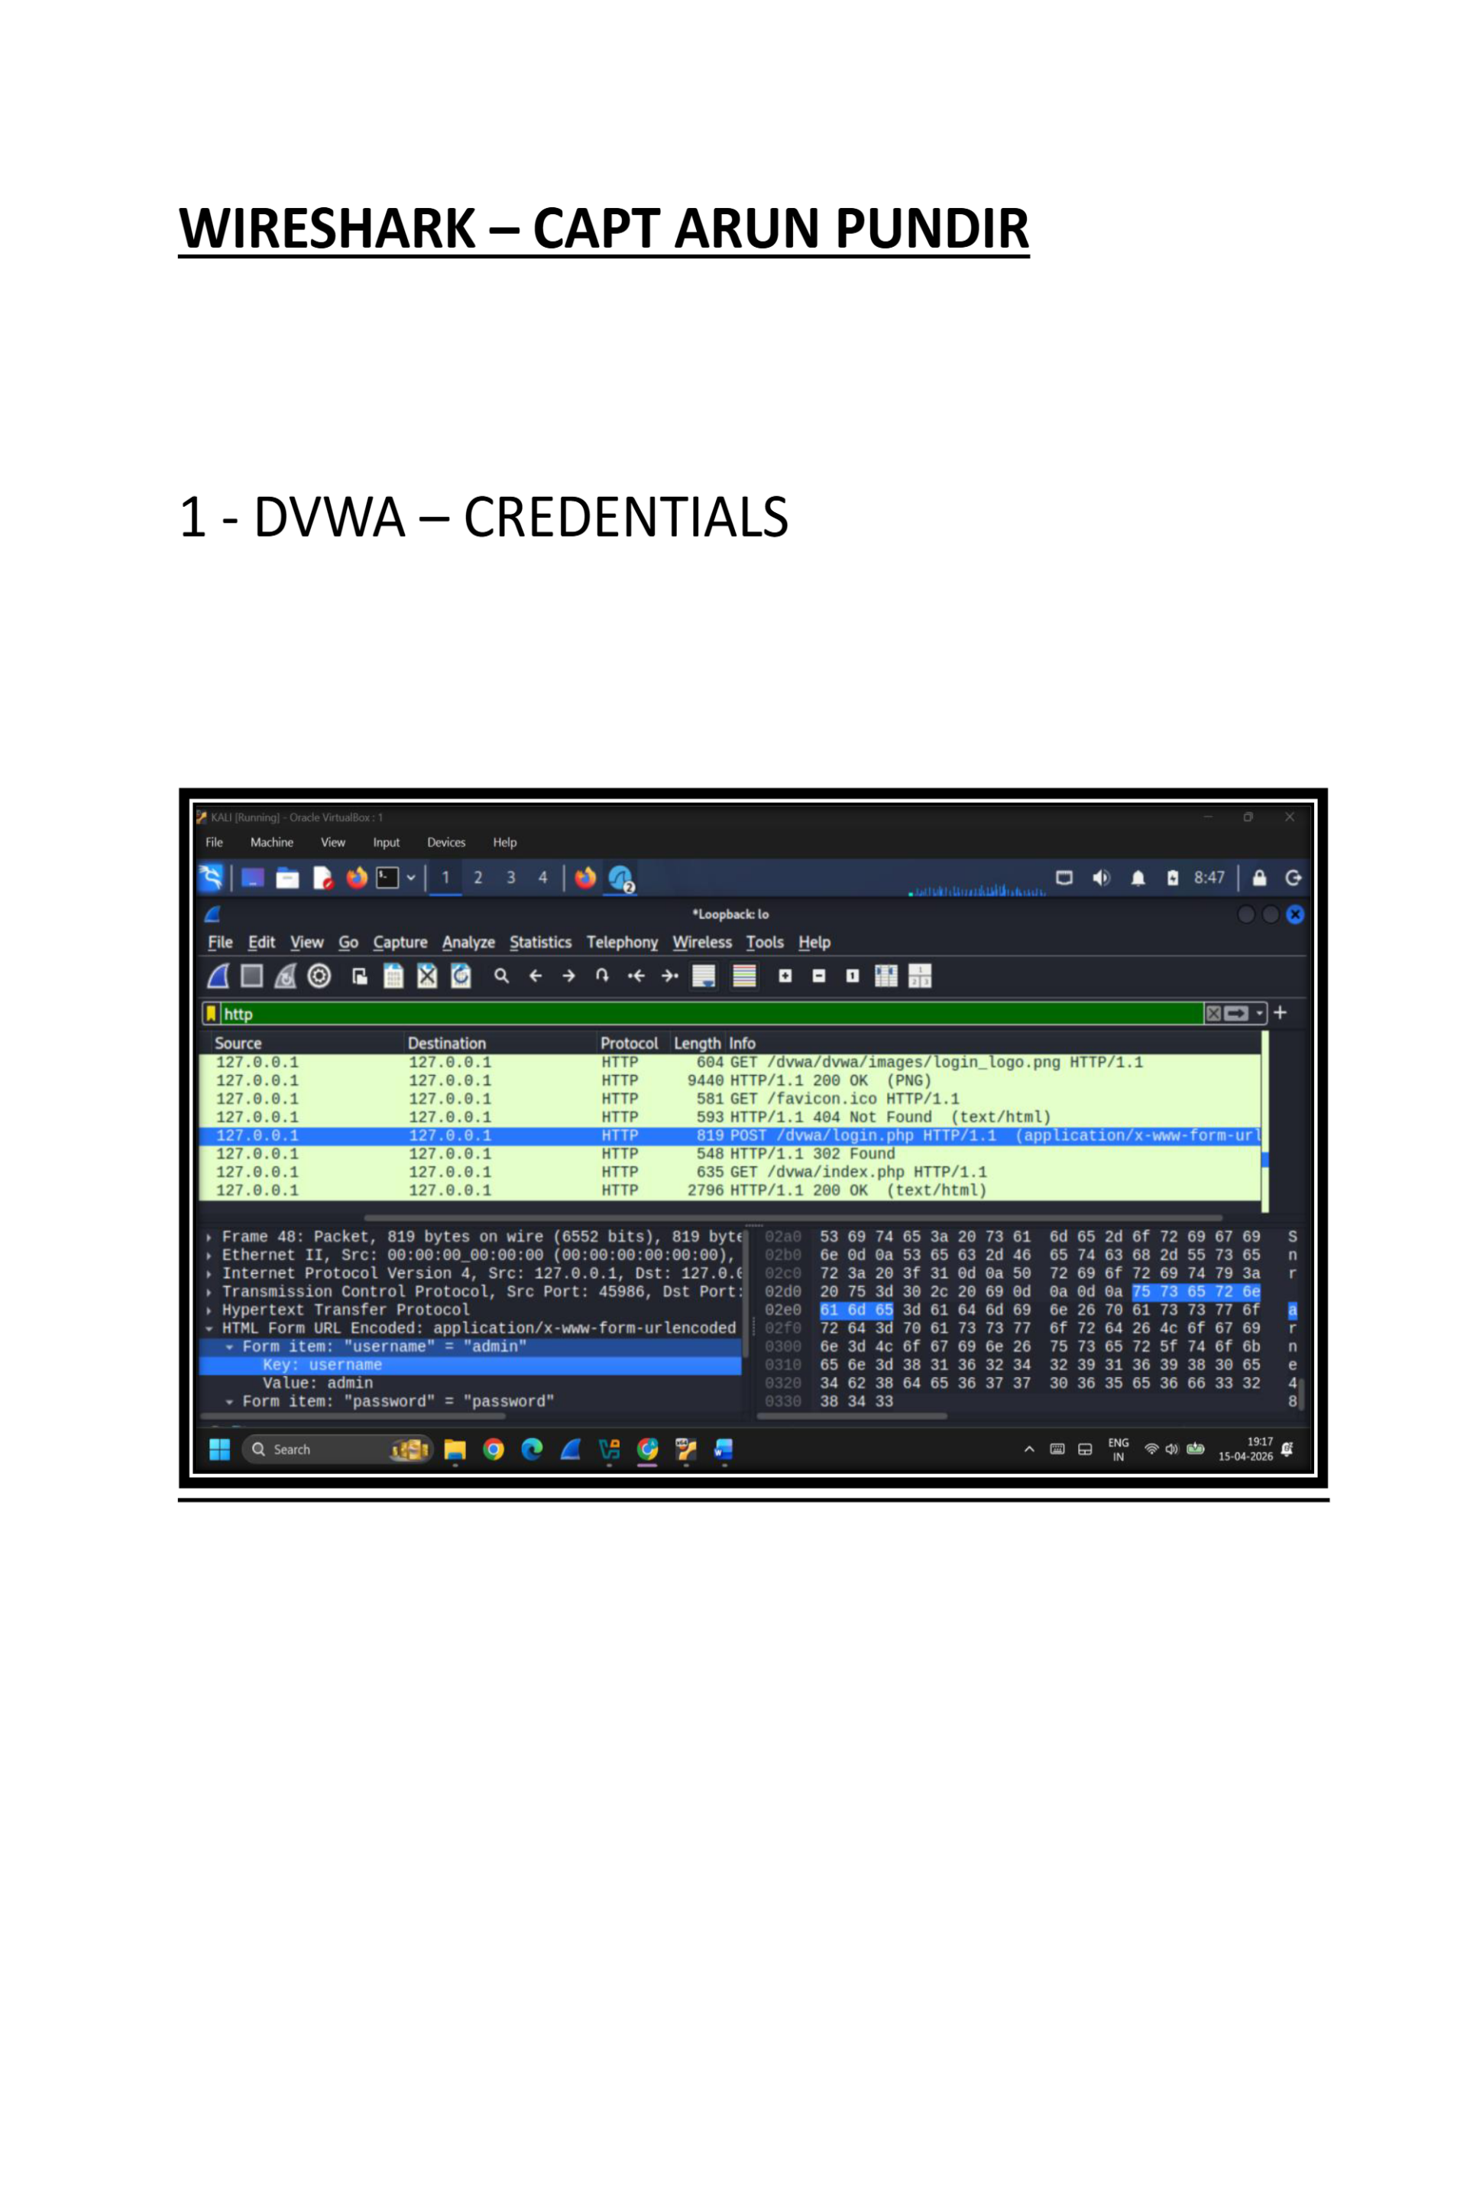

Why Absence of Encryption is dangerous:-
- Exposure of Credentials
1.1. In protocols like FTP, Telnet, and HTTP, usernames and passwords are sent in plaintext.
1.2. Attackers can easily capture and read login details using packet sniffing tools like Wireshark.
- Packet Sniffing Risk
2.1. Anyone on the same network can intercept traffic and view sensitive data.
2.2. This allows unauthorized users to monitor communication without detection.
- No Data Confidentiality
3.1. Entire communication (commands, files, messages) is visible in readable format.
3.2. Sensitive information can be exposed to attackers.
- Man-in-the-Middle (MITM) Attacks
4.1. Attackers can intercept and alter communication between client and server.
4.2. Users may not realize data has been modified.
- Session Hijacking
5.1. Stolen credentials can be reused by attackers to gain unauthorized access.
5.2. This can lead to full system compromise.
- No Integrity Protection
6.1. Data can be changed during transmission without detection.
6.2. This affects trust and reliability of communication.

