**Automate Segmentation Rule using Feedback (Automation in progress)**

Versions: 2017/02/20 RS: Initial version

1. Offer_Control_File.csv + upload it to Impala (1upload_offer_control.sql)

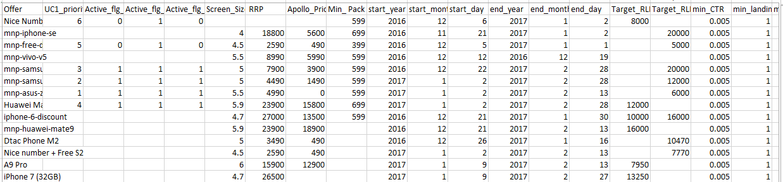

1. Impala: Append feedback of the day into sgmt_rules.feedback_tbl table (2get_feedback.sql)
2. Impala: Append the optimized rule of the day into sgmt_rules.dynamic_rules_daily table (3get_rules.sql) The logic of the rule is now as follow

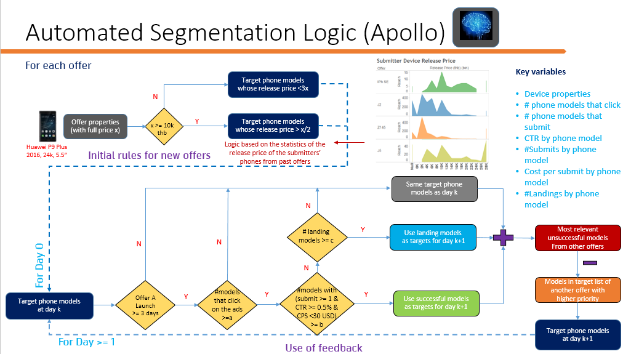

1. Shell: 2get_feedback.sql and 3get_rules.sql are runned via shell scripts: using the crontab job below:

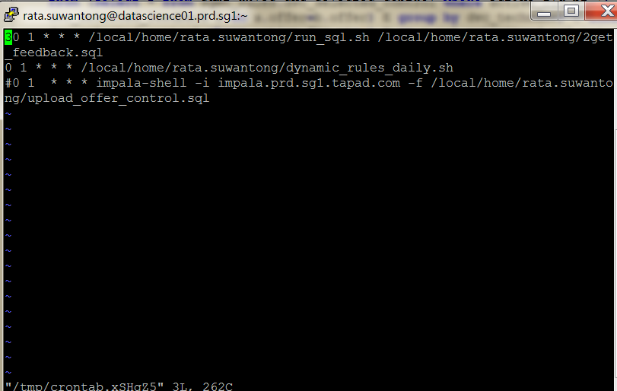

The shell scripts with _pre have to be converted to Linux format (_pre are written using Notepad++ on Windows hence the format is not compatible). The conversion can be done using for ex

tr -d '\r' <run_sql_pre.sh > run_sql.sh

rm run_sql_pre.sh

chmod 777 run_sql.sh

1. Shell: The initial sgmt_rules.feedback_tbl and sgmt_rules.dynamic_rules_daily are initialized using (with format conversion.)
2. Impala: 5DeviceBasedRuleCreation.csv is for creating initial segmentation rules based on device characteristics (price, screen, age, camera, cluster)

Current automate process status:

* The feedback table is updated automatically until the last day of 2016. I have updated the shell script that can cope with year change but does not implement it yet. (Have to check if it really functions also.)
* The dynamic_rules_daily table automate process still fails.