Executive Summary
PRISM - Post-Purchase Remorse Intervention and Signal Model
It is 1:47 am when Matt sees a jacket on Instagram from his favorite influencer. He gets excited, taps the link, lands on the product page of an e-commerce site, browses for 30 seconds, and checks out. For a few seconds, the purchase feels great. By morning, that feeling is gone. In next couple of days, as delivery notifications start coming in, a different set of questions takes over: Do I need this? Will it even look good on me? Matt sits on this doubt for days and is no longer excited to receive the order. Once it arrives, still doubtful, he initiates a return with the reason code: changed mind. This is not rare. Nearly 44% of impulse buyers report post-purchase regret. The jacket wasn’t bad, or product page wasn’t misleading. Matt's doubt was emotional. And it formed in the window between purchase and delivery.
This phenomenon is known as buyer’s remorse, which is a psychological discomfort that arises after a purchase, even when the product meets expectations. The buyer feels remorse because the decision to buy was unconsidered, emotionally driven, or made under conditions that no longer feel relevant once the purchase is confirmed.
Historically, platforms have responded to this problem with detailed product pages, clearer sizing guides, and more detailed descriptions to prevent returns. However, the remorse was never driven by the information gap to begin with. Today, e-commerce leaders like Amazon and Walmart have already scaled AI-driven personalization across acquisition in marketing, recommendations, and search, because it directly drives conversion. Yet, such post-purchase experiences like Matt’s remains largely unoptimized, despite being where a significant share of value is lost.
This document reframes buyer’s remorse as a post-purchase problem that platforms are not designed to solve today. It argues that closing the loop does not end at order delivery, it ends when the buyer feels confident in their purchase. PRISM introduces a new layer in the post-purchase journey: AI-driven personalized, behavior-aware interventions. These are not promotional or persuasive. They are designed to support the buyer at moments of doubt, reinforcing their decision with relevant context. For platforms, this extends the focus from fulfillment to retention. By identifying behavioral signals and responding in real time, PRISM not only reduces remorse-driven returns but also unlocks a new frontier of post-purchase personalization.
Disclaimer
- This case study is an independent product case study solely developed by Ramya Velchuri (She/her/hers) to demonstrate her product management thinking in the context of e-commerce post-purchase behavior. It is not affiliated with, endorsed by, or based on proprietary data from any company. All scenarios, personas, signal designs, and system architectures are original and conceptual. Any statistics cited are sourced from publicly available industry research and are referenced accordingly.
- This document is intended solely for the personal and professional use of Ramya Velchuri. It may be shared with prospective employers, recruiters, or anyone evaluating her candidacy for product management technical roles. No part of this document may be reproduced, distributed, or used for any other purpose without her explicit permission.
About the Author
Growing up in India, one of my earliest memories is sitting next to my uncle as he wrote C++ programs that made cartoonish shapes dance across a black console. To me, at the age of 8, it felt like nothing less than magic and that is where my relationship with technology began.

That curiosity stayed with me. I pursued a bachelor’s in computer science & engineering, then moved into product, first as a Software Engineer, then as an Associate Product Manager at J.P. Morgan Chase, where decisions such as changing a small button color or, building complex security modules shaped the banking experience of millions of people.
My real turning point came while helping a non-profit digitize its operations in 2021. What I thought would be a small side project ended up helping rescue ten malnourished children who had been out of reach. Technology was not the solution. It was the bridge to the solution.
That realization brought me to Kellogg School of Management, Northwestern University (Class of 2026), to learn how to design solutions that do not just scale but truly serve. During my MBA, I interned as a Sr. Product Manager - Technical at Amazon, where I fell in love with the craft of building at scale. In many ways I am still that little girl watching the black console, wide-eyed and curious, now, I have just grown into someone who wants that magic to show up not on a screen, but in someone's real life.
Thank you for taking time to review this case study. I welcome your suggestions and remarks, please feel free to reach out via LinkedIn or email:
https://www.linkedin.com/in/ramya-velchuri/
ramyasree0299@gmail.com / ramya.velchuri@kellogg.northwestern.edu
Why is this document format similar to the PRFAQ format?
During my internship at Amazon (2025), I was introduced to the PRFAQ format, a way of explaining ideas by working backwards from the customer and answering the questions a thoughtful reader would naturally ask. I found it the most effective way to communicate complex system thinking clearly and logically. This case study follows that structure for the same reason: the questions are the ones I would ask, and the answers are the ones I had to earn.
Use of AI & Tools
AI was used throughout this project as a thinking partner, not a ghostwriter. Tools I used are Claude and ChatGPT. They supported the process in the following ways:
- Fast-tracked research; surfacing relevant industry data, behavioral research, and e-commerce benchmarks quickly
- Brainstorming; exploring problem framing, signal design, and intervention approaches
- Critical review; stress-testing assumptions and challenging design decisions
- System prompt design and eval framework; collaborating on the structure and constraints of the LLM agents’ prompt
- Clarity and Structure review; improving clarity and structure of the core writing, while preserving my voice
All product decisions, system design, and final outputs reflect my own reasoning and judgment.

Table of Contents
Click on a section title to navigate to that section
Executive Summary
Disclaimer
About the Author
Use of AI & Tools
Section I: Problem Definition
- Why do existing e-commerce platforms fail to address buyer's remorse?
- Why do we need to solve this now? What is the business impact?
- Is reducing returns the right objective to measure buyer's remorse?
- What is an intervention and how does it help reducing remorse-driven returns?
- How are PRISM interventions different from promotional notifications?
- What do PRISM interventions look like?
- Is it ethical for platforms to introduce these interventions when they are the ones driving impulse buying in the first place?
Section II: User Segmentation and Scope
- What are the buyer behavioral patterns which signal remorse?
Section III: Solution Design
- What is the high-level system flow of PRISM?
- What alternatives were considered and why are they insufficient? What makes PRISM feasible?
Section III.a: Remorse Likelihood and Behavioral Profiling
- What signals do we validate to identify impulse buyers at higher likelihood of returning?
- How was the probability threshold for impulse buyers determined?
Section III.b: Intervention Design
- Once PRISM identifies an impulse buyer at high likelihood of remorse, how does it decide which interventions to introduce?
- What happens when two signals point to conflicting intervention types? How does the selection agent break the tie?
- Once intervention types are decided, how are interventions generated and delivered?
- How does a successful intervention look like in a buyer's journey?
- What are the guardrails for PRISM?
- Till how many days can the buyer see the interventions?
Section IV: Challenging PRISM - Risks & Mitigations
- Why intervene between purchase and delivery? Can the platform do something once a return is initiated?
- There is a high chance that buyers show mixed signals? how reliable are signals in understanding true behavior?
- What are some future risks? How will you mitigate them?
Section VI: Impact & Roadmap
- Which metrics will define the success of PRISM?
- How does the phased rollout plan look like?
Section VII: Technical FAQs
- What type of supervised learning model is best suited for PRISM's remorse likelihood calculation and behavioral profiling, and why?
- Are the selection and generation agents fully autonomous or is there a human-in-the-loop?
- What is the evaluation framework for PRISM agents? what does a good output look like versus a bad one?
- How is hallucination avoided when generating intervention messages?
- How are intervention outcomes logged and fed back into the model?
Appendices

Section I: Problem Definition
- Why do existing e-commerce platforms fail to address buyer’s remorse?
In e-commerce, buyer’s remorse is operationally invisible until it becomes a return. By that point, the emotional decision has already been made, and the return process is just the administrative conclusion of a psychological event that happened hours or days earlier.

What exists today | The gap
Returns are flagged only after they happen. Systems are reactive, not proactive. | No system profiles why a user returns or maps current behavior to past patterns.
One-size-fits-all solutions such as better product descriptions, clearer pricing, and improved support. | No differentiation between an impulse buyer who needs reassurance and a deal-driven buyer who needs price confidence.
Enforcement triggers only at high basket sizes or after repeated threshold violations. | Low-basket, high-frequency behavioral patterns remain invisible to existing systems.

- Why do we need to solve this now? What kind of business impact are we looking at?
Today, e-commerce leaders like Amazon and Walmart have already scaled AI-driven personalization across acquisition in marketing, recommendations, and search, because it directly drives conversion. Yet, the post-purchase experience remains largely unoptimized, despite being where a significant share of value is lost. In 2024, e-commerce return-rates average 20-25%, varying by category, and cost U.S. retailers an estimated $744 billion (Source: 2024 Return Report, Narvar) in reverse logistics alone with an average cost of $27.50 per return. 44% of returns is driven not by product/service/operational issues, but by post-purchase doubt, an area that remains unaddressed by current systems.
This creates a clear opportunity. In a saturated market where acquisition costs are rising, retaining a purchase is as valuable as acquiring one. PRISM leverages first-party behavioral data to identify and intervene in these moments of doubt. With this capability, it is projected to bring a 10% reduction in remorse-driven returns can translate into $170-300K in cost savings per 1M orders annually, while also improving customer confidence (See Appendix III for Calculations)
- Is reducing returns the right objective to measure buyer’s remorse?
Not directly. The true objective of PRISM is to improve post-purchase confidence, by being supportive not persuasive. Returns are the most observable behavioral signal of post-purchase remorse at scale. The solution focuses on reducing remorse-driven returns, those triggered by second-guessing or impulse decisions, while preserving legitimate returns caused by product or operational issues.
- What is an intervention and how does it help reducing remorse-driven returns?
An intervention in PRISM is a personalised, behavior-aware message delivered at a specific moment in the post-purchase journey. It understands how the buyer made the purchase decision based on their timing, and past patterns, and focuses on what they are most likely feeling at that moment.
PRISM maps these behaviors to underlying doubts and delivers the right message, at the right time, through the right channel. An intervention at this stage is intentionally positive: it does not add friction or restrict returns but instead helps buyers feel confident in their decision. It uses verified buyer content as evidence, real customer experiences, platform-native tools such as virtual try-on, view 360, etc. that provide credible, contextual reassurance. Where verified content is unavailable for a specific product, the system falls back on product insights and common usage patterns to keep the message relevant and honest. By resolving doubt early before a return is initiated, PRISM reduces remorse-driven returns without interfering with returns driven by product defects, fulfilment failures, or genuine dissatisfaction.
- How are PRISM interventions different from promotional notifications?
No. There is a clear distinction between promotional notifications and PRISM interventions. Promotional notifications are campaign-driven and designed to create urgency and influence purchase behavior. In contrast, PRISM interventions are informational in principle. Unlike generic messaging, interventions are tailored to the individual varying from order to order and buyer to buyer. As a result, no two buyers receive the same message, even for similar purchases, because each intervention is decided based on the buyer’s unique history and context.
- What do PRISM interventions look like?
PRISM’s intervention module introduces a set of intervention types based on different emotional drivers, each designed to address a specific form of post-purchase doubt:
Intervention Type | What it does | Example (Apparel) | Example (Electronics)
Reassurance + Social Proof | Normalizes doubt and validates the decision using real buyer experiences | “A lot of customers said they weren’t sure at first but ended up loving how these fits. Click here to read their experience” | “Many buyers initially hesitated but found the performance exceeded expectations after use. Click here to read their experience”
Visualization + Reality Anchoring | Bridges expectation vs reality using real usage and real people | “Here’s how the new jacket looks on different body types and in everyday settings. Check how it looks with your virtual try-on” | “See how this device fits into a real workspace and how people use it daily. View your workspace in 360”
Confidence Building | Reduces uncertainty by providing key product details and clear reasons to trust the choice | “Lightweight, breathable fabric and versatile fit, works for both casual and semi-formal looks. Check out the full-style guide from this buyer” | “Fast setup, reliable battery life, and seamless integration with your existing devices. Click here to get your personalised pre-configured device settings”
Ownership + First-Use Guidance | Builds attachment by making the product feel already theirs and guiding first interaction | “Your new jacket pairs well with denim or sneakers, try it for your next outing. Click here to see how this buyer styled it” | “Your new device is ready - start by setting up X feature for the best experience. Click here to see how this buyer used it on day one”
Value Confirmation | Reinforces that the purchase was a good deal using factual signals | “Customers rate this highly for quality at this price point. See how it compares to alternatives” | “Top-rated in its category for performance at this price. See how it compares to alternatives”
Anticipation Building | Shifts focus from doubt to excitement about first use | “This is the kind of piece you’ll reach for on your next weekend outing. See how others are styling it this season” | “You’ll notice the difference the first time you use it - especially in everyday tasks. See it in action”

See Appendix II for how successful interventions appear in the post-purchase journey
- Is it ethical for platforms to introduce these interventions when they are the ones driving impulse buying in the first place?
It is a fair challenge and worth answering directly. Platforms do engineer impulse purchases through countdown timers, influencer promotions, FOMO sales, and one-click checkout. PRISM is a buyer-centric system that looks at two questions that those same platforms have largely ignored:
- Can first-party behavioral data be used to make the post-purchase experience more supportive, not more persuasive?
- How can a platform reach a buyer in the moment their doubt is forming, before it becomes a return?
It does not attempt to suppress legitimate doubt, fabricate claims, but addresses the specific gap the purchase process left open. If the jacket was genuinely a good purchase for Matt, helping him see that is not manipulation. It is information he did not have when he checked out in 30 seconds at 1:47am. The system becomes questionable if it pressures users into keeping products they dislike or prioritizes margin over buyer wellbeing. Hence defining guardrails is crucial and PRISM cancels all the planned interventions the moment an order cancellation or return is initiated. Once a buyer has made their decision, PRISM respects it.

Section II: User segmentation and Scope
- What is the buyer behavioral patterns which signal remorse?
Buyer’s remorse is not a single, uniform behavior, it varies across different types of buyers. These differences show up in how users browse, evaluate, and make purchase decisions. By tracing these patterns, PRISM identifies distinct buyer personas that are more prone to post-purchase doubt. (Note: The data points are synthesized from multiple industry sources and are intended to be directional rather than exact)
Persona | Remorse Type | Key Behavior Pattern | Why They Make a Return
Impulse Buyer (emotional/FOMO-driven) | Emotional, 84-89% of all shoppers have some history of impulse purchase, 1 in 4 (25%) impulse buyers return in 30 days  (Sources: Capital One Shopping, Webtribunal 2025, Gitnux) | - Fast, unplanned checkout.  - Could arrive via social/influencer or promo triggers.  - Low page depth, minimal product evaluation  - Late-night or off-hour purchases. | Post-purchase doubt forms quickly (“Did I make a mistake?”). Returns are vague: changed mind, no longer needed.
Deal Chaser (price-driven) | Rational, 47% of global consumers identify as “value seekers” and 36% will switch brands for better price  (Sources: eFulfillment Service 2026, Scayle 2026) | - Highly price-sensitive.  - Uses discounts, coupons, and comparison tools.  - Purchases during promotions and continues price-checking after purchase. | Finds a better price post-purchase. Returns are specific: found cheaper elsewhere, item went on sale.
Methodical Researcher | Anxiety-driven, 66% of consumers feel anxiety after clicking “buy” (Source: PRNewswire-Narvar 2025) | - High comparison behavior  - Repeated sessions  - Over-analysis of options. | Low confidence leads to second-guessing and comparison of different options once the order is placed.
Expectation-Mismatch Buyer | Both these categories constitute 56% of returns.  (Source: 2024 State of Return Report, Narvar) | Not applicable in this context | Driven by product or listing quality issues. Requires PDP/content improvements, not behavioral intervention.
Experience-Driven Regret Buyer |  | Not applicable in this context | Driven by delivery or support failures. Requires operational fixes in logistics and CX.

Prioritization: Impulse Buyers
1. Largest and most impactful segment
Impulse buyers represent a significant share of remorse-driven returns. This makes them the highest-impact segment to target from both a volume and margin perspective.
2. Clear and repeatable signal patterns
Impulse behavior leaves a distinct and consistent behavioral footprint (late-night purchases, social media entry, fast checkout). This makes them the most reliably identifiable segment to build and validate a system on.
3. Fast feedback loop for system validation
Remorse forms within hours to days, allowing rapid experimentation and iteration. This enables quick validation of both the model and intervention design, reducing time to learn.

Expectation-Mismatch Buyer and Experience-Driven Regret Buyer are de-scoped
Because PRISM does not address product or service failures. By isolating behavioral personas, it avoids treating all returns as the same problem.

Section III: Solution Design
- What is the high-level system flow of PRISM?
PRISM operates in three stages from the moment an order is placed.
- Remorse Likelihood Estimation: When an order is placed, PRISM first evaluates whether the buyer has a meaningful likelihood of remorse based on their return history compared to platform benchmarks. This helps identify users with a higher baseline tendency to return items. Only buyers with elevated likelihood proceed to the next stage.
- Behavioral Pattern Matching: For users with sufficient likelihood, the system compares the current session against historical behavior. These signals are combined to compute a probability score indicating whether the current purchase resembles prior impulse-driven returns.
- Intervention selection and generation: If the probability exceeds the defined threshold (i.e. 0.60), the user is routed to the intervention system.
  - A selection agent determines the appropriate intervention type, channel, and timing window.
  - A generation agent (LLM-based) retrieves relevant evidence (verified buyer reviews, product insights) and crafts a personalized message aligned with the user’s likely doubt.
Interventions are delivered across key post-purchase windows (order confirmation, waiting period, delivery) and are capped to avoid fatigue. All interactions such as engagement, clicks, and return outcomes are logged and fed back into the system to improve both the model and intervention quality.
- What alternatives were considered instead of interventions and why are they insufficient? What makes PRISM feasible?
- Post-purchase surveys: Survey response rates typically sit below 10%, and the responses that do come in carry significant self-reporting bias. Buyers are unlikely to articulate their decision-making process, especially for emotionally driven purchases made under FOMO or social influence. The result is sparse, unreliable data that cannot serve as a primary intervention mechanism.
- Friction-based return enforcement: This may seem like a strong contender, but behavioral signals are probabilistic, not deterministic. Enforcement based on such signals is better suited for clear abuse patterns, not for buyers making returns due to doubt. Introducing friction in these cases risks the user experience and long-term trust. In Phase 1, the focus should be on refining the model and understanding behavior more accurately. Once more deterministic patterns of abuse are identified, friction-based enforcement can be considered for those specific cases.
- Loyalty and incentive programs: On the surface, this also seems like a strong contender, reward buyers for keeping their items. But it misses the point entirely.
  - It incentivizes behavior without addressing the underlying doubt. A buyer who feels genuine remorse will not have the issue addressed with loyalty points.
  - Incentivizing non-returns can become counterproductive. Platforms like Amazon already use “Returnless Refunds, typically for low-value orders (around $10-$20), where customers are refunded without returning the item to avoid reverse logistics costs. While operationally efficient, this approach highlights how easily such process can be abused and how they shift the problem rather than solve it.
  - The margin impact of running incentive programs at scale can quickly outweigh the savings from prevented returns. This makes it a costly solution to a problem that is fundamentally behavioral, not financial.
Considering these alternatives, PRISM is feasible because it builds on capabilities that already exist within most e-commerce platforms, such as first-party behavioral data (buyer analytics), notification infrastructure, and advances in LLM-based content generation. The system does not require new data collection, only better use of existing signals and more intelligent timing of communication.

Section III.a: Remorse Likelihood and Behavioral Profiling
- What signals do we validate to identify impulse buyers at higher likelihood of returning?
Before PRISM profiles a buyer’s behavioral patterns, it first establishes whether there is a meaningful likelihood of remorse based on their return history using the following Remorse Likelihood Signals.
Signal | What it checks | Implies | Why is it significant? | Value
Overall return rate | What is the user’s overall return rate compared to the platform average? | General return propensity | Helps identify users with a higher baseline likelihood of returning items, regardless of category | >25% (e-commerce avg return rate, Source: 2024 Return Report, Narvar)
Category return rate | What is the user’s return rate within the specific product category compared to platform average? | Category-specific return propensity | Captures category-driven behavior where returns are inherently higher, helps improve prediction accuracy | Category specific. Ex: >40% (Apparel), >15% (electronics)  (Source: 2024 Return Report, Narvar)

Pattern signals compare current behavior against the buyer’s past purchase patterns. They carry higher weight because they capture repeated patterns that have previously led to returns.
Signal | What it checks | Implies | Why is it significant? | Value
Return reason skew | Are more than 70% of this user’s prior return reasons remorse-type (code: changed mind, no longer needed)? | Habitual Regret Pattern | - Indicates repeatable post-purchase doubt behavior  - Strong predictor of future remorse | 2pts
Time-of-purchase match | Has this user historically returned late-night purchases, and was this order also placed late at night? | low control / fatigued decision | - Captures decisions made under low deliberation  - Higher likelihood of regret post-purchase | 2pts
Entry source match | Has this user historically returned purchases from social or influencer sources, and did this order come from the same type of source? | externally triggered purchase (FOMO) | - Identifies hype-driven decisions that are more likely to be second-guessed later | 2pts

Corroborating signals compare buyer behavior against platform benchmarks but are only considered when there is NO prior exposure to the product or category. They act as supporting evidence and cannot independently trigger an intervention. These signals are evaluated only if the buyer has NOT previously interacted with the product (or similar items) within a defined lookback window.
Signal | What it checks | Implies | Why is it significant? | Value
Time-to-purchase | If buyer visited PDP first time, did they complete the purchase faster than the platform average for this category within the current decision journey? | low product evaluation since the first visit to PDP | - Indicates a quick, low-deliberation decision  - Higher likelihood of post-purchase doubt due to limited evaluation. | 1pt
Page depth | If buyer visited PDP first time, did they spend limited time or scroll depth (i.e. did not reach reviews, Q&A, or detailed specifications) before purchasing? | low product evaluation since the first visit to PDP | - Increases chance of second-guessing after purchase. | 1pt
PRISM translates these signals into a single remorse likelihood score (0-1). Only buyers above the threshold of 0.60 are eligible for intervention. This ensures PRISM acts selectively intervening only buyers who are impulse buyers at a high likelihood of returning.
- How was the probability threshold for impulse buyers determined?
The 0.60 impulse buyer threshold is a starting point. Without real business data to calibrate against, it serves as a reasonable initial assumption, high enough to target users with a meaningful likelihood of remorse, yet low enough to retain sufficient volume for learning. In production, this threshold would be continuously refined through A/B testing, measuring its impact on return rates, intervention engagement, and LTV.

Section III.b: Intervention Design
- Once PRISM identifies an impulse buyer at high likelihood of remorse, how does it decide which interventions to introduce?
Once a buyer is eligible for intervention, PRISM passes the signal payload and model output directly to the intervention module. Using these features, the selection agent in the decisioning layer go through multi-step decisioning framework (See Appendix I Exhibit 2 for detailed intervention decisioning framework)
Step 1: Interpret and correlate signal payload to intervention type(s) in a sequence.
The selection agent analyzes the weights of the signals triggered and translates into one or more likely emotional jobs (intervention types), as outlined in Section I, FAQ 5. It, then prioritizes the emotional job most directly aligned with the buyer’s dominant doubt. It selects the highest-signal intervention type and sequences supporting ones across subsequent touchpoints. See Appendix I, Exhibit 1, for the correlation matrix of signals to intervention types.
Signal Fired | Underlying Doubt | Intervention Types
Return reason skew | "Did I make a mistake?" | Reassurance + Social Proof
Time-of-purchase match | "Do I actually need this?" | Reassurance + Ownership Framing
Entry source + low page depth | "Will it look right?" + "What am I getting?" | Visualization + Confidence Building

Step 2: Analyze when and where to introduce interventions with frequency and limits
Once the sets of interventions finalized, selection agent proceeds to understand,
When to intervene: Agent identifies the right remorse windows. Buyer’s remorse forms across predictable windows in the post-purchase journey
- Immediately after order confirmation (Window 1)
- During the waiting period before delivery (Window 2)
- Upon first interaction with the product after delivery (Window 3).
Interventions are timed to these moments, when doubt is forming but not yet acted upon.
Where to intervene: Agent selects the right channel. Instead of relying solely on notifications, interventions are embedded into natural customer touchpoints to ensure interventions feel contextual rather than intrusive.
Passive Channels: Interfaces where the buyer is already present and the intervention is embedded into the experience.
- Order confirmation page (T = 0 min)
- Order confirmation email (T = 5-10 min)
- Shipping / tracking page (T = Day 2-3)
Active Channels: Interfaces where the system reaches out to the user proactively.
- Delivery notification (T = delivery day).
- Push notification (T = 6-24 hrs. - only for high-probability above 0.80 cases)
- Post-delivery email (T = same day or +1 day - only for high-probability cases)

- What happens when two signals point to conflicting intervention types? How does the selection agent break the tie?
PRISM resolves signal conflicts through weight hierarchy and category context. The important design principle here is that conflicting signals sequence instead of cancelling each other out. A message that tries to resolve two competing doubts at once resolves neither.
    - Weight hierarchy: Pattern signals carry different predictive weights. Return reason skew is the strongest signal because it reflects a demonstrated history of remorse-coded returns, direct behavioral evidence. Time-of-purchase match and entry source match are strong but contextual. In the event of a signal conflict, the higher-weight signal takes precedence. The lower-weight signal is queued for the next intervention.
    - Category context: When two signals carry equal weight, the product category determines which intervention leads. For apparel, visualization leads. For electronics, decision validation leads to doubt about whether the choice was right.

- Once intervention types are decided, how are interventions generated and delivered?
The selection agent passes the finalized payload to the generation agent. The payload contains the signals fired, the selected intervention type, the channel, the timing window, the product category, and the available evidence type. The generation agent performs three steps in sequence:
Step 3: Retrieves the right evidence
Based on the intervention type and product context, it retrieves the most relevant verified buyer content, platform tool, or product insight. If verified content is unavailable, it falls back to usage patterns and product details instead of generating generic messaging.
Step 4: Crafts the intervention message with evidence retrieved
Using the retrieved evidence and channel constraints i.e. 60 characters for push, 150 words for email it generates a message that directly addresses the buyer’s underlying doubt. The language is warm and specific and never references the scoring system or the triggering signals. The buyer feels supported, not surveilled.
Step 5: Delivers interventions through selected channels
The message is delivered through the channel and touchpoint identified by the selection agent at the appropriate window. All user interactions are logged for retraining PRISM. Engagement signals such as opens, clicks, and return initiation are fed back into the system to improve signal accuracy and intervention relevance over time. See Appendix I, Exhibit 3, for sample LLM agent input and output formats.
- How does successful intervention look like in a buyer’s journey?
Matt, who discovers a jacket through an Instagram reel at 1:47 am spends thirty seconds on the PDP (product description) page and checks out. He has returned three prior late-night, social-driven purchases with the reason codes such as “changed mind, no longer needed” All three pattern signals fire. Remorse likelihood is high, and impulse buyer probability is 0.87.
PRISM introduces interventions across three windows: starting with reassurance and social proof at order confirmation (T=0), shifting to ownership and first-use guidance during the waiting period (T=Day 2-7), and concluding with anticipation building at delivery. (T = delivery day). Matt does not initiate a return because the decision to return never fully crystallizes. See Appendix II, for the full detailed buyer journey scenarios with PRISM.
- Till how many days the buyer can see the interventions?
PRISM intervenes only within the active post-purchase from 24 to 72 hours post-delivery. Beyond that point, doubt has either resolved naturally or already converted into a return decision. If an order cancellation or return is initiated at any point before that window closes, all remaining interventions cancel immediately.
- What are the guardrails for PRISM?
These guardrails are designed to ensure that PRISM remains helpful without becoming intrusive or over-optimizing for returns at the cost of user experience.
  - Maximum 6 interventions per order: 3 passive channels, 3 active channels
  - Maximum 2 active outreach messages under the same intervention type
  - No 2 consecutive touchpoints address the same intervention type
  - Push notification fires before email in the same window, email is fallback only
  - High-confidence active outreach i.e. pushes notification and post-delivery email, reserved for buyers scoring P >= 0.80
  - If order cancellation or return initiated at any point, then, cancel all remaining interventions immediately
Users with fewer than 5 orders then, passive touchpoints only, no active outreach

Section IV: Challenging PRISM - Risks & Mitigations
- Why intervene between purchase and delivery? Can the platform do something once a return is initiated??
It could, but by then the emotional decision has already been made. The return form is just the administrative conclusion of a doubt that formed days earlier. Matt was no longer excited to receive his order long before he opened the returns page. The window to reach him was in the days between purchase and delivery, when the doubt was still forming and had not yet hardened into a decision. Think of it like a knowledgeable store associate who senses hesitation and offers honest reassurance before the buyer walks out. That same reassurance, offered after the buyer has asked for a refund, feels like resistance, not support. This is why PRISM intervenes early and cancels all remaining interventions the moment a return is initiated. Once the buyer has decided, the system respects it.
- There is a high chance that buyers show mixed signals, for example, selecting “found a better price elsewhere” even if the purchase was impulsive. In such cases, how reliable are signals in understanding true behavior? And how much can we rely on “changed mind, no longer needed” as a reason code, given that users may select other options even when the underlying cause is remorse?
These signals are probabilistic signals for a probable impulse purchase. For MLP, they act as a starting point based on the best available first-party data. While they may seem definitive, the goal is not perfect accuracy at this stage, but to identify users with a reasonable likelihood of remorse and test whether interventions can make a difference. The use of “changed mind, no longer needed” as a proxy also has limitations, since users may select other reason codes. However, it is still one of the closest indicators of remorse-driven returns available today, so it serves as a practical signal to begin with.
In Phase 1, the system improves by learning from outcomes. By tracking engagement and return behavior after interventions, we can validate whether we are targeting the right users and refine the model accordingly. Additionally, surveys can be introduced to capture buyer intent and context especially for purchases driven by FOMO, sales, or discounts. This provides more direct insight into user decision-making and helps strengthen the signals over time.
- What are some future risks? How will you mitigate them?
- Evolving Buyer Behavior: Buyer behavior changes over time due to platform trends, seasonality, and external factors. Signals that work today may become common behavior in the future, reducing their predictive power.
Mitigation: The model should be retrained regularly using recent data, and signal weights should be reviewed periodically. A continuous holdout control group can help detect when model performance starts to decline. In addition, periodic user interviews or surveys can provide deeper insight into changing buyer behavior, and at least one A/B test annually can validate whether the model and interventions are still effective.
- Agentic Commerce: As AI agents begin making purchases on behalf of users, traditional behavioral signals may become less reliable. For example, fast checkout or low page depth may reflect automation rather than impulsive behavior.
Mitigation: Introduce a signal exclusion layer to identify and filter out agent-driven transactions (purchases with API-based checkouts or non-human interaction patterns). In the long term, PRISM could evolve to provide reassurance signals directly to users by interfacing with these agents, since users are the ones making decisions to keep the products or not.

Section V: Impact & Roadmap
- Which metrics will define the success of PRISM?
I have defined success in terms of operational, business, system quality, and guardrail metrics.
Metric | Description | Goal | Goal Basis | Metric Type
Intervention Engagement Rate | % of users who view/open or interact with interventions across surfaces (email, push, tracking) | 40% | PRISM interventions sit between two existing benchmarks. They are more contextually relevant than generic promotional notifications (open rate 20-25%) because they are tied to a specific order the buyer just placed. But they are less urgent than purely informational notifications like order confirmations or shipping updates (40-63%) because they carry additional content beyond a standard transactional update. Given this, an open rate of 40% (midpoint of the benchmarks) is set as the MLP target. This will be revisited once real engagement data is available from the A/B test. (Source: Flodesk & Klaviyo 2024) | Operational Success
Return Rate with reason code “changed mind, no longer needed”  (North Star) | % reduction in returns among users behaviorally profiled as impulse buyers. | 10% | Currently, there are no benchmarks to measure this specific metric directly. PRISM is built on the principle of personalization. Its effectiveness depends on how well interventions reinforce the buyer's confidence before a return is initiated. To draw a parallel, this is benchmarked against the conversion uplift from personalised experiences. show that well-executed personalization drives a 10-15% uplift in conversion-related outcomes. Taking a conservative stance, 10% (lower bound) is set as the MLP target as post-purchase personalization less explored use case. | Operational Success
Total Cost Savings in Return Logistics | Reduction in reverse logistics and handling costs due to avoided returns | 170-300K per 1M orders | Please find detailed calculations in Appendix III, Cost Saving Calculations for PRISM | Business Success

- How does the phased rollout plan looks like?
Category | Phase 0 (MLP) | Phase 1 (Expansion) | Phase 2 (Mature State)
Scope | Impulse buyers only. US market. | Expand to Deal Chaser and Methodical Researcher personas. Additional categories. | All remorse-driven personas. Full category coverage. Global markets.
Behavioral Profiling Model | Supervised learning model with five signals. Threshold at 0.60. Cold start rules for users with <5 orders. | Refine signal taxonomy for impulse buyers based on A/B results. Build separate models for Deal Chaser and Methodical Researcher. Expand feature set. | Unified multi-persona model with cross-persona signal blending. Add agentic commerce detection layer to exclude AI-driven purchases.
Intervention Module | Positive interventions across three remorse windows. Max six touchpoints (three passive, three active). Selection agent + generation agent with verified buyer content. LLM prompt v1. | Refine selection agent guardrails using user engagement data. Add interventions for Deal Chaser (price confidence) and Methodical Researcher (choice reassurance). Expand evaluation framework. | Introduce friction for repeat abuse such as, partial refunds, return eligibility restrictions. Applied only with strong behavioral evidence and LTV modeling.
A/B Testing & Measurement | Measure remorse-driven return reduction, engagement, and LTV impact. | Expand A/B tests across personas and categories. Persona-specific thresholds. Track F1 scores precision and recall per signal. | Full measurement framework across markets. Reinforcement learning to dynamically optimize intervention sequencing.
Agent Development | Selection agent (decisioning) + generation agent (interventions). Six intervention types. Human review fallback for missing content. | Improve system prompt using eval results. Expand intervention library and enhance fallback logic. Reduce human review via better content indexing. | Fully autonomous pipeline for positive interventions. Human review only for edge cases and friction decisions. RL-based self-improvement.
Future Scope Agentic Commerce | Flag agentic transactions (API-driven, non-human sessions). No interventions for such purchases. | Build agentic signal exclusion layer. Define agentic purchase behavior across surfaces. | Explore agent-to-agent interventions-PRISM interacts directly with purchasing agents instead of users.

Section VI: Technical FAQs
- What type of supervised learning model is best suited for PRISM's remorse likelihood calculation and behavioral profiling and why??
PRISM’s behavioral profiling is a binary classification problem. A gradient-boosted classifier such as XGBoost or LightGBM is well suited for this task for 3 main reasons,
- These models perform well on tabular data. PRISM’s signals such as return rates, reason code distributions, time-of-purchase patterns, and session behavior are structured features that tree-based models are designed to handle effectively. Neural networks would be unnecessary and harder to interpret in this context.
- They handle class imbalance well since most users do not return items, the dataset is skewed toward the negative class. Gradient-boosted models can be tuned using class weights or sampling strategies to address this imbalance.
- They offer a level of interpretability that is useful for product decisions. Feature importance helps identify which signals are driving predictions, making it easier to refine the system over time.
LLMs are not used for classification as they are better suited for generating personalized intervention content, not for structured prediction on behavioral data.
- Are the selection and generation agents fully autonomous or is there a human-in-loop?
In Phase 1, PRISM operates as an autonomous system for positive interventions. Since the messages are designed to reassure and support rather than restrict or penalize, the risk of harm is relatively low, making full automation is appropriate at this stage because the worst case is a message the buyer did not need, not a friction that harms them.
However, the system is not entirely without oversight. Guardrails are built into both agents such as constrained prompt design, approved content sources, and limits on frequency and tone to ensure outputs remain safe and relevant. Additionally, intervention outcomes are continuously monitored through engagement and return behavior. Human involvement becomes more important in two areas.
- During model tuning and evaluation, where product and data teams review performance and refine signals.
- In future phases where friction or enforcement mechanisms may be introduced. In those cases, a human-in-the-loop approach is necessary to avoid incorrect or unfair decisions.
In summary, PRISM is autonomous for positive interventions. Human-governed for model refinement and anything that restricts buyer behavior.

- What is the evaluation framework for PRISM agents, what does a good output look like versus a bad one?
The system prompt is evaluated using a combination of qualitative checks and quantitative metrics. At a qualitative level, outputs are reviewed against a simple rubric:
- Relevance: Does the message address the user’s likely underlying doubt?
- Specificity: Is it grounded in verified buyer content or concrete product context?
- Tone: Does it feel supportive and natural, not promotional or intrusive?
- Alignment: Does it match the channel constraints i.e. concise for push, richer for email?
To scale this evaluation, an LLM-as-a-judge can be used to score outputs against this rubric. It helps automate large-scale review, while periodic human checks ensure quality and prevent drift. At a quantitative level, performance is measured through:
- Engagement metrics: open rates, click-through rates, and interaction with content
- Behavioral outcomes: reduction in remorse-driven returns with code, “changed mind”, “no longer needed”
- Negative signals (guardrails): opt-outs, complaints, or drop in engagement, mute notifications
A good prompt consistently generates outputs that score high on relevance and engagement while reducing returns without harming user experience. If outputs underperform or feel misaligned, the prompt and its constraints are iterated on.
- How is hallucination avoided when generating intervention messages?
Hallucination is reduced by constraining what the generation agent is allowed to use. The system does not rely on open-ended generation. It follows a structured approach: retrieve relevant evidence, then generate the message using only that context. If verified buyer content is not available, it falls back to factual product details rather than generating unsupported claims.
Additional guardrails are applied at the prompt level. The model is instructed to avoid making claims it cannot support, not to introduce new information, and not to generalize beyond the provided evidence. Outputs are also limited by channel constraints, which reduces the risk of verbose or speculative responses. Over time, we can monitor hallucination risk through output reviews, engagement signals, and user feedback. If messages are found to be misleading or irrelevant, the prompts and retrieval logic are refined.
- How are intervention outcomes logged and fed back into the model?
Every intervention is logged with its full context, including the signals that fired, the selected intervention type, the channel, and the timing window. Along with this, user responses such as email opens, clicks, interactions, and whether a return was initiated are tracked as outcome signals. This data is aggregated to evaluate how effective each intervention was for different types of users and signals. For example, if users with high return-reason skew engage with reassurance messages and show lower return rates, that signal-intervention mapping is reinforced.
Over time, these outcomes are fed back into the model to update signal weights, improve prediction accuracy, and refine intervention selection which creates a feedback loop where the system continuously learns from real user behavior rather than relying only on historical data.

Appendices

Appendix I: PRISM Decisioning Framework
Exhibit 1: Signal to Intervention Type Mapping
Signal Fired | Underlying Doubt | Intervention Type | Why This Intervention?
Return reason skew | "Did I make a mistake?" | Reassurance + Social Proof | This user has a history of remorse-coded returns. The doubt is about the decision itself, not the product. Social proof from buyers who felt the same and stayed resolves the emotional doubt directly.
Time-of-purchase match | "Do I actually need this?" | Ownership Framing | A late-night purchase pattern suggests low deliberation and high emotional drive. By morning the doubt is about need, not quality. Ownership framing makes the product feel already integrated into their life before doubt solidifies.
Entry source match | "Will it look right on me / work for me?" | Visualization + Reality Anchoring | The purchase was driven by aspirational content. The doubt is whether reality will match what they saw. Real-use visual content bridges that gap more effectively than any written reassurance.
Fast time-to-purchase | "Did I think this through?" | Confidence Building | A fast checkout signals low product evaluation. The user did not gather enough information before buying. Surfacing specific, credible product reasons gives them the confidence the purchase process did not.
Low page depth | "What am I actually getting?" | Confidence Building | The user skipped the product detail page. The doubt is informational, they simply do not know enough about what they bought. Delivering those details post-purchase closes the gap without making them feel judged for not reading.
Delivery window - all users | "Will I regret this?" | Anticipation Building | This doubt is universal at delivery, the moment of first physical contact either resolves or crystallizes remorse. Framing the arrival as an event worth experiencing shifts the user's mindset from evaluation to anticipation.
Price-driven entry source | "Did I overpay?" | Value Confirmation | A promotional or discount-driven entry source suggests price was the primary motivator. Post-purchase price anxiety forms quickly. A factual, verifiable confirmation that the deal was genuine resolves this doubt directly.
Late night + return reason skew | "Do I need this?" + "Did I make a mistake?" | Reassurance + Ownership + First-Use Guidance | Two strong pattern signals firing together means two active doubts. Reassurance addresses the mistake doubt. Ownership framing addresses the need doubt. First-use guidance gives the user a concrete next step that makes keeping the item feel like the natural choice.
Entry source + low page depth | "Will it look right?" + "What am I getting?" | Visualization + Confidence Building | Two doubts are active simultaneously, one visual, one informational. Visualization addresses the aspiration gap first because it is the more emotionally urgent doubt. Confidence building follows with product specifics to complete the picture.

Exhibit 2: Intervention Decision Flow
Step 1: Interpret Signal Payload and Sequence Intervention Types
Window 1: Immediately after order confirmation
Window 2: Waiting period before delivery
Window 3: First interaction with the product after delivery
Input: Signal payload from behavioral profiling module, which signals fired, their weights, product category, entry source, order details. Refer Exhibit 1 for signal to intervention type mapping.
Logic:
Scenario 1: Single pattern signal fires
- That signal's intervention type is the primary type for Window 1.
- Anticipation Building is always assigned to Window 3.
Scenario 2: Two or more pattern signals fire
- Higher-weight signal determines primary intervention for Window 1.
- Lower-weight signal's job becomes supporting intervention for Window 2.
- If equal weight, category context breaks the tie: Visualization leads for apparel, Reassurance leads for electronics.
Scenario 3: Conflicting signals
- Window 1 addresses dominant doubt while window 2 addresses secondary doubt.
- No two consecutive windows address the same post-purchase doubt.
Scenario 4: Corroborating signals only
- Anticipation Building fires as the single light touch in Window 1 and Window 2 is skipped entirely.
- Anticipation Building fires again at Window 3.
Scenario 5: No signals - No intervention fires.
Output: One or more intervention type ranked by signal weight.
Scenario | Window 1 | Window 2 | Window 3
Return reason skew only | Reassurance + Social Proof | - | Anticipation Building
Time-of-purchase match only | Ownership Framing | - | Anticipation Building
Entry source match only | Visualization + Reality Anchoring | - | Anticipation Building
Return reason skew + time match | Reassurance + Social Proof | Ownership + First-Use Guidance | Anticipation Building
Entry source + low page depth | Visualization + Reality Anchoring | Confidence Building | Anticipation Building
Late night + return reason skew | Reassurance + Social Proof | Ownership + First-Use Guidance | Anticipation Building
Corroborating signals only | Anticipation Building | - | Anticipation Building
Price-driven entry source | Value Confirmation | Visualization | Anticipation Building

Fig I: Intervention Design across Order Fulfillment Windows

Step 2: Map to Windows, Channels, and Timing
Passive Channels: Order confirmation page, Tracking page, Delivery Notification.
Active Channels: Confirmation email, Push notification, and Post-Delivery email
Input: Ordered job sequence from Step 1.
Logic:

Window | Timing | Passive Channel | Active Channel | Condition
Window 1 | T = 0 min | Order confirmation page | Order confirmation email (T = 5-10 min) | All flagged users
Window 1 | T = 6-24 hrs. | - | Push notification | High confidence only (P ≥ 0.80); fires only if email not opened
Window 2 | T = Day 2-3 | Shipping and tracking page | Push notification | Pattern signal fired + Window 1 opened
Window 2 | T = Day 2-3 | - | Email fallback | Push not opened within 24 hrs.
Window 3 | Delivery day | Delivery notification | Post-delivery email (T = same day or +1 day) | All flagged users, unless return initiated
Fig II: Intervention Design across Timelines and Channels
Output: Final intervention schedule with intervention types, channel, timing, and condition for each touchpoint.

Step 3: Frequency and Guardrails
Input: Final intervention schedule from Step 2.
Logic:
- Maximum 6 interventions per order: 3 passive, 3 active
- Maximum 2 active outreach messages under the same intervention type
- No two consecutive touchpoints address the same intervention type
- Push notification fires before email in the same window, email is fallback only
- High-confidence active outreach i.e. pushes notification and post-delivery email, reserved for users scoring P ≥ 0.80
- If return initiated at any point, then, cancel all remaining interventions immediately
- Users with fewer than 5 orders then, passive touchpoints only, no active outreach
Output: Validated intervention schedule passed to generation agent.

Exhibit 3: Sample Input and Output formats
Fig III: Selection Agent Input and Output Format

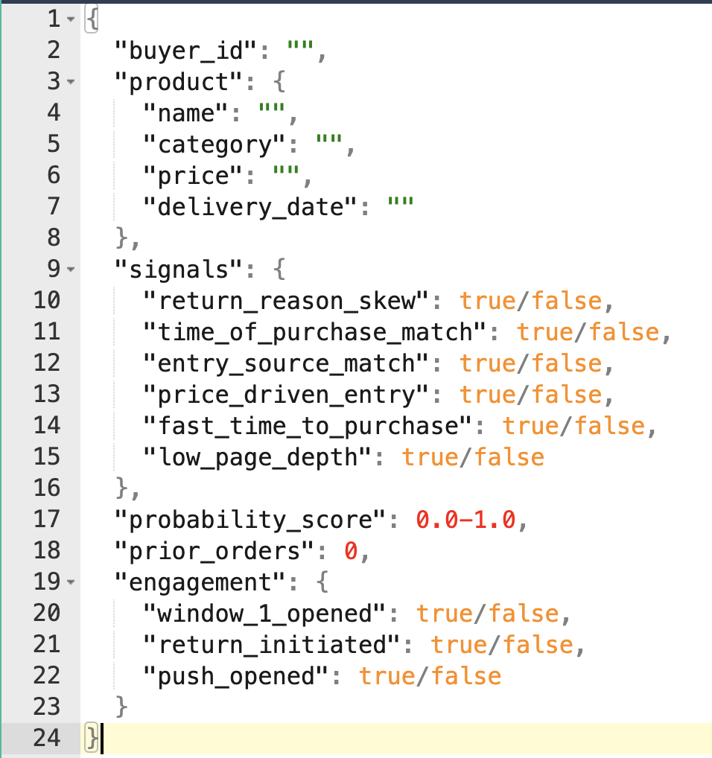
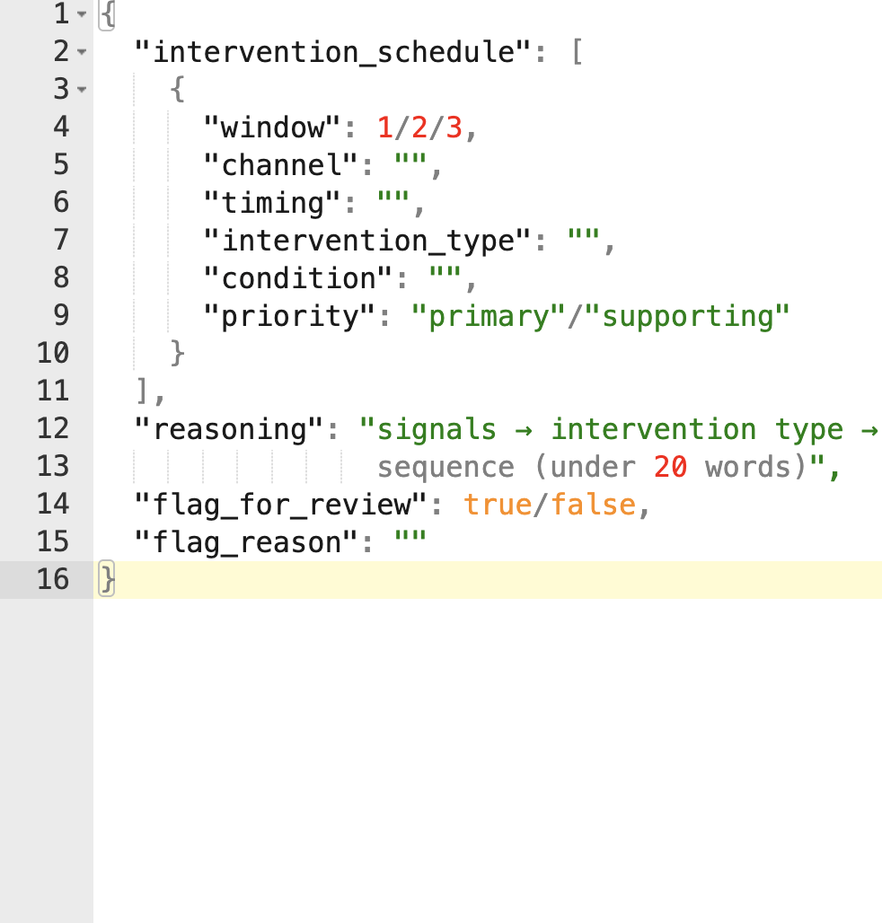

Fig IV: Generation Agent Input and Output Format

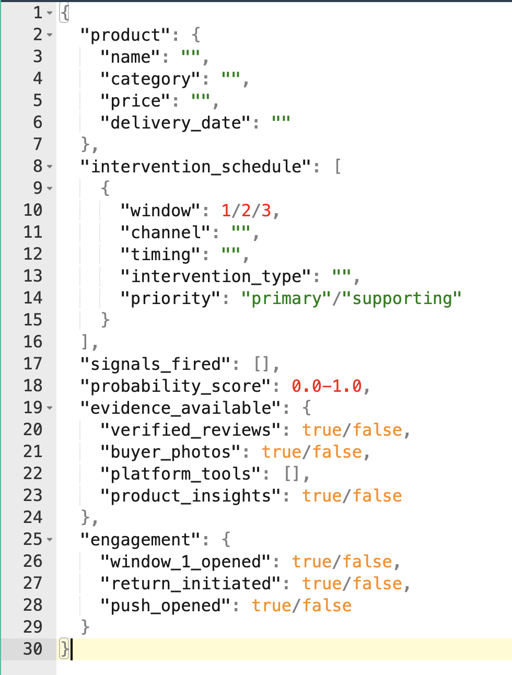
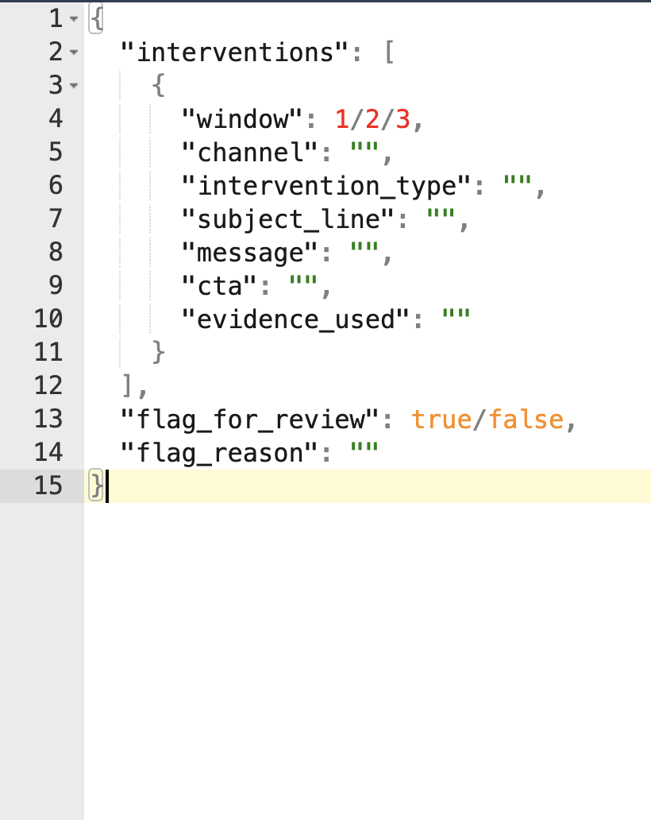

Appendix II: PRISM in Action - Sample Buyer Journeys
Exhibit A: Classic Impulse Buyer
Matt, 28, discovers a jacket through an Instagram reel from an influencer he follows. He taps the link, spends thirty seconds on the product page, and checks out at 1:47am. He has returned three prior late-night social purchases with the reason code "changed mind."
Signals fired:
- Return reason skew - 70%+ prior returns are remorse-coded
- Time-of-purchase match - history of late-night returns, current order at 1:47am
- Entry source match - history of social-driven returns, current order from Instagram
- Fast time-to-purchase - checked out faster than platform average
- Low page depth - viewed fewer pages than platform average
Remorse likelihood: high
Impulse buyer probability: 0.87
Intervention Sequence
- Window 1: Order confirmation (T = 0 min)
Channel: Order confirmation page
Intervention type: Reassurance + Social Proof
Message: "A lot of customers said they weren't sure at first but ended up loving how the jacket fits. Click here to read their experience”
Channel: Order confirmation email (T = 5-10 min)
Intervention type: Reassurance + Social Proof
Subject: "You're going to want to see what other buyers said about this one"
"Most people who own this jacket say the same thing - they kept it and wondered why they ever doubted it. Here's what buyers who felt the same way said after their first wear. Click here to read their experience”

- Window 2: Waiting period before delivery (T = Day 2-3)
Channel: Shipping and tracking page
Intervention type: Ownership + First-Use Guidance
Message: "Your new jacket arrives Thursday. Most buyers pair it with denim or sneakers for their first outing - that's when it earns its place. Click here to see how this buyer styled it”
Channel: Push notification (T = Day 2 - high confidence, P = 0.87)
Intervention type: Ownership + First-Use Guidance
Notification: "Your jacket's on its way. Here's how to wear it first. See styling ideas”

- Window 3: Delivery day (T = delivery day)
Channel: Delivery notification
Intervention type: Anticipation Building
Message: "This is the kind of piece you'll reach for on your next weekend outing. See how others are styling it this season.”
Channel: Post-delivery email (T = same day, high confidence only)
Intervention type: Anticipation Building
Subject: "It's here - here's your first-wear moment"
"When it arrives, try it with your usual outfit first. Buyers say that's always when it feels right. See how this buyer styled it on day one...”

Outcome: Matt does not initiate a return, and the order is logged as a retained outcome.
Engagement signals: email opens, link clicks. Feed back into PRISM's scoring model to improve signal accuracy and intervention relevance over time.

Exhibit B: Low-signal Buyer
Jenna, 34, discovers a pair of wireless earbuds through a flash sale banner while browsing her the e-commerce platform during her lunch break. She spends two minutes on the product page, reads a few reviews, and checks out. She has made twelve prior purchases on the platform with an overall return rate of 18%, below the platform average.
Signals fired:
- Fast time-to-purchase - checked out faster than platform average for electronics
- Low page depth - viewed fewer pages than platform average
Remorse likelihood: Low for overall return rate but category return rate for electronics is above platform average.
Impulse buyer probability: 0.63
Intervention Sequence:
- Window 1: Order confirmation (T = 0 min)
Channel: Order confirmation page
Intervention type: Anticipation Building
Message: "You'll notice the difference the first time you use these, especially on a commute or during a workout. See it in action”
No confirmation email intervention since score below active outreach threshold.
No push notification since corroborating signals only, high-confidence threshold not met.

- Window 2: Skipped
Corroborating signals only fired. No pattern signal confirmed a repeated behavioral history. Window 2 is skipped entirely, the system does not reach out proactively.
- Window 3: Delivery day (T = delivery day)
Channel: Delivery notification
Intervention type: Anticipation Building
Message: "Your earbuds are here. Ten minutes on your favorite playlist - buyers say that's the moment it clicks. See it in action
No post-delivery email since score below high-confidence threshold.
Outcome: Jenna does not initiate a return. The system logs two passive touchpoints delivered, zero active outreach sent. Engagement signals feed back into the model. Because Jenna’s impulse buyer probability was 0.63 her outcome will contribute to future threshold calibration.

Appendix III: Cost Savings Estimation for PRISM
(Note: The data points are synthesized from multiple industry sources and are intended to be directional rather than exact)

Methodology
Narvar reports that 56% of returns are driven by product, service, or operational issues. The remaining 44% are non-operational and are used here as a directional proxy for remorse-driven returns. These likely overestimates pure remorse and therefore represents an upper-bound estimate of PRISM’s impact.
Upper-Bound Scenario
Cost savings per 1M orders:
= 1,000,000 × 25% × 44% × 10% × $27.50
= $302,500 in savings per 1M orders.

Lower-Bound Scenario
To account for uncertainty in mapping non-operational returns to true remorse, a more conservative assumption is used:
% remorse-driven returns (assumed) = 25%
Revised calculation:
= 1,000,000 × 25% × 25% × 10% × $27.50
= $171,875 in savings per 1M orders.

These estimates show that PRISM can drive meaningful cost savings even with conservative assumptions. In the lower-bound scenario, where only a smaller portion of returns are assumed to be driven by remorse, the system still generates noticeable savings. The upper-bound scenario suggests the broader opportunity if a larger share of returns is influenced by post-purchase doubt. It is important to note that this calculation only includes direct savings from avoided returns and does not account for longer-term benefits like improved retention, higher repeat purchases, or increased customer lifetime value. As the system is tested and refined with real data, the overall impact is likely to become clearer and potentially stronger.

Input | Value | Reference | Rationale
Overall Return Rate | 25% | Source: 2024 Return Report, Narvar | Industry benchmark (Narvar, 2024)
% remorse driven returns (1 - %returns driven due to product/service/operational issues) | 44% | Source: 2024 Return Report, Narvar | Derived from Narvar: 56% returns are due to product/service/operational issues
% reduction in returns due to PRISM interventions | 10% | (Source: McKinsey, Forrester, and eMarketer) Reference in FAQ 22 | Conservative estimate for early-stage intervention systems
Cost per return | $27.50 | (Source: 2024 Return Report, Narvar) Reference in FAQ 2 | Average reverse logistics cost (Narvar, 2024)

