Case Study 1

Rithvik

2023-02-15

if (!require("tidyverse")) install.packages("tidyverse")

## Loading required package: tidyverse

## ── Attaching packages ─────────────────────────────────────── tidyverse 1.3.2 ──  
## ✔ ggplot2 3.4.0 ✔ purrr 1.0.1   
## ✔ tibble 3.1.8 ✔ dplyr 1.0.10  
## ✔ tidyr 1.3.0 ✔ stringr 1.5.0   
## ✔ readr 2.1.3 ✔ forcats 0.5.2   
## ── Conflicts ────────────────────────────────────────── tidyverse_conflicts() ──  
## ✖ dplyr::filter() masks stats::filter()  
## ✖ dplyr::lag() masks stats::lag()

library(tidyverse)  
if (!require("lubridate")) install.packages("lubridate")

## Loading required package: lubridate  
##   
## Attaching package: 'lubridate'  
##   
## The following objects are masked from 'package:base':  
##   
## date, intersect, setdiff, union

library(lubridate)  
if (!require("geosphere")) install.packages("geosphere")

## Loading required package: geosphere

library(geosphere)  
if (!require("sf")) install.packages("sf")

## Loading required package: sf  
## Linking to GEOS 3.11.0, GDAL 3.5.3, PROJ 9.1.0; sf_use_s2() is TRUE

library(sf)  
if (!require("mapview")) install.packages("mapview")

## Loading required package: mapview

library(mapview)

# Ask

# Prepare

# Process

tripdata <-  
 list.files(path = "./", pattern = "2022.*divvy.*.csv") %>%   
 map_df(~read_csv(.))

## Rows: 103770 Columns: 13  
## ── Column specification ────────────────────────────────────────────────────────  
## Delimiter: ","  
## chr (7): ride_id, rideable_type, start_station_name, start_station_id, end_...  
## dbl (4): start_lat, start_lng, end_lat, end_lng  
## dttm (2): started_at, ended_at  
##   
## ℹ Use `spec()` to retrieve the full column specification for this data.  
## ℹ Specify the column types or set `show_col_types = FALSE` to quiet this message.  
## Rows: 115609 Columns: 13  
## ── Column specification ────────────────────────────────────────────────────────  
## Delimiter: ","  
## chr (7): ride_id, rideable_type, start_station_name, start_station_id, end_...  
## dbl (4): start_lat, start_lng, end_lat, end_lng  
## dttm (2): started_at, ended_at  
##   
## ℹ Use `spec()` to retrieve the full column specification for this data.  
## ℹ Specify the column types or set `show_col_types = FALSE` to quiet this message.  
## Rows: 284042 Columns: 13  
## ── Column specification ────────────────────────────────────────────────────────  
## Delimiter: ","  
## chr (7): ride_id, rideable_type, start_station_name, start_station_id, end_...  
## dbl (4): start_lat, start_lng, end_lat, end_lng  
## dttm (2): started_at, ended_at  
##   
## ℹ Use `spec()` to retrieve the full column specification for this data.  
## ℹ Specify the column types or set `show_col_types = FALSE` to quiet this message.  
## Rows: 371249 Columns: 13  
## ── Column specification ────────────────────────────────────────────────────────  
## Delimiter: ","  
## chr (7): ride_id, rideable_type, start_station_name, start_station_id, end_...  
## dbl (4): start_lat, start_lng, end_lat, end_lng  
## dttm (2): started_at, ended_at  
##   
## ℹ Use `spec()` to retrieve the full column specification for this data.  
## ℹ Specify the column types or set `show_col_types = FALSE` to quiet this message.  
## Rows: 634858 Columns: 13  
## ── Column specification ────────────────────────────────────────────────────────  
## Delimiter: ","  
## chr (7): ride_id, rideable_type, start_station_name, start_station_id, end_...  
## dbl (4): start_lat, start_lng, end_lat, end_lng  
## dttm (2): started_at, ended_at  
##   
## ℹ Use `spec()` to retrieve the full column specification for this data.  
## ℹ Specify the column types or set `show_col_types = FALSE` to quiet this message.  
## Rows: 769204 Columns: 13  
## ── Column specification ────────────────────────────────────────────────────────  
## Delimiter: ","  
## chr (7): ride_id, rideable_type, start_station_name, start_station_id, end_...  
## dbl (4): start_lat, start_lng, end_lat, end_lng  
## dttm (2): started_at, ended_at  
##   
## ℹ Use `spec()` to retrieve the full column specification for this data.  
## ℹ Specify the column types or set `show_col_types = FALSE` to quiet this message.  
## Rows: 823488 Columns: 13  
## ── Column specification ────────────────────────────────────────────────────────  
## Delimiter: ","  
## chr (7): ride_id, rideable_type, start_station_name, start_station_id, end_...  
## dbl (4): start_lat, start_lng, end_lat, end_lng  
## dttm (2): started_at, ended_at  
##   
## ℹ Use `spec()` to retrieve the full column specification for this data.  
## ℹ Specify the column types or set `show_col_types = FALSE` to quiet this message.  
## Rows: 785932 Columns: 13  
## ── Column specification ────────────────────────────────────────────────────────  
## Delimiter: ","  
## chr (7): ride_id, rideable_type, start_station_name, start_station_id, end_...  
## dbl (4): start_lat, start_lng, end_lat, end_lng  
## dttm (2): started_at, ended_at  
##   
## ℹ Use `spec()` to retrieve the full column specification for this data.  
## ℹ Specify the column types or set `show_col_types = FALSE` to quiet this message.  
## Rows: 701339 Columns: 13  
## ── Column specification ────────────────────────────────────────────────────────  
## Delimiter: ","  
## chr (7): ride_id, rideable_type, start_station_name, start_station_id, end_...  
## dbl (4): start_lat, start_lng, end_lat, end_lng  
## dttm (2): started_at, ended_at  
##   
## ℹ Use `spec()` to retrieve the full column specification for this data.  
## ℹ Specify the column types or set `show_col_types = FALSE` to quiet this message.  
## Rows: 558685 Columns: 13  
## ── Column specification ────────────────────────────────────────────────────────  
## Delimiter: ","  
## chr (7): ride_id, rideable_type, start_station_name, start_station_id, end_...  
## dbl (4): start_lat, start_lng, end_lat, end_lng  
## dttm (2): started_at, ended_at  
##   
## ℹ Use `spec()` to retrieve the full column specification for this data.  
## ℹ Specify the column types or set `show_col_types = FALSE` to quiet this message.  
## Rows: 337735 Columns: 13  
## ── Column specification ────────────────────────────────────────────────────────  
## Delimiter: ","  
## chr (7): ride_id, rideable_type, start_station_name, start_station_id, end_...  
## dbl (4): start_lat, start_lng, end_lat, end_lng  
## dttm (2): started_at, ended_at  
##   
## ℹ Use `spec()` to retrieve the full column specification for this data.  
## ℹ Specify the column types or set `show_col_types = FALSE` to quiet this message.  
## Rows: 181806 Columns: 13  
## ── Column specification ────────────────────────────────────────────────────────  
## Delimiter: ","  
## chr (7): ride_id, rideable_type, start_station_name, start_station_id, end_...  
## dbl (4): start_lat, start_lng, end_lat, end_lng  
## dttm (2): started_at, ended_at  
##   
## ℹ Use `spec()` to retrieve the full column specification for this data.  
## ℹ Specify the column types or set `show_col_types = FALSE` to quiet this message.

Lets look at the data

names(tripdata)

## [1] "ride_id" "rideable_type" "started_at"   
## [4] "ended_at" "start_station_name" "start_station_id"   
## [7] "end_station_name" "end_station_id" "start_lat"   
## [10] "start_lng" "end_lat" "end_lng"   
## [13] "member_casual"

str(tripdata)

## spc_tbl_ [5,667,717 × 13] (S3: spec_tbl_df/tbl_df/tbl/data.frame)  
## $ ride_id : chr [1:5667717] "C2F7DD78E82EC875" "A6CF8980A652D272" "BD0F91DFF741C66D" "CBB80ED419105406" ...  
## $ rideable_type : chr [1:5667717] "electric_bike" "electric_bike" "classic_bike" "classic_bike" ...  
## $ started_at : POSIXct[1:5667717], format: "2022-01-13 11:59:47" "2022-01-10 08:41:56" ...  
## $ ended_at : POSIXct[1:5667717], format: "2022-01-13 12:02:44" "2022-01-10 08:46:17" ...  
## $ start_station_name: chr [1:5667717] "Glenwood Ave & Touhy Ave" "Glenwood Ave & Touhy Ave" "Sheffield Ave & Fullerton Ave" "Clark St & Bryn Mawr Ave" ...  
## $ start_station_id : chr [1:5667717] "525" "525" "TA1306000016" "KA1504000151" ...  
## $ end_station_name : chr [1:5667717] "Clark St & Touhy Ave" "Clark St & Touhy Ave" "Greenview Ave & Fullerton Ave" "Paulina St & Montrose Ave" ...  
## $ end_station_id : chr [1:5667717] "RP-007" "RP-007" "TA1307000001" "TA1309000021" ...  
## $ start_lat : num [1:5667717] 42 42 41.9 42 41.9 ...  
## $ start_lng : num [1:5667717] -87.7 -87.7 -87.7 -87.7 -87.6 ...  
## $ end_lat : num [1:5667717] 42 42 41.9 42 41.9 ...  
## $ end_lng : num [1:5667717] -87.7 -87.7 -87.7 -87.7 -87.6 ...  
## $ member_casual : chr [1:5667717] "casual" "casual" "member" "casual" ...  
## - attr(*, "spec")=  
## .. cols(  
## .. ride_id = col_character(),  
## .. rideable_type = col_character(),  
## .. started_at = col_datetime(format = ""),  
## .. ended_at = col_datetime(format = ""),  
## .. start_station_name = col_character(),  
## .. start_station_id = col_character(),  
## .. end_station_name = col_character(),  
## .. end_station_id = col_character(),  
## .. start_lat = col_double(),  
## .. start_lng = col_double(),  
## .. end_lat = col_double(),  
## .. end_lng = col_double(),  
## .. member_casual = col_character()  
## .. )  
## - attr(*, "problems")=<externalptr>

We need to know 1. Duration of the ride - duration 2. Date, extract from timestamp ‘started_at’ We will ignore corner cases where rides were taken around midnight, and use only started_at for the same - date 2. Weekday - Sunday, Monday etc. that the ride was taken. day_of_the_week 3. Whether the ride was a weekday ride(Mon..Fri) or a weekend ride(Sat,Sun).

For duration, it is simple. Luckily, the started_at and ended_at are both in POSIX_ct format as timestamps.

tripdata$duration <- tripdata$ended_at - tripdata$started_at  
tripdata <- tripdata[tripdata$duration>0,]

Date can easily be extracted, and the

tripdata$date <- lubridate::date(tripdata$started_at)

From this, we get the day_of_the_week

tripdata$day_of_the_week <- as.factor(wday(tripdata$started_at, label=TRUE))

We now need to decide whether the day is a weekday or weekend. This is simple:

weekday_or_end <- function(day)   
 ifelse(day=="Sat" | day=="Sun","Weekend","Weekday")

We define the simple one-line function. Then we plug it into the assignment below. Note that these values should be factors

tripdata$weekday_or_end <- as.factor(weekday_or_end(as.character(tripdata$day_of_the_week)))

Other columns we should have as factors are: rideable_type and member_casual

tripdata$rideable_type <- as.factor(tripdata$rideable_type)  
tripdata$member_casual <- as.factor(tripdata$member_casual)

str(tripdata)

## tibble [5,667,186 × 17] (S3: tbl_df/tbl/data.frame)  
## $ ride_id : chr [1:5667186] "C2F7DD78E82EC875" "A6CF8980A652D272" "BD0F91DFF741C66D" "CBB80ED419105406" ...  
## $ rideable_type : Factor w/ 3 levels "classic_bike",..: 3 3 1 1 1 1 1 1 3 1 ...  
## $ started_at : POSIXct[1:5667186], format: "2022-01-13 11:59:47" "2022-01-10 08:41:56" ...  
## $ ended_at : POSIXct[1:5667186], format: "2022-01-13 12:02:44" "2022-01-10 08:46:17" ...  
## $ start_station_name: chr [1:5667186] "Glenwood Ave & Touhy Ave" "Glenwood Ave & Touhy Ave" "Sheffield Ave & Fullerton Ave" "Clark St & Bryn Mawr Ave" ...  
## $ start_station_id : chr [1:5667186] "525" "525" "TA1306000016" "KA1504000151" ...  
## $ end_station_name : chr [1:5667186] "Clark St & Touhy Ave" "Clark St & Touhy Ave" "Greenview Ave & Fullerton Ave" "Paulina St & Montrose Ave" ...  
## $ end_station_id : chr [1:5667186] "RP-007" "RP-007" "TA1307000001" "TA1309000021" ...  
## $ start_lat : num [1:5667186] 42 42 41.9 42 41.9 ...  
## $ start_lng : num [1:5667186] -87.7 -87.7 -87.7 -87.7 -87.6 ...  
## $ end_lat : num [1:5667186] 42 42 41.9 42 41.9 ...  
## $ end_lng : num [1:5667186] -87.7 -87.7 -87.7 -87.7 -87.6 ...  
## $ member_casual : Factor w/ 2 levels "casual","member": 1 1 2 1 2 2 2 2 2 2 ...  
## $ duration : 'difftime' num [1:5667186] 177 261 261 896 ...  
## ..- attr(*, "units")= chr "secs"  
## $ date : Date[1:5667186], format: "2022-01-13" "2022-01-10" ...  
## $ day_of_the_week : Ord.factor w/ 7 levels "Sun"<"Mon"<"Tue"<..: 5 2 3 3 5 3 1 7 2 6 ...  
## $ weekday_or_end : Factor w/ 2 levels "Weekday","Weekend": 1 1 1 1 1 1 2 2 1 1 ...

# Analyse

weekly_trips <- tripdata %>%  
 group_by(weekday_or_end, member_casual,date) %>%  
 summarise(sum = sum(duration), mean = mean(duration), mode = mode(duration), max = max(duration), min = min(duration), count = sum(duration>10,na.rm=TRUE))

## `summarise()` has grouped output by 'weekday_or_end', 'member_casual'. You can  
## override using the `.groups` argument.

bike_prefs <- tripdata %>%  
 group_by(rideable_type, member_casual,date) %>%  
 summarise(sum = sum(duration), mean = mean(duration), mode = mode(duration), max = max(duration), min = min(duration),count = sum(duration>10,na.rm=TRUE))

## `summarise()` has grouped output by 'rideable_type', 'member_casual'. You can  
## override using the `.groups` argument.

trips_by_weekday <- tripdata %>%  
 group_by(day_of_the_week, member_casual,date) %>%  
 summarise(sum = sum(duration), mean = mean(duration), mode = mode(duration), max = max(duration), min = min(duration), count = sum(duration>10,na.rm=TRUE))

## `summarise()` has grouped output by 'day_of_the_week', 'member_casual'. You can  
## override using the `.groups` argument.

## Constructing plots

gg_weekly_sums <- ggplot(data = weekly_trips, aes(x=date, y=sum, col=member_casual)) +  
 facet_grid(weekday_or_end~member_casual) +  
 geom_point() +  
 geom_smooth()  
print(gg_weekly_sums)

## Don't know how to automatically pick scale for object of type <difftime>.  
## Defaulting to continuous.  
## `geom_smooth()` using method = 'loess' and formula = 'y ~ x'

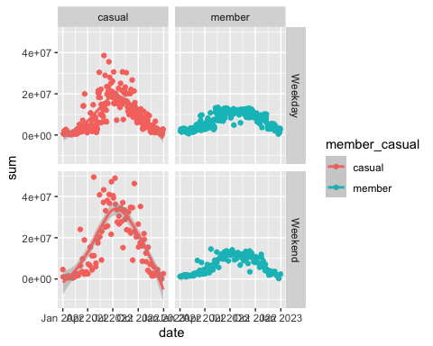

gg_weekly_means <- ggplot(data = weekly_trips, aes(x=date, y=sum, col=member_casual)) +  
 facet_grid(weekday_or_end~member_casual) +  
 geom_point() +  
 geom_smooth()  
print(gg_weekly_means)

## Don't know how to automatically pick scale for object of type <difftime>.  
## Defaulting to continuous.  
## `geom_smooth()` using method = 'loess' and formula = 'y ~ x'



g <- ggplot(data = weekly_trips, aes(x=date, y=mean, col=member_casual)) +  
 facet_grid(weekday_or_end~member_casual) +  
 geom_point() +  
 geom_smooth()  
print(g)

## Don't know how to automatically pick scale for object of type <difftime>.  
## Defaulting to continuous.  
## `geom_smooth()` using method = 'loess' and formula = 'y ~ x'

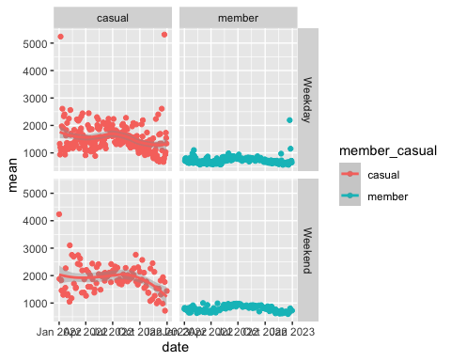

Drastic difference:-

gg_week_max <- ggplot(data = weekly_trips, aes(x=date, y=max, col=member_casual)) +  
 facet_grid(weekday_or_end~member_casual) +  
 geom_point() +  
 geom_smooth()  
print(gg_week_max)

## Don't know how to automatically pick scale for object of type <difftime>.  
## Defaulting to continuous.  
## `geom_smooth()` using method = 'loess' and formula = 'y ~ x'

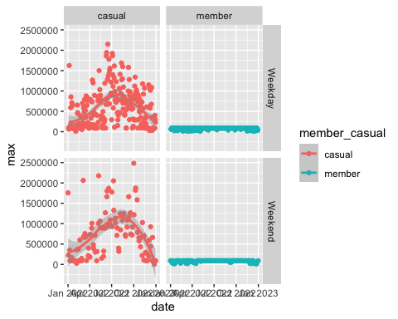

gg_bike_counts <- ggplot(data = bike_prefs, aes(x=date, y=count, col=member_casual)) +  
 facet_grid(rideable_type~member_casual) +  
 geom_point() +  
 geom_smooth()  
print(gg_bike_counts)

## `geom_smooth()` using method = 'loess' and formula = 'y ~ x'

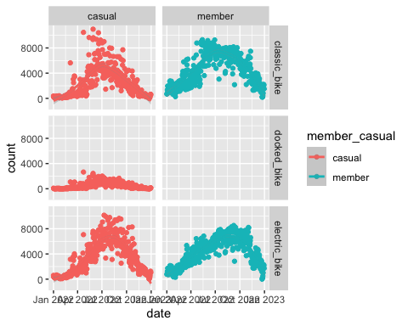

gg_bike_mean <- ggplot(data = bike_prefs, aes(x=date, y=mean, col=member_casual)) +  
 facet_grid(rideable_type~member_casual) +  
 geom_point() +  
 geom_smooth()  
print(gg_bike_mean)

## Don't know how to automatically pick scale for object of type <difftime>.  
## Defaulting to continuous.  
## `geom_smooth()` using method = 'loess' and formula = 'y ~ x'

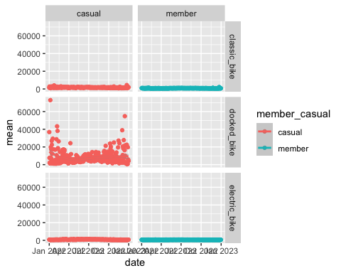

gg_weekday_hist <- ggplot(data = weekly_trips, aes(x=mean, fill=member_casual)) +  
 facet_grid(weekday_or_end~member_casual) +  
 geom_histogram()  
print(gg_weekday_hist)

## Don't know how to automatically pick scale for object of type <difftime>.  
## Defaulting to continuous.  
## `stat_bin()` using `bins = 30`. Pick better value with `binwidth`.

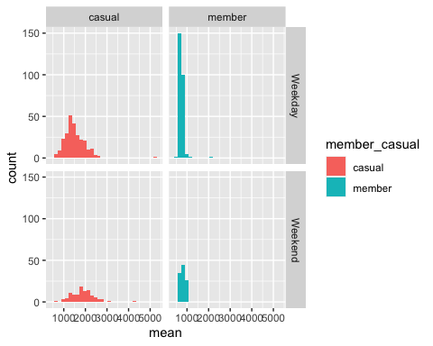

gg_weekday_bar <- ggplot(data = trips_by_weekday, aes(x=day_of_the_week, y=max, fill=member_casual)) +  
 facet_grid(.~member_casual) +  
 geom_col()  
print(gg_weekday_bar)

## Don't know how to automatically pick scale for object of type <difftime>.  
## Defaulting to continuous.

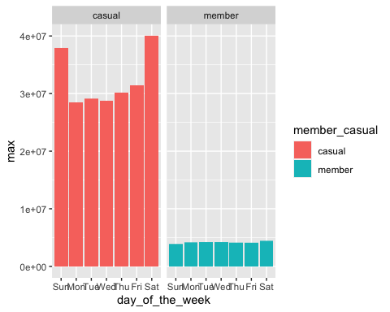

sum_trips_by_weekday <- trips_by_weekday[,c("day_of_the_week","sum")]