**UrbanMET**

Main project file location: \\GUARNERI\Urban-MET

Chattanooga’s EPB data is found in \\gist-femi-1x\n\ChattanoogaEPB

Main Leads on the project: Melissa Allen, Amy Rose, Joshua New, and Femi

UrbanMET is an LDRD project. It involves looking at how the built environment affects the weather and climate patterns and how those weather and climate patterns affect the built environment. The project is interested in urban microclimates and energy use at the neighborhood level.

Searching through the main project file location will lead to multiple documents that describe not only the project overall but also the details on some methodology. For example, the “Tech Report – ORNL TEMPLATE – Developing 3D Morphologies for Simulating Building Energy Demand in Urban Microclimates” is Thomaz’s report on processing LiDAR and also his creation of the Chicago morphologies for this project. LiDAR processing was also written up by Thomaz and can be found in a separate word document “Workflow for LiDAR” in the \\GUARNERI\Urban-MET\DataPrep4CESIUM folder.

The line between the UrbanMET project and some of the work we help Joshua New with is a little blurry. The areas we’ve worked on are the ORNL campus, UT campus, a section of the city of Chattanooga, and the EPB service area (EPB is the Electric Power Board of Chattanooga). I’m not sure if all areas are part of the main UrbanMET project and/or other side projects.

Thomaz worked on processing LiDAR data to get building footprints. He also measured ORNL buildings window-to-wall ratios (WWR). WWR are used in the building energy use calculations.

My role has been to work with the GIS files of buildings and netcdf files of weather.

The building energy modeling has very specific file structure needed to visualize (and I think run the actual modeling?) where typical shapefiles are not used. Currently (09/2017), the visualization is done in CESIUM. There are specific steps to follow when turning building footprint/shapefiles into the csv/sylk file format needed for CESIUM. The CESIUM preparation process has already been documented here: \\GUARNERI\Urban-MET\DataPrep4CESIUM. This folder is similar to what is in the Chattanooga folder on Femi’s UrbanCAT drive and also includes instructions for building extraction from LiDAR and downloading Open Street Map (OSM) data. NOTE: when gathering data for a new area Thomaz and I usually were able to find building footprints freely available online. If they weren’t available we would then go to the building data available from OSM. We used the building footprints with LiDAR data. We have some LiDAR data and building footprint data available within GIST’s data folders. Otherwise, we downloaded data found online.

I work in ArcGIS and R to create the final output files which are the csv/sylk files for the building geometry and a csv file for the weather files. Right now, other than delivering the building geometry, we are delivering weather summaries for each building in the AOI. All of the grid cells that fall on a building (or the grid cell that is closest to the building) are summarized to give a building weather summary. The R file with the script and instructions to do this are here: \\GUARNERI\Urban-MET\bldgs_ORNL_Chicago. One weather csv file is created for each building. The weather building id matches the building id in the building footprint csv/sylk file.

Different WRF (Weather Research and Forecasting model) domains and extents can be calculated, each with different grid spacing. In the Urban-MET folder there are files for the 270m grid (example, in the 2dEPVars4Linda folder) and 90m grid. The file name will include hints as to the location and grid size.

**ORNL Campus Data:**

The ORNL campus is focusing only the main campus buildings.

There are some data for two buildings (4515 and 5200) that include weather measurements at the building level. The Metasys data can be found here: \\GUARNERI\Urban-MET\MetasysData and in the \\GUARNERI\Urban-MET\ORNLMetComparison\MetasysOnBldg folders (and the Buildings_RH-Temp_Susan folder)

Meteorological data for ORNL campus are captured by several MetTowers. The towers closest to the main campus are towers B and D. The MetTower data can be found here: \\GUARNERI\Urban-MET\MeteorologicalData and in the \\GUARNERI\Urban-MET\ORNLMetComparison\ MeteorologicalData2015(xls) and TowerBTowerD folders

The WRF_output for the ORNL campus area is found in several spots. FYI, the WRF models had to be re-exported on 09/20/2017, so csv data for the 90m run before that date will not be correct (ask Melissa about 09/20/2017 email conversation if need more details).

The 270m data for the ORNL campus can be found here: \\GUARNERI\Urban-MET\WRFOutputCSV\MiscCSV and here: \\GUARNERI\Urban-MET\2dEPVars4Linda with results at the building level here: \\GUARNERI\Urban-MET\bldgs_ORNL_Chicago\ORNL\Bldg_weather_270m and a map of which points go to which buildings here: bldgs_ORNL_Chicago\ORNL\orbldgs_270m_points.png but the 90m is generally used now that it’s available.

The 90m WRF results are here: \\GUARNERI\Urban-MET\WRFOutputCSV\90mResults. Melissa has exported these from the final netcdf files. The closest grid points to the MetTowers on campus have been extracted and the main campus as well. The building summary files were calculated (refer to R file for details) and final results are here: \\GUARNERI\Urban-MET\bldgs_ORNL_Chicago\ORNL\Bldg_weather_90m.

To determine which 90m points belonged to which ORNL building I followed the instructions I’ve written down here: \\GUARNERI\Urban-MET\bldgs_ORNL_Chicago\READFIRSTBldgSummary_WRFdata.docx and the output of buildings and associated coordinates is here: \\GUARNERI\Urban-MET\bldgs_ORNL_Chicago\ORNL\grid_bldg2coord_90m.

Linda, Susan, and Carl worked on some comparisons between the building data, tower data, and wrf data. The data and results of the comparison make up the basis of the \\GUARNERI\Urban-MET\ORNLMetComparison\ folder. Powerpoint summaries are in the main Urban-MET folder. The \ORNLMetComparison\images folder has some nice maps of the campus that were exported from ArcMap.

R calculations are in the \ORNLMetComparison\WRF_output folder. compareWRF2Metays file is what was used to create some of the charts in the powerpoints. (Carl and Susan created the other plots in Excel and R respectively. I believe the Excel files are in the folder. Carl looked at the Towers and Susan looked at the Metasys Building data). The subset90m_campus file is the code to create weather summaries at the building level (although, these will need to be redone due to the WRF models needing to be rerun – see highlighted text above.)

Shapefile of the ORNL main campus buildings is in the \bldgs_ORNL_Chicago\ORNL\shapefiles folder. The grid can be created by displaying the x/y data from \\GUARNERI\Urban-MET\bldgs_ORNL_Chicago\ORNL\grid_bldg2coord_90m\ORNL_90m_grid.csv

This portion refers to the ORNLMetComparison\shapefiles folder with the previously run information we had before we realized the data was exported incorrectly from WRF: The grid90m was created using a time step from the netcdf file/csv final output and displaying the x/y. Met_Towers location was created from the x/y data in the MeteorologicalData folder. The 3 different ORNL campus files include all the campus buildings (ORNL_Buildings_2012), the main campus buildings (ORNL_Main), and the two buildings that we have Metasys data for (ORNL_4515_5200).

The \\GUARNERI\Urban-MET\ORNLBuildings folder contains data from the start of the UrbanMET project. This is where Thomaz went out and took pictures of the buildings on campus to get the Window-to-Wall ratio (WWR). The ORNLBuildings\Building Measurements contain the pdf images and calculations of his work. The ORNLBuildings\ORNL_Buildings_2012 folder contain shapefile of the campus buildings. The ORNLBuildings\Bldgs4UrbanMET folder is my first attempt to get the building data for ORNL, including Thomaz’s WWR data, into the proper format the building energy people needed. The final properly formatted data for ORNL_Bldgs can be found \\GUARNERI\Urban-MET\bldgs_ORNL_Chicago\ORNL\Bldg_geom with the “human-readable” excel format and the special csv/sylk format for CESIUM.

The \\GUARNERI\Urban-MET\ORNLBuildings\4Thomas folder contains data from Thomas Weigand’s summer 2017 project that looked at Wifi data as a proxy for building use. The rest of his data is in \\GUARNERI\ProjectThomas.

**UTK Campus**

Shapefiles were downloaded from [http://facserv.utk.tennessee.edu/buildlist.asp](http://facserv.utk.tennessee.edu/buildlist.asp%20) on 10/25/2016. Thomaz was able to find the number of floors for each building and from that we calculated height (10*#floors). The shapefiles can be found here: \\GUARNERI\Urban-MET\UTKcampus\shapefile. The csv that I sent is in this folder: \\GUARNERI\Urban-MET\UTKcampus\. This was still early in the process of when we were figuring out the right format needed for CESIUM. I believe Joshua had to make some adjustments to the file so he has what would be the final copy. The visualization result is at bit.ly/ut_buildings

From 11/01/2016 email from Joshua:

We had major stakeholders at today’s Governor’s chair meeting at UT including UT, SOM, ORNL, City of Knoxville, Knox County, and Trane (energy services private-sector company). The meeting was full of lively and important discussion. Unfortunately, we did not find a UT champion for leading an NSF proposal for the virtual UT campus, and we did not identify UT funding avenues that could leverage ORNL’s potential SEED for ORNL staff to collaborate.

Haven’t heard anything (as of 09/21/2017) about revisiting any parts of this.

**Chicago**

The Chicago Loop portion of Chicago is the area of focus. I am not sure where the LiDAR came from. Building footprints were downloaded from <https://data.cityofchicago.org/Buildings/Building-Footprints-current-/hz9b-7nh8> on 02/23/2017. The building height data was extracted from LiDAR. The initial buildings extracted from LiDAR for Chicago are located here: \\GUARNERI\Urban-MET\GISdata\Chicago\Shapefiles\ChicagoLoopLiDAR. Please see below for the final GIS building shapefiles that are used.

Along with the buildings already in the loop, Thomaz created three morphologies for the area just south of the loop. His SouthLoop_Morphs were created as described in the paper here: \\GUARNERI\Urban-MET\Tech Report - ORNL TEMPLATE - Developing 3D Morphologies for Simulating Buliding Energy Demand in Urban Microclimates 07-14-2017.docx (this is the most recent copy I could find, but be aware that a more finalized copy may be out there). There is also a powerpoint available here: \\GUARNERI\Urban-MET\SouthLoop_Morphs\Urban-MET - Creating Morphologies for Simulation of Undeveloped Parcel in Chicago South Loop.pptx

Morph1 is for supposed proposed development plans that were found in news articles, etc. when Thomaz did some research (sources are cited in ppt). Morph2 is assuming a high-density building plan. Morph3 is a low-density building plan. All the buildings in the simulated morphologies were created by copying and pasting existing buildings into the empty space. (this actually created some issues with building ID’s but that issue was resolved.) The Tech Report goes into greater detail.

The final GIS shapefiles of the buildings (and this includes the basic footprint, the proper building ID, and was used to create the csv/sylk format for CESIUM) for all of the morphologies can be found here: \\GUARNERI\Urban-MET\bldgs_ORNL_Chicago\Chicago\shapefiles with a note about all the Chicago geometry files included in a word document (\\GUARNERI\Urban-MET\bldgs_ORNL_Chicago\Chicago\note about chi bldg geom.docx) but also copied here:

Actual detailed Chicago building geometry and attributes from LiDAR can be found here:

\\GUARNERI\Urban-MET\GISdata\Chicago\Shapefiles\ChicagoLoopLiDAR

From the above shapefile location the three different morphologies were created:

\\GUARNERI\Urban-MET\SouthLoopMorphs

Shapefiles –

bldgs_ChicagoLoop_Morph1_RW

bldgs_ChicagoLoop_Morph2_High

bldga_ChicagoLoop_Morph3_Low

and from the individual morphologies above a simplified building geometry for each scenario was created. Unique IDs were created for each building and data was prepped for CESIUM.

The simplified building geometry shapefiles and csv for CESIUM can be found here:

\\GUARNERI\Urban-MET\bldgs_ORNL_Chicago\Chicago\ shapefiles and bldg_geom folders

Some of the data in the \\GUARNERI\Urban-MET\GISdata\Chicago\Shapefiles folder is when I was first trying to get the original LiDAR buildings to dissolve and get the footprint, wall, and points to create the proper csv/sylk format for CESIUM. This includes the BldgWalls folder. The Building_Footprints__Current_ is all the building footprints for all the Chicago area, not just the Loop.

As mentioned in the copied note above, the formatted files for CESIUM are found here: \\GUARNERI\Urban-MET\bldgs_ORNL_Chicago\Chicago\bldg_geom and include both the “human readable” excel file and the specially formatted csv/sylk file. I’ve include a variety of options as I wasn’t sure how the data were going to be displayed and entered into CESIUM. So, there is the main Chicago Loop as it currently is, the 3 morphologies by themselves, and the 3 morphologies with the main Chicago Loop.

The 90m WRF csv output files for the Chicago area are here: \\GUARNERI\Urban-MET\WRFOutputCSV\90mResults. Again, FYI, the WRF models had to be reexported on 09/20/2017, so data for the 90m run before that date will not be correct (ask Melissa about 09/20/2017 email conversation if need more details). These have now been rerun. The files have been extracted/exported from the final netcdf files. If the filename includes “KC199” that refers to the weather station that is closest to the Chicago Loop. So that file will only include the grid cell closest to that weather station. (see \\GUARNERI\Urban-MET\ChicagoMetStations for some information on the weather stations in Chicago). Also, only the portion of the netcdf coverage of Chicago Loop area was extracted. The netcdf covered a much larger area and only the relevant portion was extracted.

Following the instructions in the word document and the R script here: \\GUARNERI\Urban-MET\bldgs_ORNL_Chicago\. I was able to get building level weather summaries using the grid cells that fell on each building. The 90m grid (view x/y coordinated in arcmap) and the building associated coordinates for the 90m grid are here: \\GUARNERI\Urban-MET\bldgs_ORNL_Chicago\Chicago\grid_bldg2coord_90m. The building level weather summary data for the 90m wrf results is here: \\GUARNERI\Urban-MET\bldgs_ORNL_Chicago\Chicago\CHIbldg_weather_90m.

Carl created animations for the Chicago Loop area to visually show the difference in the different morphologies for a single day in January and a single day in July. This will not need to be redone due to above highlighted note because he was working from netcdf data and the issue was with converting the data to csv. His data are here: \\GUARNERI\Urban-MET\Carl. He left the following note about the animation process:

The raw data, MXDs, and AVI videos for each morphology and variable are in the following folder: \\GUARNERI\Urban-MET\Chicago90m_WRF\nc_files

The AVIs were converted to GIFS using a cloud-based website, so there aren’t local versions of them. There are many options online to convert from AVI to GIF but I found the following website to be the easiest to use: <https://convertio.co/avi-gif/>

That same folder above contains a quick word document outlining the methodology for creating the animations, from importing the netCDF files to exporting AVIs.

The final output for the GIFs in PowerPoint are in the following folder: \\GUARNERI\Urban-MET\Carl

At the time I needed to go through the netcdf files and calculate new variables before I extracted the single day for him. The variables that were calculated were Temperature in F, Wind Speed at 10m, and Relative Humidity in Percent. The nco code that I used in the linux environment is here: \\GUARNERI\Urban-MET\Chicago90m_WRF\nco_calc.txt. This is usually run before Melissa exports the entire final csv but at the time Carl did this the model was still running and the final csv wasn’t ready. NOTE: Much of what is in the Chicago90m_WRF file is for Carl and represents the data we had at that time, which is NOT the final version.

**Chattanooga**

The Chattanooga data is in the \\gist-femi-1x\n\ChattanoogaEPB folder. I’m not sure it’s “officially” part of Urban-MET but it’s essentially using similar methods.

We initially did a small section of Chattanooga to visualize. Just the area above a bend in the river. Thomaz worked with the LiDAR and I downloaded OSM data and once Thomaz had the heights within the OSM buildings, I converted the data to the proper csv/sylk format for CESIUM. This small area evolved into a larger project with Joshua New.

The service area for the Electric Power Board (EPB) of Chattanooga is the new extent (which includes the tiny section we had previously done). The area that EPB covers differs depending on the source! We found online data and the data in HSIP did not match. Joshua provided an image of the area (that I think he got from the people at EPB directly) which, of course, didn’t match any of the previous extents we had found.

I georeferenced the image from Joshua \\gist-femi-1x\n\ChattanoogaEPB\Linda\EPB_Chattanooga\AOI\EPB_ServiceTerritory.png and EPB_ServiceTerritory1.tif, digitized a shapefile (EPB_ServiceArea.shp), and created a bounding box of the area (EPB_BBox.shp).  The Tennessee LiDAR derived building footprints data set from TNGIC (<https://tn.gov/finance/topic/gis-data-topic>) has been clipped to the bounding box AOI (\\gist-femi-1x\n\ChattanoogaEPB\Linda\EPB_Chattanooga\bldg_footprints_only, the EPB_Buildings.shp ).

Thomaz found LiDAR data from TN 3DEP project; see coverage below. 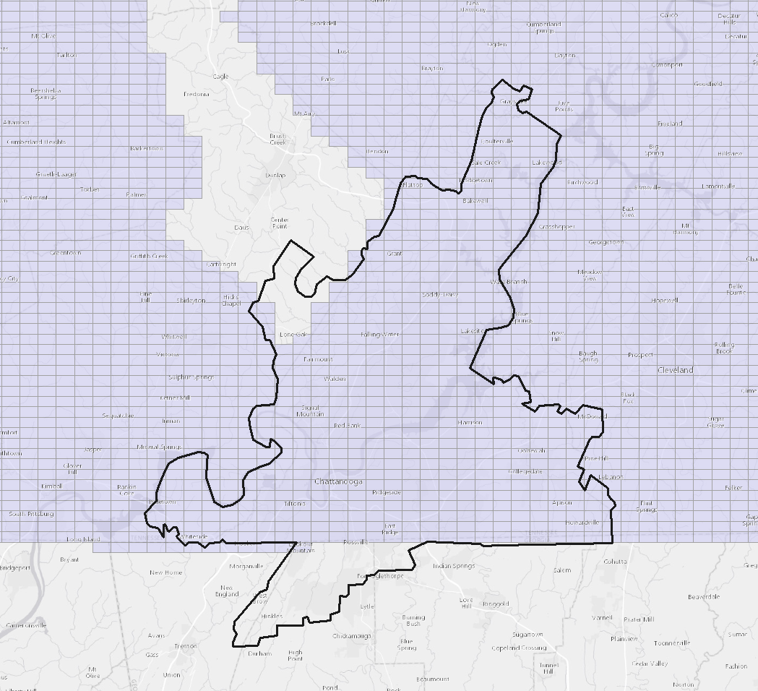

Note from email with Thomaz:

You’ll notice two empty legs:

* 1 in the NW (Sequatchie County). I found LiDAR data for it. The accuracy/point spacing will be similar but not exactly the same (E.g. Vertical accuracy is 12.5cm instead of 10cm). However, this area is mostly undeveloped. I see no buildings from TN data, so acquiring this is probably unnecessary and I’ll let it be.
* 1 leg south of the Georgia border. Here we’ll need both LiDAR and buildings. I’m searching for LiDAR now via Georgia Dept of Natural Resources.

If you’d like to help with buildings for that Georgia leg would be great. Especially if they have to come from OSM, then you can use your handy extract tool.

And that’s what happened with the GA data. I’m not sure where he found the LiDAR data from but it was somewhere online. I extracted the OSM buildings for that area of GA \\gist-femi-1x\n\ChattanoogaEPB\Linda\EPB_Chattanooga\bldg_footprints_only, the EPB_GA_osmbldgs.shp.

We dealt with the building heights to make sure what we had were buildings and not structures that wouldn’t have power (again see Thomaz’s report \\GUARNERI\Urban-MET\Tech Report - ORNL TEMPLATE - Developing 3D Morphologies for Simulating Buliding Energy Demand in Urban Microclimates 07-14-2017.docx)

I joined both the GA and TN data \\gist-femi-1x\n\ChattanoogaEPB\Linda\EPB_Chattanooga\EPB_Chattanooga_allbldgs_allcoverage

The final data we sent Joshua is this \\gist-femi-1x\n\ChattanoogaEPB\Linda\v2 with everything in the proper format. (I’ve also created a deliverables folder so you’ll see the same in there. \\gist-femi-1x\n\ChattanoogaEPB\Deliverables)

**EXTRA:**

<https://techcrunch.com/2017/07/12/nyu-releases-the-largest-lidar-dataset-ever-to-help-urban-development/>

We have downloaded the very detailed LiDAR data which covers Dublin, Ireland. There is an external hard drive with the 2015 data on it. This could be a potential area of future study.