**Great Lakes Forested Watershed** **Analysis** **Template**

**Section**: Characterizing the Watershed

**Topic:** Forests

**Author(s):** Randy Swaty

Contents

Questions Addressed: 1

Datasets Used & Justification: 1

Analysis Performed: 2

Results: 2

Existing Vegetation Types 2

# Questions Addressed:

* How much of each ecosystem occurs today?
* What are the patterns of vegetation cover and height?

# Datasets Used & Justification:

For this section we relied on data from the LANDFIRE Program (<https://landfire.gov/>). LANDFIRE is a shared program between the wildland fire management programs of the U.S. Department of Agriculture Forest Service Fire and Aviation branch, and the U.S. Department of the Interior, that provides more than twenty landscape-scale geo-spatial products, 950 vegetation models, and a suite of tools that support all-lands planning, management, and operations.

The specific products we used were: LANDFIRE’s Existing Vegetation Cover, Height and Type spatial data (<https://landfire.gov/vegetation/evc>, <https://landfire.gov/vegetation/evh> and <https://landfire.gov/vegetation/evt>)

LANDFIRE was used in this section of the analysis for multiple reasons including:

* All lands data that covered the assessment area
* Solid documentation and support
* Used in hundreds of peer reviewed journal articles, is base data for several federal programs (e.g., Interagency Fuel Treatment Decision Support System; <https://iftdss.firenet.gov/landing_page/>) and is easy to integrate, meaning all LANDFIRE datasets are designed to be used together

# Analysis Performed:

For this section we 1) downloaded the aforementioned LANDFIRE datasets (all 2022), 2) clipped those data to the Area of Interest in R, then 3) made charts in R, maps in QGIS.

# Results:

## Existing Vegetation Types

Using the coarsest level of classification in the LANDFIRE 2022 Existing Vegetation Type dataset we found that Agricultural and Hardwood types were the most dominant, covering 29% and 25% of the region, respectfully (EVT-Phys Chart). Exotics, Mines-Well and Wind Pads, Shrubland, Grassland and Sparsely Vegetated types were all minor, cumulatively mapped on < 2% of the region.

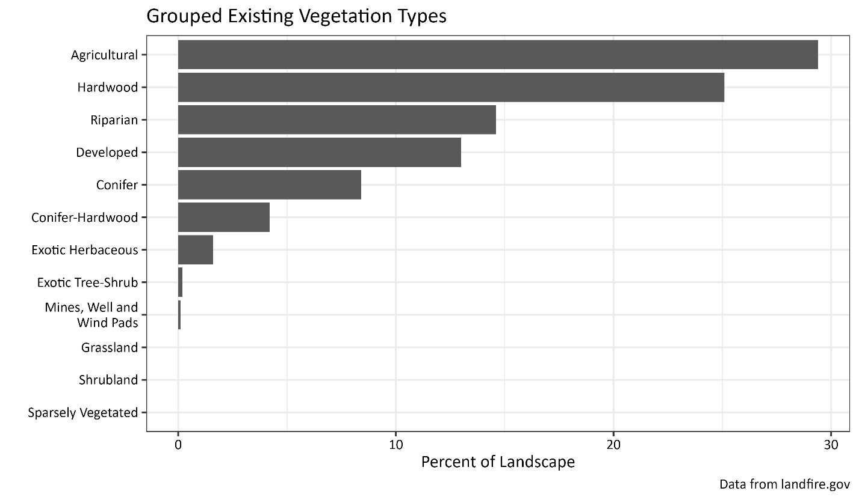

At the finest level of classification in the LANDFIRE 2022 Existing Vegetation Type dataset we found 132 types at the finest level of attribution (EVT_NAME attribute), with 101 of those type representing > 1% of the area. The top 20 types covered ~80% of the area. For the chart and map below, we lumped all “Agricultural” and “Developed” Types together, as there are many types within those broader categories.

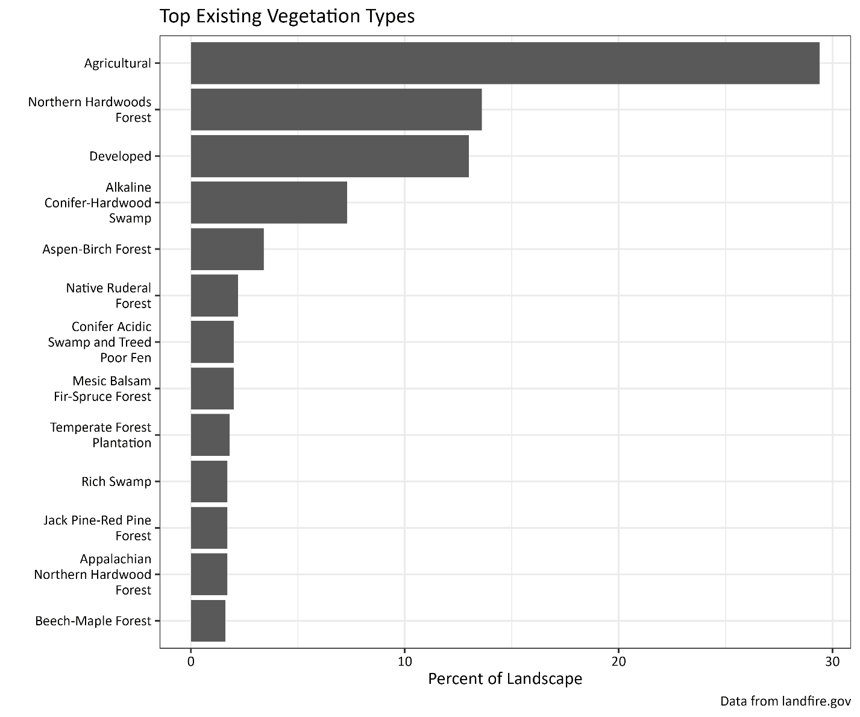

Geographically, we found that the Developed types were located primarily along the coasts of the Great Lakes and/or in the more southerly areas. The Agricultural types were primarily found in the southern portions of MI and WI, across the IN and OH portions of the region, and widespread across the NY portion of the watershed. Across the region “Hardwood” types were dominant. In WI and MI especially there were widespread representations of ‘Riparian’ types such as the ‘Alkaline Conifer-Hardwood Swamp”, and fire-adapted ecosystems such as the ‘Jack Pine-Red Pine Forest’.

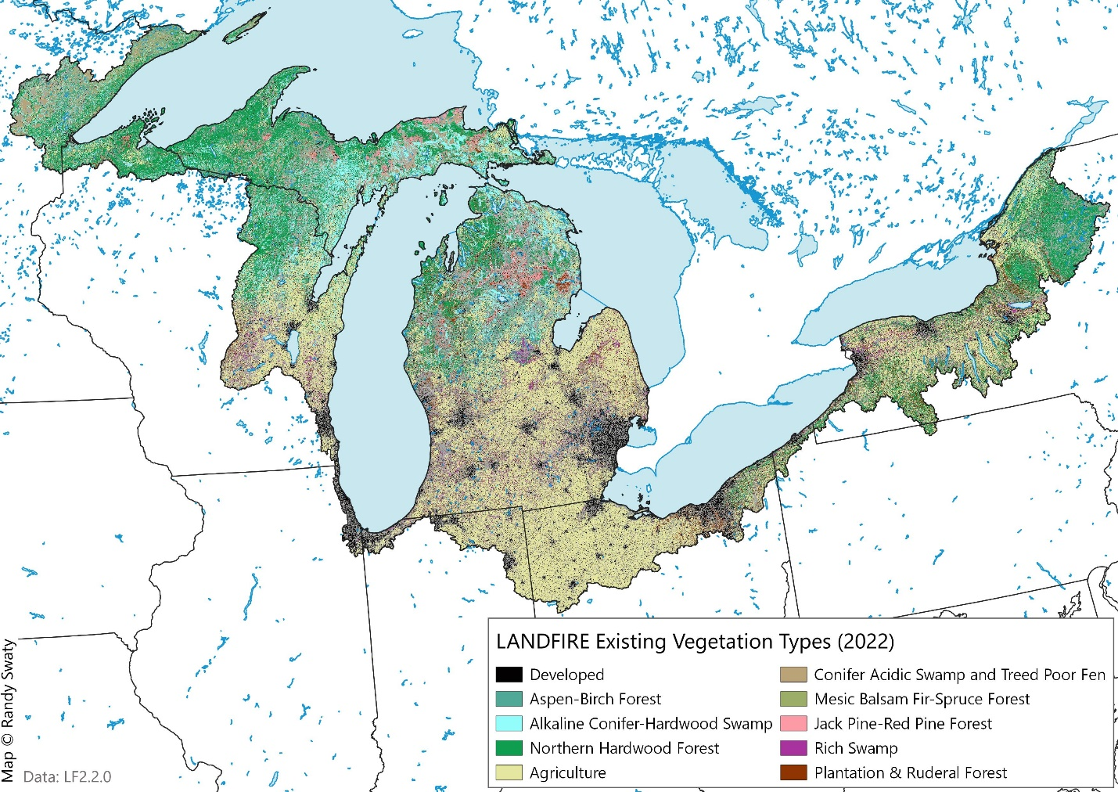

## Existing Vegetation Cover

For the non-Agricultural and undeveloped areas, LANDFIRE Mapped a substantial amount of the ‘Tree’ lifeform with canopy cover ranging from 60-80% (~27% of the entire region). In the LANDFIRE Existing Type dataset some areas classified in the grouped attribute as “Agriculture” are split into “Agriculture” and “Herbaceous” cover in the EVC dataset. The “Herbaceous” lifeforms were mapped over agricultural EVTs such as “Eastern Cool Temperate Pasture and Hayland” and “Eastern Cool Temperate Fallow/Idle Cropland” whereas the “Agricultural” types in the EVC data were mapped as types such as “Eastern Cool Temperate Row Crop” in the EVT dataset. Additionally, there were some ‘natural’ EVTs mapped with a ‘herbaceous’ lifeform in the EVC data. These types included “Laurentian-Acadian Wet Meadow” and “Northern & Central Ruderal Meadow”.

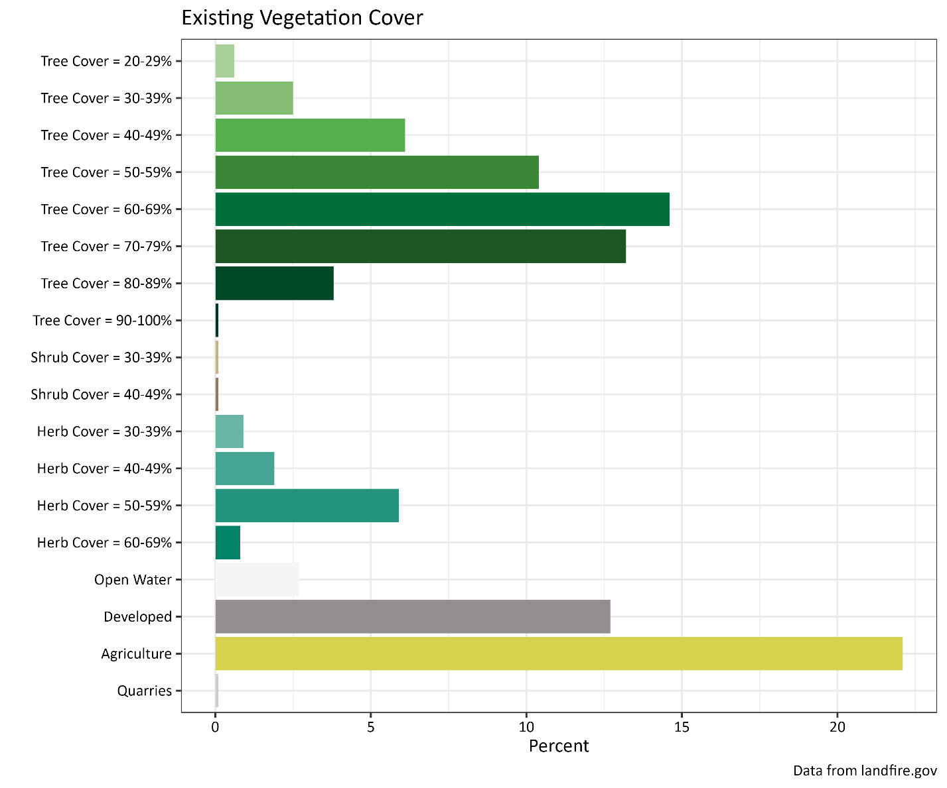

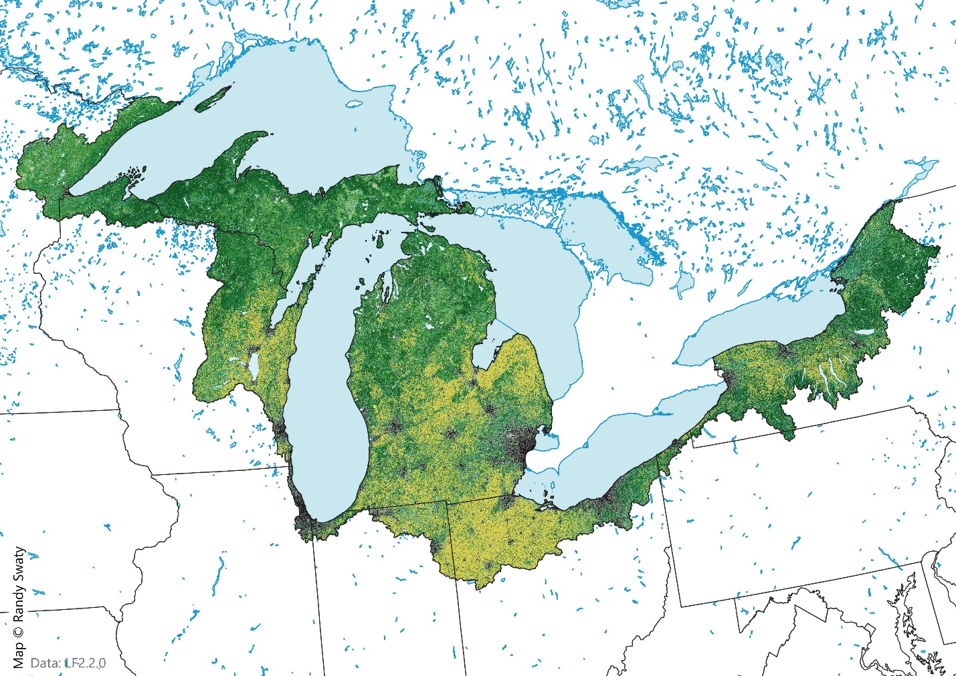

## Existing Vegetation Height

Across the region LANDFIRE mapped mostly “Tree” lifeform, with most being in the 15-20M range. In this chart % Cover categories that were > 0.1% of the landscape were removed for clarity. For example, there were pixels labeled as Trees > 25M, but they were extremely rare, covering > 0.1% of the landscape cumulativily. Because the pixel labels are an average of the tree height across the pixel, there could be a higher, or lower percentage of the region with trees taller than 25M.

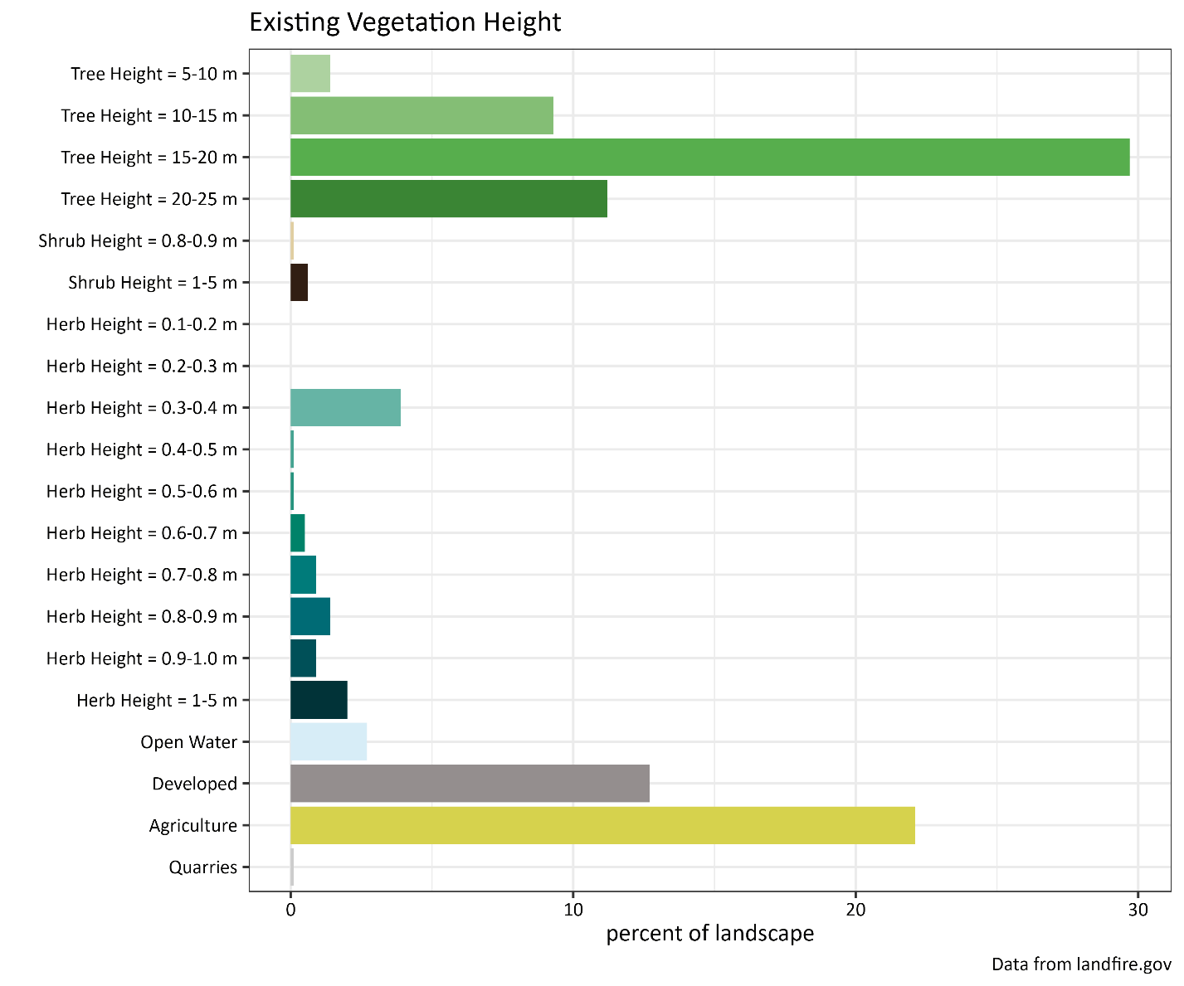

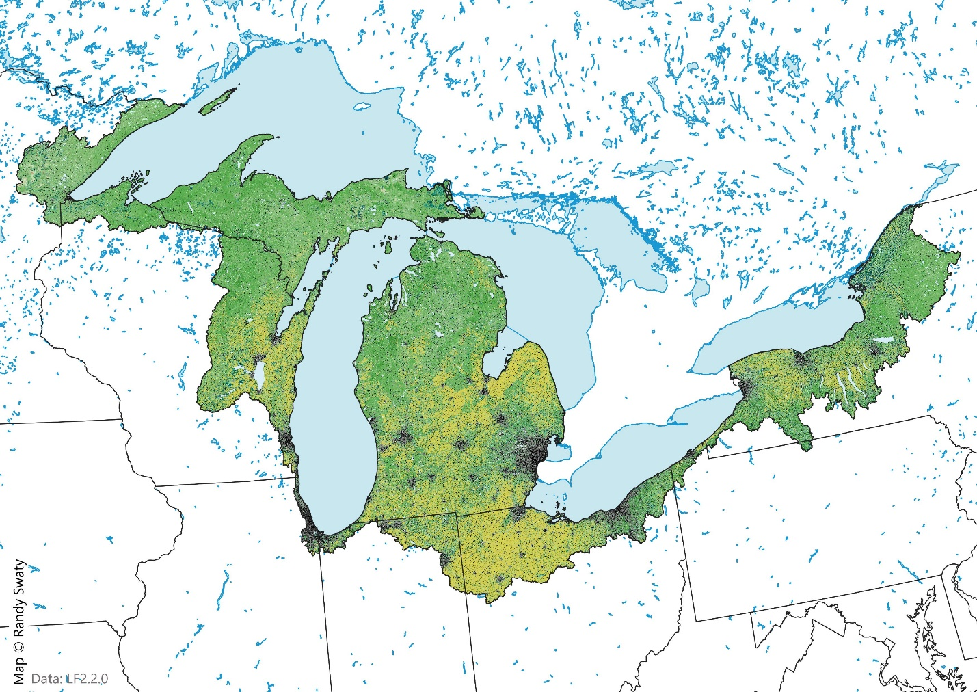

Discussion:

In broad terms, ~33% of the region has been converted to Agricultural or Developed land types, leaving ~67% as natural vegetation, most of it forested. Geographically the more northerly areas of the region remain most forested, with some notable exceptions in the NE OH, sliver of PA and the NY portions of the region. The largest urban areas generally follow this pattern as well.

**Main Message:** What is the take-away message from this analysis