**Great Lakes Forested Watershed** **Analysis** **Template**

**Section**: Characterizing the Watershed

**Topic:** Forests

**Author(s):** Randy Swaty

# Questions Addressed:

* Prior to European Colonization (referred to as ‘historical’ below)
  + How much of each ecosystem occurred?
  + How much disturbance was there?
* Currently (ca 2022)
  + How much of each ecosystem occurs today?
  + What are the patterns characterization of vegetation cover and height?
* Comparing the two
  + Which broad ecosystem groups have transitioned to which (how much hardwood have transitioned to conifer, or agriculture)?
  + How much late succession habitat were there historically compared to currently

# Datasets Used & Justification:

For this section we relied on data from the LANDFIRE Program (<https://landfire.gov/>). LANDFIRE is a shared program between the wildland fire management programs of the U.S. Department of Agriculture Forest Service Fire and Aviation branch, and the U.S. Department of the Interior, that provides more than twenty landscape-scale geo-spatial products, 950 vegetation models, and a suite of tools that support all-lands planning, management, and operations.

The specific products we used were:

*For the historical maps and values:*

* Biophysical Settings (BpS) spatial data (for mapping historical ecosystems; <https://landfire.gov/vegetation/bps>)
* Biophysical Settings Reference Conditions Table (for assessing historical amounts of succession classes per ecosystem; <https://landfire.gov/vegetation/bps-models>)
* Succession Class Descriptions (to help identify ‘Late-Succession” classes; from <https://apexrms.github.io/landfirevegmodels/)>

*For the current maps and values:*

* Existing Vegetation Cover, Height and Type spatial data (<https://landfire.gov/vegetation/evc>, <https://landfire.gov/vegetation/evh> and <https://landfire.gov/vegetation/evt>)
* Succession Classes (to calculate current amounts of succession classes per ecosystem; https://landfire.gov/vegetation/sclass

LANDFIRE was used in this section of the analysis for multiple reasons including:

* All lands data that covered the assessment area
* Only dataset we are aware of that allows for comparison of late-succession habitat, past to present
* Solid documentation and support
* Used in hundreds of peer reviewed journal articles, is base data for several federal programs (e.g., Interagency Fuel Treatment Decision Support System; <https://iftdss.firenet.gov/landing_page/>) and is easy to integrate, meaning all LANDFIRE datasets are designed to be used together

# Analysis Performed:

For this section we 1) downloaded the aforementioned LANDFIRE datasets (all for 2022, except the BpSs for which we used the 2020 version), 2) clipped those data to the Area of Interest in R, then 3) made charts in R, maps in QGIS.

# Results:

## Historical Ecosystems

LANDFIRE mapped 51 separate ecosystems (BpSs) for the area of interest, most of which were minor in prevalence. Thirteen BpSs dominated the historical landscape, cumulatively covering ~80% of the area (see bar hart below). Of the 51 ecosystems most (55%) were grouped as ‘Hardwoods’, followed by ‘Riparian’ (20%), Hardwood-Conifer (12%), and Conifer (8%) groups. Other groups (Grassland, Shrubland and Savanna) were minor representing ~ 1% cumulatively. While these groups of ‘Other’ ecosystems were relatively rare, those lifeforms (e.g., Grassland) may have been present as components of other ecosystems. LANDFIRE defined up to 5 succession classes for each ecosystem (See “Succession Classes” section below); some of the dominant ecosystems, especially the fire-adapted ones such as the North-Central Oak Barrens had a “Grassland” succession class, that while not a large component of the landscape would have added to the heterogeneity of the landscape.

Geographically, the “Tension Zone”, or transition area between different two vegetation groups was prevelant in Michigan, with the Northern Hardwoods being dominant to the north, and the Beech-Maple and Oak types being dominant to the south. The Beech-Maple and oak types extended south into the Indiana and Ohio portions of the Great Lakes Basin. Farther to the west, the White-Spruce-Fi-Hardwood Forest and Acidic Peatland systems had substantial representation. Swamp systems were scattered across the region, with Michigan, Ohio and New York having the bulk of that type. The Pine-Hemlock-Hardwood ecosystem was most prevalent in the “thumb” region of Michigan, and portions of north-central New York.

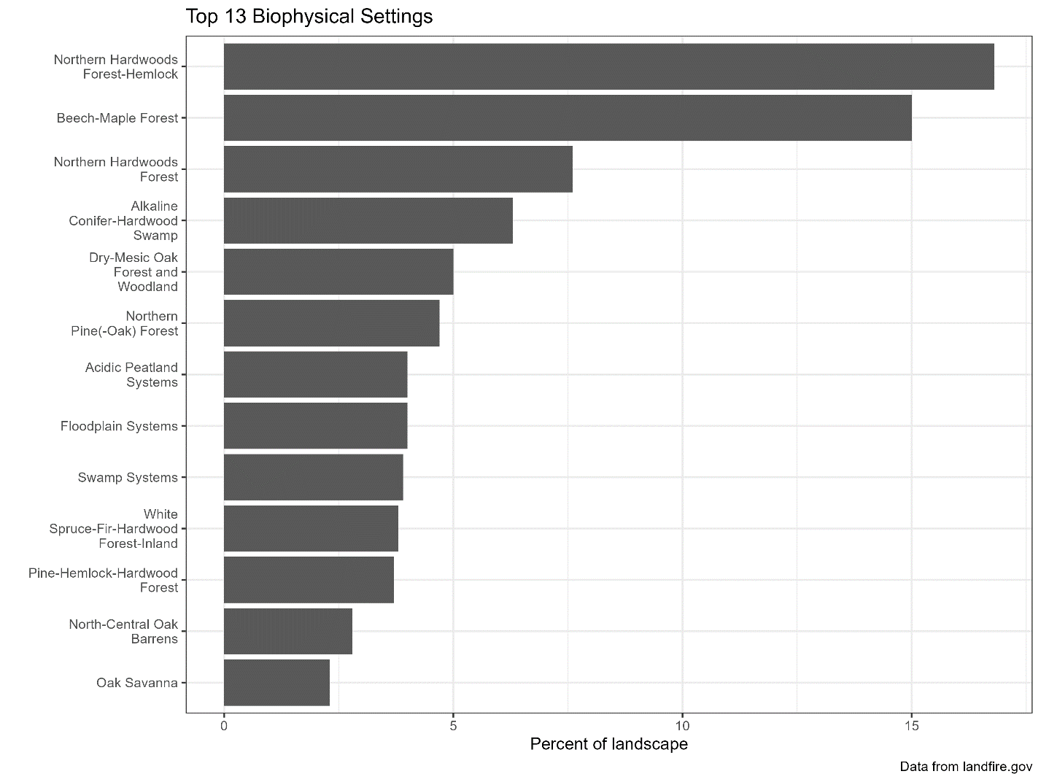

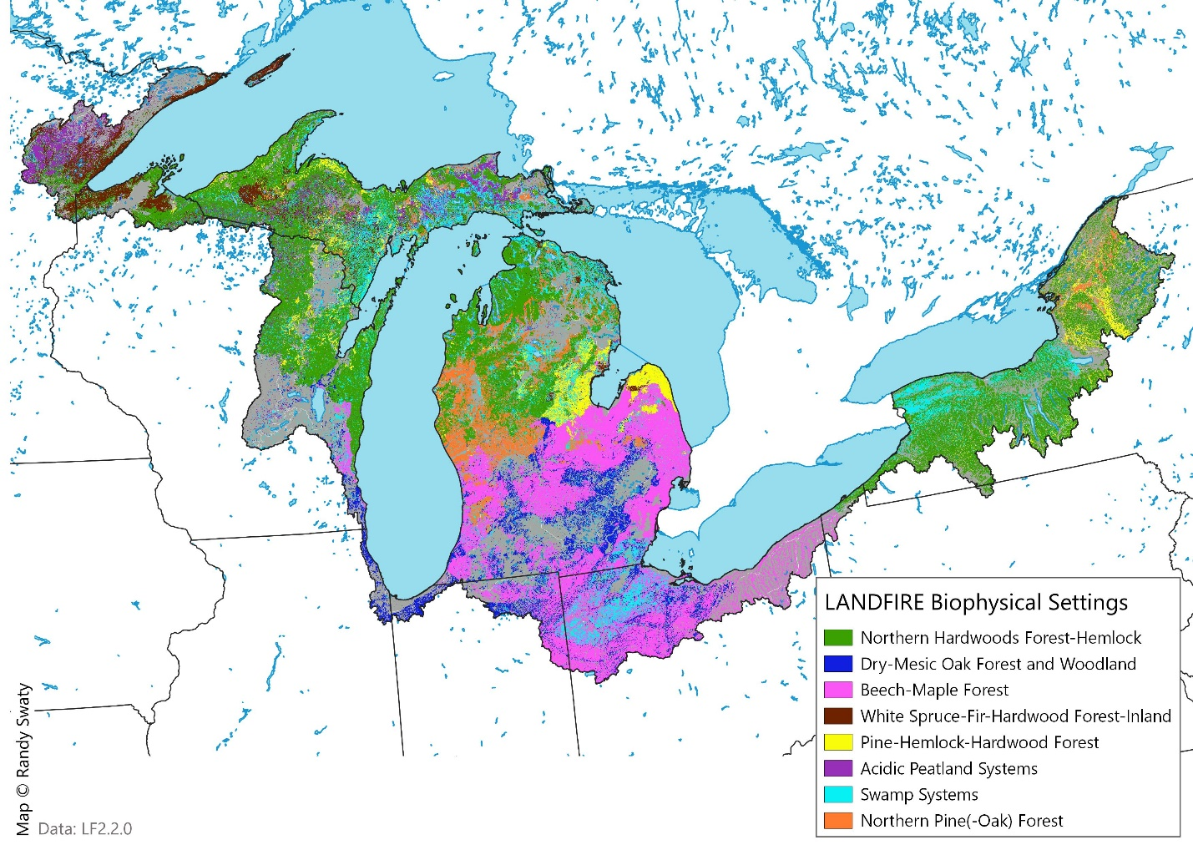

**Discussion:** What do the results show about the region and what are the implications?

**Main Message:** What is the take-away message from this analysis

**Great Lakes Forested Watershed** **Analysis** **Template**

**Section**: Natural Forests

**Topic:** Recent Forest Change

**Author(s)** Anderson

**Questions Addressed:**

* How has the forest changed over the last 20 years?
* How much management, turnover, conservation and conversion has occurred?
* How is the change distributed across geographies and ownerships,

**Datasets Used & Justification**

**Analysis Performed**

**Results: Maps and statistics**

**Discussion**

**Main Message**