Reducing wildfire risk to communities by restoring fire-adapted forests in ways that support jobs, lower long-term costs, and sustain local economies.
Michigan can reduce wildfire risk while protecting communities and supporting rural economies through targeted forest management and practical state investment. The goal is to avoid high-intensity events that drive damage, emergency response costs, and long-term recovery needs. Many of Michigan’s forests are adapted to fire and function best with it under the right conditions.
Historical Context Across the Region
Much of the Northwoods region frequently experienced fire historically, and many of these fires were relatively low intensity. We estimate there would have been approximately 1.2 million acres of fire each year before widespread Euro-American settlement and modern fire suppression. These fires reduced litter on the forest floor and promoted tree regeneration. We are not suggesting Michigan needs that much fire today, but we do need to take better care of our forests to prevent costly, high-intensity wildfires.
The Problem
In many areas, fuels have accumulated and forest conditions have shifted while development has expanded into forested landscapes. When fire occurs under these conditions, it is harder and more expensive to control and poses greater risk to communities and responders. The concern is not simply more fire, but fire burning under conditions that make it more damaging, dangerous, and costly. Our analysis shows that in Michigan, over 4.7 million acres have high to very high wildfire exposure risk. The risk is projected to grow due to lengthening burn seasons and limited forest product markets and industry capacity, which make it more challenging to manage our forests. Lack of management in fire-adapted ecosystems can also reduce the reliability of timber supply, threaten water quality through erosion and sedimentation after severe fire, and disrupt recreation access and outdoor tourism. Storms such as the spring 2025 ice storm also matter because downed wood can increase fuel loads, limit access, and raise future suppression costs.
What Works
Reducing fuels near communities and infrastructure lowers fire intensity and improves conditions for response. Mechanical thinning and prescribed fire are effective, practical tools for restoring safer conditions and reintroducing fire where it benefits forest systems. TNC has a strong history of developing practical, science-based solutions in the fire and forest management realms, including approaches that help communities reduce risk while maintaining healthy, working forests.
Current Constraints
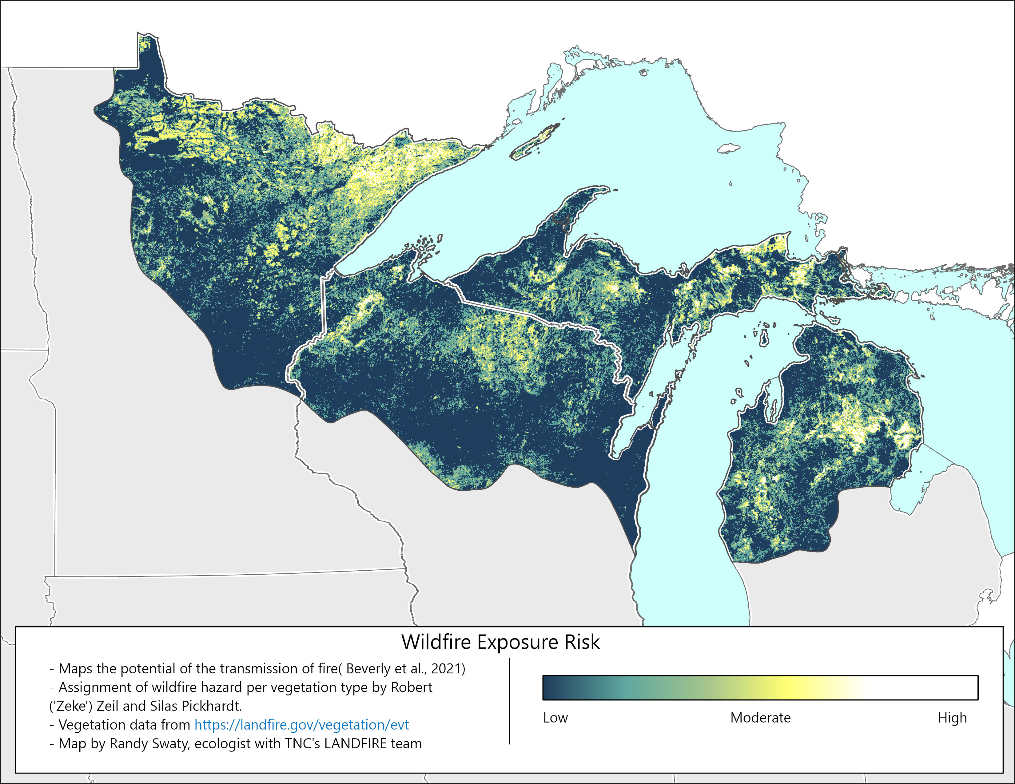
Implementation is constrained by limited markets for low-value wood, mill closures, and uneven public support for active management. A significant portion of treatment work produces material that is costly to handle and difficult to move, slowing the pace of work.
Why Invest Now
Targeted state investment can address these constraints while reducing risk. Priority investments include hazardous fuels reduction near communities, prescribed fire capacity, workforce and contractor capacity, forest products and utilization infrastructure, and post-storm fuel mitigation where downed wood and access issues increase future risk.
Economic and Operational Benefit
Proactive management supports local jobs tied to Michigan’s forest landscape and reduces long-term public expense. It also helps sustain the forest products industry by keeping forests productive and treatments economically viable, protects water supplies by reducing the likelihood of severe post-fire runoff and sedimentation, and maintains recreation access by lowering the chance of closures, damaged infrastructure, and long recovery periods. Suppression, infrastructure damage, and recovery costs increase significantly under high-intensity conditions, making prevention a more predictable and cost-effective approach for the state.
Key Point
Wildfire risk reduction is a practical issue of public safety, workforce capacity, rural economic resilience, and cost control. Michigan has an opportunity to reduce wildfire risk before costs escalate by investing in practical forest management, local workforce capacity, and markets that make treatment work economically viable.

