Host Resource Guide Contents
Staff Directory 3
Addresses 4
Welcome to Umpqua-Tugman Management Unit 5
Other Volunteer Opportunities 6
Volunteer Duties and Expectations 6
Safety 8
Natural Disasters & Major Emergencies 8
Medical and Law Enforcement Emergencies 8
Safety Training 8
PPE 9
Other Safety Information 10
Park Rule Enforcement 10
Taking a Report 11
Example Incident Report Card: 12
Park Rules Quick Reference Guide 13
Greeting 17
Greeting campers and answering questions 17
Selling firewood, fire starters, and helmets 17
Maintaining the information kiosk (Umpqua) 17
Maintain the host supply shed 18
Cleaning Procedures 19
Tools & Supplies 19
Campsites 20
Ash Handling Guidelines 20
Rustic Yurts and Cabins 21
Deluxe Yurts 22
Electric Grills 22
Bathroom 22
Kitchen 22
Living Room 23
End of Day Responsibilities 23
Monthly Cleaning Duties 23
Cleaning the Day Use Area 24
Laundry 24
Doing Park Laundry 24
Washing Curtains 24
Washing your own Laundry 25
What Ifs 25
Extra Duties 25
Golf Carts and Utility Vehicles 27
Helping Campers – FAQ 29
Campsites 29
Yurts & Cabins 30
General 31
Local Resource Directory 34
Maps 39
Umpqua & Tugman 39
Nearby Hiking Trails 43
Beach Access from Umpqua by Car 45

Staff Directory

Randy Copsey | Park Manager | 541-999-0610
Stephanie Cunningham  (Umpqua office) | Park Specialist | 541-271-4118
Franki Allegra | Park Ranger (VSL) | 541-999-6691
John Sperling | Park Ranger | 541-999-6710
Heather Kern | Park Ranger | 541-999-6656
Rick Whyde | Park Ranger | 541-999-8987
Tugman Booth | Landline | 541-759-3604
Randall Logo | Ranger Assistant | 541-297-5276
Bruce Daugherty | Ranger Assistant | 541-294-0333
Giovanna Arana | Ranger Assistant | 541-294-2475
Pearl Medlock | Ranger Assistant | 541-294-2882
James Jones | Ranger Assistant | 541-294-0855
Tara McDowell | Region [Volunteer] Program Coordinator  tara.mcdowell@oprd.oregon.gov
Francisco Garibay | Region HR Representative  francisco.j.garibay@oprd.oregon.gov
Robert Smith | OPRD Safety Program Coordinator  robert.j.smith@oprd.oregon.gov

Addresses
Mail and deliveries (Umpqua and Tugman) | 460 Lighthouse Rd  Reedsport, OR 97467
Umpqua physical address (for emergency services) | 460 Lighthouse Rd  Winchester Bay, OR
Tugman physical address (for emergency services) | 72549 Hwy 101  Lakeside, OR

Welcome to Umpqua-Tugman Management Unit
We are so grateful to have you volunteering with us! Oregon State Parks welcomes over 52 million visitors per year—way more than our limited staff could ever keep up with. We are entirely dependent on skilled and dedicated volunteers to keep our parks clean, beautiful, and running smoothly. Thanks to you, millions of people get to experience the wonders of 255 natural, cultural, scenic, and historic sites in the beautiful state we call home. And by helping people connect with our public lands, we not only shape their experiences—we also foster a culture of conservation, preservation, and stewardship that will carry into future generations. That’s a big deal!
This guide is yours to keep for the duration of your service at the Umpqua-Tugman management unit. Feel free to mark it up with notes and highlights. It contains most, but not all, of the information you will need to be a successful park host in our management unit. We don’t expect you to memorize everything in here, and you are sure to encounter scenarios that are not included in this guide. Use your best judgment, and ask for help when you need it! The rangers, ranger assistants, other hosts, the park manager and park specialist are a team, and we are all here to support you. We are always happy to answer questions.
When it comes to the park host program, I tend to think that Oregon State Parks is getting the better end of the deal. Dedicating 20-30 hours of your time each week—and getting no income in return—takes more than just a good work ethic; it also requires a generous spirit. But public service does come with some intangible benefits that I hope you will enjoy: experience, knowledge, new friends and opportunities, a sense of purpose, a community, and more.
I hope you enjoy your time hosting at the Umpqua-Tugman Management Unit. If there is any way that we can make the experience better for you, please let me know. I am always open to feedback on improving our host program.
Thank you and happy trails,

Franki Allegra, Volunteer Service Coordinator
Umpqua-Tugman Management Unit
December 18, 2024

Other Volunteer Opportunities
You can search for volunteer opportunities throughout Oregon State Parks on the Volunteer Voice Website. You can also find important volunteer program updates and information.
https://sites.google.com/view/oprdvolunteervoice/home
Another great way to find new assignments is to join the Urgent Needs email list. VSLs use this list for last-minute recruitments within the next 60 days. It’s a great way to get into those more exclusive parks! You can join on the website above.
If you have a specific park in mind, it’s always a good idea to contact the Volunteer Service Leader and let them know you are interested in hosting, even if they don’t have any openings posted at the moment. If they get to know you a little, they might be the one to reach out to you in the future. And who knows, you might catch them right after a cancellation and they will be grateful that you saved them some time on posting a recruitment.

Volunteer Duties and Expectations
Our management unit has two types of host assignments. “Greeting hosts” are responsible for selling firewood and answering camper questions. “Maintenance hosts” are responsible for cleaning campsites and yurts, as well as various other maintenance tasks around the park. There are also “Relief Hosts” who take over greeting on the Greeting Hosts’ days off, and do maintenance on the other days. All hosts interact with the public and represent Oregon Parks and Recreation, so you are expected to be friendly and professional (even if a camper wakes you up at 2:00AM. Yes, really!).
You should have already received a detailed Assignment Description in your email inbox for your specific assignment. There is a hard copy in the Forms section of your binder. The following sections provide more detail about our management unit’s standards for completing the tasks you may be expected to perform. Contact the VSL if you have any questions about your assignment after reading this guide. There is also a directory of local resources that you (and campers) may find useful during your time here.

At Umpqua MU, volunteers are responsible for:
- Cleaning yurts, cabins, sites
- Cleaning day-use areas
- Selling firewood
- Rule advisory
- Answering camper questions
- Landscaping: pruning, hedging, push-mowing, weed-eating, etc.
- Emptying trash and running trash compactor
- Minor maintenance tasks (work orders)
- Restroom checks
- Other approved projects

Rangers are responsible for:
- Daily host assignments
- Cleaning restrooms
- Rule enforcement
- Making/changing reservations
- Payments/refunds
- Operating riding mowers, chainsaws, tractors
- Scheduled maintenance and inspections
- Logging lost & found items
- Safety training

Safety

Natural Disasters & Major Emergencies
In the case of a large-scale emergency (fire, tsunami, etc.), the assembly point for Umpqua Lighthouse State Park is the park shop yard. For William Tugman State Park, the assembly point is the Tugman day use restroom. Both Umpqua and Tugman State Parks are outside of tsunami inundation zones based on models developed by the State of Oregon Department of Geology and Mineral Industries. In the case of an earthquake or tsunami, do not attempt to evacuate the park via Highway 101, as floods, downed trees, and car pileups are likely.
Winchester Bay tests tsunami warning system on the first Wednesday of the month at 11:00 AM.
Lakeside tests tsunami warning system on the last Tuesday of the month at 6:00 PM.

Medical and Law Enforcement Emergencies
If you encounter a situation where EMS or law enforcement response is warranted, immediately call 911. After calling 911, call the park manager and the ranger on duty.
If you are unable to reach the park manager, leave a message, and attempt to contact the district manager. If you cannot reach the district manager, call the region manager. Never involve yourself in a situation that puts you or others at risk.

Safety Training
We require all hosts to receive training from a ranger before using electric and gas-powered equipment. Hand tools do not require training, but may require PPE. We will train you on the essential equipment when you arrive. If you would like to be trained on additional equipment, let The VSL know and she will arrange it. Each type of equipment has a Job Safety Analysis (JSA) which is required reading.

PPE
Whatever you are working on, make sure that you are comfortable with the assigned task, can complete it in a safe manner, and have the appropriate personal protective equipment (PPE). If you do not have the appropriate PPE to complete the task, inform a staff member. Do not continue with the task until you receive the necessary PPE. Remember that when you are working with OPRD cleaning chemicals such as #65 Heavy Duty Cleaner and #67 Alpha HP Peroxide Disinfectant, proper PPE includes eye protection.
The parks supply all the PPE you will need to complete any assigned task safely, including:
- Nitrile gloves (cleaning)
- Rubber dipped string gloves (yard work)
- Leather gloves (blackberry pulling)
- ANSI level A3 cut-resistant gloves (trash handling)
- Safety glasses
- Ear plugs/ear muffs
- Hard hats
- Face shields
Before starting any assignment, ask yourself five questions:
- How could I get hurt if something goes wrong?
- How can I prevent injury to myself and others?
- Do I have the proper tools, training, and PPE?
- Do I need to let someone know when and where I will be working?
- Do I need help?
These questions constitute the OPRD Job Hazard Assessment and should be addressed at the start of any new task.

Other Safety Information
Fire Extinguishers are located in every office, booth, pipe chase, shed, ranger truck, cabin, and yurt.
First aid kits are located in the offices, shops, booths, ranger trucks, and the sheds in site 1, site 14, and site A44. Portable first aid kits and sawyer first aid kits are available for special tasks. You may offer supplies from the first aid kits to visitors upon request, but we do not advise performing first aid on visitors.
AEDs/Defibrillators are located in the Umpqua office and the Tugman booth.
Rough-skin newts pose a hazard to pets as they contain a deadly neurotoxin. They can be found in the lakes as well as on land, especially after rain. They are 4-6 inches long and reddish-brown, with a bright orange belly. If your dog swallows a newt, induce vomiting immediately.
Poison ivy and poison oak are not found in either park.

Park Rule Enforcement
Rule enforcement is not part of your duties as a park host. This means you should not ask visitors to comply with park rules. You are permitted to inform campers of park rules. You are not required or expected to do so (although you should certainly do so if they ask you to).
When you witness or receive a report of a rule violation, inform a ranger if:
- You do not feel comfortable contacting the visitors
- You are not able to contact the visitors (such as if they are not in their site)
- You advised them of the rules and they did not comply
- You advised them of the rules and they agreed to comply, but violated the rule again at a later time
- The rule violation is severe or poses an immediate danger to people or park resources

Taking a Report
In the event you witness or receive a report of someone violating a park rule, report it to a ranger on duty. If no ranger is on duty, fill out an incident report card to give to the next ranger on duty. Incident report cards are located in the back sleeve of your binder. If the rule violation is severe or requires immediate attention, contact the park manager.
Example scenarios:
Write an incident report | Contact the park manager
A camper has a dog inside a yurt that is not pet-friendly. | You receive a report that the dog is tearing furniture apart and causing damage.
You receive a report that a camper is gathering firewood from the forest. | You see a camper using a chainsaw to fell and buck small trees.

Example Incident Report Card:
Incident Report Card
Host Reporting Franki
Date 5/4/23 | Time 7:45 AM
Reporting Party Site A18 Dave | Contact Phone Number(s) ???
License Plate Number | Vehicle Make/Model
Location of Incident Site A16
Campers complained of loud talking and music in site A16 12AM - 2AM.

Park Rules Quick Reference Guide
Keyword | Rules
ATVs/OHVs | Not allowed to drive in the park. They must be towed in and out. Only street-legal vehicles can drive in the park.
Bicycles | Allowed in the park and on trails unless otherwise marked. Children under 16 must wear helmets. E-bikes are permitted.
Boats | Motor boats are permitted on Lake Marie, although there is no boat ramp. Boating and fishing regulations are enforced by Oregon State Police and Oregon Department of Fish and Wildlife, not by Oregon State Parks. More information can be found on the ODFW and Oregon Marine Board websites.
Camping | Camping is only allowed in designated campgrounds. No one may occupy a site without a reservation. There is a maximum of 14 consecutive nights. After 14 days, campers must vacate the park for 72 hours (they may go to another Oregon State Park).
Day Use | Gatherings of more than 50 people, events that sell tickets or goods, and events using amplified sound systems require a special use permit from the manager. The fee is $100. Overnight parking is not allowed in the day use areas except the gravel parking lot on the North side of Tugman, where parking (not camping) for up to 12 hours is permitted. The restroom is open 24 hours.
Dogs | See Pets
Drones | There are no specific rules regarding drones. We ask campers not to fly drones in busy areas, such as the campground and swimming areas, where they may be a nuisance or hazard. It is better to fly them in the day use area, away from the swim beach and while it is not busy.
Dumping | RV waste must be dumped in an RV dump or a sewer drain a camper’s own reserved site, not in toilets or sink drains. Dumping garbage and animals is illegal. OAR 736-010-0040.5
Extra Vehicles | One extra vehicle is allowed per site at $7 per night. It does not have to be in the site. Trailers and vehicles that are towed in are not charged a fee.
Fires | Fires should never be left unattended. They must be extinguished with water. See also: firewood. 736-010-0040.2
Fire Bans | Fires are not allowed when the park is under fire restrictions. Posters outlining the exceptions will be posted in the campground. OAR 736-010-0040.3
Firewood | Visitors may only burn paper products and untreated natural wood free of attached metal, nails, glass, or plastic. Firewood may not be more than 24 inches in length. Petroleum-based accelerants are prohibited. OAR 736-010-0040.2
Fireworks | Fireworks are not allowed in any Oregon State Parks. This includes firecrackers and sparklers. OAR 736-010-0040.8c
Garbage | Garbage must be disposed of in appropriate receptacles. Only garbage generated while using park property is allowed (no home garbage). Removing items from garbage and recycling containers (dumpster diving) is prohibited. See also: Dumping OAR 736-010-0040.5
Helmets | Children under 16 are required by Oregon law to wear helmets when riding bicycles, scooters, skateboards, or other wheeled devices that are not mobility aids. Helmets are available to purchase from the greeting hosts for $10. ORS 814.485
Hiker-Biker camp | These sites are for hikers and bikers. Campers staying in these sites may not bring a vehicle, including motorcycles. Parking is not available. Maximum stay is three consecutive nights. Walk-in reservations allowed.
Metal Detectors | Permits are required for using metal detectors in the park. Campers can contact the park office to obtain a permit from the manager.
Motorcycles | Motorcycles can be driven in or out of the campground, but may not be used recreationally within the campground. Extra vehicle fees must be paid for motorcycles, but the nightly fee covers up to two motorcycles.
Noise | Quiet hours are 10PM to 7AM. During this time, campers should limit their noise so it cannot be heard outside of their site. Outdoor speakers must be turned off. Rangers may also contact campers for causing a nuisance outside of quiet hours.
Parking | Vehicles must be parked with three wheels on the pavement in a site or parking space. They may not park on the grass or the roadway. Extra vehicles are subject to a fee of $7 per night. See also: Day Use
Pets | Pets must be on a six-foot leash. They are not allowed inside buildings except for pet-friendly yurts.  When in an off-leash area or in the water, they must be under voice control. Service animals must be under voice control. Pets should not be left unattended in a campsite. Livestock is not allowed in the parks.
Picking berries/plants/ mushrooms | Visitors may harvest up to one gallon of berries or mushrooms per person per day (changed from 5 gallons in 2023). They may not damage or uproot living plants.
Quiet Hours | See Noise
Smoking | Smoking is not allowed in Oregon State Parks, except in your campsite or your vehicle. Smoking is not allowed inside yurts.
Vehicles | Washing vehicles in the park is not allowed. Hosts can wash vehicles in the shop yard.  Working on vehicles, such as painting and engine work, is not allowed except in an emergency.  See also: Extra Vehicles, Day Use, and Parking

Greeting
The greeting hosts reside in sites 1 and 3 at Umpqua and sites A42 and A44 at Tugman. They work shifts from 2PM to 8PM five days a week. As a greeting host, you should remain in your site during your entire shift, and wear your volunteer vest. You may remain inside your camper; you do not have to sit outside. If you have to leave the site, post a note on your sign stating when you will return.
During your shifts, you are responsible for the following tasks:

Greeting campers and answering questions
Familiarize yourself with the Helping Campers FAQ in this document. Umpqua and Tugman do not have scheduled booth hours, so you are the first point of contact for most campers coming into the park, and they will have a lot of questions for you. If you don’t know the answer, call or text the ranger on duty. After hours, consider the urgency of the question and whether it can wait till tomorrow.
Note that we do not require campers to check in upon arrival, so they do not have to stop and talk to you. Unlike other parks, we do not issue parking passes except on request.

Selling firewood, fire starters, and helmets
Sales are made through a Ventek machine. Campers can use a card or cash to pay for items (no change is given), then give their receipt to the host. Unlock the Ventek cabinet at the beginning of your shift, and close and lock it at the end of your shift. Place your receipts in an envelope and drop it in the booth drop box for a ranger to process the next day. Do not accept any cash from campers.

Maintaining the information kiosk (Umpqua)
Check and replenish the maps, brochures, self-registration envelopes, tide tables, and any other fliers or pamphlets at the kiosk by the campground entrance. Restock the maps and envelopes at the front of the booth.

Maintaining the host supply shed
Keep supplies stocked from the shop in the supply shed in your site, and clean it at the end of every month. Alert a ranger if any supplies are needed.

Cleaning Procedures

Tools & Supplies
Below is a list of supplies that are typically used to clean yurts, cabins, and campsites. All of these supplies are provided by the park, so if anything is missing or unavailable, please let us know. You will probably want to make sure you have all these items in your cart before you go out to clean yurts.
- Cleaning cloths  - Paper towels  - #65 all-purpose cleaner (green)  - #67 disinfectant (clear/white)  - #63 odor eliminator (pink)  - Nitrile gloves  - Cut-resistant trash handling gloves  - Scrubbing sponge  - Large and small scrub brushes  - Small trash bags  - Large trash bags  - Pet waste bags | - Mop or Swiffer  - Cobweb brush on extension pole  - Scouring powder (Comet)  - Rubbish bucket  - Metal ash bucket  - Square shovel (for fire pit)  - Lawn rake  - Blower with battery  - Scraper/putty knife (for picnic tables)  - Flashlight
If cleaning deluxe yurts, you will also need the following:
- Dawn dish soap
- Toilet paper
- Aluminum foil

Campsites
Follow these campsite cleaning procedures for all sites, including the campsites with yurts and cabins.
- Clean out firepit. (See Ash Handling Guidelines)
- Litter pick around site, and rake natural debris away from fire pit, picnic table, and areas where campers may want to set up a tent.
- Blow off asphalt pad if needed.
- If there was a reservation tag associated with the departing reservation, remove it from the site marker post at the front of the campsite.
- If there are any issues in the site that require further maintenance (broken picnic table board, displaced fire pit, etc.) let staff know and we will either address it, or give you the tools to do so yourself.

Ash Handling Guidelines
- Put on eye protection, leather gloves, and long pants.
- Check if the ash is hot by splashing water on it. If it’s still hot, wet it down thoroughly.
- Remove charcoal and partially burnt wood that is larger than a grapefruit and place it on the grill for the next campers.
- Clean out the ash with a shovel and place it in a metal bucket with a lid.
- Transport the ash to the collection container in the shop yard. If the ash was hot, flood the bucket with water and allow it to sit overnight.
- Dispose of cool ash in the ash collection container. Make sure the area around the container is kept clear.

Rustic Yurts and Cabins
- Retrieve key from drop box after camper checks out.
- Remove any debris from mattresses and other surfaces with a vacuum or cleaning cloth.
- Use duster to remove cobwebs from ceiling and walls.
- Wipe down surfaces with SE #65 heavy duty cleaner, scrub dirt spots where necessary.
- Spray mattresses, chairs, tables, and touch points with #67 Alpha-HP Alpha HP peroxide disinfectant. Disinfectant must sit for at least 10 minutes in order to be effective. After disinfectant has had time to sit, wipe down mattresses, table, and chairs.
- Remove used garbage bags from cans and replace. Wipe down garbage can interior if necessary. Hang one extra bag on the rim of the can.
- Sweep or vacuum floor and porch. Shake off entryway mat outside.
- Mop floor with #67 Alpha-HP and cloth mop or Swiffer
- Make sure that futons are in upright position and door curtain is drawn open (away from door handle).
- If strong odors are present, replace the curtains with clean ones and spray #63 to eliminate the odors. Report smoking to a ranger.
- Remove cobwebs from porch.
- Inspect outside of yurt and remove cobwebs from the edge of the roof.
- Lock the deadbolt
- Inform a ranger if there are any maintenance issues.

Deluxe Yurts
Follow the instructions for the standard yurts, but add the following steps for the bathroom, kitchen, living room, and electric grill.

Electric Grills
- Fill kitchen sink with hot water and Dawn dish soap.
- Remove grilling tray from the unit and soak in the sink while you perform other cleaning tasks in the yurt.
- Scrub tray with green sponge or white Doodlebug scrub pad (brown pads are too abrasive).
- Clean grill utensils with SE #65.
- Replace the tinfoil in the drip tray and on the utensils.
- Scrub all surfaces with #65 and sponge or white Doodlebug pad.
- Spray down surfaces with #67 HP.

Bathroom
- Wipe down all bathroom surfaces with SE #65 (all toilet surfaces including the base, sink, shower walls and fixtures, shelves, towel bars, light switch and thermostat).
- Wipe down mirror with SE #65 and paper towels.
- Use toilet brush and SE #65 to clean inside toilet bowl.
- Restock toilet paper rolls as needed. Leave 1 extra roll of toilet paper in the bathroom.
- Spray #67 Alpha-HP on all bathroom surfaces and touch points, including the shower curtain. Leave it to air dry.
- Replace shower curtain if it has visible mold.

Kitchen
- Wipe down counters, shelves, cupboards, and other surfaces with SE #65.
- Wipe down microwave and refrigerator inside and out. Clean underneath microwave as well. If needed, wash the microwave plate with dish soap.
- Wipe down sink with SE #65 and rinse.
- Spray #67 Alpha-HP on all kitchen surfaces and touch points.

Living Room
- Wipe down television with #67 Alpha-HP.
- Remove cobwebs/dust from the ceiling fan with cobweb duster on extension pole.

End of Day Responsibilities
After you have finished your cleaning duties for the day, refill any chemical bottles that are low, put all supplies back where they belong, and clean and put away any tools that you used through the course of the day. Return your utility vehicle to the shop and follow the instructions for vehicle safety inspection. Leave the vehicle clean and ready for the next volunteer to use.

Monthly Cleaning Duties
Some extra cleaning duties will be assigned at the end of each month:
- Test smoke alarms and fire extinguishers and sign fire extinguisher tag
- Remove mattresses and thoroughly vacuum or wipe down futon and bed frames. Flip mattresses over.
- Clean drains with Bio-Clean enzymes.
- Pull refrigerators away from wall and clean behind and underneath them. Clean out fridge drip tray.
- Wipe dust from wall slats with a damp cloth or duster on a pole. Dust ceiling fan.
- Scrape moss and lichen off of picnic tables (or clean with a pressure washer).
- Clean drains with Bio-Clean enzyme (deluxe yurts and sink waste disposals)
- Clean and restock cleaning supply storage area (located at Tugman old shop and Umpqua site 14).

Cleaning the Day Use Area
Some days, you may be assigned to clean the day use area of your park. This includes the following tasks as needed:
- Empty trash containers. Only use the thick, clear plastic liners for these cans. Always wear cut-resistant gloves.
- Litter pick
- Empty pet waste buckets and refill baggies
- Mow using push mowers, hedge and weed-eat
- Check restrooms and refill toilet paper, paper towels, and soap if needed. Contact a ranger if the restroom needs immediate cleaning.

Laundry

Doing Park Laundry
At Umpqua, the host in the laundry room site is responsible for doing park laundry. At Tugman it falls to the host in site A42. Laundry includes cleaning cloths, mop heads, rubber-dipped gloves, and yurt curtains, and may occasionally include other items such as uniforms. Curtains and uniforms should be washed separately from rags. Rags and mop heads should be washed separately because mop heads collect a lot of hair. Please leave the washer clean for the next person.
Bleach is not required for washing cleaning cloths (our detergent is a disinfectant) but some hosts prefer to use it on occasion to keep cloths looking clean. After washing park laundry with bleach, please run an additional rinse cycle after removing the laundry so you don’t leave any residue for the next person.

Washing Curtains
Yurt and cabin curtains are not washed on a schedule. They should be washed when they appear stained, or if there is evidence of smoking in the yurt or cabin. Any host can wash curtains if the machine is available (coordinate with the person doing their laundry that day) or they can leave the curtains for the laundry host to clean if spares are available in the meantime.

Washing your own Laundry
You can sign up for laundry times on the calendar in the laundry room. If Do not do laundry during another host’s scheduled laundry time. Please use your own detergent (our detergent is very harsh and you wouldn’t want it on your clothes anyway).
For bulky items, there are laundromats in Reedsport and North Bend that have extra-large machines. They also offer a drop-off service. Cards and cash accepted (not coins). See the Resource Directory for details.

What Ifs
Any time you encounter a site, yurt, or cabin that has been damaged, is missing amenities, or has been left in serious disarray, alert staff and allow us to document the scene prior to cleaning.
If you encounter any biohazardous material (human waste, vomit, blood, needles, etc.) do not attempt to clean. Inform staff and we will address it.
If you find anything that is potentially dangerous or illegal while cleaning (gun, drugs, etc.), do not touch the item. If it is found in a yurt or cabin, lock the door and inform park staff. If you feel safe doing so, secure the area and wait for staff to arrive.

Extra Duties
There are many extra duties that may be assigned to you throughout your work week, or that you may volunteer for. If you have any questions about any of those duties or if there is anything specifically that you are interested in working on, let a ranger know.
Extra duties may include:
- Pressure washing structures or asphalt surfaces
- Replacing picnic table boards
- Pruning and raking around sites and trails
- Blowing off trails and walkways
- Stocking supply rooms
- Leveling signs, bollards, and firepits
- Cleaning and organizing sections of shop or other storage/utility buildings
- Removing and hauling brush or wood to county burn pile
- Spreading gravel
- Sewing new curtains
- Weed eating and push mowing
- Planting or replanting trees and shrubs
- Edging curbs and paths
- Repairing/replacing/re-rocking spigot/outdoor sink drains
- Clearing out ditches and culverts
- Cleaning up storm debris
- And many more!

Golf Carts and Utility Vehicles
Golf carts and utility vehicles (John Deer gators) are available for hosts to use during working hours. Tugman has five golf carts and Umpqua has two golf carts and two gators. You will not be assigned a utility vehicle; they are first-come, first-serve, so it is important to leave them in good, clean condition for the next person (after all, you never know which one you might be driving tomorrow). On of the most common types of incident (including injuries and property damage) in Oregon State Parks is incidents involving golf carts. To keep our parks safe, and maintain our equipment, and keep a friendly work environment, please follow these guidelines:
Follow all DMV Laws
Even though golf carts and gators are not street-legal, you still need to follow DMV laws on park roads, such as stopping at stop signs, keeping under the posted speed limit, and driving on the right side of the road. Use your hand to signal before turning. Do not take the utility vehicles out of Tugman or onto Lighthouse Road past the day use area in the south or the campground entrance to the north.
Note that you must have a valid driver’s license to operate these vehicles. If your license is suspended or expires during your volunteer service, we need to know immediately. It does not mean you will be dismissed from service!
Park Safely
Whenever you exit the vehicle, place it in neutral, engage the parking brake, and take the key with you. Avoid back-in parking. Many vehicle incidents in Oregon State Parks happen while backing up. It is better to back into a site than park head-in and back into a roadway, where you are more likely to encounter vehicles, pedestrians, bicycles, and other obstacles. If possible, avoid backing up entirely. If you are working in a two-person team, one person is required to act as a spotter while backing up.
Inspect your vehicle
A safety inspection checklist is posted on each utility vehicle. Perform an inspection before you take the vehicle out and after you put it back for the day. Alert a ranger to any new damage. If you notice any problems that might affect driver safety, such as faulty brakes or a flat tire, do not drive the vehicle and alert a ranger immediately. If a ranger is not available, tag the equipment out so no one else can drive it (safety lockout equipment is available in the shop).

Helping Campers – FAQ
Whether you are a greeting or maintenance host, you are bound to encounter many campers who have questions about the park. This section will prepare you to help campers with their most common questions and issues, and thereby provide excellent customer service. If you don’t know the answer to a camper’s question, contact a ranger (use your best judgment after hours. Many problems that campers think are urgent can actually wait till tomorrow).

Campsites
Can I camp here tonight?
As of January 1, 2024, all Oregon State Parks campgrounds are reservation only. Campers can go online to make a same-day reservation. Wifi is available at the booth. If a camper cannot get on the wifi or needs to pay with cash, then a ranger can make the reservation for them. Campers may no longer self-register for sites as they did in the past. Please direct campers to the website first, then call a ranger if assistance is still needed.
Can I extend my reservation?
This can be done online or with the assistance of a ranger, if the site is available.
Can I switch sites?
Sometimes campers arrive to find that the site they reserved does not meet their expectations. A ranger can move their reservation to another available site. After hours, call the park manager to move their reservation, or if it is for one night and the campground is not busy, you can authorize a switch. They will have to pay any difference in price (Umpqua only). If their site is not usable (examples: electricity not working, RV cannot fit in the site) then they may use one of the emergency sites. These are site 40 at Umpqua and sites B19 and B22 at Tugman. Always notify a ranger ASAP if you have authorized someone to occupy an emergency site.

Yurts & Cabins
How do I get into my yurt/cabin?
Yurts and cabins are equipped with electronic deadbolts. The key code is sent to the campers via email before their arrival. Sometimes campers are unable to locate the key code in their email. You may give them the code to get into their yurt or cabin after confirming their reservation is on the check-in list (ask for their last name).
Can I check in early?
Check-in time is 4:00PM, but campers are welcome to check in before then if their site is vacant or their yurt has already been cleaned. Occasionally, they may insist on checking into a yurt even when you tell them you haven’t cleaned it yet. This is not worth fighting them over! But do let a ranger know if this happens, in case we get complaints about the conditions.
Can I stay in this yurt/cabin tonight?
Same-day reservations can be made for yurts and cabins before 6PM. Direct the campers to go online.
Can I look inside this yurt/cabin?
You may let visitors go inside a yurt or cabin under your supervision if it is unoccupied and if you feel comfortable doing so. If you do not feel comfortable, just say no. There are video tours of the yurts on Youtube.
Can I get my pet fee refunded?
Some yurts and cabins are designated as pet-friendly and include an extra pet fee of $10 per night. If a camper is staying in a pet-friendly yurt or cabin but does not have a pet, a ranger can refund their pet fee. This is done on the honor system. Let the next ranger on duty know and they will issue a refund to the camper’s card (no follow up from them is required). Service animals are not pets, but emotional support animals are pets. Service animals are allowed in any building and the pet fee does not apply to them. Never assume that a dog is not a service animal.

General
Where is the beach?
The closest beach access to both parks is the South Umpqua Jetty Beach Access in Winchester Bay. Parking is free and there is a vault toilet. There is a map in the maps section.
Where can I hike?
See the hiking trail map at the end of this document.
Where can I dump my RV wastewater?
There is an RV dump station at Tugman that is free for the public to use. Umpqua does not have an RV dump station. Campers may not pull into a vacant site to use the sewer hookup.
Campers heading North may prefer to use the dump station at Honeyman State Park, just south of Florence. There are dump stations in Winchester Bay and Reedsport that charge a fee.
Where do I get my parking pass?
We do not require campers to display a parking pass in either park. If a camper wishes to visit a fee park during their stay (such as Shore Acres, Heceta Head Lighthouse, and Woahink Lake at Honeyman), a ranger or greeting host can provide them with a parking pass so they do not have to pay the fee. Parking at all Oregon State Parks is included with camping until 10PM on the day of checkout.
Where can I park my extra vehicle?
One extra vehicle is allowed per site, at a fee of $7 per night. They must be parked on the pavement in the site or in an extra vehicle parking space. They may not park on the grass or the roadway. A vehicle is something that drives into the campground (is not towed). The $7 fee covers one car or up to two motorcycles.
What’s the park mailing address?
We do not accept camper mail. Campers should have their mail sent General Delivery to the post office in Reedsport or Lakeside.
What kind of fishing do you have around here?
Eel Lake is stocked every spring by ODFW, usually with trout. It is also home to largemouth bass, crappie, bluegill, and yellow perch. It is also home to two protected species: coho salmon and pacific lamprey (called “eels” by the local tribes).
Lake Marie is stocked by ODFW every spring, usually with trout. Lake Marie does not have a boat launch.
Do you offer any discounts?
Oregon State Parks offers two discount (actually, free) camping programs, called Special Access Passes. We do not accept discount passes from other agencies, such as NPS.
- The Oregon State Parks Disabled Veteran Pass includes free day use parking and ten nights of free camping per calendar month (campsites only; no yurts or cabins). Veterans from any state and with any degree of disability are eligible.
- The Oregon State Parks Adoptive/Foster Family Pass includes free day use parking and 14 nights of free camping per calendar month (campsites only; no yurts or cabins). Only Oregon families are eligible.
Campers must apply for these passes online or at the Salem office. They must display their pass in their vehicle. Passes cannot be shared with friends and family; the passholder must be present in the site (for the foster pass, the adopted/foster children must be present as well). Passes do not cover extra vehicle fees or the $8 reservation fee charged by Reserve America. Campers must still make a reservation.
Douglas County Parks offers a 10% discount on all reservations to Oregon State Parks Special Access Pass holders.
Why can’t I do ____? I pay taxes!
This may not exactly be a question, but it is often brought up by campers who are breaking the rules. Oregon State Parks is funded by user fees and Oregon State Lottery funds. We do not receive any tax revenue. This can be a good opportunity to educate park visitors. Be respectful and cautious when dealing with angry visitors. The best thing to say might be “Let me call a ranger for you.”

Local Resource Directory

Health
Lower Umpqua Hospital (24-hour ER) | 600 Ranch Rd.  Reedsport, OR 97467 | 541-271-2171
BestMed Urgent Care  (Mon-Fri 8AM – 8PM) | 1226 Virginia Ave.  North Bend, OR 97459 | 541-305-4224
Walgreens Pharmacy  (Daily 9AM-9PM) | 3411 Broadway Ave.  North Bend, OR 97459 | 541-756-0118
Lower Umpqua Veterinary Clinic (Mon-Fri 9AM - 5PM) | 199 Port Dock Rd, Reedsport, OR 97467 | (541) 271-4696
Downtown Health & Fitness  $10 classes for seniors, punch cards and memberships available | 440 Central Ave, Coos Bay, OR 97420 | (541) 267-3948
Planet Fitness | 1236 Teakwood Ave, Coos Bay, OR 97420 | 541-512-5858

Groceries
Safeway Reedsport  (7AM – 10PM) | 1499 Hwy 101, Reedsport, OR 97467
McKay’s Reedsport  (6AM – 9PM) | 1300 Hwy 101, Reedsport, OR 97467
McKay’s Lakeside  (7:30AM – 8PM) | 200 S 8th St, Lakeside, OR 97449
Dollar General Lakeside  (8AM – 10PM) | 1215 N 8th St, Lakeside, OR 97449
Walmart North Bend | 2051 Newmark Ave, Coos Bay, OR 97420
Safeway North Bend (6AM-11PM) | 1735 Virginia Ave, North Bend, OR 97459
Fred Meyer Coos Bay | 1020 S 1st St, Coos Bay, OR 97420
Grocery Outlet | 1385 Newmark Ave, Coos Bay, OR 97420
Natural Grocers Coos Bay | 598 N Broadway, Coos Bay, OR 97420
Coos Head Food Co-op | 353 S 2nd St, Coos Bay, OR 97420
Coos Bay Farmers’ Market  Wednesdays 9AM-2PM, May – October  Accepts SNAP/EBT | 320 Central Ave, Coos Bay, OR 97420

Hardware & Automotive
Kel-Cee Ace Hardware  (Daily 8AM – 6PM) | 1350 Oregon Coast Hwy S, Reedsport, OR 97467
Hennick’s Hardware  (Daily 9AM – 5PM) | 205 N 8th St, Lakeside, OR 97449
Harbor Freight Tools | 1611 Virginia Ave Suite 303, North Bend, OR 97459
Tony’s RV Service and Repair | 541-267-1664
Cory’s Mobile RV Repair | 541-290-4985
Alpha RV Mobile Services | 541-209-2403
Reed’s Import Specialist  (auto mechanics) | 2349 Broadway Ave, North Bend, OR 97459  (541) 756-6482
Automotive Electric  (auto mechanics, domestic only) | 63091 US-101, Coos Bay, OR 97420  (541) 269-9588
Les Schwab Tire Center | 174 16th St, Reedsport, OR 97467 (541) 271-3601
AutoZone North Bend (7:30AM – 8PM) | 2035 Newmark St, North Bend, OR 97459  (541) 751-0797
NAPA Auto Parts | 1480 Highway Ave, Reedsport, OR 97467

Law Enforcement
State Police | 800-442-2068
Coos Co. Sheriff (Tugman) | 541-396-2106
Douglas Co. Sheriff (Umpqua) | 541-440-4471

Parks & Recreation
Oregon State Parks Reservations | 1-800-452-5687
Oregon State Dept of Fish & Wildlife | 541-888-5515
Douglas County Parks Department | 541-957-7001

Other Resources
Fresh Coast Laundry Works (laundromat)  8AM – 8PM (last loads at 7PM).  Cash, debit or credit. Drop-off service available. | 320 N 14th St, Reedsport and  1921 Virginia Ave, North Bend,
Mast Bros. Towing | 541-271-3019
Holy Smoke Towing | 541-216-7300
CB Cab Co. | 541-707-4464
Reedsport Locksmith | 541-271-5625
Lakeside Library – Coos County (Tugman)  Hours vary. | 915 N Lake Rd, Lakeside, OR 97449
Lower Umpqua Library – Douglas County (Umpqua). Hours vary. | 395 Winchester Ave, Reedsport, OR 97467
Propane
T’ree Acres gas station  Osprey Point RV Resort  Chevron Reedsport | ¼ mile south of Tugman on 101  1505 N Lake Rd, Lakeside  5 miles north of Umpqua on the left just past Safeway

Maps

Umpqua & Tugman
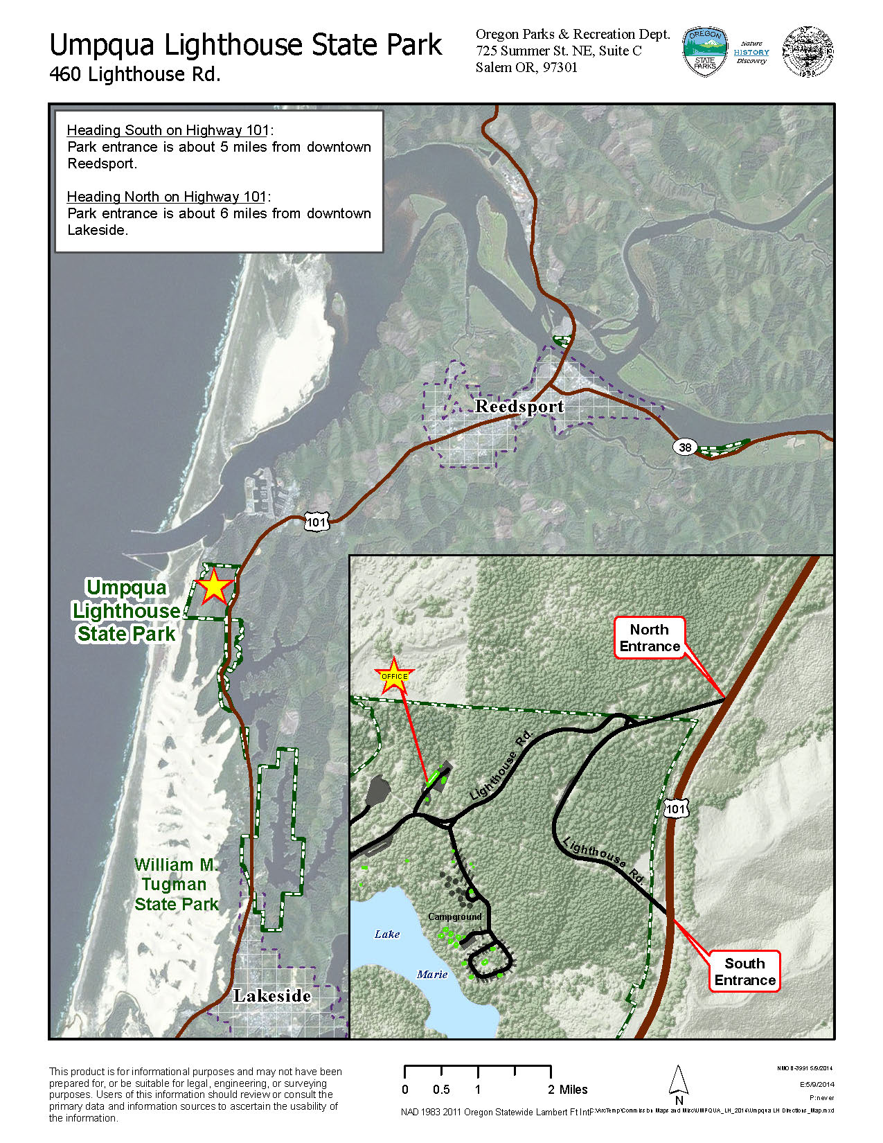

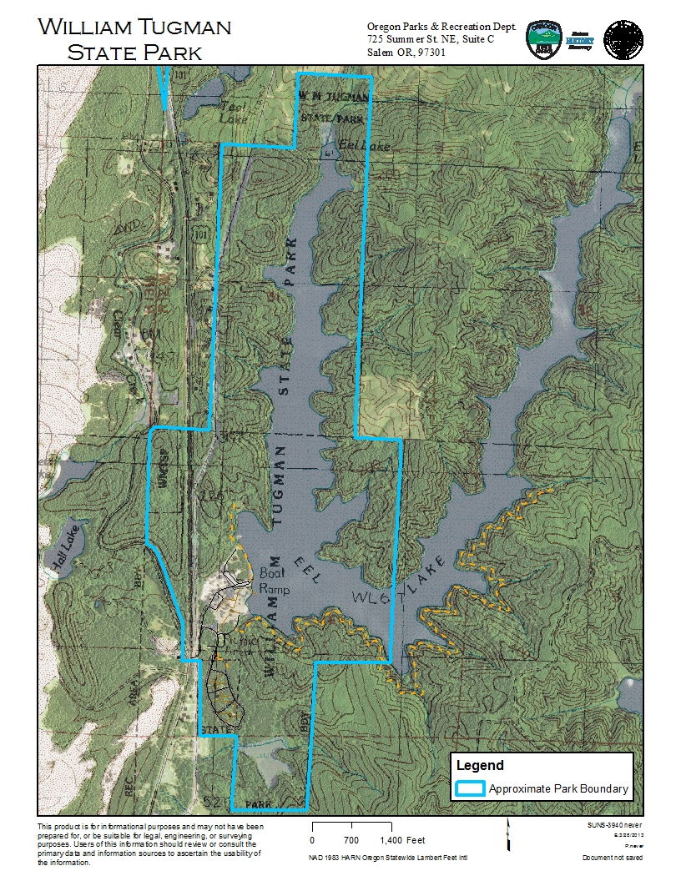

Nearby Hiking Trails
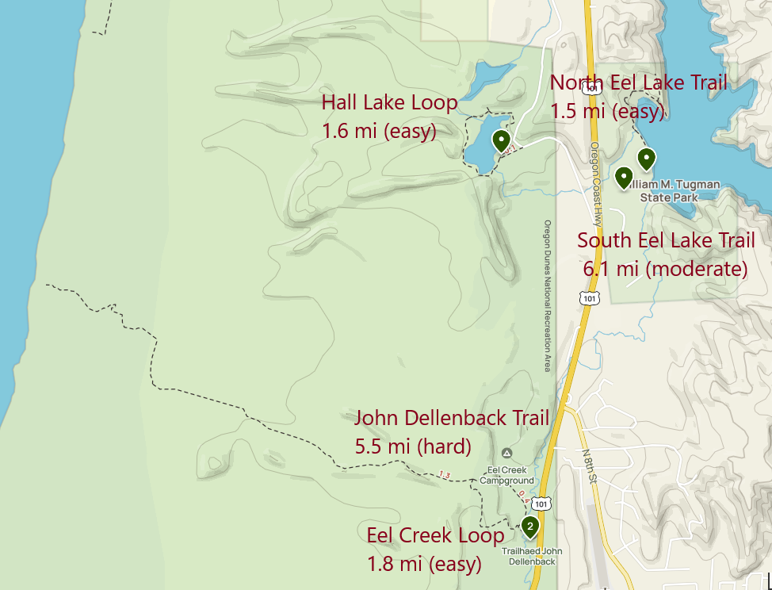

Beach Access from Umpqua by Car
