- Install xcode
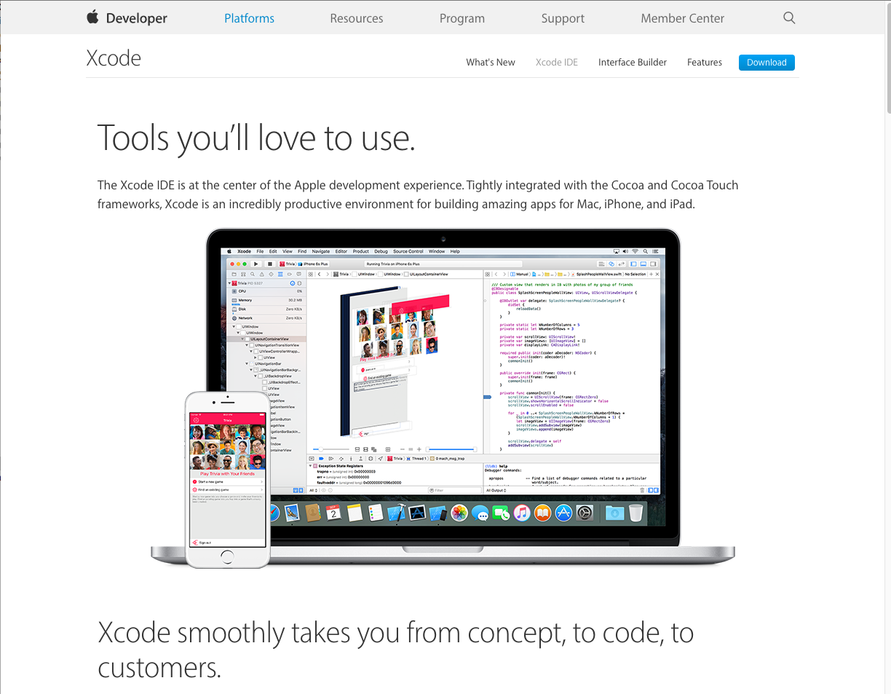
- Install NodeJS .
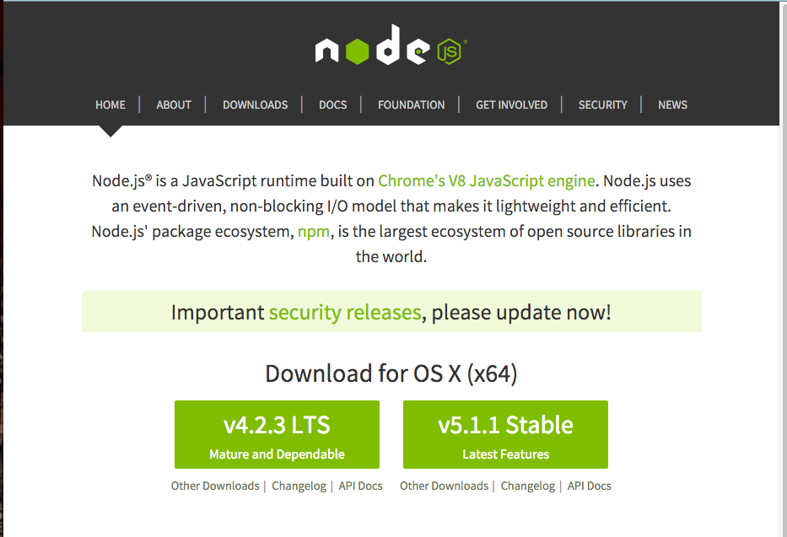
- Install ionicframe work with below command in terminal
$ sudo npm install -g cordova ionic
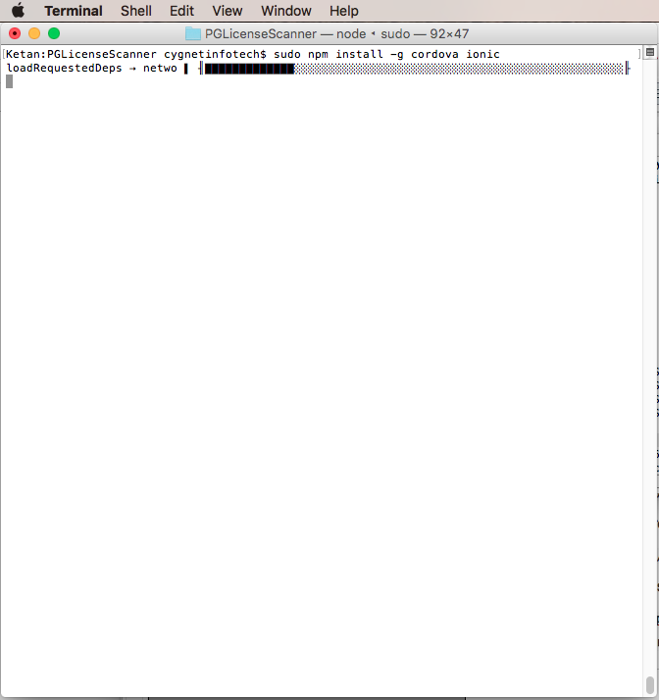
- Download source code. And copy source folder to your Live Folder in your machine. (MobileScanningApplication/PhonenGap/PGLicenseScanner/)
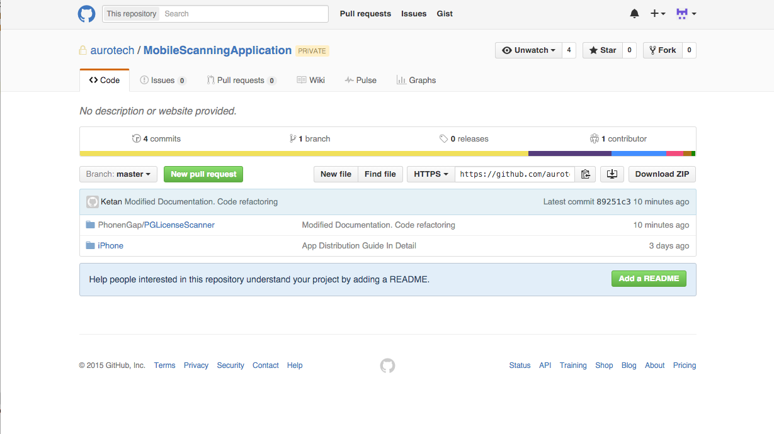
- Now Open Terminal and go to path PhonenGap/PGLicenseScanner/
$ cd /../PhonenGap/PGLicenseScanner/
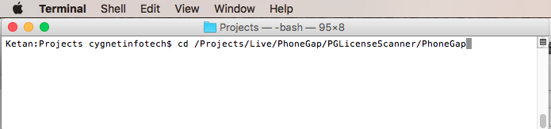
- www/config.xml please rename your package name in “id” as per you have created on Appstore. After change in config.xml file you have to make 'ionic build' command in terminal.
<widget id="com.cygnet-development.RollingBall" version="0.0.1" xmlns="http://www.w3.org/ns/widgets" xmlns:cdv="http://cordova.apache.org/ns/1.0">
<name>LicenseScanner</name>
- PDF417 Plunging Installation
  - Download Latest version of PDF414 plugin.
  - Go to path of project folder into Terminal.
$ cordova plugin add ../pdf417-phonegap/Pdf417
$ ionic build
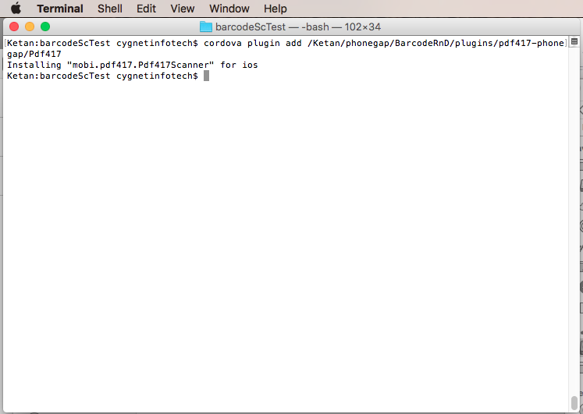
- Run project from Terminal (if ios-sim is not install than first install)
- Before running application from Terminal ,install simulator for iOS Terminal . Where Options is device simulator name. If any device is connected with machine than it will automatically run on devices (Don't give device name for that as per screen).
$ sudo npm install ios-sim -g
$ ionic run ios [options]
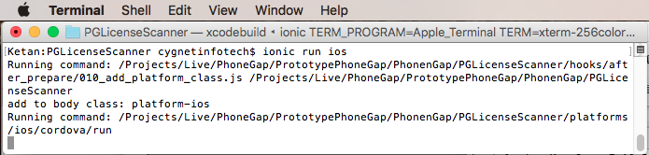

- If you want to start with X-code than go to folder ofPhonenGap/PGLicenseScanner/platforms/ios/PGLicenseScanner.xcodeproj with Finder. For screens please click here.
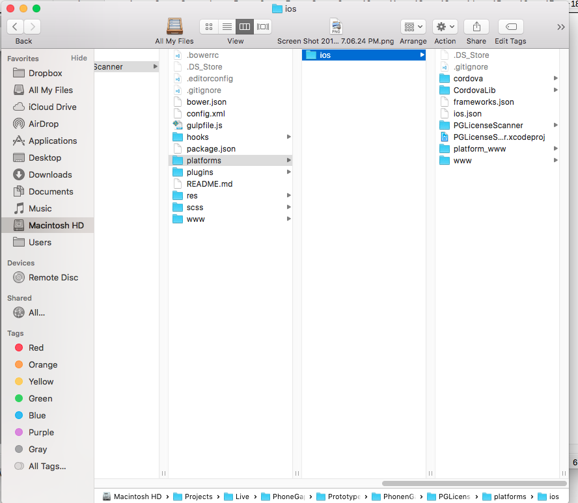
- Double Click on PGLicenseScanner.xcodeproj.
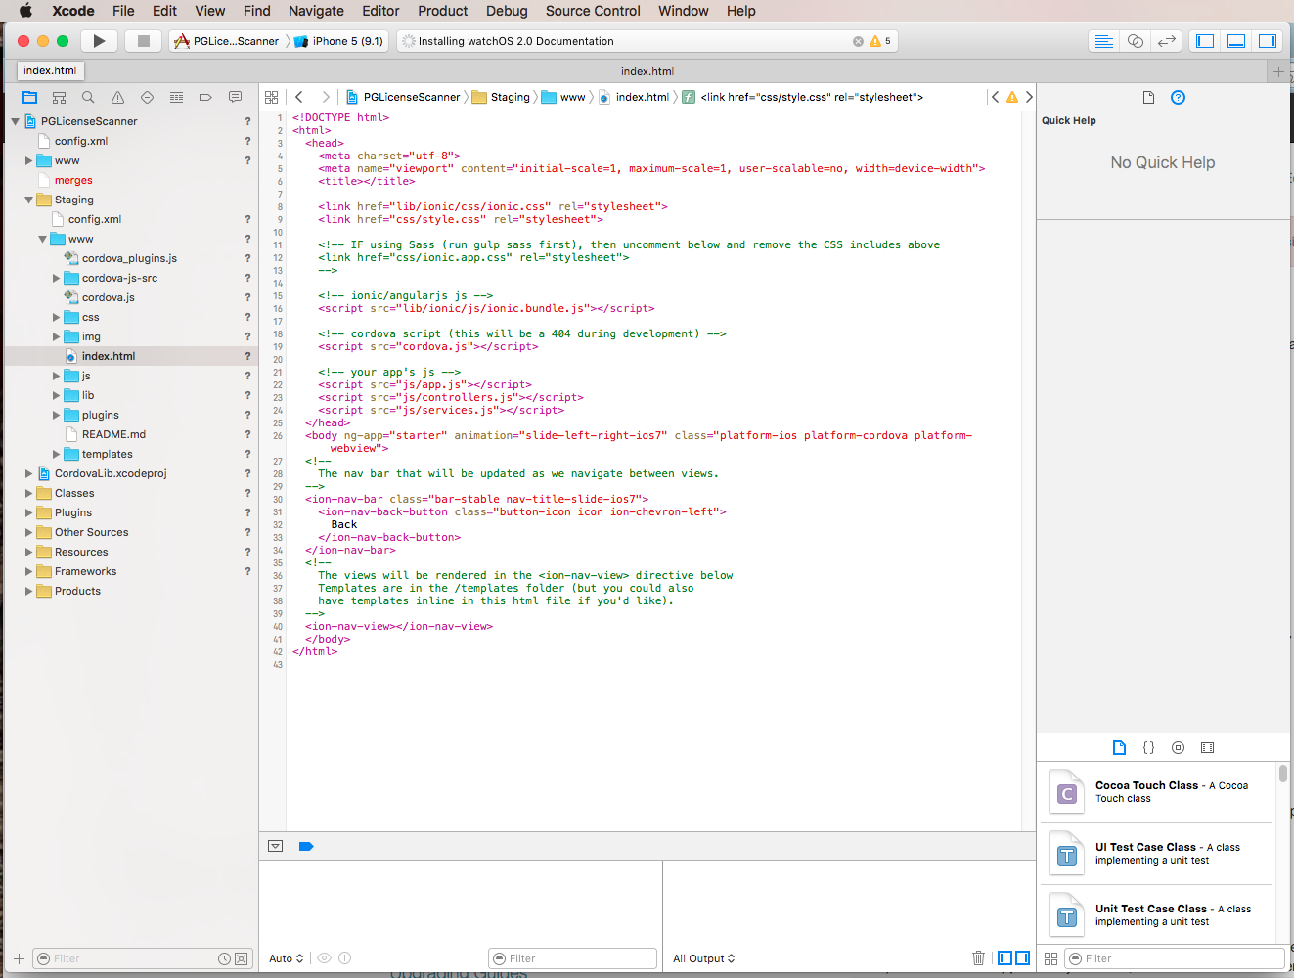
- Select Any device/simulator from Top-Left options.
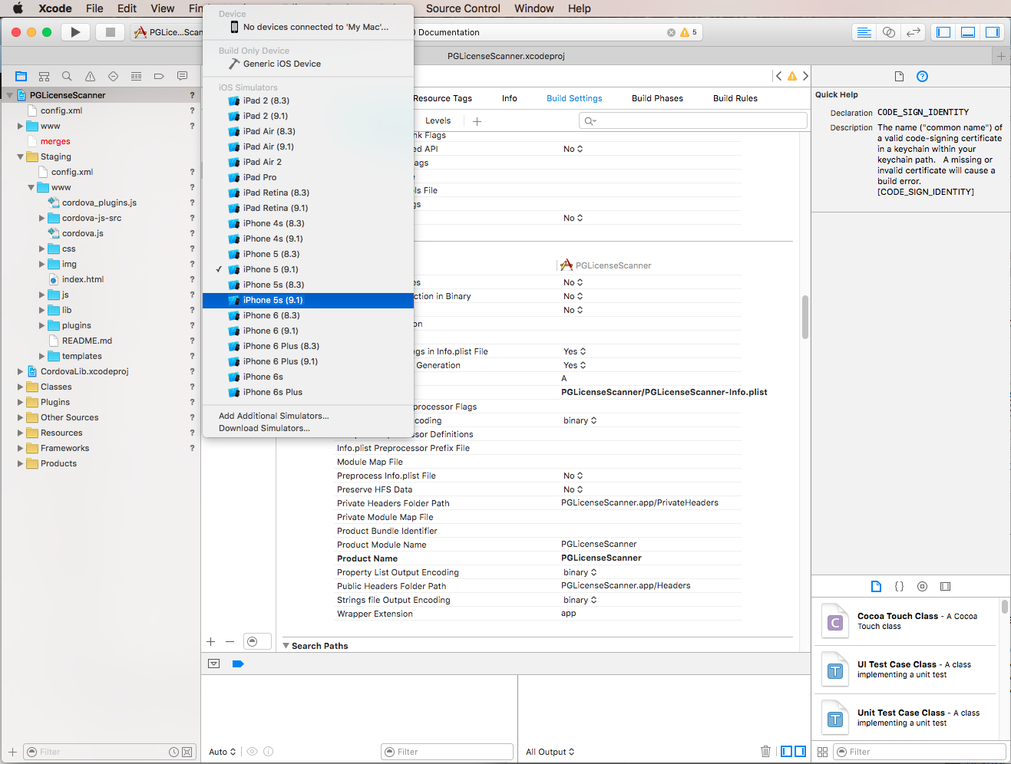

    - Click on run button. And check your app on simulator/device after installing.
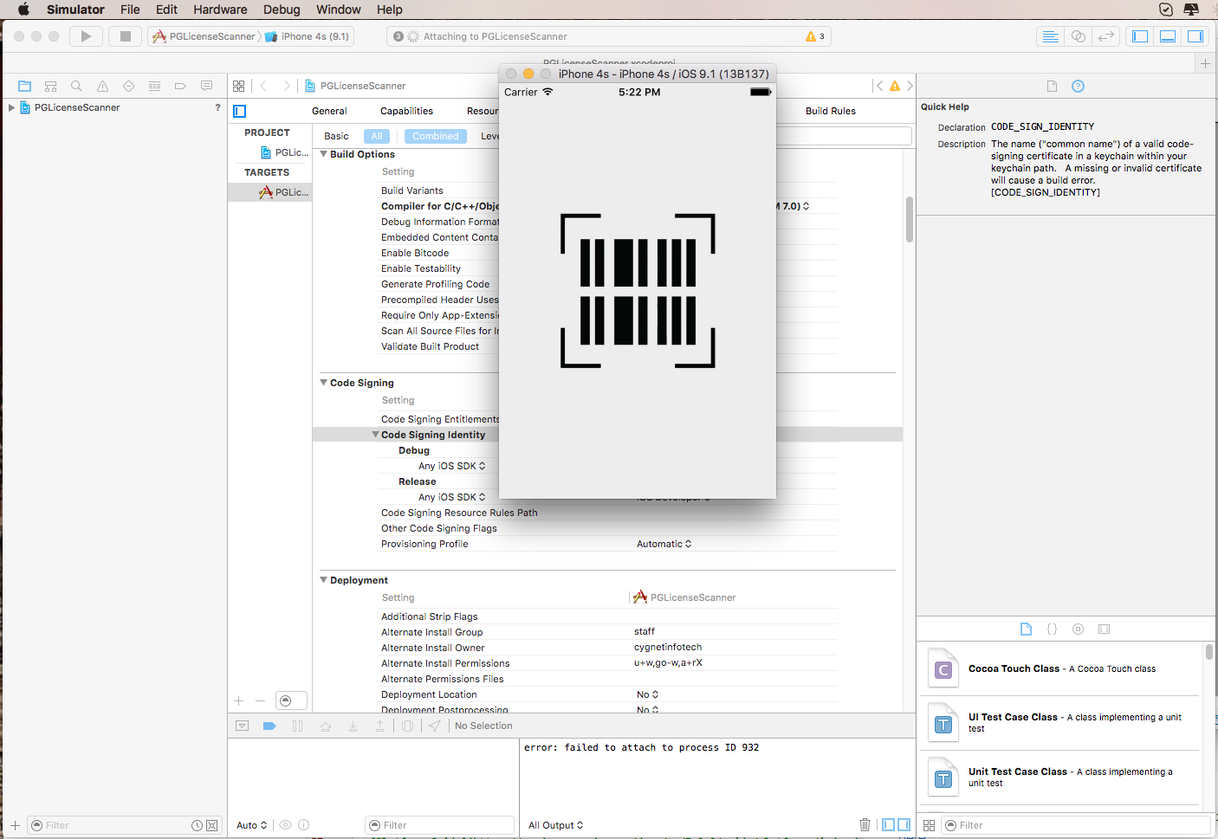
Notes :

If you go through with x-code as IDE than don't go with Terminal to run application.
For pdf417scanner barcode scan you have to use device.

LicenseScanner
LicenseScanner is Ionic Base Project(Mobile Application). This project is scan Barcode from Driver License and get detail of Driver like Name, Address and Age. And check out driver age with as settings.
- Ionic is the open source HTML5 Mobile Framework for building amazing, cross-platform hybrid native apps and mobile websites with HTML, JavaScript, and CSS. If you know how to build or design websites, you will be able to build a real mobile app with Ionic! for more information about openfda please visit [http://ionicframework.com/]

What is Ionic?
Ionic is a powerful HTML5 SDK that helps you build native-feeling mobile apps using web technologies like HTML, CSS, and Javascript. Ionic is focused mainly on the look and feel, and UI interaction of your app. That means we aren't a replacement for PhoneGap/Cordova or your favorite Javascript framework.
Ionic is an HTML5 mobile app development framework targeted at building hybrid mobile apps. Hybrid apps are essentially small websites running in a browser shell in an app that have access to the native platform layer. Hybrid apps have many benefits over pure native apps, specifically in terms of platform support, speed of development, and access to 3rd party code.
Think of Ionic as the front-end UI framework that handles all of the look and feel and UI interactions your app needs in order to be compelling. Kind of like “Bootstrap for Native,” but with support for a broad range of common native mobile components, slick animations, and beautiful design.
Unlike a responsive framework, Ionic comes with very native-styled mobile UI elements and layouts that you’d get with a native SDK on iOS or Android but didn’t really exist before on the web. Ionic also gives you some opinionated but powerful ways to build mobile applications that eclipse existing HTML5 development frameworks.
Since Ionic is an HTML5 framework, it needs a native wrapper like Cordova or PhoneGap in order to run as a native app. We strongly recommend using Cordova proper for your apps, and the Ionic tools will use Cordova underneath.

Why Ionic ?

There's No Web SDK
- It's the wild-west for hybrid apps
- We need to bridge the gap between web and native
- We need rich, native-style UI components and interactions
- We need UI APIs, not just jQuery widgets
Ionic is that missing piece when creating native apps with web standards. Just drop in some CSS and JavaScript, and you’ll quickly get up to speed developing native applications with HTML5. In Short Ionic is providing Mobile Designed components to create application for cordova.
Code Documentation

Code structure
This is a very typical app structure that I see. On the surface, it seems to make a lot of sense and is very similar to a lot of MVC frameworks. We have a separation of concerns, controllers have their own file controller.js, views have their own folder with templates,external libraries have their own folder Lib, etc.

- www
  - css
  - img
  - js
    - app.js
    - controller/
      - home.ctrl.js
      - settings.ctrl.js
      - tab.ctrl.js
      - userdetails.ctrl.js
    - services.js
    - config.js
    - ng-cordova.js
    - factory.js
  - lib
  - templates
    - tab-dash.html
    - tab-settings.html
    - tab-userDetail.html
    - tab.html
  - index.html
  - config.xml

- index.html
  - Head : Put link css and js files which will use for application.
  - <ion-nav-bar> : The ion-nav-bar element will only work correctly if your content has an ionView around it. It have different buttons/tabs which change one view to another view.
  - <ion-nav-view> : As a user navigates throughout your app, Ionic is able to keep track of their navigation history. By knowing their history, transitions between views correctly enter and exit using the platform’s transition style. An additional
benefit to Ionic’s navigation system is its ability to manage multiple histories. For example, each tab can have it’s own navigation history stack
  - ng-app = “scannerApp” : scannerApp is defined in app.js
- templates
  - Templates are designed as per ionic framework components.
  - being able to load these files on demand rather than making the browser load everything.
- App.js
  - For defining angular module and config stateprovider
- services.js
  - Angular services are substitutable objects that are wired together using dependency injection (DI). You can use services to organise and share code across your app.
- config.js : Constants are defined.
- ng-cordova.js : plugin factory methods are defined.(camera, file upload and default free barcode scanner plugin)
- Contollers/
  - tab.ctrl.js -> TabCtrl : To define event/expression for Tab.html
  - home.ctrl.js -> DashCtrl : To define event/expression for Tab-dash.html
  - userdetails.ctrl.js -> UserdetailCtrl : To define event/expression for Tab-userDetails.html
  - settings.ctrl.js -> SettingsCtrl : To define event/expression for Tab-settings.html
- config.xml
  - Configuration of application Many aspects of an app's behaviour can be controlled with a global configuration file, config.xml. This platform-agnostic XML file is arranged based on the W3C's Packaged Web Apps (Widgets) specification, and extended to specify core Cordova API features, plugins,icons,splashscreens and platform-specific settings.

View Detail of code in simulator page.

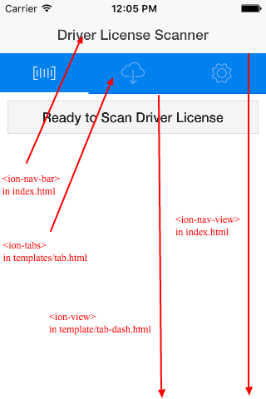
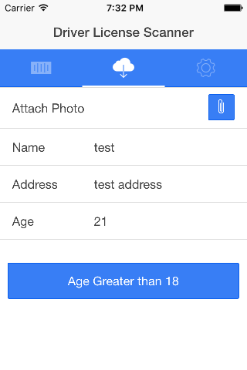

  - After getting data from LicenseScanner open second tab.
  - In second tab you can find data from scanner.
  - In this screen clip grunt-button will allow to upload image from device.
  - When image selected than it will be uploaded on server with params of name, address and age.

Functions
scanLicense() have called on first tab.
Which have pointed to below cordova function.
cordova.plugins.pdf417Scanner.scan()
Which is defined in plugins/mobi.pdf417.PdfScanner/www/pdf417scanner.js
which is plugged with native code of plugin pdf417 -> cdvpdf417.m file have written function of pdf417Scanner.scan which have open camera interface. When camera have detects specific barcode type of pdf417 than it will send back response with JSON format.

