As is shown in the figure, the input array is p{1,2,3,4,5,6,7,8,9}

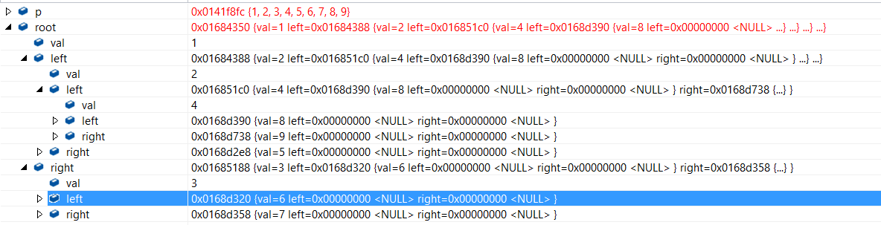

Root:1

Left:2

Left:4

Left:8

Right:9

Right:5

Right:3

Left:6

Right:7

So it is like this:

1

2 3

4 5 6 7

8 9

思路：用queue做宽度优先搜索，每次按行（即按数组顺序）进行插入。