Rojan, Fig1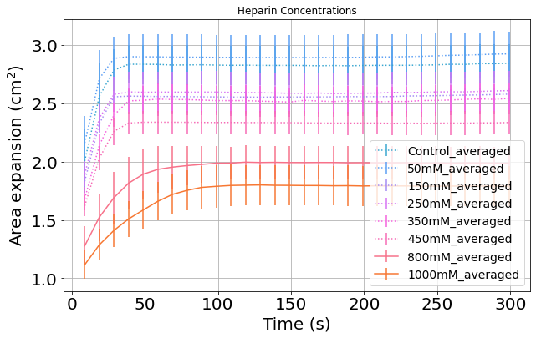Domenica, Fig2
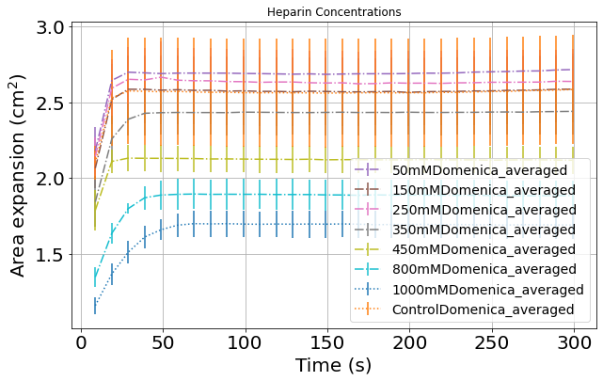
Truncating all cases to 30-250 seconds range for fair comparison.
ANOVA Result on AUC: F=39.001, p-value=0.0000
Multiple Comparison of Means - Tukey HSD, FWER=0.05
====================================================================================
---------------------------------------------------------------------------------------------
Rojan, Fig3 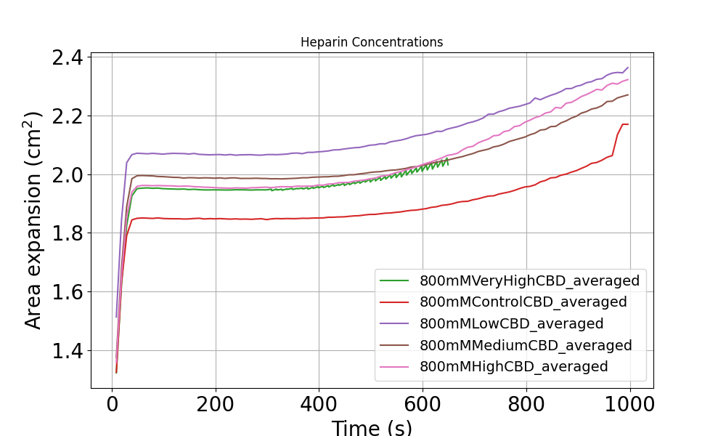
Domenica, Fig4
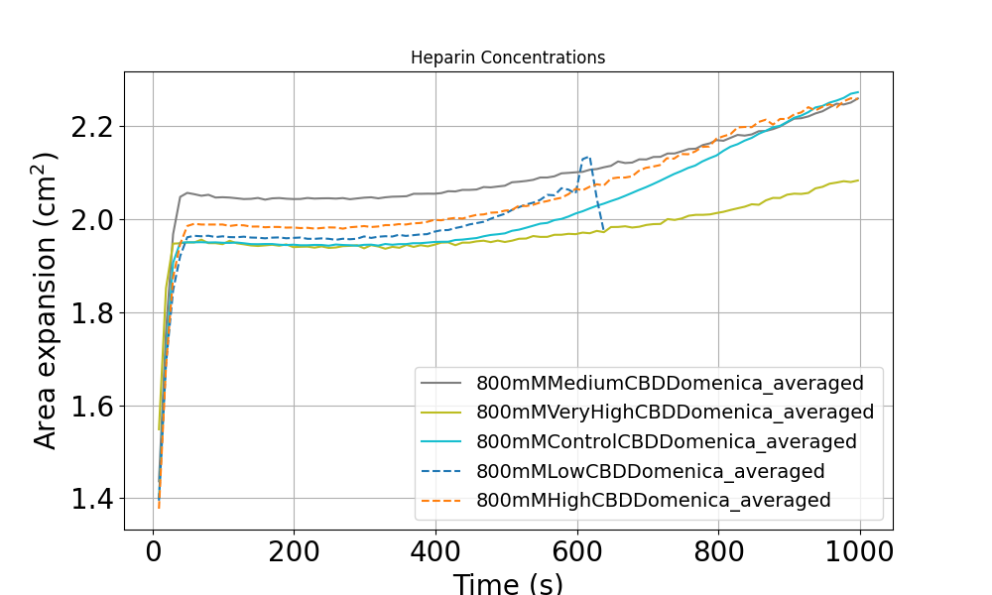
Heparin Effect:
Fig5
