Set path   
C:\flutter\bin  
C:\Users\Pradeep\AppData\Local\Pub\Cache\bin

<https://www.youtube.com/watch?v=jqxz7QvdWk8&list=PLjVLYmrlmjGfGLShoW0vVX_tcyT8u1Y3E>

<https://console.firebase.google.com/project/flutter-pradeep-f14c6/overview>

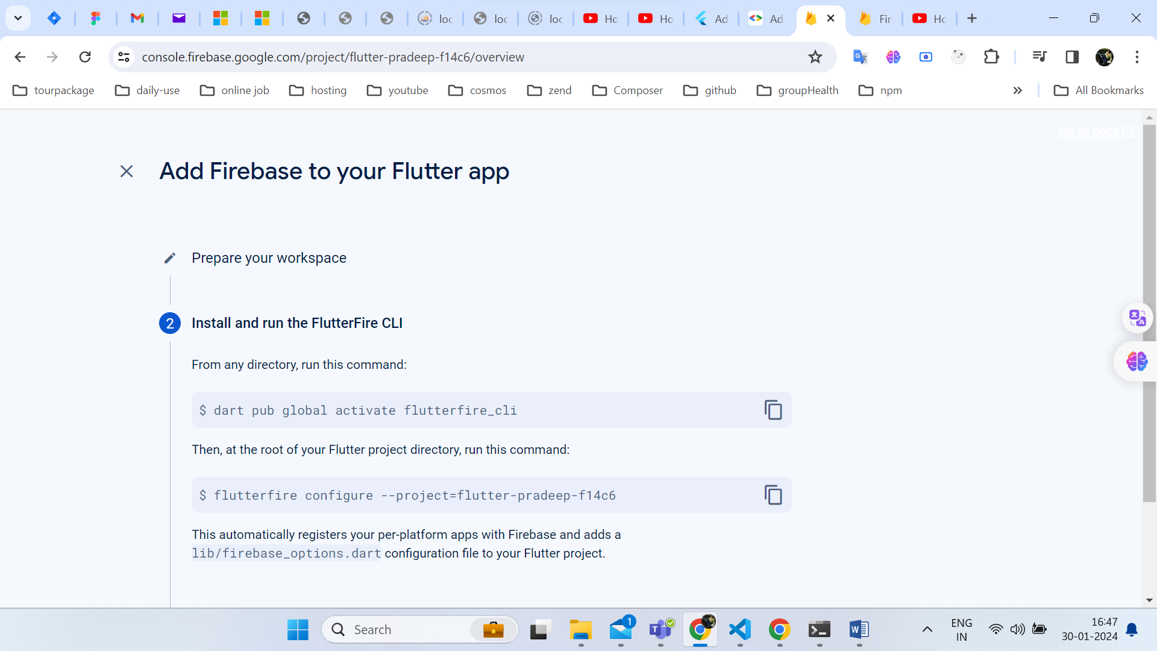  
  
after two commands

Flutter pub outdated  
flutter pub add firebase_core  
  
debugger  
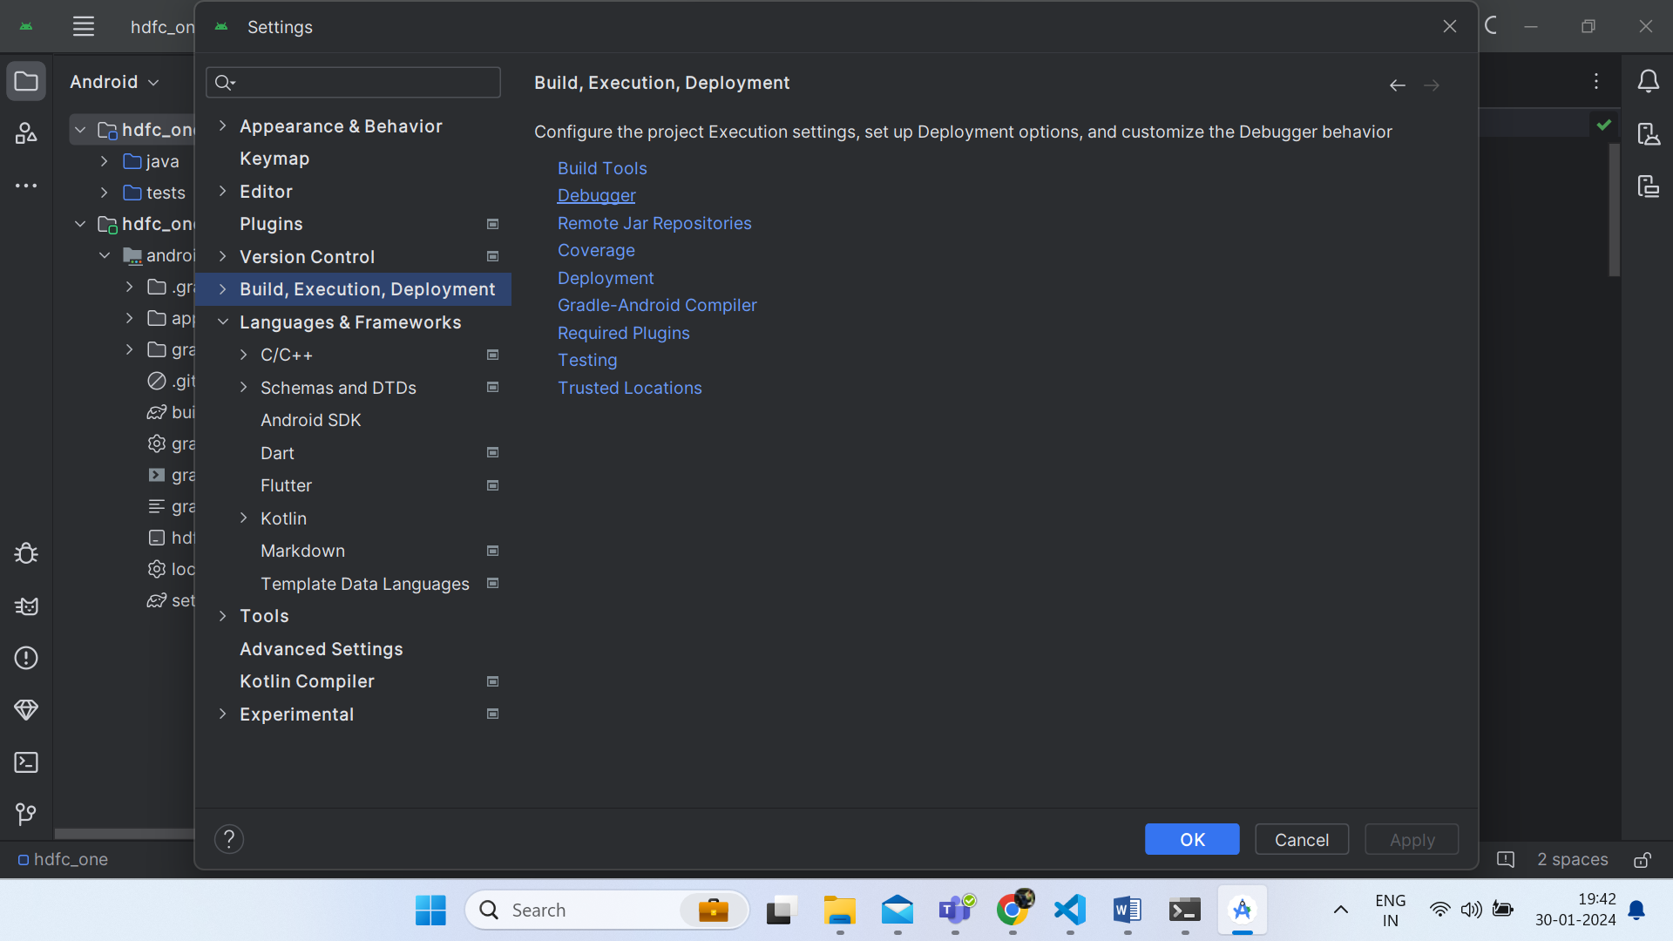  
  
flutter run   
2

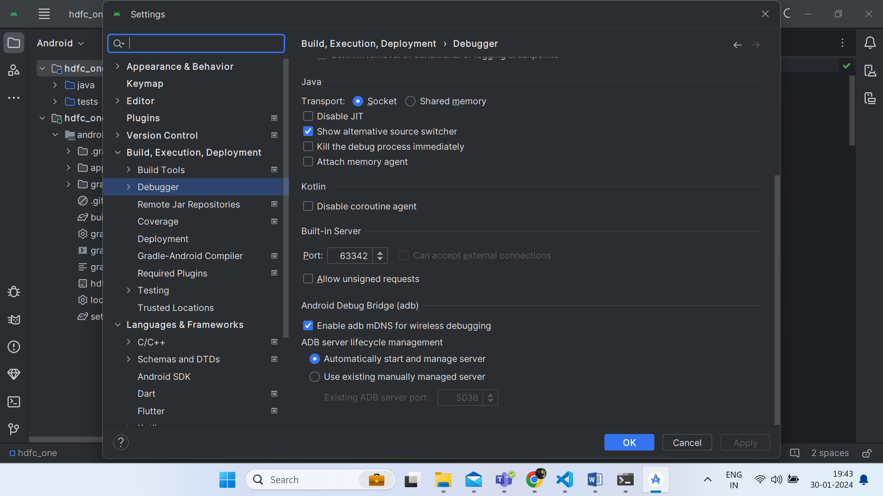

PS C:\projects\flutter_projects\hdfc_one>