Processing Rethinking Food Markets coffee Honduras data
Prepared by: Raquel Sofía Zapata-Valencia

This document outlines the process for analyzing the data collected in the Rethinking Food Markets study on coffee in Honduras. It includes documentation of the process for managing, cleaning, and merging the baseline and endline databases, as well as methodological notes on the use of codes.

Cleaning documentation process
This section describes the processing, cleaning, quality analysis, and merging procedures for the RFM baseline and final surveys for coffee in Honduras. All the files referred to in this document are in the folder “RFMcoffeeHonduras.”

Processing baseline and endline separately
The original baseline survey data are in the “/01_data/raw/baseline” directory. These include six Excel files (one for each version of the survey), each containing 21 sheets: modules A through K, seven loops for aggregations, a closing module, and a main module. The overall goal of the baseline processing is to combine all these files and sheets into a clean and single file named “baselineAgg.csv.”

The original endline survey data are in the “/01_data/raw/endline,” and consists on a single Excel file containing worksheets for each level of aggregation. In line with the baseline, the goal of the processing is to produce a single, clean file named “endlineAgg.csv.”

The following subsections describe the workflow for both data sets. The first step, described in Section 1.1.1. baselineMergeCode.R, is performed only for the baseline, so the specific paths will be indicated. From that point forward, the steps are the same for both the baseline and the endline, so the paths and names will be defined generally as “XLINE”.

baselineMergeCode.R
The file “/02_code/baseline/baselineMergeCode.R” does the following:
- Create a variable name mapping to establish a correspondence between the alphanumeric codes of the variables (used primarily in the baseline) and the descriptive names (used primarily in the endline).
- Create functions to:
  - Rename variables to descriptive names based on the mapping.
  - Merge Excel sheets based on a common ID.
  - Capitalize column names in a dataframe.
  - Process each Excel sheet.
- Perform the aggregation
  - Take all the original files named “RM2023CAFEV#.xlsx” located in the “/01_data/raw/baseline” directory.
  - Combine the sheets that have the same aggregation level (modules A-K and the main sheet).
  - Update the labels of some variables.
  - Save the file “/01_data/raw/baselineRaw.xlsx” with all versions combined, and one sheet for each level of aggregation.

XLINEProcessingCode.R
The file “/02_code/XLINE/ XLINEProcessingCode.R” does the following:
- Declare the paths to use and the dictionary, filtering it for the XLINE variables.
- Starting from “/01_data/raw/XLINE/XLINERaw.csv,” load a dataset for the main sheet and each loop or aggregation level. At this point, automated cleaning corrections can be applied for each level.
Examples of loops: people, plots, sales methods, coffee varieties...
- Based on the “/02_code/dictionary.xlsx,” filter it for the main dataset and each aggregation level.
- Using the script “02_code/XLINE/XLINECorrections.R,” make changes to variables directly in the database. To do this, create the file “01_data/processed/XLINE/XLINECorrections.xlsx” with the specified changes for each variable and loop, ensuring that the aggregation ID of the edited observations is preserved. These changes include deleting observations, correcting duplicates, and modifying variable values.
Example of changes: the assessment of duplicates and the correction of variables values, submitted by ESA Consultores, were performed using this method. In addition, the quality check described in step 7 also generates alerts prompting review of the variables and, when necessary, editing them using this method.
- For each aggregation level, perform the operations by variable described in the dictionary, so that all variables are reported at the producer level.
Examples of aggregations: sum the number of hectares per plot, sum the number of kilograms of coffee sold by method, proportion of coffee plants by variety…
- Once all loops are at the same level, it combines all resulting variables into a single aggregated database, “/01_data/raw/XLINE/XLINEAgg.csv.”
- Performs data quality analysis and generation of the report “03_tables/XLINE/XLINEQualityCheck.RData.”

This script relies on two other scripts that contain functions to perform this process.

XLINEProcessingFunctions.R
Based on the information in the dictionary, this script contains functions to:
- Identify variables within each Excel sheet and map them to the dictionary.
- Convert categorical variables into dummy variables, for both single and multiple selections.
- Standardize coffee weights to kilograms of green parchment, unit prices to prices per kilogram of green parchment, areas to hectares, and distances to meters.
- Add each loop at the producer level according to the operations specified by variable.

XLINECheckFunctions.R and XLINEQualityCheck.RData
The script “02_code/XLINE/XLINEqualityCheckFunctions.R” contains functions to:
- Verify whether questions marked as relevant were answered
- Check whether the GPS coordinates provided in the survey correspond to the intervention municipalities
- Filter out invalid responses for respondent or buyer names
- Extract invalid phone numbers based on the minimum number of characters
- Ensure that the margin of difference for dependent variables (e.g., quantity produced vs. quantity sold) does not exceed a specified percentage
- Verify compliance with logic constraints in the survey (question skips and valid responses)

Based on these functions, the file “03_tables/XLINE/XLINEQualityCheck.RData” generates a report with alerts:
- Duplicates check
- Outliers in key variables
- Valid responses to relevant questions
- Compliance with logic constraints
- Valid names and phone numbers
- Geolocation compliance
- Evaluation of the margin of difference in dependent variables

Harmonization: joining baseline and endline
Starting from datasets “/01_data/raw/baseline/baselineAgg.csv” and “/01_data/raw/endline/endAgg.csv,” the goal of the harmonization is to combine both surveys into a single database that identifies common variables and allows for the creation of graphs and the computation of regression models. The following subsection describes the process.

mainCode.R
The file “/02_code/harmonization/mainCode.R” does the following:
- Declare the paths to use, the dictionary and the treatment group assignment files.
- Joins both surveys using the combine_datasets function and generates two databases: longDF and wideDF
- Computes the regression models following the dictionary, using the run_regression_models function
- Construct the graphs following the dictionary, using the generate_plots variable.

This script relies on three other scripts that contain functions to perform this process.

combineFunction.R
This code performs several functions that allow both databases to be merged. The main idea is to identify the variable class of each variable in each database and, based on this, detect the common variables between rounds by their names and classes. For the “long” database, the common observations are appended, keeping the common variables in the same column, while the rest will only be filled in for the corresponding survey. In the “wide” database, common observations are merged, and the variables corresponding to the baseline are identified by the suffix “_baseline”.

regressionFunctions.R
The regression code identifies observations by their treatment arm based on their location. From this, the dictionary defines which variables will be used in the models, as follows:
- If column type_column=1, the variable will be treated as an explanatory variable.
- If column type_column=2, the variable corresponds to the treatment status.
- If column type_column=3, the variable will be treated as independent
- If column logarithm=1, the variable enters the model in logarithmic form
The code iterates through the variables marked as dependent, using the same independent variables and controls. These models can customize the logarithmic transformation of the variables, allowing for log-log, log-normal, normal-log, and their variations in multiple regression. The results are storage in the route “03_tables/harmonization/model_summaries.html.”

graphFunctions.R
The graphics code identifies observations by their treatment arm based on location. It then loads geospatial data at the national, departmental, municipal, and community levels. Based on this, it identifies the desired variables for each type of graph in the dictionary by marking 1 in the column as appropriate:
- bar_plot_avg: generates a graph showing the average of the variable for each treatment type, separated by period, and another graph for both periods combined
- bar_plot_cnt: generates a chart showing the count of the variable for each treatment type, separated by period, and another chart for both periods combined
- line_plot_x and line_plot_y: generates a chart showing the relationship between x and y for each treatment type, separated by period, and another chart for both periods combined
- donut_plot: generates a donut chart showing the percentage share of the variable
- choropleth_plot: generates different charts of the variable at the department, municipality, and community levels.
- grouping_var: represents the aggregation charts of the graphs. The baseline vs. endline indicator is generally used for this grouping.
The results are storage in the route “03_plots/harmonization.”

Methodological notes (README)
#' ---------------------------------
#' README – RFMcoffeeHonduras
#' Last updated: May, 2026
#' ---------------------------------
#'
#' This folder contains the code for cleaning and performing exploratory data analysis for the Rethinking Food Markets CGIAR initiative regarding the coffee supply chain in Honduras. The results were obtained using R 4.5.1, and the necessary libraries can be downloaded from The Comprehensive R Archive Network (CRAN).
#' The folder is organized as follows:
#'
#' “01_data": includes the raw and processed databases from the baseline and endline surveys, as well as the map files for the cleaning and exploratory data analysis process:
#' 1.1. “maps”: contains shapefiles for Honduras at the departmental, municipal, and village levels, updated as of October 2016.
#' 1.2. “raw”: contains original databases from the baseline and endline surveys, as well as the treatment assignment and implementation data. The three main files are:
#' Baseline survey: ./raw/baseline/baselineRaw.xlsx
#' Endline survey: ./raw/endline/endlineRaw.xlsx
#' Treatment group assignment: ./implementation/ttmAssign_labels.xlsx
#' 1.3. “processed”: contains the intermediate and final databases; that is, data that has undergone some level of processing. The four main files are:
#' Baseline aggregated: ./processed/baseline/baselineAgg.csv
#' Endline aggregated: ./processed/endline/endlineAgg.csv
#' Long-form surveys joined: ./processed/harmonization/longDF.csv
#' Wide-form surveys joined: ./processed/harmonization/wideDF.csv
#'
#' “02_code”: includes the files used for cleaning, merging, quality checks, and exploratory data analysis of the baseline and endline surveys:
#' 2.1. “dictionary.xlsx”: This is the main file for data merging and analysis. It is dynamic and contains a list of all variables, including the survey to which they belong, the variable type, the level of aggregation within the survey and the operations used to aggregate them, as well as their use in regression models and the generation of graphs.
#' 2.2. “baseline”: contains the code used for merging, cleaning checking the quality of the baseline survey data. The main file is “baselineProcessingCode.R”, which calls the other scripts to perform each task.
#' 2.3. “endline”: contains the code used for merging, cleaning checking the quality of the endline survey data. The main file is “endlineProcessingCode.R,” which calls the other scripts to perform each task.
#' 2.4. “endline”: contains the code used to merge the initial and final databases, as well as to generate graphs and calculate regression models. The main file is “mainCode.R,” which calls the other scripts to perform each task.
#'
#' “03_tables”: includes the results of the quality checks and the regression models that were performed. It contains folders for “baseline,” “endline,” and “harmonization,” depending on the outcome.
#'
#' “04_plots”: includes the results plots and graphs that were constructed. It contains folders for “baseline,” “endline,” and “harmonization,” depending on the outcome.
#'
#'
#' The process for executing the codes is as follows:
#' 1. Update the “./02_code/dictionary.xlsx” with the desired aggregation of variables. At this point, updates can also be made to the graphs and regressions needed for step 5
#' 2. Open the “./RFMcoffeeHonduras.Rproj” and use it to open the scripts below. This allows for the use of standardized paths.
#' 3. If a change is needed to the baseline processing, run the scripts “./02_code/baseline/baselineMergeCode.R” and then “./02_code/baseline/baselineProcessingCode.R”.
#' 4. If a change is needed to the endline processing, run the “./02_code/endline/endlineProcessingCode.R”
#' 5. If any changes were made to steps 3 and 4, the entire “./02_code/harmonization/mainCode.R” script must be run. If only graphs or regressions need to be added, the last two sections of this file - “Graphs (longDF)” and “Regression models (wideDF)” - can be run after updating the dictionary.

Exploratory data analysis
The study began with a baseline of 1,875 observations and 660 variables, while the endline comprised 1,481 observations and 815 variables, including 7 replacements and 6 unidentified cases. When merging both datasets, a total of 1,385 common observations were identified, with 281 variables successfully matched. In addition, there were 386 variables unique to the baseline and 535 variables unique to the endline, highlighting both the continuity and expansion of the information collected across the two rounds.

Below are some charts generated during the exploratory data analysis:
Some donut charts
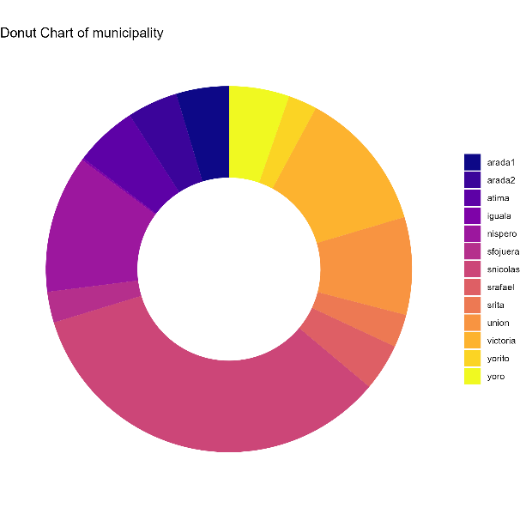 | 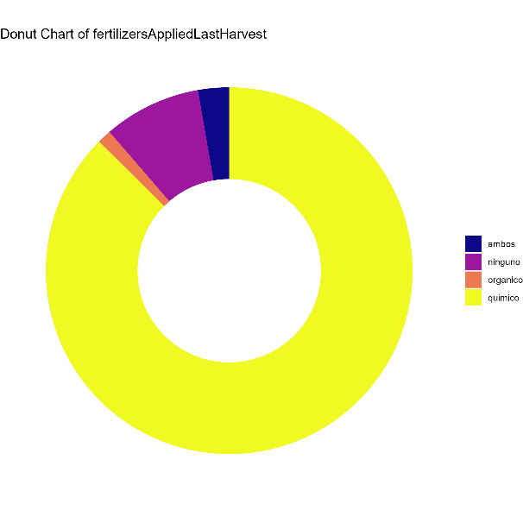
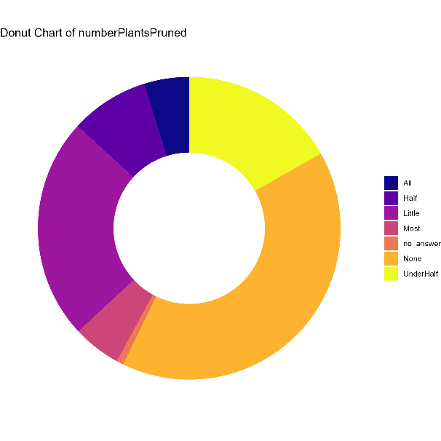 | 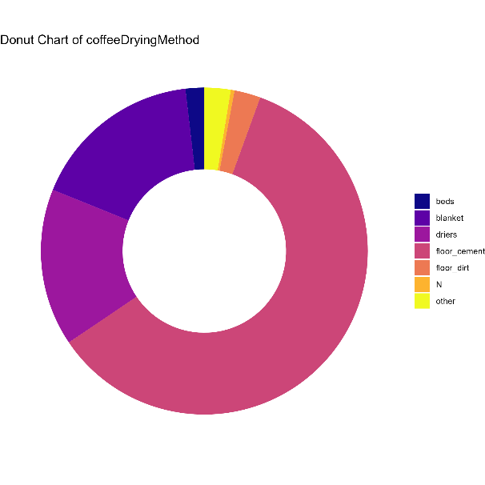

Density of plants per hectare, by treatment group
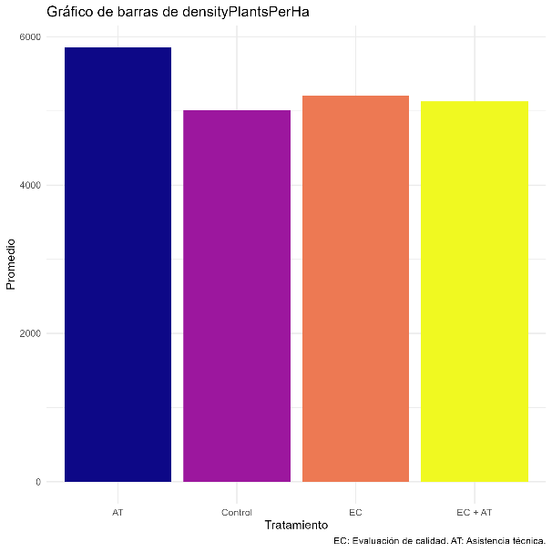 | 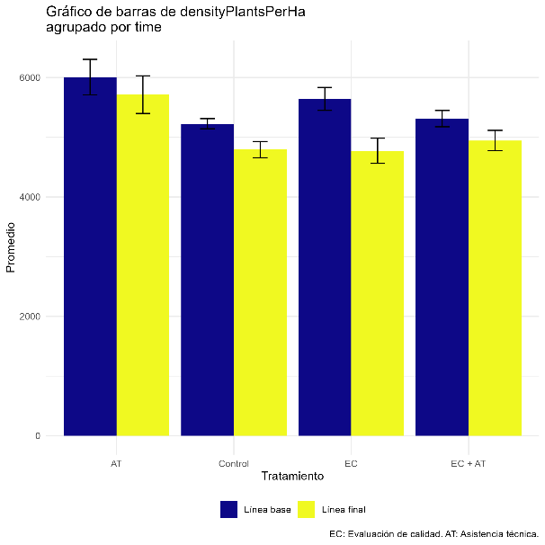

Average yield per hectare, by treatment group
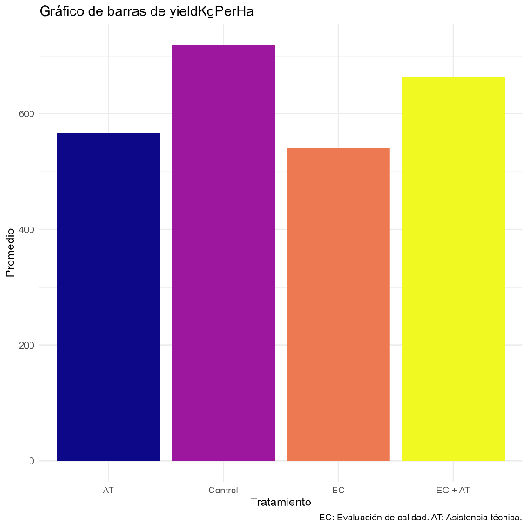 | 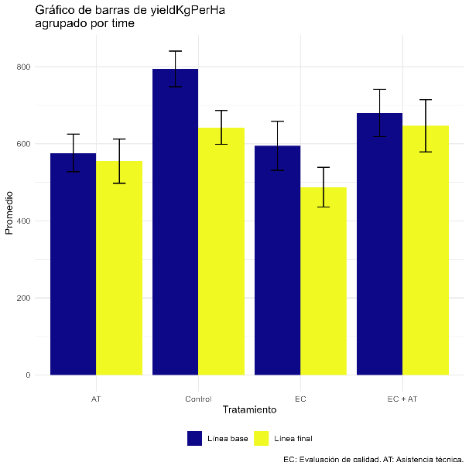

Count of farm aspects improved, by treatment group
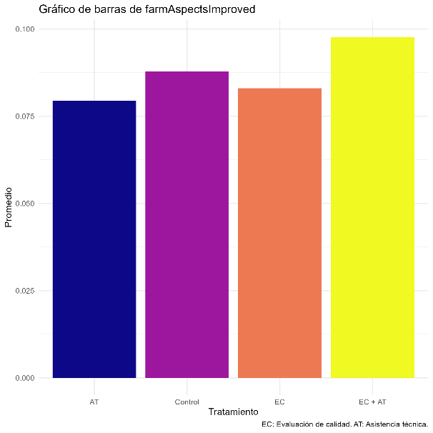 | 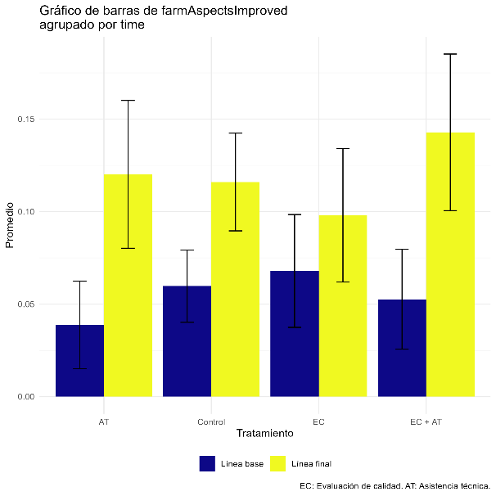

Below are some examples of regressions computed during the exploratory data analysis

Regression Model Summaries
 | Dependent variable:
 | log(amountOfCoffeeProducedLastHarvestInKgGreen) | log(amountSoldInKgGreen_typ) | log(densityPlantsPerHa) | aspectsImproved | log(maximumReceivedPriceForCoffeeInKgGreen_typ) | log(minimumReceivedPriceForCoffeeInKgGreen_typ) | log(yieldKgPerHa)
 | (1) | (2) | (3) | (4) | (5) | (6) | (7)
treatment1 | -0.062 | -0.218*** | -0.035 | -0.477*** | 0.197*** | 0.182*** | -0.158**
 | p = 0.376 | p = 0.003 | p = 0.287 | p = 0.0005 | p = 0.00003 | p = 0.0002 | p = 0.016
treatment2 | 0.087 | -0.014 | 0.100*** | -0.111 | 0.390*** | 0.365*** | 0.016
 | p = 0.220 | p = 0.848 | p = 0.003 | p = 0.417 | p = 0.000 | p = 0.000 | p = 0.804
treatment3 | 0.034 | -0.303*** | 0.051 | -0.204 | 0.184*** | 0.078* | 0.068
 | p = 0.617 | p = 0.00003 | p = 0.117 | p = 0.132 | p = 0.0001 | p = 0.094 | p = 0.296
log(amountOfCoffeeProducedLastHarvestInKgGreen_baseline) | 0.796***
 | p = 0.000
log(amountSoldInKgGreen_typ_baseline) |  | 0.747***
 |  | p = 0.000
log(densityPlantsPerHa_baseline) |  |  | 0.355***
 |  |  | p = 0.000
F4C_baseline |  |  |  | 0.168*
 |  |  |  | p = 0.052
log(maximumReceivedPriceForCoffeeInKgGreen_typ_baseline) |  |  |  |  | 0.087***
 |  |  |  |  | p = 0.008
log(minimumReceivedPriceForCoffeeInKgGreen_typ_baseline) |  |  |  |  |  | 0.094***
 |  |  |  |  |  | p = 0.003
log(yieldKgPerHa_baseline) |  |  |  |  |  |  | 0.477***
 |  |  |  |  |  |  | p = 0.000
Constant | 1.044*** | 1.290*** | 5.371*** | 0.664*** | 4.299*** | 4.067*** | 3.043***
 | p = 0.000 | p = 0.000 | p = 0.000 | p = 0.000 | p = 0.000 | p = 0.000 | p = 0.000
Observations | 1,352 | 1,339 | 1,355 | 1,358 | 1,260 | 1,260 | 1,351
R² | 0.616 | 0.583 | 0.052 | 0.012 | 0.070 | 0.065 | 0.183
Adjusted R² | 0.614 | 0.582 | 0.049 | 0.009 | 0.067 | 0.062 | 0.181
Residual Std. Error | 0.919 (df = 1347) | 0.948 (df = 1334) | 0.435 (df = 1350) | 1.820 (df = 1353) | 0.589 (df = 1255) | 0.595 (df = 1255) | 0.866 (df = 1346)
F Statistic | 539.128*** (df = 4; 1347) | 467.156*** (df = 4; 1334) | 18.466*** (df = 4; 1350) | 4.120*** (df = 4; 1353) | 23.550*** (df = 4; 1255) | 21.743*** (df = 4; 1255) | 75.476*** (df = 4; 1346)
Note: | *p<0.1; **p<0.05; ***p<0.01

Additional documentation
All codes, data, and objects referenced in this document are in the RFMcoffeeHonduras folder. Below are specific links to the relevant files:
- dictionary.xlsx
- longDF.csv
- wideDf.csv

