A Novel Point Inclusion Test for Convex Polygons Based on Voronoi Tessellations

Rahman Salim Zengin

Volkan Sezer

The point inclusion tests for polygons, in other words the point-in-polygon (PIP) algorithms, are fundamental tools for many scientific fields related to computational geometry, and they have been studied for a long time. The PIP algorithms get direct or indirect geometric definition of a polygonal entity, and validate its containment of a given point. The PIP algorithms, which are working directly on the geometric entities, derive linear boundary definitions for the edges of the polygons. Moreover, almost all direct test methods rely on the two-point form of the line equation to partition the space into half-spaces. Voronoi tessellations use an alternate approach for half-space partitioning. Instead of line equation, distance comparison between generator points is used to accomplish the same task. Voronoi tessellations consist of convex polygons, which are defined between generator points. Therefore, Voronoi tessellations have become an inspiration for us to develop a new approach of the PIP testing, specialized for convex polygons. The equations, essential to the conversion of a convex polygon to a Voronoi polygon, are derived. As a reference, a very standard convex PIP testing algorithm, *the sign of offset*, is selected for comparison. For generalization of the comparisons, *the ray crossing* algorithm is used as another reference. All algorithms are implemented as vector and matrix operations without any branching. This enabled us to benefit from the CPU optimizations of the underlying linear algebra libraries. Experimentation showed that, our proposed algorithm can have comparable performance characteristics with the reference algorithms. Moreover, it has simplicity, both from a geometric representation and the mental model.

point inclusion test ,point in polygon ,convex polygon ,Voronoi tessellations

# Introduction

Various point inclusion tests are used in many applications , including planning for autonomous driving , geographical information systems , and computer graphics . Any improvements on the efficiency of the point inclusion tests will provide a direct benefit to the mentioned areas.

When autonomous driving related planning applications are considered, planning is mostly done in a 2D space. Collected real-time sensor data, especially Lidar-based point cloud data, is mapped to the 2D space. Collision check is one of the most critical components of the motion planning. Several simplifications on collected data and vehicle representation is required to make it efficient. Modeling the vehicle as a circle or combination of several circles is one of the widely used techniques for collision check. Although this simplification works well for most situations, there is always an accuracy problem depending on the number of circles, that are used to model the vehicle .

In order to make a more accurate collision check, footprint of the car can be modeled as a convex polygon. In order to make a real-time motion planning, efficient collision-check algorithms, that are capable of testing big batches of points against the convex polygon model of the car, are needed. Even though there are simple and well known algorithms, we propose an alternative algorithm based on Voronoi approach to accomplish the same task.

Geographical information systems is another field that relies on point inclusion tests. It is used to process large databases of cartographic data. Measurements taken in the field must be matched with the prior information related to the area. Using the measurements, point inclusion tests are run against big databases to accomplish that task.

Another field, in which the point-in-polygon queries are actively being used, is computer graphics . A scene contains many object models, which are composed of polygons. For visualization on the screen, proper rasterization of the geometric data is needed. To match the pixels on the screen with the geometric data, the polygons are mapped to the screen plane. Then membership of every screen pixel is determined via point inclusion testing, so that the pixels can be painted properly.

Voronoi tessellations consist of convex polygons, and there is a huge literature related to Voronoi tessellations. Simplest point inclusion tests are based on line equations and point-to-line distance calculations. Conversion of a convex polygon to a Voronoi polygon has the advantage of using only point-to-point distance calculations. Required equations for the conversion of a convex polygon to a Voronoi polygon are derived step-by-step, throughout this paper.

For completeness, two simple and well known point inclusion methods are summarized, and then compared with our proposed method. In order to compare the algorithms in an equal manner, all algorithms are implemented using vector and matrix operations instead of simple loops, with the help of the related libraries. In this way, computations are handled more efficiently. As a result, the proposed algorithm showed comparable performance with the reference algorithms.

The structure of the paper is as follows: In (Section 2) two reference algorithms are mentioned and the notation is given. In (Section 3), conversion of a convex polygon to a Voronoi polygon is described, and required equations are derived. In (Section 4), the point inclusion testing via the generators is described. In (Section 5), expected performance of our proposed algorithm is discussed. In (Section 6.1), for a certain generated test data, correctness of our proposed algorithm is proven via comparison against *the sign of offset* algorithm. In (Section 6.2), experimental setup is described, experimental results are shared and discussed.

# Background

The reference point inclusion algorithms are explained. Then, notation of the paper is given.

## The ray crossing method

*The ray crossing* method is the golden standard of the point inclusion tests. It can be used for simple polygons. As shown in the (Figure 1) a ray directed to the $+x$ direction is used to count crossings of the ray and the polygon. If the ray crosses the polygon edges in odd numbers it is inside, otherwise it is outside.

All edges of the polygon are checked whether they are on the same $y$ level of the point. If applicable, line equation in the two-point form is used to determine the half-plane of the point. For a $+x$ going ray it must be on the left half-plane. If so, it is counted as a crossing.

The pseudocode of the ray crossing implementation, which is used for experiments, is given in (Algorithm [alg:crossing]).

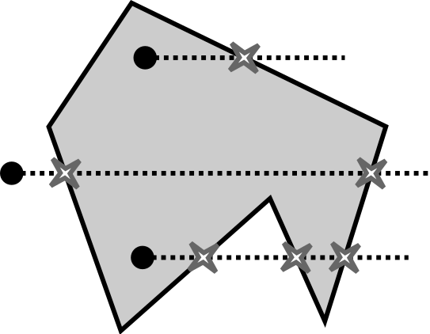

Ray crossing method

()

## The sign of offset method

*The sign of offset* method is the simplest point-in-polygon algorithm, specialized for convex polygons. A point in a convex polygon is shown in (Figure 2). For an edge of the polygon, the offset of the point to the line passing through the edge is calculated. If the offset of the point has the same sign for all edges of the polygon, the point is inside. Otherwise, it is outside.

The pseudocode of the implemented algorithm is given in (Algorithm [alg:offset]).

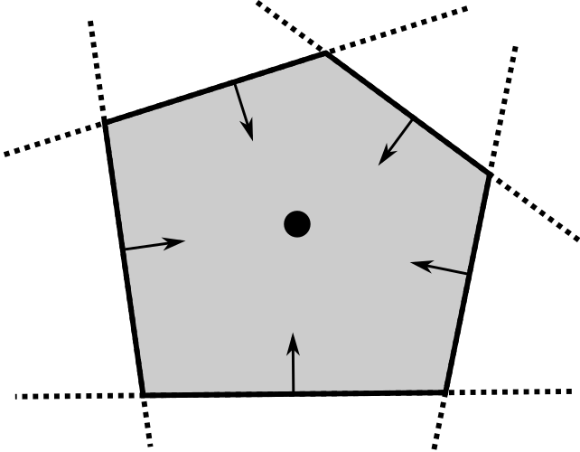

The sign of offset method

()

## Notation

For simplicity and clearance, definitions related to Voronoi tessellations are slightly modified and adapted.

Throughout this paper, only 2-dimensional Euclidean space, $R^{2}$ is considered. Boldface denotes a vector, such as $x={\left(x_{1},x_{2}\right)}^{T}$. Superscript $​^{T}$ denotes transpose as usual. For a polygon which has $n$ vertices, vertices of the polygon are denoted with additional indexes, such as $q_{i},q_{j}$, where $i,j=\{1,…,n\}$ and $i≠j$ where edges considered. The set of vertices of the Voronoi polygon is $Q=\{q_{1},…,q_{n}\}$.

A Voronoi polygon is a convex region, defined by an inner generator point and some outer generator points such that,

$$\begin{matrix}V\left(p_{0}\right)=\{ & x| ∥x−p_{0}∥≤∥x−p_{k}∥ \\ & ∀k∈\{1,…,n\}\}\end{matrix}$$

where $V\left(p_{0}\right)$ denotes Voronoi polygon related to the generator point $p_{0}$.

A generator point $p_{k}$ belongs to the set of generator points $P$ of the Voronoi polygon. The inner generator point is always indexed as $p_{0}$, independent of the edge count $n$. For every edge of the Voronoi polygon there is an outer generator point, so that the set of generator points is $P=\{p_{0},p_{1},…,p_{n})$.

Edges are equidistant set of points between the inner generator and outer generators. Precisely,

$$e_{k}=\{x| ∥x−p_{0}∥=∥x−p_{k}∥\}$$

where $k∈\{1,…,n\}$. The set of edges of the $V\left(p_{0}\right)$ can be denoted as $E=\{e_{1},…,e_{n}\}$.

The whole set of edges is called the boundary, and it is denoted related to the inner generator point as $∂V\left(p_{0}\right)$. Although a Voronoi graph has multiple polygonal regions, throughout this study, we are only interested in defining a single Voronoi polygon.

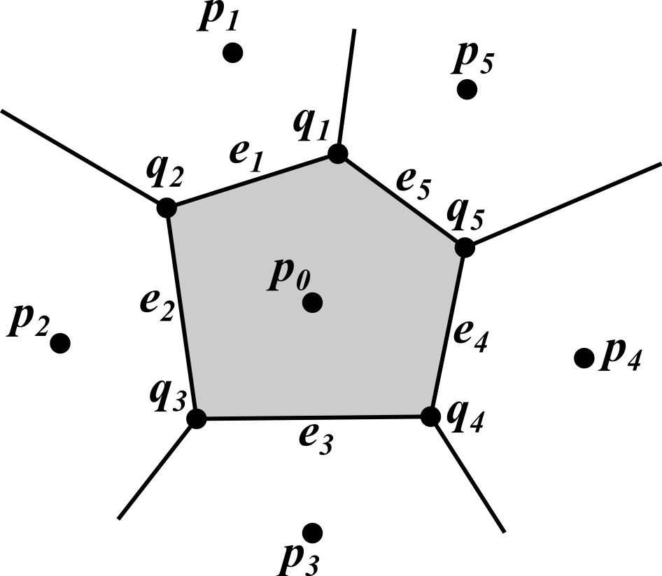

Generators, vertices and edges of a Voronoi polygon

# Conversion of convex polygons to Voronoi polygons

Vertices of a convex polygon ( $q_{i}$ in Figure 3) can be taken as the vertices of a Voronoi polygon. Edges of a convex polygon ($e_{k},\text{where} k=\{1,…,5\}$, in Figure 3) can be taken as the boundary of a Voronoi polygon.

Because determination of the generator points ( $p_{k}$ on Figure 3) is only constrained by $∂V\left(p_{0}\right)$, any internal point can be chosen freely as $p_{0}$. But to distribute the outer generators homogeneously, and to have a guaranteed point inside, the centroid of the polygon is used as the inner point. Then, the outer generator points can be found accordingly.

As shown in (Figure 3), placement of generator points determines both $∂V\left(p_{0}\right)$, and the edges going to the infinity. However, our problem is only constrained on $∂V\left(p_{0}\right)$.

The problem of finding $\left(n+1\right)$ generator points is constrained on $n$ vertices of the polygon. So, there is freedom to choose one of the generator points. Although setting any of the generator points sets all the others, setting the inner generator is more reasonable; because all the edges are defined depending upon it.

The centroid of a polygon can be calculated as follows:

Let $Q$ be a cyclically ordered set of polygon vertices and $q_{i},q_{j}$ are subsequent vertices accordingly. Summation over $Q$,



gives the area ([eq:area]) and centroid ([eq:centroid]) of the polygon. The pseudocode of the centroid calculation is given in (Algorithm [alg:centroid]).

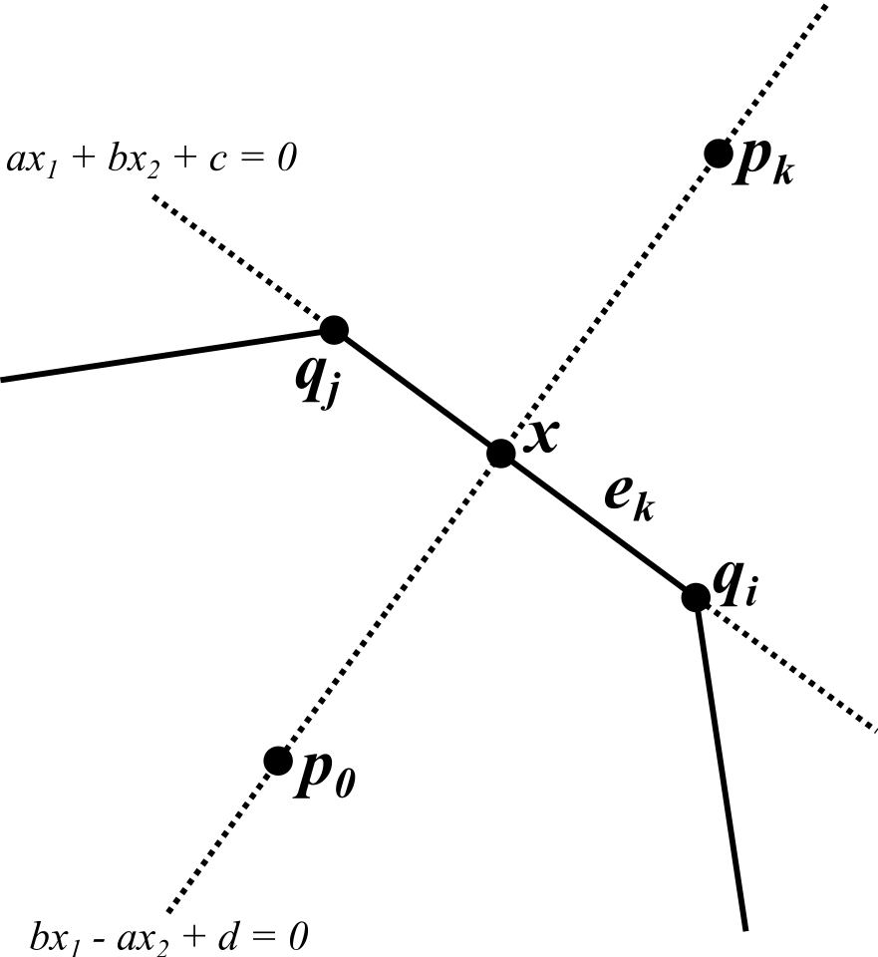

Finding outer generator of an edge

()

For two subsequent vertices $q_{i},q_{j}$ of a polygon, two-point form of the line equation can be written as

$$\left(x_{2}−q_{i2}\right)\left(q_{j1}−q_{i1}\right)=\left(x_{1}−q_{i1}\right)\left(q_{j2}−q_{i2}\right)$$

where the vertices are $q_{i}={\left(q_{i1},q_{i2}\right)}^{T}$ and $q_{j}={\left(q_{j1},q_{j2}\right)}^{T}$.

The standard form equation of the line passing through an edge can be derived from two-point form equation. As shown in (Figure 4), $q_{i}$ and $q_{j}$ are two vertices of the edge $e_{k}$, $x$ is a point on the edge. As defined in ([eq:edge]) $p_{0}$ and $p_{k}$ are two points, equidistant to the $e_{k}$. The line passing through $p_{0}$ and $p_{k}$ is perpendicular to ([eq:two_point_form]).

Solving $x$ for two equations gives

$$x=\frac{\left(\left[\begin{matrix}b_{k}^{2} & −a_{k}b_{k} \\ −a_{k}b_{k} & a_{k}^{2}\end{matrix}\right]p_{0}−c_{k}\left[\begin{matrix}a_{k} \\ b_{k}\end{matrix}\right]\right)}{a_{k}^{2}+b_{k}^{2}}$$

where

$$\begin{matrix}a_{k}=q_{i2}−q_{j2} \\ b_{k}=q_{j1}−q_{i1} \\ c_{k}=−\left(a_{k}q_{i1}+b_{k}q_{i2}\right)\end{matrix}$$

$p_{0}$ and $p_{k}$ are equidistant to $x$. Writing this equation and leaving $p_{k}$ alone on the left hand side gives $p_{k}$ as

$$\begin{matrix} & p_{k}−x=x−p_{0} \\ ⇒ & p_{k}=2x−p_{0}\end{matrix}$$

By substituting ([eq:intersection_x]) into ([eq:equidist]), outer generator points can be found as

$$p_{k}=\frac{\left(\left[\begin{matrix}b_{k}^{2}−a_{k}^{2} & −2a_{k}b_{k} \\ −2a_{k}b_{k} & a_{k}^{2}−b_{k}^{2}\end{matrix}\right]p_{0}−2c_{k}\left[\begin{matrix}a_{k} \\ b_{k}\end{matrix}\right]\right)}{a_{k}^{2}+b_{k}^{2}}$$

The generator calculation procedure is given in (Algorithm [alg:generators]).

()

# Point inclusion test via generator points

After the set of generators $P$ has been found, the point inclusion test is simply testing the condition provided in ([eq:voronoi_polygon]).

()

The ordinary distance metric for the definition of the Voronoi polygon is *Euclidean distance* or equivalently *L2 norm*. To test the inclusion of a random point, its distances to all generators are calculated. If it is closest to the generator $p_{0}$, it is inside of the polygon. Otherwise it is outside of the polygon.

Ordinarily, calculating the *L2 norm* of a vector ([eq:L2_norm]) takes squaring, summing and then square rooting of the vector components.

$$∥x∥=\sqrt{x_{1}^{2}+x_{2}^{2}}$$

However squaring of both sides of ([eq:voronoi_polygon]) does not change the order of distances, because squaring is a monotonic operation.

$$V\left(p_{0}\right)=\{x| ∥x−p_{0}∥_{2}^{2}≤∥x−p_{k}∥_{2}^{2}\}$$

The square root and the square vanish, when these are applied together. Then equation ([eq:vpoly_w_sqnorm]) becomes

$$\begin{matrix}V\left(p_{0}\right)=\{x| & {\left(x−p_{0}\right)}^{T}\left(x−p_{0}\right) \\ ≤ & {\left(x−p_{k}\right)}^{T}\left(x−p_{k}\right)\}\end{matrix}$$

The derived simplification ([eq:vpoly_simpl]) is an alternate way of distance comparison. It improves the performance of comparisons and preserves the order of distances.

The pseudocode of the proposed point inclusion testing algorithm is given in (Algorithm [alg:voronoi]).

# Algorithm analysis

The calculation of the polygon centroid takes $O\left(n\right)$ time, when it is done sequentially. Similarly, the outer generator point calculations have time complexity of $O\left(n\right)$. But considering the Single Instruction Multiple Data (SIMD) capabilities of modern CPUs, for small sizes of $n$ computations will be optimized to be done with time complexity of $O\left(1\right)$.

For $n$ vertices and $m$ points; $\left(n+1\right)m$ distance calculations are done. Then using distances to the inner centroid as a reference, the number of distance comparisons to be made is $nm$. Conversion related computations are done initially, and are independent of the number of processed points. As the number of points $m$ of the processed points increases, the conversion cost becomes less effective on the overall computational cost.

In practice, for determination of the status of a point, doing all computations and comparisons is not always needed. If the point under test is found to be closer to an outer generator, this breaks the $∀$ condition of ([eq:voronoi_polygon]). An early break opportunity arises here for a sequential implementation of the algorithm.

# Experimental results and discussion

## Correctness

To test correctness of the proposed point inclusion algorithm, random test points are sampled (Figure 5) around the polygon. The set of generators for the tested polygon are also plotted.

Inclusion test results of *the sign of offset* algorithm are used as the ground truth. For the same test set, both algorithms gave the same results. The correctness of the proposed algorithm is proved via this testing procedure. The correctness of the algorithm can be seen in (Figure 5) by looking at different coloring of the dots.

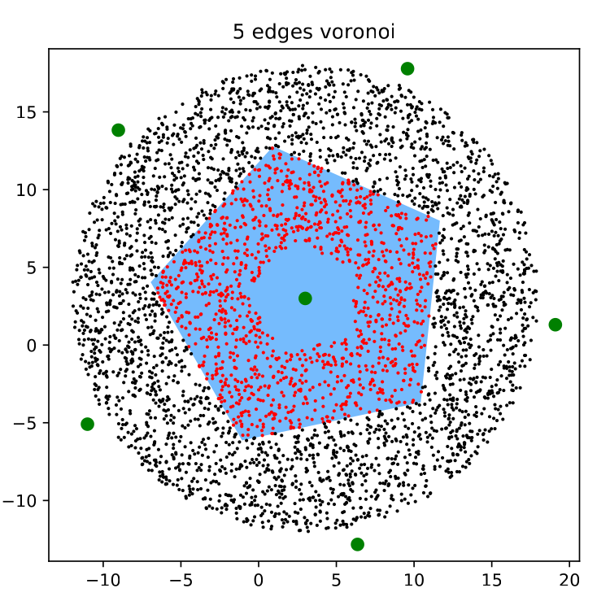

Correctness test of the proposed algorithm

## Performance

In order to make a fair comparison, calculations are performed for all vertices, edges or generators etc. Thus, experimental results reflect theoretical complexity.

The CPU used for the experimentation is Intel(R) Core(TM) i7-7700, running at 3.60GHz frequency. The system has 32GB of RAM.

For ease of reproducibility, all implementations are done using Python and related libraries . The source code to reproduce the results is shared.

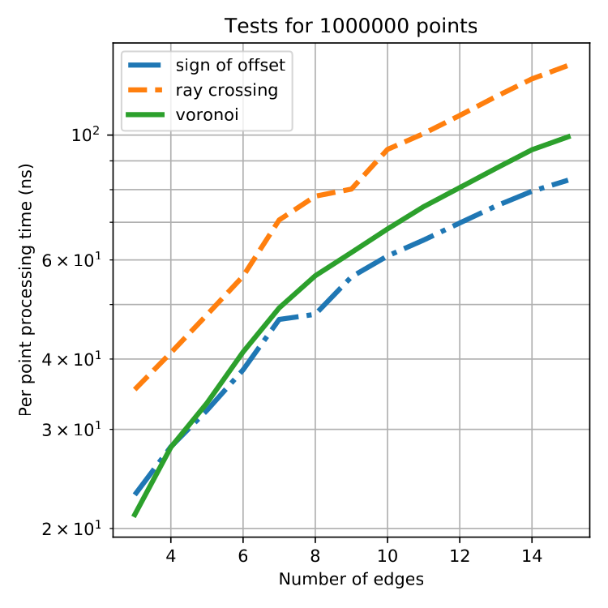

Test results for varying number of edges

In order to reduce effect of the runtime overhead, point inclusion tests are conducted with a point batch size of $1×{10}^{6}$. The number of polygon edges is changing between $3$ to $15$. As it is illustrated in (Figure 6), the proposed algorithm gives comparable results with the reference algorithms.

# Conclusion

A systematic approach to convert a convex polygon to a Voronoi polygon is developed throughout this work. As a meaningful internal generator point selection scheme, centroid calculation of a polygon is chosen. The equations, related to the centroid calculation, are given consecutively. After that the equations, required to calculate outer generators in relation to the inner generator and the vertices of the convex polygon, are derived.

In order to demonstrate the advantages of our proposed algorithm, it is implemented as only vector and matrix operations, without branching. Reference algorithms are also implemented in a similar way. Certain tests are carried out to show that, our proposed algorithm not only works properly, but also its performance is comparable with the reference algorithms.

Conversion of a convex polygon to a Voronoi polygon takes constant time. It only depends on the number of edges of the polygon. If the geometry is known to be constant prior to the use, Voronoi equivalent of the convex polygon can be calculated in advance. Both polygon vertices and generator points can be stored together in a database with only about $2×$ of the original storage capacity needed.

The purpose of this paper is to show that, a precomputed set of test points based on the Voronoi region idea can be effectively used for testing a point inside a convex polygon, in a SIMD fashion. The methods developed here can be extended to nonconvex polygons, and can be applied to prior point-in-polygon algorithms.

# Acknowledgements

This work was supported by the Turkish Scientific and Technological Research Council (TUBITAK) under project no. 118E809.

We would like to thank the reviewers for their thoughtful comments and their constructive remarks.